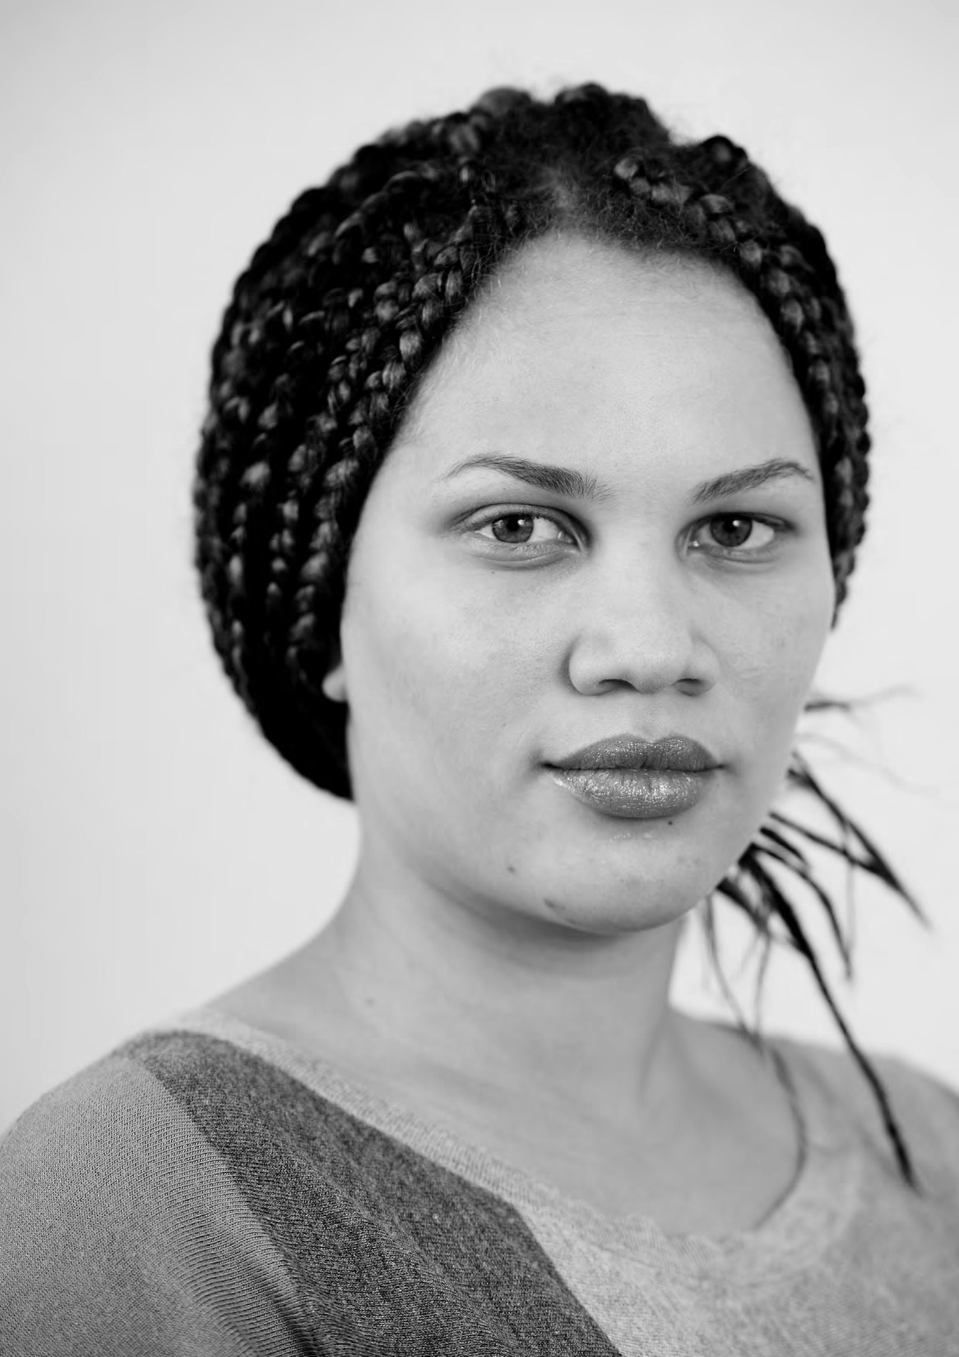

PATIENT-LED ASSESSMENTS OF THE CARE ENVIRONMENT
RESULTS CALCULATION FOR 2015

Contents
Scoring algorithm 3
Multiple choice questions (except food) 3
Food 3
Tasting section 3
Food weightings and scoring 4
Scoring allocation 6

Scoring algorithm
The scoring system set out below applies to all areas of the assessment with the exception of the Organisational questions – food section, which is explained in further detail below.
The allocation of scores for the 2015 PLACE assessments is as follows:

Pass Qualified pass Fail | =  =  = | 2 points  1 point  0 points
Yes answers No answers | =  = | 2 points  0 points

Multiple choice questions (except food)
In all cases the top score is 2 and the bottom score is 0.
Scores for intermediate points on the scale depends on the number of options. So, for example:
If there are three options the scoring is 2, 1 and 0.
If there are four options the scoring is 2, 1⅓, ⅔, and 0.
If there are five options the scoring is 2, 1½; 1, ½, and 0.
If there are six options the scoring is 2, 1.6, 1.2, 0.8, 0.4 and 0

Food
The questions in the Organisational questions – food section are scored by reference to a weighting algorithm which places the emphasis of those areas which patients have advised are the most important in relation to others.
There are three weighting categories in addition to any unweighted questions, these are: Category 3 – high importance;
Category 2 – medium importance; Category 1 – low importance.
The weightings follow a 5:2 method, which means a Category 3 question is five times more important that a Category 1; and a Category 2 question is twice as important as a Category 1.
The precise allocation of points across the questions follow the 5:2 method and can be seen in the table below.
Some questions are unweighted and follow the 2 to 0 formula as set out in the multiple-choice formula above.
Some questions are unscored
Please see the Organisational questions assessment form for information on which weighting category applies to each question, or whether questions are unweighted or unscored.

Tasting section
All questions in the first section are scored 2 – 0.
The Hydration question is scored as set out under multiple choice questions above. Questions in the Tasting Section are scored:-
Food Taste – this is a Category Three weighted question scored in accordance with the table below (5-options);
Food Texture – this is an unweighted question scored 2; 1; 0. Food Temperature – this is an unweighted question scored 2; 0.
The final result for each of the four categories (cleanliness; condition appearance and maintenance; privacy dignity and wellbeing; and food and hydration) will be expressed as a %.
This % is calculated by reference to the score achieved expressed as a % of the maximum score possible.
The score achieved is based on all the points allocated as set out above.
The maximum score possible is the total number of boxes in which a response has been entered (excluding Not Applicable responses) x 2 – 2 being the maximum score for each response.
The on-line system will allocate each box to the appropriate category and calculate the score accordingly – rounding only once where the final score ends in a fraction. This will also take account of the fact that some scores may be a fraction (e.g ⅔) and others to a decimal point (e.g. 1.2).

Food weightings and scoring

Hospital type | Weight | 2 options | 3 options | 4 options | 5 Options
Mixed acute and mental health delivered from the same hospital by the same provider | 3 | 3.70968  0 | 3.70968  1.85484  0 | 3.70968  2.47312  1.23656  0 | 3.70968  2.78226  1.85484  0.92742  0
Mixed acute and mental health delivered from the same hospital by the same provider | 2 | 1.48387  0 | 1.48387  0.74193  0 | 1.48387  0.98924  0.49462  0 | 1.48387  1.1129  0.74193  0.37096  0
Mixed acute and mental health delivered from the same hospital by the same provider | 1 | 0.74193  0 | 0.74193  0.37096  0 | 0.74193  0.49462  0.24731  0 | 0.74193  0.55644  0.37096  0.18548  0

Hospital type | Weight | 2 options | 3 options | 4 options | 5 Options
Acute/community including hospices | 3 | 3.78151  0 | 3.78151  1.89075  0 | 3.78151  2.521  1.2605  0 | 3.78151  2.83613  1.89075  0.94537  0
Acute/community including hospices | 2 | 1.5126  0 | 1.5126  0.7563  0 | 1.5126  1.0084  0.5042  0 | 1.5126  1.13445  0.7563  0.37815  0
Acute/community including hospices | 1 | 0.7563  0 | 0.7563  0.37815  0 | 0.7563  0.5042  0.2521  0 | 0.7563  0.56722  0.37815  0.18907  0
Hospital type | Weight | 2 options | 3 options | 4 options | 5 options
Mental health and learning disabilities | 3 | 3.94495  0 | 3.94495  1.97247  0 | 3.94495  2.62996  1.31498  0 | 3.94495  2.95896  1.97246  0.98623  0
Mental health and learning disabilities | 2 | 1.57798  0 | 1.57798  0.78899  0 | 1.57798  1.05196  0.52599  0 | 1.57798  1.18348  0.78899  0.39449  0
Mental health and learning disabilities | 1 | 0.78899  0 | 0.78899  0.39449  0 | 0.78899  0.52598  0.26299  0 | 0.78899  0.59174  0.39449  0.19724  0

Scoring allocation

CLEANLINESS
All questions from the cleanliness and hand-hygiene sections from all assessment forms including these sections.

CONDITION APPEARANCE AND MAINTENANCE
Organisational Questions Facilities relating to Buildings and Facilities; Access and Car Parking and Equality Duty.
All questions from the Condition Appearance and Maintenance section from all assessment forms including these questions.
All questions except Hearing Loops and Wheelchair-accessible toilets from the Access section from all assessment forms including these questions.
Safety.
Signs (inside and outside the building). Temperature.

PRIVACY DIGNITY AND WELLBEING
Organisational Questions Facilities relating to Internet Access; Recreation/Activity Areas; Children’s Services; Children’s Emergency Departments; Facilities for Family etc to stay overnight.
External Social Spaces.
All questions from the Privacy Dignity and Wellbeing section from all assessment forms including this section.
Staff appearance.
Television and Radio Access. Internal Social Spaces.
Changing and Waiting Facilities. Hearing Loops
Wheelchair accessible toilets

FOOD
All questions from the Organisational Questions – Food and Food – Assessors assessment forms.

DEMENTIA-FRIENDLY ENVIRONMENTS
All questions from the Dementia assessment in Communal, Ward, Emergency and Outpatient assessment forms.
Natural light from Ward assessments
All questions except Hearing Loops from the Access section of all forms in which these questions appear.
Questions relating to Internal Social Spaces (dayrooms) from ward assessments.
All questions except wheelchair accessibility from External Social Spaces in the external areas assessment.

Questions relating to food as follows:- From the Ward-based assessment
- Is there a separate area away from the bed-side where patients can eat together;
- Is there a system in place which allows for the identification of vulnerable patients who require assistance with eating.
- Packaged foods
- Staff involvement
- Adapted cutlery
- Is crockery and glassware used of familiar design and in a distinctive colour that contrasts with tables and trays;
- Is water freely available and independently accessible.

From the Organisational Questions – Food assessment
- Availability of snacks mid-morning, mid-afternoon and evening;
- Provision of hot milk-based dring in the evening;
- Availability of finger-foods;

WARD FIRST/LASTING IMPRESSION
Not scored

PATIENT ASSESSMENT SUMMARY SHEET
Not scored

