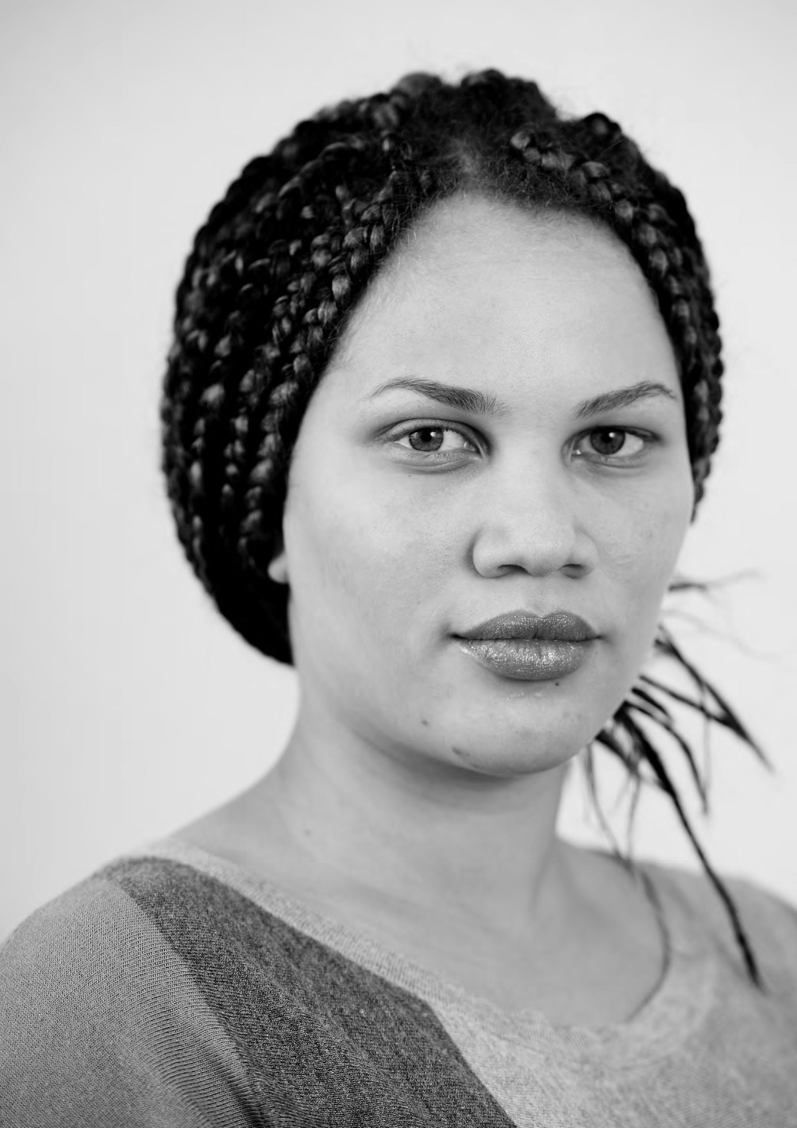

PATIENT-LED ASSESSMENTS OF THE CARE ENVIRONMENT ORGANISATIONAL QUESTIONS – FOOD AND DRINK – TREATMENT CENTRES

Ward name/type

Enter Y against ONE OPTION ONLY
below
Patients can choose from a range of light meals and snacks, e.g baked potato, pasta, salad, toasted sandwich, cheese or beans on toast
Patients can choose from a range of substantial snacks, e.g sandwiches or filled rolls, toast
with a range of toppings
Patients are offered a light snack, e.g. cheese and biscuits, sweet biscuits, confectionery
There is no food available
Enter Y against ONE OPTION ONLY
below
Patients can choose from a range of tea and coffee (including decaffeinated versions) and 2 other hot and/or cold drinks, for example herbal teas, fruit-based drinks and milk-based drinks
Patients can choose from a range of tea and coffee (including decaffeinated versions) and one other hot or cold drink, for example herbal teas, fruit-based drinks and milk-based drinks
Patients can choose from a range of tea and coffee (including decaffeinated versions) only
Patients can choose from a range of tea and coffee (excluding decaffeinated versions) only

Organisational questions – food and drink – Treatment Centres 2

