PATIENT-LED ASSESSMENTS OF THE CARE ENVIRONMENT GUIDANCE TO ORGANISATIONS ON THE RECRUITMENT
AND PREPARATION OF
PATIENT ASSESSORS

Contents
Foreword 3
Introduction 4
Recruitment 5
Who? 5
How many? 5
What skills? 5
Where from? 5
Support for volunteers 6
Management of volunteers 6
Safeguarding and insurance 6
Payment and reimbursement 7
Training/preparation 7
Conclusion 7

Foreword

Good environments matter. A clean environment is the foundation for lower infection rates, whilst good food promotes recovery and improves the patient experience. High standards of privacy enhance patient dignity, and good maintenance and décor support a safe and comfortable stay.
But good environments don’t just happen. Without the concerted efforts of all staff, an organisation can become complacent or worse, and the benefits of cleanliness, good food, privacy and proper maintenance are lost.
Patient-led assessments of the care environment (PLACE) aim to improve standards across all hospitals, hospices and independent treatment centres providing NHS-funded care. They put patient wishes at the centre of the assessment process, and they use information

gleaned directly from patient assessors to report how well a site/organisation is performing – in terms of national standards and against other similar organisations.
This guidance document explains how patients are involved in the assessments and offers advice and guidance to those who are responsible for recruiting patient assessors.
The main purpose of a PLACE assessment is to get the patient view. You will therefore need to organise your assessment to make best use of the patients who are helping you. The structure of the visits should be planned around their needs – not those of the site/ organisation.

Introduction

NHS England and the Department of Health recommend that all hospitals, hospices and independent treatment centres providing NHS- funded care undertake an annual assessment of the quality of non-clinical services and the condition of their buildings. These assessments are referred to as patient-led assessments of the care environment (PLACE).
They look at:
- how clean the environments are;
- the condition – inside and outside – of the
building(s), fixtures and fittings;
- how well the building meets the needs of those who use it, for example through signs and car parking facilities;
- the quality and availability of food and drinks; and
- how well the environment supports people’s privacy and dignity.
The assessments apply to all hospitals of all types. This includes acute, specialist, children’s, mental health, learning disabilities, community and independent hospitals that provide NHS- funded care. The assessments also apply to hospices and independent treatment centres.
Assessments are carried out annually by people who use the building – relatives, carers, friends, patient advocates, volunteers or trust membership and trust governors – supported by staff. We use the term ‘patient-led’ to make it clear that the patients’ voice is the one that matters most.
The purpose of this document is to set out broad principles and guidance on how patient assessors should be recruited and trained/prepared. Final decisions should be made locally dependent on the specific circumstances.

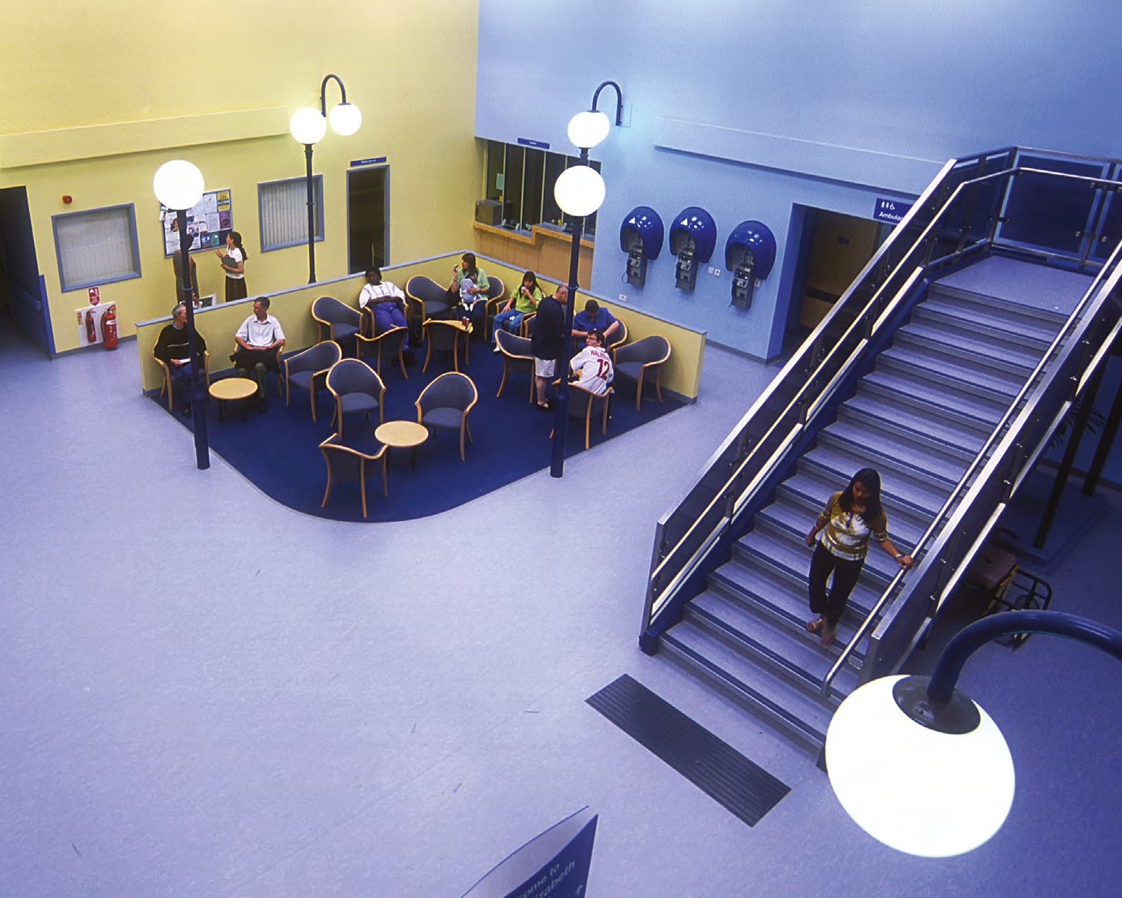

Recruitment

Who?
Anyone whose experience of the site/ organisation is as a user, rather than a provider, of services can be a patient assessor. The term includes relatives, carers, friends, patient advocates, volunteers or trust membership and trust governors, as long as they have the patient’s view as their focus. Current or recent members of staff (that is, who have left the organisation within the previous two years) should not act as patient assessors at their own site, even when they are also patients. They can act as staff assessors, or can be patient assessors at other sites/organisations. Teams should be a mix of people who use the building/ site and broadly reflect the local population using the service.

How many?
There is no maximum number of patients in a PLACE team. As a minimum, patient assessors should make up 50 per cent of the team (including any sub-teams). There should always be at least two patient assessors, even in smaller sub-teams, so in practice this is likely to mean that more than 50 per cent of the overall team will be patient assessors.
Assessments should not go ahead with only one patient assessor. Contingency plans should be in place so that assessments can still go ahead if a patient assessor is not available.
The exact number you need depends on how you want to organise your assessment – for example if you want several smaller teams or one large one. It may be easier to split into small teams, each checking two or three wards or departments. This also allows the use of a wider range of patient assessors, including those who might not be physically fit enough to assess a whole site.

What skills?
Anyone can be a patient assessor. The process has been designed to be as inclusive as possible. It is important that the assessment process is set up around the needs of the patient assessors, and site/organisation should be flexible in making their arrangements so that patient assessors are able to be fully involved. Such flexibility may include, for example:
- on large sites, undertaking the assessment on more than one day so that patient representatives, particularly more elderly people, are not unduly burdened;
- establishing several small teams who can share the burden of a large assessment, with each team assessing just a few wards or departments; and
- inviting specific patient representatives to take part in aspects of the assessment for which they are most suited without having to
undertake the full assessment – for example, children may be involved in assessing children’s services, sight-impaired people may have a particularly useful role to play in assessing wayfinding.

Where from?
The first route to identify patient representation should always be through local Healthwatch, who have the right to join any PLACE assessments. In addition to local Healthwatch, or where they decline to be involved, organisations may need to recruit additional patient assessors. This may be via trust members, patient committees, community engagement networks or other existing links.
Alternatively, organisations may choose to recruit patients with no previous assessment experience, selecting patient assessors specifically to undertake PLACE assessments.
Patient assessors should broadly reflect the patient population. Factors such as age, disability or ethnicity should be actively taken into account – children’s hospitals, for instance, might wish to consider how young people can be involved, and it is always good practice to include the views of those with mobility or sensory impairments.
Additionally, there are many national and local organisations who could be approached. These are too numerous to list individually, but the following organisations have agreed to direct organisations to useful guidance or other support systems:
- The National Children’s Bureau have a network of trained Young Assessors – organisations providing children’s services may find this model useful;

- The National Council for Palliative Care has contact with a wide network of people who have personal experience of palliative and end of life care, who are keen to improve care for others; and
- The Royal National Institute for Blind People
– sight impairment should be no barrier to involvement in this process.
In addition, two major patient representative organisations, Age UK and the Patients Association, who were represented on the PLACE steering group, have extensive experience in supporting assessments/ inspections of all types.
DH and the Health and Social Care Information Centre (HSCIC) have produced a short guide for anyone thinking of becoming a patient assessor. Organisations may wish to make this available through their local networks.

Representatives from the local Healthwatch should always be offered the chance to take part in PLACE assessments. If they decline to be involved, the organisation will need to seek patient assessors from other sources.

Support for volunteers

Patient assessors are the focus of the PLACE process, so it is important that organisations demonstrate that they value their services. For effective involvement, people need to feel supported and recognised – and there are many ways this can be achieved. Often, the major motivator is seeing improvements made as a result of involvement and the PLACE system has been designed specifically to promote this. But other methods are important too, including being thanked, receiving acknowledgement, or participating in training. Organisations who take the development of patient assessors seriously should find that they benefit well beyond the PLACE process, by building a cadre of committed volunteers.

Management of volunteers

Organisations carry a duty of care for patients, staff and other volunteers’ wellbeing, and safeguarding their welfare should be paramount.
Organisations should have local arrangements and practices in place for the safe recruitment and continued monitoring of patient volunteers. These arrangements will include steps that the organisation needs to take to assure themselves that volunteers are “fit and proper” to become PLACE patient assessors. These steps may include a Criminal Records Bureau check (see note below), references or group interview.
Organisations should also ensure that local safeguarding arrangements are up to date, and embedded within the organisation so that all staff are familiar with and understand them.

Safeguarding and insurance

The Government stated its intention in May 2010 to scale back the Vetting and Barring Scheme and the criminal records regime to more proportionate and common sense levels. Please follow the link for more information:
http://www.dh.gov.uk/health/2012/08/new- disclosure-and-barring-services-definition-of- regulated-activity/
The NHS Employment Check Standard was updated to reflect these changes and can be seen at:
http://www.nhsemployers.org/ RecruitmentAndRetention/Pages/Recruitment- and-retention.aspx
PLACE patient assessors will not be undertaking a regulated activity as defined by the Safeguarding Vulnerable Groups Act 2006. They are therefore not eligible to apply for enhanced disclosure and barring checks, and organisations are not entitled to ask a volunteer to apply for this type of check. Organisations could ask volunteers to apply for a standard disclosure and barring check if individual volunteers are eligible, but they should consider the activities and the supervision of their patient assessors when making that decision.
Organisations should make a risk-based assessment of whether it is proportionate and necessary to request such a check. Patient assessors should be accompanied at all times by staff.
As with all volunteers, organisations will need to ensure that appropriate insurance arrangements are in place.

Payment and reimbursement

Organisations should follow their own local policies for reimbursement. Most organisations reimburse travel expenses and provide appropriate refreshments, whilst some also offer a small honorarium. For more information on remuneration of volunteers, please use the following link:
http://www.dh.gov.uk/en/ Publicationsandstatistics/Publications/ PublicationsPolicyAndGuidance/DH_4138523

Training/preparation

In general training/preparation for both staff and patient assessors, will be carried out locally.
Organisations may provide the training/ preparation themselves or in partnership with others (for example local Healthwatch).
Training/preparation may take place at any time either before the assessment or on the day.
Training/preparation should not happen too far in advance, since the information needs to be fresh in the minds of the assessment team. The precise format of any training provided should be determined locally but should include as a minimum:
- patient confidentiality and expected standards
of behaviour during the assessment;
- aspects of hand hygiene, infection control, and procedures on entering side rooms;
- the content of the assessment and the supporting guidance;
- the scoring methodology and supporting guidance;
- information about the site/organisation and its services, particularly where there is specific additional guidance to be applied
(for example wards for those with dementia, hospitals providing mental health and/or learning disabilities services);
- the role of patient assessors and how the assessment will be organised, for example the areas to be assessed, and the aspects to be covered. On a large site, teams may be split in order to cover the full range of services; and
- the specific functions of patient assessors in completing the patient assessment summary sheet.
Training/preparation should also cover such topics as what to do in an emergency (for example cardiac arrest) and any limits on the assessment process (for example, ensuring that the process does not intrude unreasonably on patient privacy or staff activities).
The assessment process has been designed to be self-explanatory, and so providing training should not be unduly burdensome. Patient assessors can do much of the preparation at home, simply by reading the assessment form and guidance.

PLACE assessments are aimed at describing what matters to patients. Every attempt should be made to involve a wide range of patient assessors who can together deliver a comprehensive, patient-led overview of the services. Disclosure and barring system checks are not normally needed, as patient assessors are not carrying out a regulated activity, do not have access to confidential patient information, and are accompanied at all times by members of staff.

Conclusion

PLACE assessments have the patient voice at their core. Without committed, well-prepared patient assessors, the system will fail.
Organisations should draw on the widest possible range of representatives (always including local Healthwatch) to ensure that they can deliver robust, meaningful evaluations that they can then use as a springboard to improvement.

