Piloting Accessible Information Standard

Flagging Patient Access Needs in SystmOne

Progress Report

Content.

Section1 Background

Section 2 What have local disabled people told us about their access needs and communicating with their GP practice?

Section 3 What will be required from the practice?

Section 4 Pilot project systems implementation check list and process

Section 5 Progress to date

Section 6 Pilot Timeframes

- Background

A project steering group consisting of a GP from Bingley Medical Practice, with CCG and CS staff working in engagement, equality and diversity and data quality and with some local disabled people from Bradford’s Strategic Disability Partnership board (SDP) began meeting approximately one year ago.
The group were reviewing poor patient experience feedback received from patients and carers whose accessibility information needs were not being met. This included for example, appointment letters being sent to people with visual impairments, translators for language or BSL not being arranged at clinics or information not provided in a way that can be used.
The group has identified a way of flagging patients with communication and access needs in Systmone.
SystmOne is a centrally hosted clinical computer system developed by TPP (The Phoenix Partnership). It is used by healthcare professionals in the UK predominantly in Primary Care. The system is being deployed as one of the accredited systems in the government's programme of modernising IT in the NHS
The Local Authority in Bradford is also moving to SystemOne in Aug 2015 and the results of this pilot will be shared with colleagues together with recommendations for rolling out to a wider cohort of member practices.
- What have local disabled people told us about their access needs and communicating with their GP practice

“People talk to my mum and dad because it is more convenient. I know what I want to say and am quite capable of telling people what I need from them but I need a bit more time to form my words and I need people to take the time to listen.”

“We are all individuals and have different needs. People should be aware that we need particular help when we walk into a service. It would be great if our files were flagged making the receptionist or other staff aware – my dentist and my bank know that I am blind.”

These are just two of the stories Airedale, Wharfedale & Craven, Bradford City and Bradford Districts CCGs have heard from local people who want staff at their local doctors’ surgery to be aware of their individual needs. These may be linked to disability, language spoken or carer status for example.

A local women with a visual impairment summed things up:

“Many of the issues we encounter are pretty basic like people telling us to ‘go over there’ and pointing in a direction which we obviously cannot see. We have talked about this sort of thing for so long – now I just want to be able to shake someone’s hand in 12 months’ time and thank them for helping me to be treated in an appropriate way.”

Contacting the practice and making the appointment
- Many Deaf people have to travel to the surgery to do this because the practice doesn’t accept texts or emails
- Some people, for example people with learning difficulties, would benefit from a double appointment so that things can be properly explained, and it would be helpful if the surgery knew this when the patient is contacting them to make an appointment.
Getting into the building
- Some practices in older buildings are still not easily accessible for people with mobility difficulties. It can be hard to park near the doorway and then to get through the doorway.
In the waiting room
- Blind and partially sighted people often can’t see the call board that lets patients know when it is their turn to go into the consulting room in many practices.
- Deaf people can’t hear the noise attached to the call board or hear their name being called out if that is the system their practice uses.
- For people with mobility difficulties it can be difficult actually getting through the waiting room and into the consulting room.
- For people with learning disabilities it can be hard to work out where to go once you know it’s your appointment. Some people with learning disabilities will not be able to read their name when it comes up on the call board.
- For people with mental health problems it can be a very stressful and difficult time waiting in the waiting room for your appointment, particularly if there are delays.
During the consultation
- Some disabled people need a double appointment (see making the appointment heading)
- It’s important to be clear about the specific reasonable adjustment for that patient, for example, one profoundly deaf patient who ideally needed an electronic note taker, arrived at an appointment to find a BSL interpreter was there when she does not use BSL.
Referral to secondary care
- Deaf BSL users have reported many difficulties with this part of the patient journey. It generally isn’t clear when you receive your appointment at hospital whether a BSL interpreter has been booked or whose responsibility it is to do this. Trying to find out can sometimes involve up to 5 or 6 phone conversations with different members of hospital staff, which if you’re deaf you obviously need to get someone else to make.
- Blind people still receive letters detailing their appointment. It is often considered that it’s perfectly reasonable to expect that a blind person has somebody else to read letters for them. We should always be aiming for autonomy.

- What will be required from the practice?
- Identify potential patient volunteers who have one or more of the seven communications and/or access needs.
- Send out letter and information sheet in appropriate format until 10 patients have agreed to participate in the pilot.
- Agree time and date for staff/ to attend 1 hr practice staff awareness training to be delivered by Bradford Talking Media at the practice.
- Arrange for patients to come into the practice to complete the questionnaire (arrange home visits if this is not convenient) Questionnaires to be delivered by both practice staff and steering group member.
- Questionnaire analysis - Agree reasonable adjustments between patient and GP practice
- Clear up patient home screen and complete check list
- Arrange pilot start date this will coincide with the SystmOne template protocol being installed onto your system and a half day training session provided for practice clinician management and staff.
- Pilot project systems implementation check list and process
Deployment Checklist

- Clear down any reminders in the patients’ records which are identified as having access needs

- Ensure Organisation Preferences are configured so that reminders are visible on the home screen, high up the screen and are set to expanded

- Import and publish Protocols from DQ webpages, System Tools

- Add ‘ WYCSU Patient Access’ template into clinical tree

- Ensure all relevant team members are aware of what this particular reminder/status alert means and why it should be observed

- Ensure all relevant team members have seen the overview of the functionality required to support this process

- Consider whether patients with special access needs will be given a separate recall that indicates a special requirement. i.e.: Recall Type: ACCESS NEEDS. Freetext: CHD Annual Review.

Processes

Patient identified as having Access Need
- Access need is identified and added into ‘ WYCSU Patient Access’
- Protocol triggers to prompt user to add Reminder & Recurring appointment text
Booking appointment
- Reminder appears advising reception team that patient has access need and what their explicit requirements are
- Appointment booked, recurring appointment text dropped into details of appointment
Viewing Record
- Protocol triggers data entry template which shows ‘view’ of requirements and option to add additional comments
- Template can be cancelled or populated

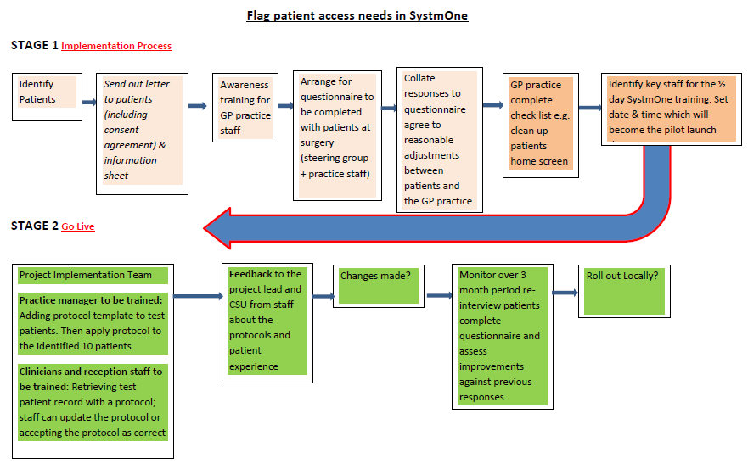
.

- Progress to date

Bingley Medical Practice (the pilot practice) have identified between 10 – 15 patients with communication and access needs. These patients were selected from a broad range of specific needs the seven main areas we have identified for this project are:
- Visual Impairment
- Learning disability
- Mental Health
- Language
- Hearing Impairment
- Physical disability
- Caring responsibilities

A template letter of introduction has been developed for the practice to copy onto its headed paper and send to potential patient volunteers. The letter serves two purposes:
- Presents an overview of the pilot and what is expected of the patient volunteer.
- Consent Agreement

Along with the letter is an information sheet which provides an overview of the project who is involved and an offer to provide further information if required.
Training for practice staff has been identified as a requirement and arrangements to deliver a 1 hour workshop to practice staff is in place and will be delivered in May 2015
Working with the VCS, Bradford City and Districts and AWC CCG’s have developed a questionnaire that will act as a guide for practice staff when talking to patients about their access needs, it will support the patient and practice to agree an adjustment that is reasonable to both parties and will be used before and after flagging to evaluate its success in improving patient access and experience.
The questionnaire analysis and reasonable adjustment agreement process will be discussed at the next steering group meeting arranged for late May.
Arrangement for the Implementation of the SystmOne template and protocol and a half day training allocation are in place and will be delivered simultaneously with the pilot launch date. An information and guidance sheet for the template and protocol has been produced

- Key Anticipated Timeframes

April 2015 –
- Work products e.g. Questionnaires – letters- guidance docs, information sharing etc. too be agreed and signed off.
- Invited Bradford Metropolitan District Council to Steering Group Meetings to share information and experiences.
- Expanded the pilot to a further four local GP practices who are well established in the implementation process and are due to receive staff awareness training.
- Practice managers and pilot leads have attended steering group meetings which have included a demonstration how the new SystmOne template and protocol will be implemented into the GP practice system
- Bradford Talking Media to produce questionnaire in accessible formats BSL & Audio
May 2015 –
- Patient/Volunteers are contacted and consent to participate in pilot.
- Practice agrees date/s and time for questionnaire event at the GP practices with volunteers
- Staff awareness training delivered
June 2015 –
- Deliver Questionnaires in appropriate format
- Agree reasonable adjustments between patient and practices
- Launch pilot – Implement SystmOne template and protocol with ½ day training session
Sept 2015 –
- After 3 months of launch date re-interview patient volunteers completing the same questionnaire.
- Assess improvements to communication and access needs measured against previous patient responses and experiences

