Cervical Screening Drop-in – Q&As 17th September 2025

- How do I reinstate a patient who has previously been ceased from the national cervical screening programme?
Please complete the following form Reinstate-Form-Final-v4.0.docx and follow the guidance- Screening – Reinstate – NHS Cervical Screening Administration Service
Full information can be found here https://csas.nhs.uk/support/ Please note that if a patient has been incorrectly ceased, you will need to do an audit on all your patients who have been ceased for ‘No Cervix’. This will ensure no further patients have been incorrectly ceased.
- How long do results take to show on the NHS App?
The introduction of the NHS App has not impacted the turnaround time (TAT) of results. Results via letter or App notification should be the same and are usually within 2 weeks for samples that are sent to the Norfolk and Norwich lab.
- How do I cease a patient from the programme following a total hysterectomy?
Patients can be ceased two different ways following a total hysterectomy. Once you are clear the patient does not have a cervix (this has to have been clearly communicated to the GP practice that the patient is not eligible for cervical screening programme).
Option 1- a patient can be ceased via the CSAS website using the following link- https://csas.nhs.uk/support/. Complete the form Cease-Form-Final-v6.0.docx and upload. We recommend that a patient is ceased as soon as the GP practice has received the information from the hospital.
Option 2- a patient can be ceased for ‘No Cervix’ when they appear on your prior notification lists (PNLs).
- Do recall dates on local clinical systems need to be amended for the patients now on a 5-year routine recall?
CSMS should be checked for every patient and local clinical systems should not be relied on for accurate recall dates. Those patients with HPV negative result after 1st July, and no other significant history, will now be recalled after 5 years.
- Where can I find information regarding mentor update training?
Mentor updates will be provided by the training provider of the trainee. Please contact your training provider for information on mentor training. Guidance- Education pathway - GOV.UK
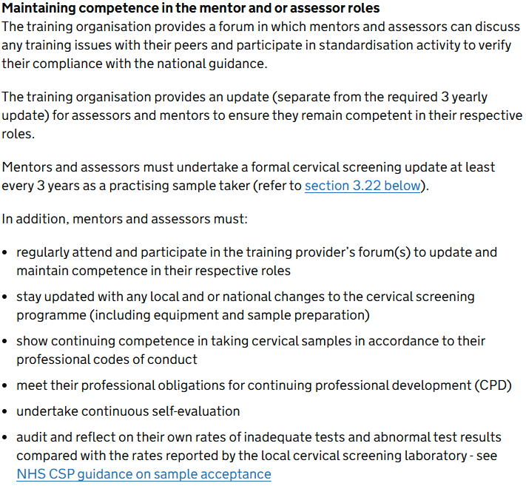

- If a patient is receiving colposcopy treatment in London and moves to Essex what is the local management plan?
The patient needs to be referred to an appropriate Essex NHS trust or hospital that offers colposcopy services. The receiving hospital will take primary responsibility for the patient's onward care, identify the correct specialist consultant, and determine the local management plan, which will likely involve continuing or adapting the treatment plan from London. The patient's care team in London should help facilitate this referral to ensure a smooth transition.

- How to access the cervical sample taker database (CSTD).
Register with NNUH lab on the sample takers database by emailing CSTDhelpdesk@nnuh.nhs.uk You will then be able to access the database and review all results.
- If a patient is ceased from the programme, do they need to be contacted periodically to confirm this status?
No, patients don’t have to be contacted every 5 years if they are ceased from the programme. Historically patients who have opted out of the screening programme due to ‘patients informed choice’ would be contacted every 5 years, however this is now not mandatory but is good practice.

- If a patient is seen in colposcopy and returned to routine recall, whilst persistently HPV positive, should I be concerned?
Colposcopy will decide regarding patient recall based on their findings. Always check the patient history and, if there is still concern, check with the laboratory. It is likely the patient is following untreated CIN1 pathway: https://www.gov.uk/government/publications/cervical-screening-pathway-requirements-specification/cervical-screening-pathway-requirements-specification
Please see flow chart below (bottom left) and follow up for untreated CIN1. On the second ‘hrHPV positive / Cytology negative’ sample, a repeat in 3 years is recommended. The rationale is that these patients have been seen in colposcopy to exclude high grade abnormality and, whilst in follow up they may not have cleared the virus, their cytology is negative. Prior to HPV Primary screening algorithms, these patients would have been advised R36.
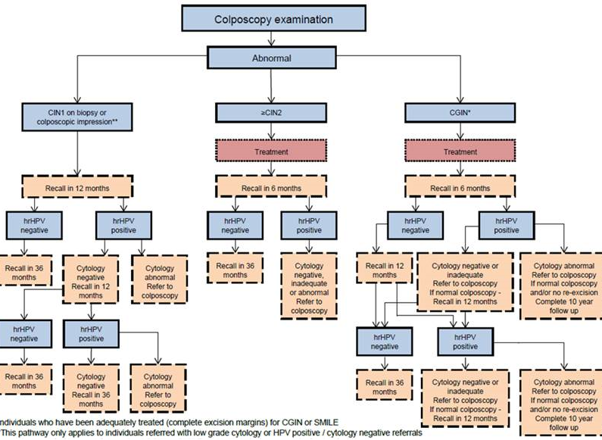

- What recall should be used if I cannot see results on the CSMS but the results have been sent to the practice?
This would not happen. All results are uploaded to CSMS. Please contact the lab to discuss this specific case further.
- Will local clinical systems be updated to reflect the extended intervals?
Local clinical systems are not integrated with CSMS so will not be automatically updated to reflect extended intervals. CSMS is the only reliable source of information on next test due date (NTDD).

- What action should be taken for ceased patients who are now >64yrs old?
Patients over 65 will not be offered cervical screening. CSMS will automatically cease a patient once they are over the age of 65. People who have previously had abnormal cervical cells are only automatically ceased from recall when they have completed the relevant follow up. Those who have not completed relevant follow up continue to be invited for non-routine cervical screening after the age of 65 if necessary.
People aged 65 or over who have had a previous cervical abnormality remain in recall until they have completed follow up, even if they have not responded to their most recent screening invitations. This may include people who have had a positive HPV test but no abnormal cytology. People who remain eligible for non-routine screening are not ceased automatically due to age. Further information can be found here- section 3.1- Ceasing and deferring women from the NHS Cervical Screening Programme - GOV.UK

- Can I cease a patient if they have had a total abdominal hysterectomy (TAH)? Is this the responsibility of the gynae team?
It is not the responsibility of the gynae team to cease the patient from the cervical screening programme. The gynae team will write a letter to the GP practice informing them of what the patient has had done. If you are unsure if any of the patient’s cervix remains, please contact the gynae clinic to check. The letter should state the patient no longer has a cervix so does not require any further cervical screening. A total abdominal hysterectomy should remove both the uterus and cervix through an incision of the abdomen. If the discharge letter is unclear, then please check further. Please see section 3.2- Ceasing and deferring women from the NHS Cervical Screening Programme - GOV.UK

- How do I code a patient with bicornuate uterus who is being seen in colposcopy?
Unfortunately, we cannot comment on READ or SNOMED coding, please refer to your local guidance.

