Cervical Screening Drop-in Session Q&A’s 18th March 2026

- How long before cervical screening should patients be advised to stop using vaginal oestrogen?

- The national guidance states to stop using topical oestrogen 48 hours before the cervical screen. During the examination, the clinician should also check that excess cream is not present. NHS Cervical Screening Programme – Good practice guidance for sample takers - GOV.UK Section 12.2.

- NNUH lab also refer to the NICE ‘best practice’ guidance that recommends a a 2￼week pause, where possible, to avoid potential sample contamination. This provides a good balance between minimising the risk of cream contaminating the slide while still allowing women to gain the full benefit of using oestrogen prior to screening.

- When cytology ICE forms are generated, is there a log/audit to see results? or is it best to keep our own record.

- There is no specific ICE form log. The guidance does state that it’s the practitioner’s responsibility to ensure there is a result for every sample taken. All results are automatically sent back to the sample taker/GP practice via an electronic record from the lab. Practices can then add these results to the local system. Results are also uploaded to the CSMS (which generates result letters).

NHS Cervical Screening Programme – Good practice guidance for sample takers - GOV.UK Section 7.2

- Results and failsafe – maintain a register of tests taken and check that a test result has been received from the laboratory for every sample taken, (the practice must have a procedure in place to investigate any sample result not returned)

- NNUH lab are able to see what ICE/ICE-NI forms have been requested on the system. This is why it is important to cancel a request if the patient does not attend or a sample can not be taken. By cancelling the request NNUH will not expect the sample. Guidance on how to cancel a ICE/ICE-NI request is on the presentation from 18th March 2026.
- How soon can a 12 month or 3-year recall be taken?

- Samples cannot be taken more than 3months before the NTDD. If samples are taken too early, they will be rejected by the lab. Sample takers should always check the CSMS to make sure patients are due for screening. This will be clearly stated on CSMS, please see example below.

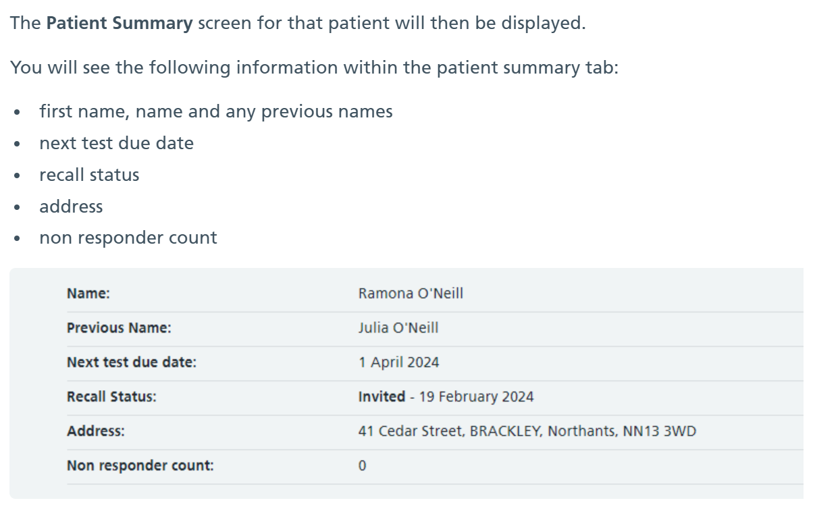

Guidance for acceptance of cervical screening samples in laboratories and pathways, roles and responsibilities - GOV.UK
Samples taken more than 3 months before an individual’s next test due date should be considered out of programme if they are:
- a routine recall
- an early repeat test in 12 months following an HPV positive/cytology negative test
- a follow up test after colposcopy or treatment

- Is the 3 yearly cervical screening update online training out yet?

- The Cervical Screening update module has been updated (December 2025) with the correct screening intervals. The module is to be updated again with information about self-testing. Sample takers should be encouraged to access the module if they are now due or overdue for the update.

The e-LFH module can be found here: NHSE elfh Hub

- Can purple ICE paper forms be used for cervical screening?

- In GP practices ICE or ICE-NI should be always used to generate the sample form. This minimises the risk of booking errors. In sexual health services or extended access clinics where there is no access to ICE or ICE-NI, CSMS can be used to generate the HMR101 form. The purple ICE paper forms are supplied by NNUH lab, using the purple bags and purple paper helps identify cervical screening samples when being transported to the lab.

- What is the read code for sending third reminders on SystmOne?

- There are a number of different read codes used on GP systems. This can be a topic of discussion at one of the drop-in session to see what other GP practices use.
- For issues, setting up new codes, or changing organisation IDs (ODS codes), you can contact the TPP Helpdesk or email:

- TPP Setup Support: SystmOneSetup@tpp-uk.com
- Deployment Specialist Team: Deployments@tpp-uk.com
- Ardens Support (for Ardens users): support-systmone@ardens.org.uk

- Why are some patients with a HPV negative result recalled in 3 years?

- Depending on the patients cervical screening history, for example previous positive HPV result or abnormal cytology, they may be recalled in 3years. If you are unsure if the interval is correct, the lab can be contacted on CytologySeniors@nnuh.nhs.uk to confirm.
Extended Screening Interval Clinical Pathway protocol - GOV.UK
1.5 Test result is hrHPV negative (Primary or TTOC) with a routine recall action code. Previous recent* test result either:
- hrHPV positive/cytology negative or ?non cervical glandular neoplasia with a 12-month recall action code
- hrHPV positive/cytology inadequate with a 3-month recall action code
- hrHPV positive/cytology either negative, borderline change in squamous cells, borderline change in endocervical cells, low-grade dyskaryosis or ?glandular neoplasia (non-cervical) and an ‘S’ action code or HPV unreliable/no cytology/S action code following an HPV positive result with inadequate cytology/repeat in 3 months
- Remain on 3-year recall. At 36-month recall test if hrHPV negative (Primary) NTDD 5 years
*This is defined as any hrHPV positive result recorded in a participant’s screening history in the preceding 5-year period that is not subsequently followed by a clinician-sampled hrHPV negative result. If the previous hrHPV positive result was greater than or equal to 5 years previously then it is not considered recent.
NHS Cervical Screening Programme – Good practice guidance for sample takers - GOV.UK
5. Screening intervals
The programme sends screening invitations to people with a cervix who are registered with their GP practice as ‘female’ at the following ages and intervals.
- For those aged 25 to 64 screening is every 5 years with a first invitation issued at 24.5 years to ensure screening starts promptly at 25
- Those over age 65 are only screened where they have not been screened since age 50 or have had recent abnormal tests or have never been screened
The high negative predictive value of hrHPV testing and lower false negative rate means screening intervals have been lengthened in individuals aged 24.5 to 49 years to 5 years. Those who test negative for hrHPV and have no recent hrHPV positive result are now recalled in 5 years, whilst those who test negative for hrHPV but have had a recent hrHPV positive test result are called in a further 3 years. At the next test in 3 years’ time a further negative hrHPV test result means the individual can have their recall set in 5 years’ time.

- Where is the expiry stated on the sample pots?

- The expiry date is printed on the side of a Thin Prep sample pot and should be checked before taking every cervical sample.
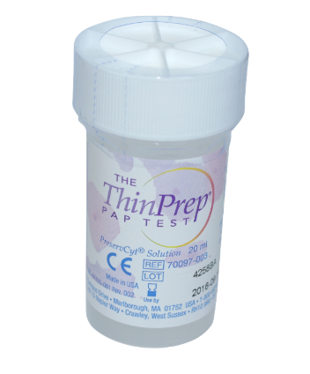
Guidance for acceptance of cervical screening samples in laboratories and pathways, roles and responsibilities - GOV.UK
Check the vial to make sure that it has not passed its expiry date and that it has at least 14 days remaining. HPV testing cannot be carried out on expired vials.

- What is the contact email address for the Cervical Sample Takers Database (CSTD)?

- For any queries, or to register with the database, please email cstdhelpdesk@nnuh.nhs.uk

- What is the screening pathway for patients living with HIV and how is this documented on CSMS?
- Patients living with HIV should be screened every 12 months, please see official guidance below. The CSMS will not record a patient’s HIV status. Sample takers should highlight ‘Retroviral’ (RVI) on the request form, so the lab is aware, so they are able to give the patient the correct recall.
- https://www.gov.uk/government/publications/cervical-screening-programme-and-colposcopy-management/5-screening-and-management-of-immunosuppressed-individuals

- 2.6 Individuals who are human immunodeficiency virus (HIV) positive
All individuals newly diagnosed with HIV should have cervical surveillance performed by, or in conjunction with, the medical team managing the HIV infection. Annual screening should be performed with an initial colposcopy if resources permit. Subsequent colposcopy for any screening abnormality should follow national guidelines. The age range screened should be the same as for HIV negative individuals.
Despite the higher cervical treatment failure rate, high grade CIN should be managed according to national guidelines. Lesions less severe than CIN2 should generally not be treated as these are likely to represent persistent hrHPV infection of the cervix which responds poorly to treatment and may clear spontaneously. Regular cytological surveillance will detect progression.
Research published in 2005, 2012 and 2013 advises close co-operation between Colposcopists and medical teams managing individuals with HIV to ensure that individuals are not over treated if there is a possibility of enhancing immunocompetence (for example by raising CD4 counts following compliance with antiretroviral therapy).
Individuals who are HIV positive can cease cervical screening at age 65 if they fulfil the other general criteria for ceasing.

- If you cannot check the patient history, for example due to an IT issue, what is the process for taking a sample?

- As discussed at the drop-in session, blank request forms should only be used in extenuating circumstances. If there are any issues with IT, you should do everything you can to take a sample and not cancel clinics. It is always advisable to check CSMS for a patients NTDD and history. However, if this is not available, the lab can be contacted to check NTDD and local GP systems can be used to review last test. It is not usual practice to rely on this in normal circumstances as GP systems recall dates do not always reflect the National Screening Programme records. If blank request forms are used, state on the form why it is being used.
https://csas.nhs.uk/wp-content/uploads/2024/07/Cervical-Screening-Platform-_-HMR10193.pdf .
NHS Cervical Screening Programme – Good practice guidance for sample takers - GOV.UK
Access to patient screening records on the call/recall IT system
- a sample taker to generate and print a pre-populated sample request form (where the receiving laboratory has agreed that this is the preferred method for submitting forms)
Guidance for acceptance of cervical screening samples in laboratories and pathways, roles and responsibilities - GOV.UK
4.2 Sample request forms
Should electronic requesting not be in use, sample takers should use the cervical screening test request forms available via the call and recall IT system. Only this version contains the full screening history. Use of other versions may result in delays due to the laboratory checking the full history on the call and recall system, or the risk of issuing an inappropriate management recommendation by the laboratory. Sample takers must have knowledge of the the call and recall IT system to download the correct test request form and be an authorised user. They should follow the guidelines for completion of the form and produce the preferred size for their laboratory (commonly, size A5).
If a non-call and recall system request form is used for a legitimate reason (for example the patient is not yet registered or the call and recall system is unavailable), explain this to the laboratory on the call and recall system request form. Also provide the person’s recent or relevant screening history.
Where laboratory electronic requesting systems are in use, there must be mechanisms in place to provide the past screening history as it is on the call and recall system. This makes sure sample takers do not take unnecessary samples and laboratories are able to give correct patient management recommendations.

- Who do I contact for issues with Smart Card access and permissions?

- The local Registration Authority (RA) for your area can assist with changes to Smart Card access. If you are unsure who your local RA is, please contact your SIT via the relevant inbox:
  - Essex: england.essexscreening@nhs.net
  - East Anglia: england.ea-phsi@nhs.net
  - Herts, BLMK: england.cancerscreening@nhs.net
SIT’s can provide local information to support Smart Card access.

- What information is shared with patients following three consecutive HPV positive screens, referral to colposcopy and return to three yearly recall?

- Colposcopy units do not use a national template letter for these patients. This means each colposcopy unit has a different letter. The SIT team have reached out to a number of units to ask for some examples. This will be discussed at a future drop-in session. If you have any concerns, please contact your local colposcopy department.

- If a patient has a cervical screen taken privately are GP practices notified so the patient is not recorded as a non-responder?

- Private screening is not part of the NHS National Cervical Screening Programme. Patients who choose to have private screening should continue to be recalled and be considered a non-responder. A patient’s private test will not be recorded on CSMS.

- When is the next training for novice sample takers?

- There are several training providers who run courses throughout the year. If you are unsure which training provider to contact, you can contact your local training hub or SIT for more information. A list can be found on our SIT website: NHS England — East of England » Useful contacts and below:

    - Equip – forthcoming training events
    - Clinical training limited – Courses are developed and delivered at different levels by using various learning styles to address individual requirements.
    - University of Essex – campuses in Colchester and Southend
    - Anglia Ruskin University (campuses in Chelmsford and Cambridge) – University courses at Anglia Ruskin University
    - University of Hertfordshire – Continuing professional development health online prospectus and application portal
    - University of East Anglia – Fundamentals of general practice
    - North of England pathology and screening education centre – Provides training in Norfolk and Suffolk
    - University of West London- www.uwl.ac.uk
    - MKM Healthcare- www.mkmhealthcare.co.uk
We do not endorse or fund any of these and advise you do your own investigation prior to choosing a provider. Please book directly with the training course provider.

- What happens to results if a patient does not have the NHS App or a smart phone?

- Patients will continue to receive results via letter if they are not digitally enabled. If the digital notifications are not received/read within 72hours a letter is automatically generated.

- Does stopping topical oestrogen affect the patients HRT schedule and risk of bleeding?

- Guidance around topical oestrogen can be found here: Common questions about vaginal oestrogen - NHS Any concerns around side effects, as a result of prescribed medication, should be discussed on an individual basis with a GP.

- What is the guidance on cervical screening when the patient is menstruating?
- NHS Cervical Screening Programme – Good practice guidance for sample takers - GOV.UK
- An appointment should be made when the individual is not bleeding, avoiding the two days before and after bleeding if possible. This will reduce the risk of an inadequate sample and the need for a retest. If a cytology sample is required, the cells may be obscured by blood if the sample is taken while the patient is bleeding.

- If a patient is newly registered to the practice and there is a reminder to ‘check if the patient needs referring’, which referral is this is reference to?

- The CSMS will send GP practices notification of any newly registered patients with previous abnormal test results. These patients will appear on the ‘patients to review’ tab. These patients should already be managed correctly by the lab and colposcopy. This notification is to highlight a new patient and their abnormal result. Practices should check the patients CSMS to confirm the last test result and the patients current recall status, identifying if any follow up is underway and if so, are there any notes in the patients’ medical record. GP practices should not have to make a referral if the patient is being managed correctly. If you are unsure then contact the colposcopy department.

- When contacting non-responders, should each contact be coded?

- Every contact with a patient should be coded to enable auditing of the number of contact attempts made.
- CSAS sends out screening invitation and reminder communications to the following schedule:
Six weeks before a patient’s test is due | Invitation will be sent
18 weeks after the first invitation communication, if no test has been carried out | Reminder will be sent
14 weeks after their reminder communication, if no test has been carried out | Patient will be labelled as a non-responder and GP practices will be notified
Invitations, reminders and results communications – NHS Cervical Screening Administration Service
NHS Cervical Screening Programme – Good practice guidance for sample takers - GOV.UK
It is also important that these are correctly coded for QOF.

- How do you register with Futures NHS?

- Futures - Futures
- If you have an nhs.net email address, you can visit the Futures website to register and request to join any workspace including East of England Cervical Screening workspace - Futures

- If a patient is a non-responder, can you change the invite / recall date?

- The recall dates for non-responders will be set automatically when they become a non-responder.
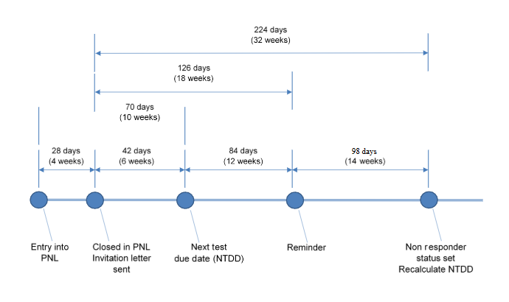For example, if the patient was due for screening in April 2025, they will automatically be set to non-responder status by CSAS 26 weeks later and the NTDD will be recalculated for April 2030 (if they are on 5 year recall). It is important to remember that a non-responder can attend for screening at any point and do not need to be reinvited to attend.

- How do you cease patients who want to opt-out of the programme?

- Ceasing and deferring women from the NHS Cervical Screening Programme - GOV.UK
2.2 Voluntary withdrawal
People can choose to withdraw from the cervical screening programme at any time, and do not have to give a reason for their decision.
Every person who wishes to withdraw permanently from the screening programme must be:
- provided with (or signposted to) sufficient information, in an appropriate and accessible format, to support an informed decision
- given the opportunity to discuss their decision with a GP or other suitably qualified health professional (but they do not have to take up this opportunity)
- informed that withdrawing from the programme means they will not receive any future invitations or reminder letters about cervical screening from the programme
- asked to put their withdrawal request in writing, ideally using the standard template ceasing form available from the NHS Cervical Screening Administration Service (CSAS); if this is not possible, a record should be made at the time of the request (call and recall must receive and retain a copy)
- advised that they can return to the programme at any time providing they are still eligible for screening (following the process in the return to recall section below)
- notified in writing when the ceasing has been completed (their name is removed from call and recall)
Ceasing documentation
A person should put their request for permanent withdrawal from cervical screening in writing if possible. This is to ensure there is no misunderstanding and that they are not ceased from call and recall in error. The template ceasing form available from CSAS should be used. This contains the information needed to support a withdrawal request and is the preferred method of communication. The GP practice should arrange for the form to be provided to the individual. A clear and unambiguous written request signed by the individual is also acceptable.
If a person will not or cannot provide a written request, the GP or a suitably qualified healthcare professional should document the request in writing, noting the time, date and content of the conversation.
The withdrawal request is an important part of the person’s screening record. The GP practice must retain a copy of the document within the person’s medical record.

- If a patient has moved, and the address is updated when they attend for their screening, will the results letter go to the correct address?

- The address provided to the lab with the sample is the address that the results will be sent to. Patients should be encouraged to change their address as soon as possible with the reception/admin team to reduce the risk of any errors.

- Can you record both HRT and Mirena coil when completing the sample form?

- There is space on the form to record free text if you need to provide more information to the lab.

