

East of England HPV Primary Screening Service

For action:

The maintenance of complete training records and uploading of training certificate is a NHS CSP requirement.

Please make sure that all sample takers in your practice are up to date with their cervical screening training. All sample takers should have 3 yearly update training and complete the online update training available on https://portal.e-lfh.org.uk/

How to Upload a Training certificate to the CSTD

1.Log into CSTD | East of England
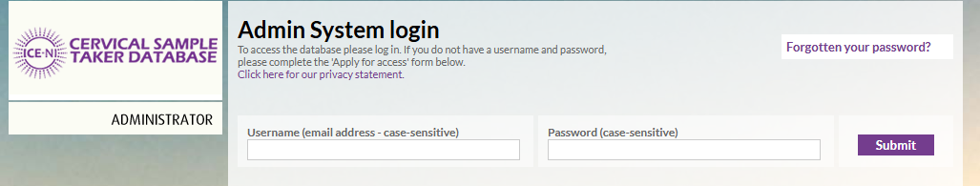

yo

2. Open Sample Taker Management
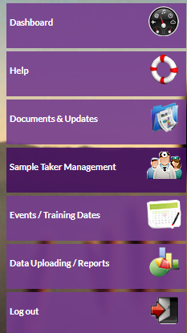

Click on the sample taker management tab on the left-hand side

3. Find the sample taker, search for and select the sample taker whose training certificate need to upload.

4.Open the sample taker profile and click on the Upload link ‘Click here to upload’.
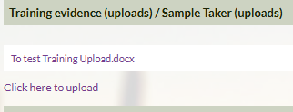

5. Continue to stage 2,’click ‘Continue to stage 2’
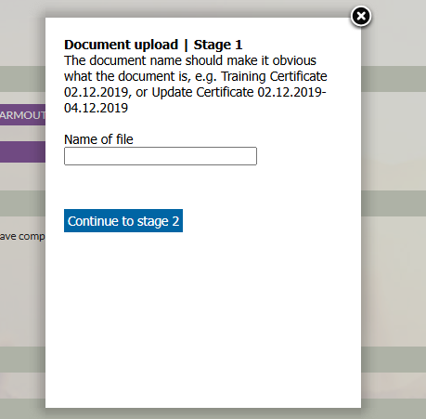

6. Choose the training certificates on your local drive by clicking on ‘Select files’.
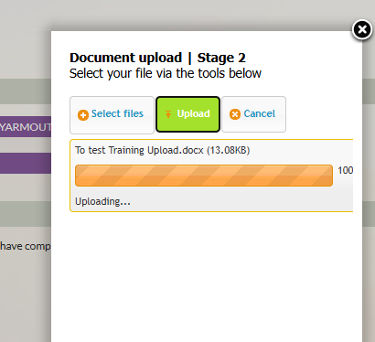

7. Upload the Certificate. Click on ‘Upload’
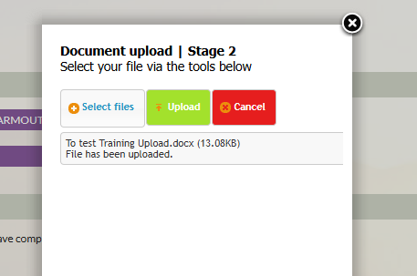

8. Upload confirm. Upload document should now appear in the training evidence uploads section.
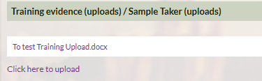

9. Update Training Record. Click ‘update training record’
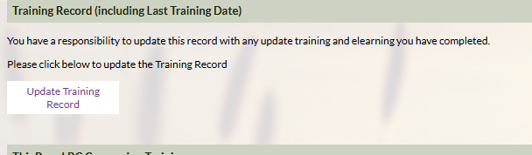

You must click on Update Training Record as below

10. Enter the Last Training Date. Input the last training date in the training record and save changes.
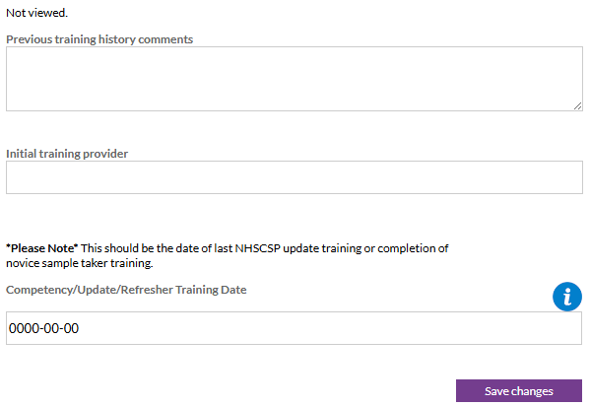

Click Save Changes again before exiting the profile.

Key notes: If you do not have access to NNUH CSTD please apply for the self-access to the CSTD | East of England or for any support - contact cstdhelpdesk@nnuh.nhs.uk

