South London Specialised Services Transformational Programme - Bulletin No. 6 (February 2018)

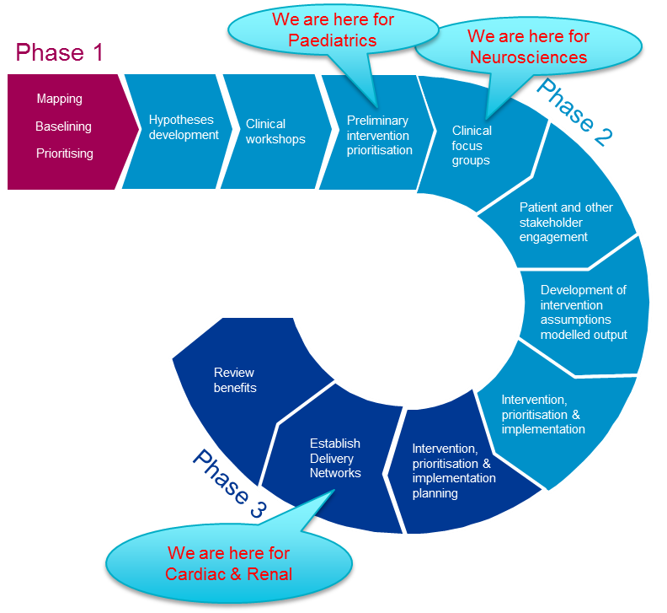
This Bulletin can be read in isolation, but is intended to be read as a follow-on from Bulletins No. 1, 2 ,3, 4 and 5 (December 2016, February , April, July and November 2017)

NHSE PROGRAMME PROGRESS:
Over the past 13 months, the programme has conducted three phases of work resulting in a number of identified and prioritised interventions:
- Phase 1: Mapping of specialised services and prioritising cardiac, renal, paediatrics, cancer and neurosciences service groups
- Phase 2: Identification of detailed interventions for each workstream, validating and modelling the impact
- Phase 3: Prioritisation & sequencing of interventions, identification of delivery mechanisms, implementation and incentivisation, modelling potential impact of interventions on North London, and adding the impact of enhancing the acute kidney injury pathway

PRIORITY SERVICE GROUPS: update of progress to date

Renal and cardiac service groups: From the last bulletin, progress have been made by Cardiac and Renal Operational Delivery Networks (ODNs) :

Cardiac:
- Progress made on the collective procurement project with a view to streamlining products leading to savings. Clinical meeting scheduled for Friday 2nd March.
- Project Manager for expanding inter-hospital transfer system workstream commenced role in January; begun engagement with key stakeholders to agree design principles, pilot, and communication requirements.
- Team also working to develop consistent cardiac service pathways and strengthen multi-disciplinary team (MDT) working
Next steps:
- Continue recruitment process for project support.

Renal:
- First working group meetings were held on: Standardisation of Pathways (16th Jan), Joint Procurement Planning (19th Jan) and Advanced Care planning (29th Jan).
- Formal appointment of senior clinical leads as chairs and deputies for Standardisation of Pathways Advanced Care Planning and Procurement working groups.
- Renal procurement group developed and circulated a bespoke clinical questionnaire to collect detailed information on procurement and contracting of services by trust by site for return 9th Feb.
Next steps:
- Set up a working group on Virtual Clinics.
- Appoint to role of Project Management Office Assistant.

Paediatrics service group:
Meeting with Trusts’ Chief Executives has been scheduled for the 15th of March to agree and sign final version of the Paediatric network intent document and mandate. A clinical workshop hosted by NHS England will follow on the 11th April to launch the network and agree next steps. Significant engagement has been undertaken to ensure clinical engagement across South London and South East region.
Next steps:
- Prioritisation of interventions
- Patient workshop to be scheduled in May/June

Neurosciences service group:
- Final long list of interventions includes the addition of the traumatic injury to brain across London (TrIBAL) audit.
- Programme reviewed lessons learned from Neuroscience Clinical Network.
- Started scoping exercise to begin engagement with third party charitable sector and patients.
- Initial conversations to address host provider of delivery network.
Next steps:
- Agree hosting arrangements for Neurosciences delivery operational network (ODN).
- Finalise Equality and Health Inequalities (EHI) screening and publish it in our website.
- Drafting of mandate and sign-off by Trusts’ Chief Executives.
- Patient workshop/s to be scheduled in March/ April.

PROGRAMME MANAGEMENT: update of progress to date

Managing interdependencies: The importance of effectively managing interdependencies was noted at the start of this Programme. The appropriate level of consideration is continuously being given to interdependencies with non-specialised services as well as wider, pan-London and national work, and interdependencies with other programmes of work impacting south London are being carefully managed. Regular discussions continue to take place with STP Leads across South West London and South East London to ensure that approaches and communications are as unified and streamlined as possible. The South London programme team also regularly shares opportunities for improvement with the wider pan-London programme team, and vice versa.

Broader programme communications and engagement:
Since the last bulletin, programme members have been supporting renal and cardiac operational delivery networks (ODNs) with their communication strategy, as well as arranging meetings with the British Heart Foundation and Kidney Care uk.

Paediatrics engagement has been focused on developing a south London network, intent document and mandate. As explained earlier, there is a clinical workshop scheduled for the 11th of April, south London network will be established then, and patient workshop/s will follow. Linkages have been made with the Healthy London Partnership and the Evelina network as well as the south region (Brighton’s medical director and NHS England Specialised Commissioning south region colleagues).

Different clinical focus groups to discuss acute/community neurosciences, have been held during the last months. The Programme is working with third party charitable sector and patients to arrange patient workshops on neurosciences.

The programme is keen to have continuous patient engagement, and SEL STP patient representatives are part of the Steering Group, attending monthly meetings. The team is currently working to identify patient representation from SWL STP. Team members attended SEL Equalities and Patient Engagement Stakeholder Reference Group on 7th December as well as SEL Patient and Public Advisory Group on 11thDecember, as well as SWL Patient and Public Engagement Steering Group (PPESG) on 7th February.

NHSE London region’s internet pages contain a section about the South London programme, as well as wider pan-London specialised services transformation work taking place. Documents such as these bulletins will be shared on this webpage going forward: https://www.england.nhs.uk/london/our-work/transformation-of-specialised-services/south-london-programme/

For more information:
If you would like to find out more about the Programme of work, initially it is suggested that you speak to the contact who sent you this Bulletin. Alternatively you can contact Charlotte Slater, Programme Manager, or Silvia Novo, Programme Officer, who are based within NHS England’s Specialised Commissioning Team: charlotte.slater4@nhs.net
s.novo@nhs.net

