Service Specification No. | 1.0
Service | Familial Hypercholestrolaemia Clinics (adult and shared care service with BCH for children under the age of 16) (which forms part of the Familial Hypercholestrolaemia Programme of Care across the West Midlands)
Commissioner Lead
Provider Lead/Host Organisation | University Hospitals Birmingham NHS Trust
Period | 2015/16
Date of Review | 2016/17

1. Population Needs

National/local context and evidence base

Familial hypercholesterolaemia (FH) is a genetic condition that causes a high cholesterol level in the blood. It is caused by mutations in genes of the pathway that clears low-density lipoprotein (LDL) from the bloodstream (in the majority of patients in the gene for the LDL receptor). Elevated LDL-cholesterol is present from birth and may lead to early development of atherosclerosis and coronary heart disease. Children carrying the FH gene have been shown to have well established atherosclerosis as demonstrated by thickening of the carotid artery.

FH is a genetic problem with a dominant mode of inheritance and can therefore be passed from parent to child. Each family member has an even chance of inheriting the problem. The disease does not skip generations. This means that children and grandchildren of family members who do not have the defect are not at risk from FH. Effective treatments are available. The key to improving outcomes for people with early FH is early identification which will enable early initiation of preventative treatment. Therefore, whenever FH is diagnosed, it is important that all close relatives are followed up so they can start preventative treatment.

There are two types of FH:

- Heterozygous – where an individual inherits one copy of the defective gene. This is the most common form.
- Homozygous – where an individual inherits two copies of the defective gene.

Levels of understanding about the condition are low. However, the condition is relatively common. The prevalence of heterozygous FH in England is estimated to be at least 1 in 500. This means that over 106,000 people are affected in the country. Both adults and children are under-diagnosed.

If untreated, having this condition leads to:

- a 50% risk of coronary heart disease by the age of 50 years in men and
- a 50% risk of coronary heart disease by the age of 60 years in women

Homozygous FH is much rarer, with a prevalence of approximately 1 in 1,000,000. Symptoms appear in childhood, and are associated with very early death from CHD.

Each individual identified with a confirmed diagnosis of FH (termed the “index case”) has on average 4-5 first degree relatives, of whom 50% on average will have FH. Each affected first degree relative then becomes a new index case and their first degree relatives (for example their children) can be tested. Thus each index case can be expected to lead to the identification of 4-5 new FH subjects if systematic cascade testing is carried out. (The word “systematic” here implies not just testing first degree relatives but extending this to second and possibly even third degree relatives as recommended by the NICE guidelines.)

FH is hugely under diagnosed. Although more than 106,000 people in the UK have the disease, a 2008 survey of lipid clinics indicated that 15,000 cases are known at most. Thus, approaching 90% of people with FH go undetected and may be disabled or die from CHD early in life, often in their 40s or 50s, sometimes earlier.

The Institute for Health and Clinical Excellence (NICE) published guidance (CG71) on the identification and management of FH in August 2008. This guidance clearly states that risk algorithms such as Framingham or QRISK are not appropriate for estimating CHD risk in FH patients, and the high CHD risk in FH patients is often not recognised by GPs who therefore do not offer adequate lipid lowering therapy, or identify the familial nature of the disease (and therefore relatives are not tested).

Evidence Base

The Institute for Health and Clinical Excellence (NICE) published guidance for Identification and management of familial hypercholesterolaemia (CG071), Full guideline, August 2008.
- Healthcare professionals should offer all people with FH a referral to a specialist with expertise in FH for confirmation of diagnosis and initiation of cascade testing.
- Cascade testing using a combination of DNA testing and LDL-C concentration measurement is recommended to identify affected relatives of those index individuals with a clinical diagnosis of FH. This should include at least the first- and second- and, when possible, third-degree biological relatives.
- The use of a nationwide, family-based, follow-up system is recommended to enable comprehensive identification of people affected by FH.

Further NICE guidance published in December 2011 (DG 2) recommended the use of comprehensive genetic analysis to confirm the diagnosis of FH in index cases and the use of targeted sequencing to accurately detect FH in relatives of people with FH.

In August 2013 NICE quality standard QS41 was published on the identification and management of FH, which recommends that people with a clinical diagnosis of FH are offered DNA testing as part of a specialist assessment

NICE gives the key priorities for implementation as:
- Diagnosis by DNA analysis
- Identifying people with FH using cascade testing
- Management (adults and children/young people)

The Cardiovascular Disease Outcomes Strategy (March 2013) states that implementing cascade testing for those currently identified with FH will result in an additional 35,000 diagnosed bring the total to about 50%, which currently stands at 15%.

2. Scope

Aims and objectives of service

The overall aim of the West Midlands system of care for FH is to reduce mortality and morbidity from cardiovascular disease through the early identification of those with familial hypercholestrolaemia and the systematic on-going management. Maximum benefit will be achieved by the initiation of lifestyle advice and medical management in childhood.

The aims of the FH clinics and the cascade screening service is to:

- To provide leadership and clinical expertise in the management and support of adults and, where relevant, families with FH.
- To assess all individuals with clinically definite or possible FH as defined by the Welsh FH genotype screening criteria.
- To initiate an agreed management plan for individuals with FH.
- To manage children with FH in local family clinics and where necessary, shared care arrangement with paediatric units in the West Midlands.
- To ensure that all individuals with FH have an appropriate annual review in an appropriate setting, according to the CG71 guidelines (as per Fig 1).

See Appendix 1 – Strategic overview & Operational overview

Service description/care pathway

The service is part of the West Midlands regional FH Programme of Care pathway which can be found in Fig 1 page 4.

- Screening

There is previous experience from the Wales FH screening programme, and the West Midlands FH Service would wish to build on that experience by using the Welsh FH genotype scoring criteria to select those patients who should be offered genotyping. The Welsh criteria are described in the table below:

*Ethnic difference exist; take 0.5 mmol/L off each target for South Asian ethnicity (TC 7.0 mmol/L and LDL 4.5 mmol/L respectively for the NICE 2008 FH thresholds) in the absence of significant hypertriglyceridaemia and consider a similar reduction for Afro-Caribbean ethnicity**.
**Please refer to Heart of England lipid clinic ethnicity data; significant differences between Caucasian and South Asian populations exist with an approximate difference of 0.5 mmol/L in LDL and total cholesterol. Afro-Caribbean levels were also lower than Caucasian but not significantly which may be due to the relatively few Afro-Caribbean patients in the cohort examined.

The Welsh FH project has used a score of 6 points or more as a threshold to determine whether or not genotyping should be requested on any patient. A review was undertaken of the lipid data taken from the laboratory information systems on patients investigated by their GPs from the Heart of England NHS Foundation Trust and University Hospital Birmingham NHS Foundation Trust in 2014/2015. Extrapolating this data pro rata to the population of the West Midlands suggests that approximately 1800 patients would have total cholesterols of 9 mmol/L or more, or LDL cholesterols which would attract a Welsh FH criteria score of 5 points and hence would be very likely to have FH. It is proposed that the West Midlands genotyping project would be targeted (in the initial phase) to those with a total cholesterol of 9 mmol/L AND a Welsh FH score of 6 points or more. It is suggested that this would be a manageable number of patients with which the FH nurses could deal and is likely on the Welsh experience to generate a significant proportion of mutation positive patients for cascade of relatives.

See Appendix 2 – West Midlands Genetic Testing Pathway
See Appendix 3 – Genetic Test Request Form - Genetic screening will take place at the Bristol Genetic Screening Laboratory for all West Midlands patients.

- Detail of Pathway

- Assess patients using standard criteria for FH genotyping in all clinics (Welsh criteria of 6 points AND/OR a total cholesterol 9 mmol/L or more).
- Where patients meet criteria, refer to FH nurses to assess and coordinate genetic screening
- Phenotype +ve: nurses add to database initiate cascade screening
- Patients referred to local clinic for follow up check
- Discharge to GP care with management plan for majority of patients (expectation of a minimum of 80%).
- Phenotype –ve
- discharge from FH cascade screening but added to screening database
- Patients (-ve) back to local clinic treated and discharged to GP care with management plan
- Cascaded patients assessed
- +ve patients to local clinic and as above
- -ve patients discharged and plan to GP

Fig 1 . FH West Midlands Regional Pathway

. 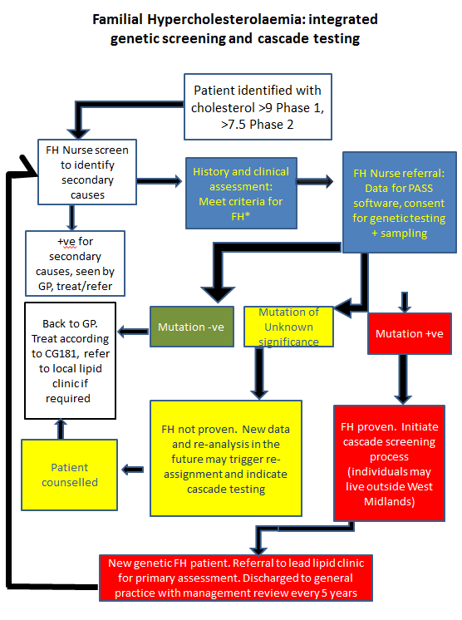
- Paediatrics

All children at risk of or diagnosed with FH will be seen in family clinics in local settings with paediatric support present. The family clinics will have links to paediatric units.

Children who are not suitable for shared care and will require clinical management at The Birmingham Children’s Hospital as follows;

- Children diagnosed with Homozygous FH.

- Children with total cholesterol >12mmol/l +/- xanthomata or xanthelasmata as they could potentially be homozygous
- All children with another complex disorder (e.g. Trisomy 21) and cholesterol levels consistent with possible FH.
- Children that will need to have statins prescribed outside of licensed indications i.e. where statins are considered in children under the age of 6.
- Children that local FH service feel will benefit from expert input and that is sometimes needed to convince families to start their children on statins.
- Children with significant biochemical abnormalities e.g. very abnormal liver functions
- Population covered

The West Midlands has a population base of approximately 5.5 million people.

See Appendix 4; CCG Population split with expected prevalence of FH, within the West Midlands

- Interdependencies with other services
The provider will work directly with, but not limited to, the following professionals to ensure a seamless service:

- Rare Disease Centre, Queen Elizabeth Hospital, University Hospitals Birmingham NHS Trust, including LDL apheresis service
- FH Cascade Clinics
- The Bristol Genetic Laboratory
- General Practitioners and community services
- The Birmingham Children’s Hospital Service
- The PASS team
- Familial Hypercholesterolemia Register and Audit (Royal College of Physicians)
- Local Audit where required

3. Applicable Service Standards

Applicable national standards

- The National Service Framework for Children, Young People and Maternity Services (Department of Health, 2004)
- Transition: getting it right for young people (Department of Health, 2006)
- Seeking consent: working with children (Department of Health, 2001)
- Clinical Guidelines 71, Identification and management of familial hypercholestrolaemia (The National Institute for Health and Clinical Excellence, 2008)
- Quality standards for Familial Hypercholestrolaemia (The National Institute for Health and Clinical Excellence, to be produced in 2013)
- Cardiovascular Disease Outcomes Framework (2013)

Service outline

The regional West Midlands FH Service will maximise quality across the region and to minimise costs and administration for the service. The administration and governance of the service will be based in the new Rare Diseases Centre at the Queen Elizabeth Hospital, Birmingham. There will be a cohort of nurses who will run peripatetic clinics around the West Midlands, each nurse covering the populations served by a number of lipid clinics in the most geographically advantageous way, including primary care.

The FH nurses will have appropriate professional supervision from within the Rare Diseases centre and the IT infrastructure to support PASS will also be there. The FH nurses will receive patients who have been referred to the lipid clinics with potential FH. This can be by either actual (i.e. after having been seen at the lipid clinic) or virtual referral from GP's or hospital colleagues as appropriate (e.g. Advice and Guidance via Choose and Book).

As per NICE guideline and quality standards, patients meeting the Simon Broome criteria will be accepted. They will be seen by the FH nurse who will assess suitability for genetic screening as index cases. The nurses will also liaise with the relevant laboratories to identify potential index patients with historically high cholesterols who can be targeted via their GP to consider referral if appropriate.

4. Key Service Outcomes

Additional information requirements for the West Midlands FH networks annual report (other than those generated through PASS)

To be agreed
5. Location of Provider Premises

Stakeholder Level of Interest/Involvement
West Midlands Acute Trusts (13 in total) current provider of lipid clinics Trusts are;
- Dudley Group Hospitals NHS Trust,
- University Hospitals Birmingham NHS Trust – Host Organisation
- University Hospitals Coventry and Warwick NHS Trust
- Queens Hospital Burton-on-Trent
- Heart of England NHS Foundation Trust
- Shrewsbury and Telford Hospitals NHS Trust
- University Hospitals of North Midlands
- Sandwell and West Birmingham Hospitals NHS Trust
- Walsall Healthcare NHS Trust
- Worcestershire Royal Hospitals NHS Trust
- Royal Wolverhampton Hospitals NHS Trust
- The Birmingham Children's Hospital Foundation Trust
- County Hospital Wyre Valley NHS Trust

Patients will also be seen in an appropriate Primary Care settings when possible

Appendix 1
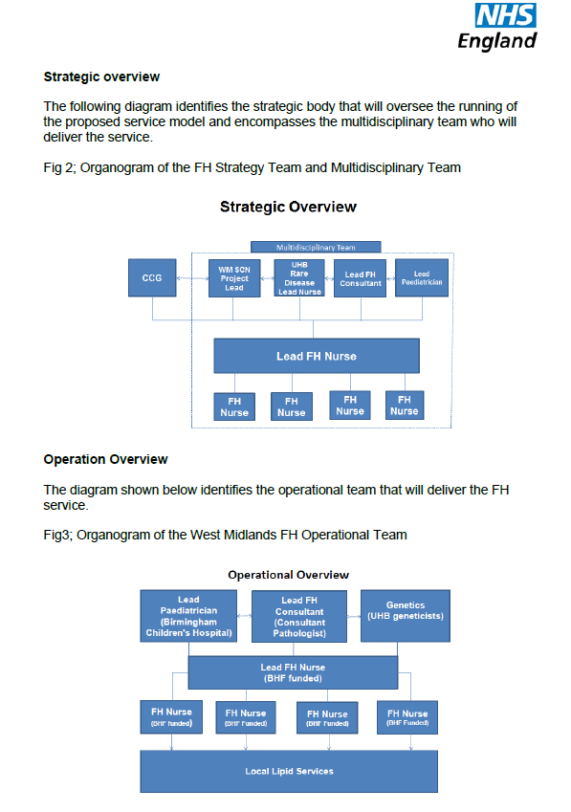
Appendix 2
West Midlands Genetic Testing Pathway
Bristol Genetics Service

Testing
Support
Advisory
Monitoring
Primary care patients who meet the Welsh FH criteria (and/or cholesterol > 9 mmol/L), known patients and active case finding

Cardiology patients who meet the Welsh FH criteria (and/or cholesterol > 9 mmol/L)
Standardised referral form
FH clinician confirms diagnosis, orders DNA test on index cases who meet Welsh criteria (and cholesterol > 9 mmol/L)
Referral to FH Nurse led clinic for Full DNA sequencing
Mutation positive
Mutation negative
Cascade using DNA
Known FH clinic cases
Cascade using cholesterol.

Trigger genetic investigation by the genetics unit in the future
Positive DNA result or high cholesterol- patients referred to FH Clinic. GP informed.
Negative DNA result or low cholesterol – patient discharged. GP informed.

Note: That the trend is moving towards cascade testing only when a mutation has been identified. A significant proportion of mutation negative individuals with raised LDL-C are now thought to have polygenic inherited disease. Cascade testing provides much lower yield and therefore is likely to be much less cost-effective
Appendix 3
Genetic test request form
(Based on the UKGTN Testing Criteria)

Name of disease(s)
HYPERCHOLESTROLEMIA, AUTOSOMAL DOMINANT (143890)
HYPERCHOLESTROLEMIA, AUTOSOMAL DOMINANT, TYPE B (144010)
HYPERCHOLESTROLEMIA, AUTOSOMAL DOMINANT, TYPE 3 (606945)

Name of gene(s)

Tick
 | Full gene sequencing
 | Other specified gene | Name of specific gene

Patient name: Date of birth:
Patient postcode: NHS Number:
PASS reference number:
Name of referrer:
Title/Position:
Lab ID:

Referrals will only be accepted from one of the following:

Referrer | Tick if this refers to you
Clinical geneticist
Consultant Lipidologist
Consultant in Metabolic Medicine
Consultant Cardiologist
FH cascade nurse

Minimum criteria required for testing to be appropriate:

Criteria  One of the following: | Tick if this patient meets criteria
Welsh FH criteria score of 6 points or more AND/OR a total cholesterol of 9 mmol/L or more
Total or LDL-C above the 95th percentile for age and gender in children
Family history or confirmed familial hypercholestrolaemia (provide details of mutation, family relationship and testing laboratory.

Appendix 4
CCG Population split with expected prevalence of FH, within the West Midlands

CCG | General information
CCG | Population | FH population 1/500 (approx.)
Arden, Herefordshire and Worcestershire
Coventry and Rugby | 460,000 | 920
Herefordshire | 210,000 | 420
Redditch and Bromsgrove | 170,000 | 340
South Warwickshire | 270,000 | 540
South Worcestershire | 288,000 | 576
Warwickshire North | 184,000 | 368
Wyre Forest | 112,000 | 224
Birmingham, Solihull and the Black Country
Birmingham Cross City | 730,000 | 1460
Birmingham South and Central | 250,000 | 500
Dudley | 305,000 | 610
Sandwell and West Birmingham | 535,000 | 1070
Solihull | 235,000 | 470
Walsall | 274,000 | 548
Wolverhampton City | 262,000 | 524
Shropshire and Staffordshire
Cannock Chase | 132,000 | 264
East Staffordshire | 135,000 | 270
North Staffordshire | 213,000 | 426
Shropshire | 300,000 | 600
South East Staffordshire and Seisdon Peninsular | 210,000 | 420
Stafford and Surrounds | 144,000 | 288
Stoke-on-Trent | 279,000 | 558
Telford and Wrekin | 172,000 | 344

The West Midlands regional service will initially use a scoring criteria of lipid score of 9mmol/L, however as the service develops the criteria should lower to 7.5mmol/L in line with NICE guidance CG71.

