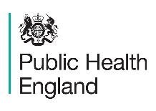

East Midlands Clinical Network
Health Education England

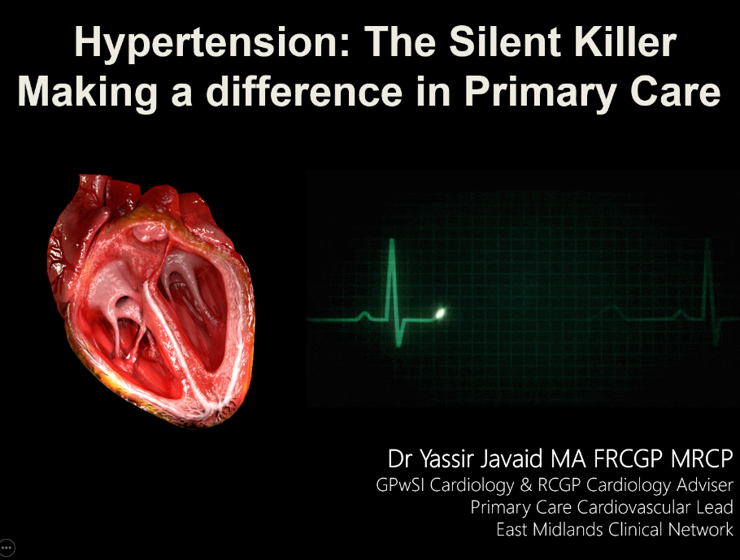
- New upskilling module available via
E-learning for Healthcare www.e-lfh.org.uk
An account to ‘e-learning for Health’ is required to access this training module.
- Developed by East Midlands Diabetes with Vascular Diseases Clinical Network and Public Health England East Midlands.
- Accredited by Royal College of General Practitioners.
- Funded by Health Education England
- Created by Dr Yassir Javaid (MA FRCGP MRCP), GPwSI Cardiology & RCGP Cardiology Advisor, Primary Care Cardiovascular Lead for East Midlands Diabetes with Vascular Diseases Clinical Network

On-line upskilling learning module via ‘e-learning for healthcare’

Why focus on hypertension?
There is huge underdiagnosis, inaccurate diagnosis of hypertension, which calls for the improvement of treatment for hypertension and the NHS Long Term Plan addresses this by making hypertension one of the top 3 cardiovascular priorities, alongside atrial fibrillation and lipid management. The target is that over the next 10 years, 80% of the expected prevalence of hypertension should be diagnosed and of those diagnosed, 80% treated to target as per NICE guidelines – which is significantly above what is currently being achieved.

What is the purpose of this training?
This 45 minute on-line upskilling learning module incorporates up to date guidelines and evidence based aims specifically addressing the needs for front-line primary care in the diagnosis and management of hypertension and CVD risk including familial hypercholesterolaemia, atrial fibrillation, dyslipidaemia and other cardiovascular disease related conditions.

What are the key learning outcomes and objectives?
This hypertension upskilling learning module has been accredited by the Royal College of General Practitioners (RCGP), therefore, if you are a GP, you would be entitled to learning credits.

You can expect to achieve the following learning outcomes:

- Understand NICE / European Society of Cardiology (ESC) guidance on establishing a diagnosis of hypertension
- Recognise blood pressure targets depending on co-morbidity
- Understand the Hypertension Treatment algorithms and be able to follow accordingly
- Be able to assess cardiovascular risk and target organ damage - introducing Joint British Societies recommendations on the prevention of Cardiovascular Disease and British Heart Foundation's “heart age”
- Be able to recognise electrocardiogram (ECG) changes in people with hypertension
- Be able to identify secondary hypertension
- Be able to assess your level of knowledge via a short informal question and answer session after the training has been delivered.

The learning objectives are to identify:

- The Global Burden of Disease for premature avoidable cardiovascular deaths and the opportunity for addressing better hypertension management
- The epidemiology of hypertension and association with heart disease and stroke
- The risk factors for essential hypertension
- The pathophysiological consequences of chronic uncontrolled hypertension - direct and target organ damage
- The importance of screening for hypertension
- Atrial fibrillation and its intrinsic relationship with hypertension
- How to establish a diagnosis of hypertension
- The thresholds for referral to secondary care
- Lifestyle interventions for prevention and/or management of hypertension
- How to assess cardiovascular risk 10-year risk vs lifetime risk (Qrisk2 vs JBS3)
- Introduction to the concept of “heart age”
- How to address broad cardiovascular risk factors and co-morbidities - how they influence management of hypertension.
- The use of pharmacological treatment
- Sprint trial implications and the subsequent update of the European Society of Cardiology Guidance for hypertension
- Specific aspects of management of hypertension in patients with Type 2 Diabetes
- Isolated systolic hypertension
- When to suspect secondary hypertension and diagnostic work up
- Diagnosis and management of patients with Familial Hypercholesterolaemia

Clinicians who attended the face to face training programme commented as follows:

- ‘Inspiring to improve treatment’;
- ‘Very relevant with practical application, essential learning, excellent coaching style’;
- ‘The best training I have been to for a long time for changing my practice’.

If you don’t already have an account with e-learning for healthcare, please click the login/register button at the top of the page to allow you to access this training module and any other programme you wish to access.

To sign up/register on to e-learning for Healthcare - https://www.e-lfh.org.uk/
To access the Hypertension programme - https://www.e-lfh.org.uk/programmes/hypertension/

