Primary care immunisation update webinar series 2022 – a free training resource for immunisers in London Developed and provided by UKHSA London and funded by NHS England and NHS Improvement London

Immunisers in primary care in London can access FREE immunisation update training across 2022. The series of webinars are designed to support immunisers to fulfil the requirement for annual immunisation updates and are free to access. The webinar series has been running since September 2018 and a programme has been designed for 2022 incorporating 10 topics focused on the learning needs of immunisers in primary care. The monthly webinars will begin in February and run until December (excluding August) 2022. Immunisers are welcome to attend all webinars to achieve five hours of recorded learning in 2020 or to select webinars relevant to their practice/learning needs.

How does it work?
- webinars will be provided monthly featuring a specific topic, each lasting 30 minutes
- repeat webinars will run each month, offering a choice of date and time (three choices- please sign up for one only)
- time will be allocated in each session for questions from delegates
- certificates of attendance will be sent following delegate evaluation

Who can attend the webinar?
- any competent immuniser working in a primary care setting who requires update training

What do I need to do?
- select the webinar/s you wish to attend and register at the links below
- each delegate must register to attend the webinar individually
- instructions on how to join the webinar (phone-in or Teams) will be sent 3-5 days prior to the webinar
- please ensure you have time in your diary to set up Teams/dial in beforehand

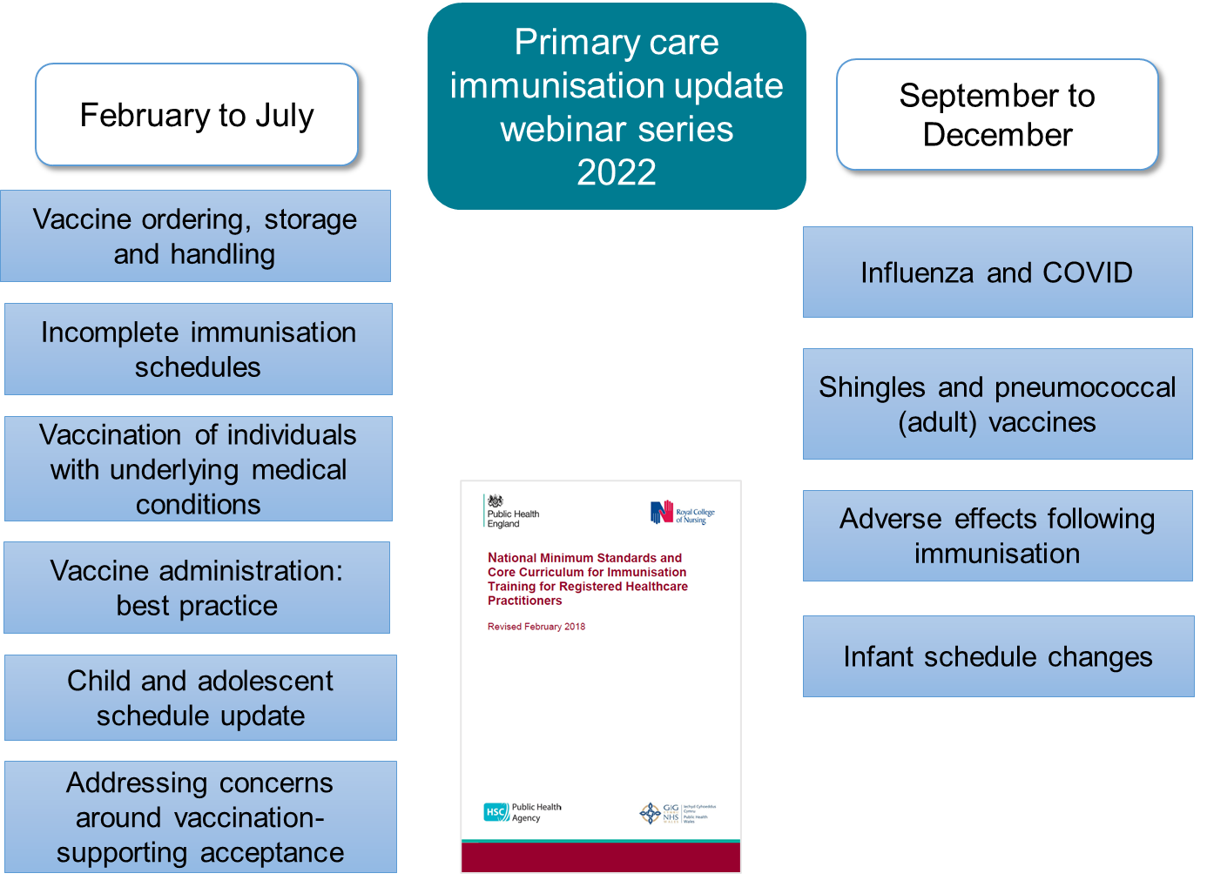

To book a webinar please use the links on the next page, further information on each session is provided at the booking link.

Primary Care Immunisation Update Webinar Series – February-April 2022
Please could all delegates ensure that:
- you only register for one webinar per monthly set to maximise space for other delegates
- if you wish to change any bookings please cancel and re-book on Eventbrite
 | Date | Start time | Link to register
February 2022 Vaccine ordering, storage and handling.
1 | 17/02/22 | 10 am | https://february22-webinar1-vaccineordering.eventbrite.co.uk
2 | 17/02/22 | 1:30 pm | https://february22-webinar2-vaccineordering.eventbrite.co.uk
3 | 24/02/22 | 10 am | https://february22-webinar3-vaccineordering.eventbrite.co.uk
March 2022 Incomplete immunisation schedules
1 | 17/03/22 | 10 am | https://march22-webinar1-incompleteimmsschedules.eventbrite.co.uk
2 | 17/03/22 | 1:30 pm | https://march22-webinar2-incompleteimmsschedules.eventbrite.co.uk
3 | 24/03/22 | 10 am | https://march22-webinar3-incompleteimmsschedules.eventbrite.co.uk
April 2022 Underlying medical conditions
1 | 05/04/22 | 10 am | https://april22-webinar1-underlyingmedicalconditions.eventbrite.co.uk
2 | 13/04/22 | 10 am | https://april22-webinar2-underlyingmedicalconditions.eventbrite.co.uk
3 | 13/04/22 | 1:30 pm | https://april22-webinar3-underlyingmedicalconditions.eventbrite.co.uk

If you would like to contact the webinar team, please email: ImmsTraining@phe.gov.uk

