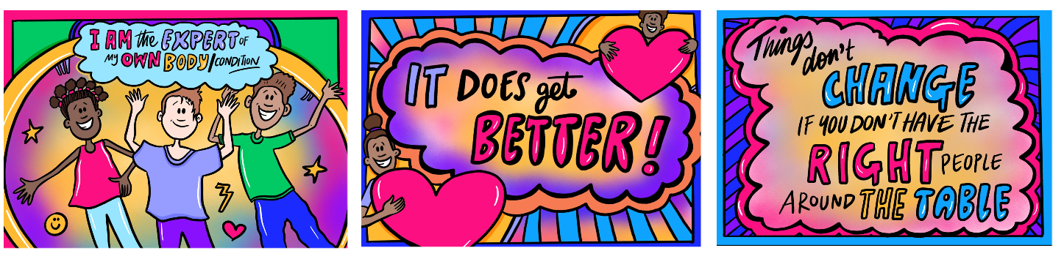
Our Voice, Our Care campaign
Putting young people at the centre of their healthcare
March 2023
Campaign toolkit
We are campaigning to:
- empower young people to know that they have rights in healthcare, and they can expect to be listened to and engaged with by healthcare professionals

#OurVoiceOurCare
- motivate healthcare professionals to improve their engagement skills and build positive relationships with young people
#YourVoiceYourCare

Campaign background:
The NHS England – London Babies, Children and Young People’s (BCYP) Transformation team has been working closely with a Youth Steering Group to make sure that young people’s voices are being heard and informing how we work to improve health outcomes for young people in London.
An in-person workshop took place in July 2022, supported by Partnership For Young London, Spotlight, London Youth, Barnardo’s Health, and Voice and Influence teams, and the Mayor of London. The workshop featured a reverse panel of young experts who shared their views and experiences of healthcare within the NHS.
The panel discussed several topics including how young people access healthcare, engagement, and the importance of diversity in healthcare and how it can be improved to provide better care. See this presentation which captures the eight initial themes which emerged from the workshop, reflecting young people’s experiences and barriers encountered when accessing healthcare. These themes can help services and healthcare professionals to reflect on how they are currently engaging with young people, and what they may do differently.
Following this event, the BCYP team and their Youth Steering Group members worked together to refine and condense these themes into four key statements.
Through the Our Voice, Our Care campaign, these statements are now being shared to reach young people and healthcare professionals across London:
Dear healthcare professionals:
- I am the expert of me: I know my mind and my body better than anyone, tap into that
- Accessing healthcare is complex (especially when you’re young), recognise how much it’s taken for me to get help here today
- Being listened to and valued helps me trust you, please know the little things really are the big things, a smile, cultural intelligence, a youth friendly environment, really do matter
- How you engage with me empowers and builds my confidence in my mind and body
Campaign video
As part of this campaign, a short film has also been produced to help these four statements and highlights from the reverse panel discussion.
Watch the video here.

How to support this campaign:
We want to encourage healthcare professionals to really think about how they are listening to young people, and to make lasting changes that will put young people at the centre of their own healthcare:
- Watch and share this video with your teams and organisations to help get London talking about young people’s healthcare experiences
- Engage with the campaign hashtags on social media: #OurVoiceOurCare #YourHealthYourCare
- Young people can learn about their rights in healthcare and encourage their peers to do the same – see our reading suggestions at the end of this toolkit
- Healthcare professionals can share the campaign resources with your children and young people’s networks

Resources
Please find resources and messaging below to help you share this campaign on social media, with your organisations, and across your networks in health, education and youth services.
Illustrations by Beci Ward
Download and share these illustrations on social media or your website using our suggested messaging below.
When sharing these images please credit the illustrator:
Beci Ward (Studio Beci).

Copy to add to your newsletters or websites:
Title: Putting young people at the centre of their healthcare choices and decisions
NHS England – London’s Babies, Children and Young People’s (BCYP) Transformation team and its Youth Steering Group members has launched a campaign to empower young people to know that they have rights in healthcare, and they can expect to be listened to and engaged with by healthcare professionals. The campaign also aims to motivate healthcare professionals to reflect on their engagement skills and build positive relationships with young people.
Working with the BCYP team’s Youth Steering Group, the Our Voice, Our Care campaign centres around four statements which young people want every healthcare professional to know:
- I am the expert of me: I know my mind and my body better than anyone, tap into that.
- Accessing healthcare is complex (especially when you’re young), recognise how much it’s taken for me to get help here today.
- Being listened to and valued helps me trust you, please know the little things really are the big things, a smile, cultural intelligence, a youth friendly environment, really do matter.
- How you engage with me empowers and builds my confidence in my mind and body.

Learn more about this campaign and how you can show your support here.

Social media messaging:
Scroll down to find assets and suggested messaging to help share this campaign on your social media channels.
Supporters of the campaign are welcome to use one or both of our campaign hashtags:
#OurVoiceOurCare
#YourVoiceYourCare
Follow the @BCYP_NHSLDN Twitter account to keep up with this campaign and our wider work.

Assets and notes on usage  (Right click on links below to download full-sized files) | Suggested messaging:
Twitter
- Download campaign animation  - Download Twitter post image  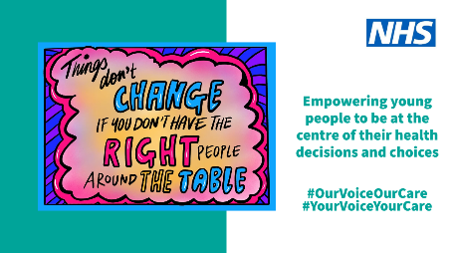  Suggested Alt text:  An image of NHS London’s Our Voice, Our Care campaign showing an illustration with the words: Give the young person their voice. | Tweet 1:  Young people have shared 4 key messages to help healthcare professionals know how to best support them.  Learn about the #OurVoiceOurCare campaign here: https://www.england.nhs.uk/london/london-clinical-networks/our-networks/london-babies-children-and-young-peoples-transformation-team/youth-engagement-and-voice/  #YourVoiceYourCare #IAHW2023 @BCYP_NHSLDN
Tweet 2:

I am / We are are proud to support @BCYP_NHSLDN’s #OurVoiceOurCare campaign which is helping to put young people at the centre of their healthcare.

Watch and share the campaign video: https://www.youtube.com/watch?v=vcxfmF--hTo

#OurVoiceOurCare #YourVoiceYourCare #IAHW2023 @BCYP_NHSLDN

Facebook and LinkedIn posts

- Download campaign animation  - Download image  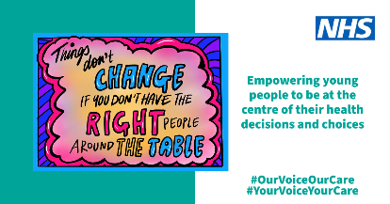  Suggested Alt text:  An image of NHS London’s Our Voice, Our Care campaign showing an illustration with the words: Give the young person their voice. | We are sharing four key statements about healthcare which young people want healthcare professionals to know:  - I am the expert of me: I know my mind and my body better than anyone, tap into that  - Accessing healthcare is complex (especially when you’re young), recognise how much it’s taken for me to get help here today  - Being listened to and valued helps me trust you, please know the little things really are the big things, a smile, cultural intelligence, a youth friendly environment, really do matter  - How you engage with me empowers and builds my confidence in my mind and body  Watch the full video and learn more about the Our Voice, Our Care campaign here:  https://www.england.nhs.uk/london/london-clinical-networks/our-networks/london-babies-children-and-young-peoples-transformation-team/youth-engagement-and-voice/  #OurVoiceOurCare #YourVoiceYourCare
Instagram posts

- Download campaign animation (1:1 format for Instagram feed posts)  - Download Instagram post image  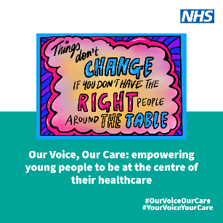  Suggested Alt text:  An image of NHS London’s Our Voice, Our Care campaign showing an illustration with the words: Give the young person their voice. | Long caption:  There are 4 things that young people want healthcare professionals to know when providing care or support:  - I am the expert of me: I know my mind and my body better than anyone, tap into that  - Accessing healthcare is complex (especially when you’re young), recognise how much it’s taken for me to get help here today  - Being listened to and valued helps me trust you, please know the little things really are the big things, a smile, cultural intelligence, a youth friendly environment, really do matter  - How you engage with me empowers and builds my confidence in my mind and body  Share this post to let young people know that their voice counts.  #OurVoiceOurCare #YourVoiceYourCare  Short caption:  I am / We are proud to support the #OurVoiceOurCare campaign which is helping to put young people at the centre of their healthcare.  Search ‘NHS London youth voice and engagement’ to learn more.  #OurVoiceOurCare #YourVoiceYourCare
Instagram Reels, Stories, or TikTok

- Download vertical video | Description:  I am / We are proud to support the #OurVoiceOurCare campaign which is helping to put young people at the centre of their healthcare.  Search ‘NHS London youth voice and engagement’ to learn more about this work.  #OurVoiceOurCare #YourVoiceYourCare

More information
For young people:
- British Youth Council | Youth Rights In Healthcare
- Brook resources and support on sexual health and wellbeing
- Common Room report: Rights for young people with Long Term conditions
- Mind overview of healthcare rights including mental health rights for 11-18 years
- Get your Healthcare rights resources, developed by National Children’s Bureau
- RCPCH superhero animation on rights

For healthcare professionals:
- NHS England – London BCYP website
- Children and young people's rights in healthcare - a summary (publishing.service.gov.uk)
- Council for Disabled Children’s training resource for professionals working with young people with SEND
- General Medical Council 0-18 years - ethical guidance summary
- Me First resources and communication model for healthcare professionals working with young people
- NICE guidance recommendations | Babies, children and young people's experience of healthcare | Guidance | NICE
- RCPCH guidance on rights to access healthcare

