Trust headed paper – send with easy guide leaflet (www.gov.uk/phe/bowel-screening-easy-read)
Dear Mrs Anne Belinda (example subject)

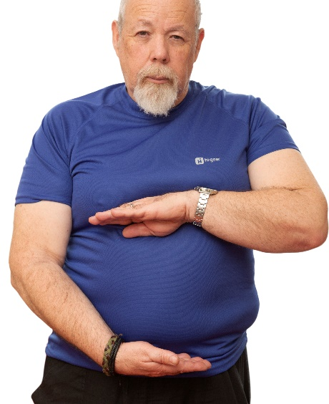 | We are inviting you to do a test at home soon to check if your bowel is healthy.
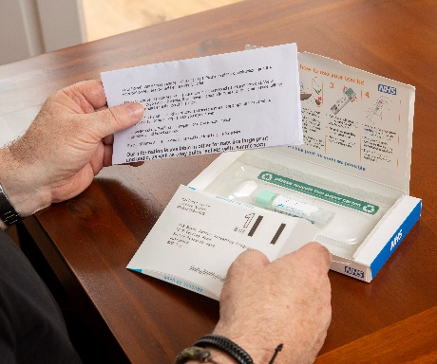 | In about 2 weeks we will send you a screening test kit in the post.  The kit has instructions on what to do.
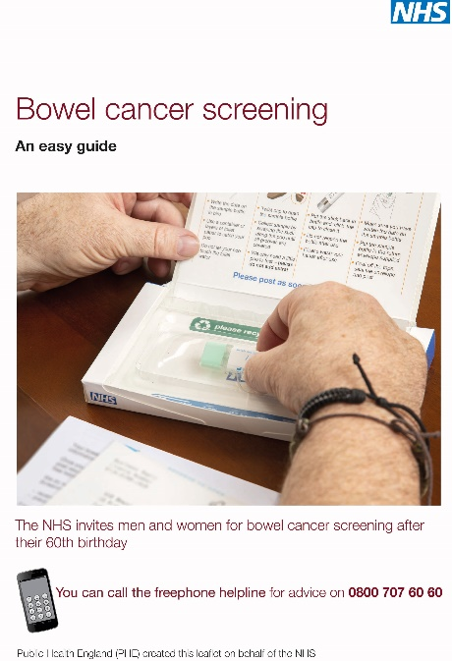 | There is an easy guide leaflet with this letter that tells you about bowel cancer screening.  The leaflet can help you decide if you want to do the test.
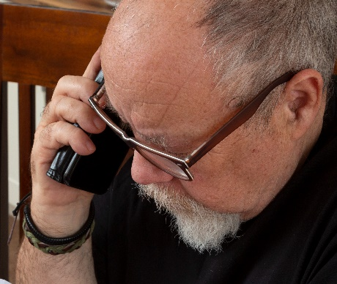 | For help or more information, speak to:  - our helpline on 0800 707 6060  - your learning disability team or doctor  - your local screening centre on Click here to enter text.  Or you can ask someone you trust to help you with this.

