Practice headed paper – This letter includes text boxes to be completed before sending
Dear Click here to enter text.
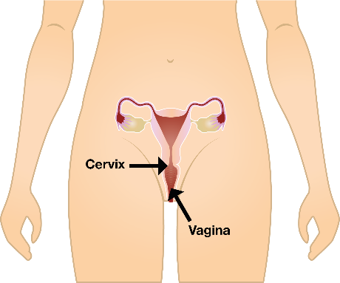 | We are inviting you to have a test to check if your cervix is healthy. The cervix is inside your body at the top of your vagina.  You might have heard the test called the smear test.
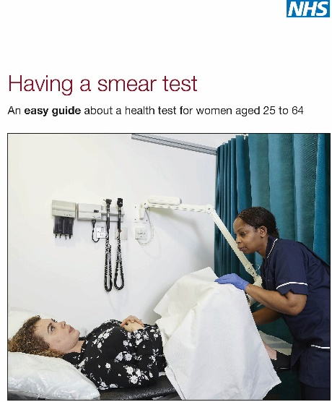 | There is an easy read leaflet which looks like this that tells you about the smear test.  The leaflet can help you decide if you would like to do the test.  You can say yes or no. It is your choice.
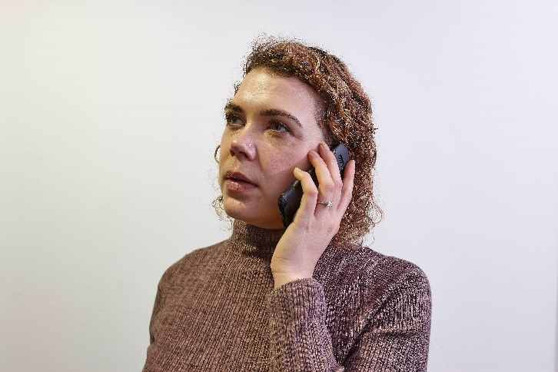 | Speak to your doctor’s surgery to make an appointment. You can call Click here to enter text.  or come and see us.  If you need extra help or information, call your learning disability team on insert number here.

Yours sincerely

