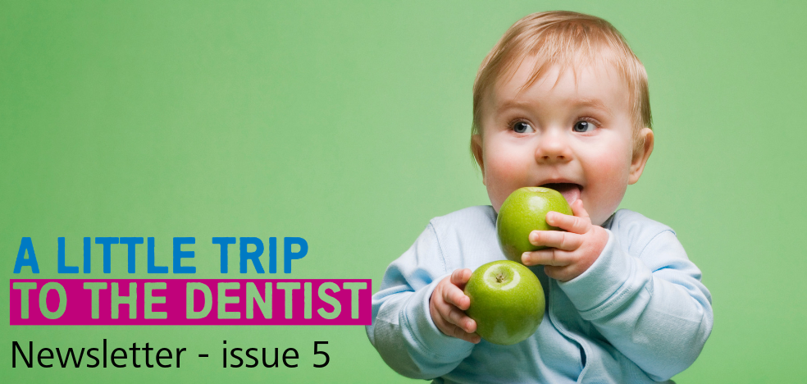
Welcome to the latest edition of our A Little Trip To The Dentist newsletter. These updates aim to let you know how you can get involved with the excellent work going on across the West Midlands area.

Janet’s intro
As far as our campaign themes go, this month’s is certainly a topical one. It’s rare we’ll catch up on the news and not see a story about obesity in children or the sheer amount of sugar we’re consuming. But it’s rare that these stories talk about the very close relationship between maintaining a healthy weight and good oral health.

It makes sense when you think about it that the same foods which might cause a child to put on weight can also cause tooth decay. The stats speak for themselves when you learn that as many as 12% of children in England have decay in their teeth by as early as three years old. Government figures suggest that the number of overweight or obese children aged between four and five is as much as 22%.

Thankfully, the work being done to tackle some of this is also tackling poor oral health without even really realising it. By reducing the amount of sugar children are consuming, we’ll hopefully see fewer children requiring tooth extractions and other interventions at a very young age.

But that’s not to say that we don’t need to be spreading the message about this close link, to ensure that parents are mindful of all aspects of their baby’s health. That’s why this month’s toolkit is all about what parents need to be looking out for when choosing what to feed their little one.

We also want more health professionals to know about good oral health. Families, whether rightly or wrongly, often see all health professional in the same way so may ask a question of a pharmacist when it’s actually more appropriate for their dentist. This is why we don’t just aim this campaign at dentists. We want all frontline staff to know more about oral health so when asked they are confident dealing with questions.

Finally, I’d just like to round this off by saying a big thank you once again to everyone who has supported our campaign so far. Engaging with the wider health system has always been an ambition of the NHS England and NHS Improvement dental team in the Midlands, so to see so many of you supporting it is both humbling and shows the power of system working.

Thank you again and keep an eye out next month for our final West Midlands-only toolkit – focused on tooth brushing.

Janet Clarke
Chair – West Midlands Local Dental Network, NHS England and NHS Improvement – Midlands

Out of hours dental consultation
Hopefully you’ve already shared your views on NHS England and NHS Improvement’s proposed changes to out of hours dental services in the West Midlands. If you haven’t, we would encourage you to have your say via our online consultation which details exactly what the proposed changes are, why we think they’re necessary and how you can get more information. Please also share the consultation with patients or families as the more views we can capture, the better the service will be for people who may have to use it. You can find the consultation on the NHS Engage website.

Our latest theme

This month we’re focusing on the link between healthy weight and the promotion of good oral health. Helping babies maintain a healthy weight can start as early as six months old, when they first start being introduced to solid foods.

Introducing babies to a variety of different food groups alongside breast or formula milk, helps provide the nutrients they need and will help set them up for a lifetime of healthier eating. This also promotes better general health, along with a reduced risk of tooth decay.

Listening to you
Your feedback is vital and helps us make sure that the materials we’re providing are fit for purpose. Many of the comments we’ve received have been asking for more graphics or images to use alongside your communications so we’ve added more to this month’s toolkit. Make sure you keep sending in your feedback using the contact details at the end of this newsletter or in the toolkit.
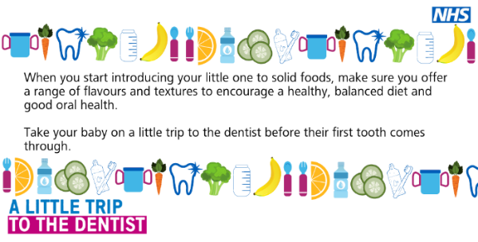
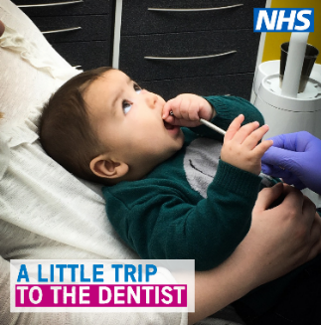
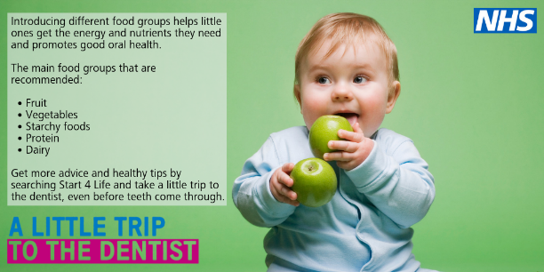

Twitter corner

We’re looking for case studies
Do you have a patient or family that would be happy to share their story with us? Or have you been doing some work in your practice or organisation you’re really proud of? Email rebeccalauren.read@nhs.net for more information or to share your idea.

Training and development
VSM Healthcare is hosting two modules about oral health care for very young children. Once complete, you will receive an ECPD certificate.
Module 2a http://vsmhealthcare.com/starting-well-module-2a-ecpd/
Module 2b https://vsmhealthcare.com/starting-well-module-2b-ecpd/
There are two free videos which give you basic knowledge around children’s oral health. One was developed by HENRY and the other by the West Midlands Local Dental Network at NHS England.
Health Education England has teamed up with the Royal College of Surgeons to develop a 20-minute e-learning course, all about oral health for children. Anyone is welcome to complete the training, including teachers, nurses, GPs and the general public.
There is also dedicated training available for pharmacy teams on the Centre for Pharmacy Postgraduate Education website.
Claire Stevens, spokesperson for the British Society of Paediatric Dentistry, has written an article for BDJ Team about how to examine a child under two.
Get in touch
If you have anything you’d like to add to our next newsletter, or you’d like to share some of the good work going on in your area, don’t hesitate to get in touch. You can email rebeccalauren.read@nhs.net – alternatively you can call the NHS England & NHS Improvement – Midlands Communications team on 0113 825 1757.

