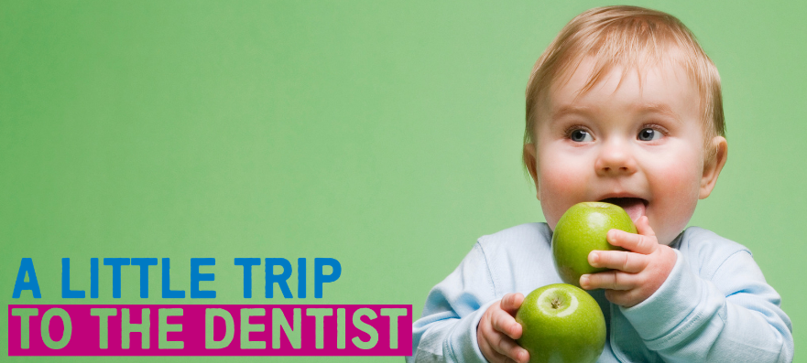
Toolkit 5 – Healthy weight and healthy teeth
This toolkit provides you with the materials you need to support A Little Trip To The Dentist. This campaign focuses on children’s oral health and has been developed by NHS England and NHS Improvement (Midlands) in partnership with Public Health England.
To ensure the campaign’s success, we’re looking to you to share these messages with all of your relevant stakeholders, including staff, patients, families and other areas of our health system. Please do feel free to adapt any of the following resources.
August’s theme
This month, A Little Trip To The Dentist is exploring Healthy Weight and Healthy Teeth. We’ll be highlighting the importance of dental check-ups early on, while emphasising how a healthy diet and regular physical activity contribute to maintaining a healthy weight in childhood and beyond.
The amount of sugar that children consume on a daily basis is a major contributing factor to gaining weight, along with low levels of physical activity. The National Diet and Nutrition Survey found that sugary drinks account for 30% of four to 10 year old’s daily sugar intake. Children’s consumption of added or processed sugars significantly exceeds the maximum recommended level. Sugar is also a significant risk factor for tooth decay.
Toolkits we’ve previously shared have included messages around sugar and weaning. These materials can be found on the NHS England website. You are welcome to use these alongside this month’s toolkit, as much of the messaging goes hand-in-hand:
- Weaning - the dietary choices made when a baby is first introduced to solid foods can affect their favoured foods later in life
- Sugar - ensuring a baby has a balanced diet with enough amounts of each food group helps babies maintain a healthy weight and promotes good oral health.
Giving babies a varied and balance diet alongside breast or formula milk, which provides most of the nutrients they’ll need, will help set them up for a lifetime of healthier eating, which will mean better general health and a reduced risk of tooth decay.
Statistics
- Across the country, 9.5% of children in reception are obese, and this rises to 20.1% of year 6 children
- In the West Midlands, most areas have higher levels of childhood obesity than the England average. For children in reception the highest rates are seen in Sandwell and Wolverhampton where 12.8% of children are obese. In year 6 this has risen to 28.2% of children in Sandwell, the highest level in the West Midlands
- In the West Midlands the lowest levels of childhood obesity for children in reception are in Solihull (7%), and in year 6 are in Shropshire (16.0%)
- Across the country, only around one in five under twos have had their teeth checked by a dentist
- In the West Midlands, most areas have attendance rates in this age group of up to 5% under the national average (21%)
- As many as a quarter of five-year-olds have already experienced some level of tooth decay, with an average of three or four teeth affected
- Estimates suggest that around 12% of children in England may have decay in their teeth by as early as three-years-old
- A child in England has a rotten tooth removed in hospital every 10 minutes
- A recent study by the University of Birmingham shows that only 3% of children in England have visited the dentist before their first birthday.
How you can help
The following communications materials can help you support A Little Trip To The Dentist internally within your organisation and externally in your local area. Feel free to adapt and make any necessary amends for your own use.
Included in this toolkit:
- Social media content – for use on your personal or organisation’s social media channels including a tweet pack and suggested Facebook posts – these can also be adapted if your organisation has other social media accounts
- Newsletter and website articles – articles to share via your internal and staff communications channels or on your organisation’s public-facing website. These can be adapted for blog posts or longer social media posts as required
- Accompanying resources – you’ll find a host of accompanying resources available to you too and links to these are provided below. They include photos and visual resources to use in addition to your communications messaging (graphics, posters, email footers, etc.)
- Useful links – again, to accompany your communications activity you can use any of the useful links we have provided towards the end of the toolkit. This includes videos, sources of further information and more.
If you are from a dental practice, you can also use this toolkit to promote the availability of free NHS appointments for babies and children at your surgery.
Social media content
Below you will find content for use on your social media channels. Please feel free to adapt and amend as required for your audience, or simply copy and paste the below. You may also use the following as inspiration to create some of your own content.
Note: please use photographs you have appropriate consent for, or use the images supplied alongside this toolkit.
Tweet pack
Tweet | Image
Babies don’t need salt or sugar added to their food. Salt is not good for their kidneys and sugary foods can cause tooth decay. Get helpful healthy tips:  https://www.nhs.uk/start4life/weaning/what-to-feed-your-baby/around-6-months/ #ALittleTripToTheDentist @NHSMidlands  Take your baby to the dentist even if their teeth haven’t come through | 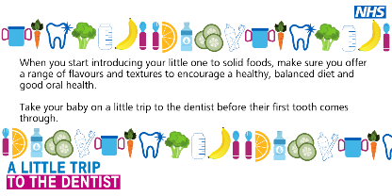
It’s never too early to take your baby on #ALittleTripToTheDentist – taking your little one to see a dentist before their first tooth comes through encourages good oral health for life. You can find a local NHS dentist here: https://www.nhs.uk/Service-Search/Dentists/LocationSearch/3 @NHSMidlands | 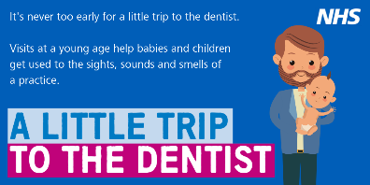
Introducing your little one to a range of food groups ensures they get all the energy and nutrients they need and gets them used to a range of tastes early. A healthy balanced diet also encourages good oral health. Start4Life has more tips: https://www.nhs.uk/start4life/weaning/what-to-feed-your-baby/around-6-months/ #ALittleTripToTheDentist @NHSMidlands  Take your baby to the dentist even if their teeth haven’t come through | 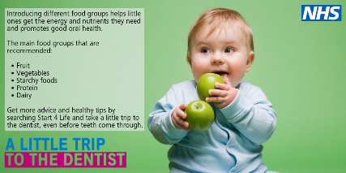
It’s estimated that around 12% of children have some tooth decay by as early as three yrs. #ALittleTripToTheDentist regularly and even before teeth come through can help spot issues before they have chance to get worse. Find a local NHS dentist: www.nhs.uk/service-search @NHSMidlands | 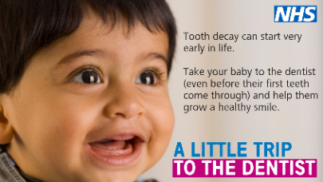
To ensure your baby maintains a healthy weight it’s best to start them off with a small amount of solid food, once-a-day. Avoid sugary snacks as they can cause tooth decay. #ALittleTripToTheDentist @NHSMidlands  Take your baby to the dentist even if their teeth haven’t come through. | 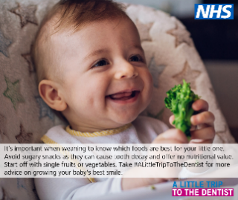
When your baby is ready to start weaning introduce a wide range of flavours and textures, avoiding salt and sugar. This promotes good oral health and prevents tooth decay. Book #ALittleTripToTheDentist for your little one: https://www.nhs.uk/Service-Search/Dentists/LocationSearch/3 @NHSMidlands
When your baby reaches between 7 and 9 months old, you can start them on three solid meals a day. Steer clear of snacks. If your baby is hungry in between meals, you can offer extra milk feeds to help keep their teeth healthy. #ALittleTripToTheDentist @NHSMidlands

Take your baby to the dentist even if their teeth haven’t come through
Babies don’t need teeth to take #ALittleTripToTheDentist – early visits give parents the opportunity to get advice on how best to care for their baby’s mouth and helps them get used to check-ups. Find a local NHS dentist: www.nhs.uk/service-search @NHSMidlands | 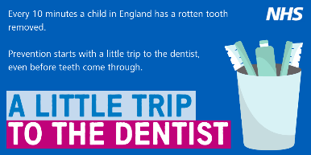
Everyone loves finger food, and what better way to show your child that eating solid foods can be fun too? Cut fruit and vegetables into different shapes and slices to add some excitement to their meal. Getting plenty of fruit and vegetables is important for babies as it helps promote a healthier lifestyle and good oral health. #ALittleTripToTheDentist @NHSMidlands

Take your baby to the dentist even if their teeth haven’t come through
Avoid adding sugar and salt to your baby’s food, as babies don’t need them. Don’t forget, tooth decay can start very early in life so be sure to take #ALittleTripToTheDentist even before teeth come through: www.nhs.uk/service-search @NHSMidlands
The Start4Life website and @NHS_Parents have lots of top tips for a healthy start for you and baby: https://bit.ly/2dZ4nsI #ALittleTripToTheDentist @NHSMidlands  Take your baby to the dentist even if their teeth haven’t come through | 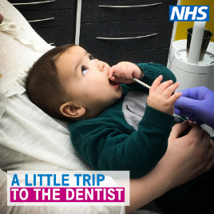
Help your little one grow their best smile by taking #ALittleTripToTheDentist – children are seen free at NHS dentists. Find a local dental practice at: www.nhs.uk/service-search @NHSMidlands | 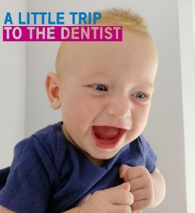

Facebook Posts

Facebook Post | Image
When you start introducing your little one to solid foods it’s good to include a wide range of food groups. This ensures they get all the energy and healthy nutrients they need. Fruit, vegetables, starchy foods, protein and dairy are all important ingredients to make up a balanced diet for your baby. Taking your baby to the dentist before their first tooth and a healthy lifestyle help encourage good oral health from the beginning and as your child grows. Start4Life has lots more useful tips, take a look: https://www.nhs.uk/start4life/weaning/what-to-feed-your-baby/around-6-months/ @NHSMidlands #ALittleTripToTheDentist
Everyone loves finger food, and what better way to show your child that eating solid foods can be fun too? Cut fruit and vegetables into different shapes and slices to add some excitement to their meal. Getting plenty of fruit and vegetables is important for babies as it helps promote a healthier lifestyle and good oral health. You’re encouraged to take your baby to the dentist. Find one local to you: www.nhs.uk/service-search @NHSMidlands #ALittleTripToTheDentist
Remember babies don’t need salt or sugar. Avoid adding them to your little one’s food to encourage a healthy balanced diet and good oral health. Babies shouldn’t eat salty foods as salt is no good for their kidneys and sugary foods can cause tooth decay. It’s also wise you take your baby to their dentist before their first tooth. Get more helpful, healthy tips here: https://www.nhs.uk/start4life/weaning/what-to-feed-your-baby/around-6-months/ @NHSMidlands #ALittleTripToTheDentist | 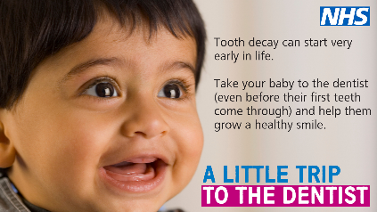
When your baby reaches 7 to 9 months, you can introduce three solid meals a day to their diet. However, NHS guidance advises to steer clear of snacks. If you find that your baby is hungry in between meals, you can offer extra milk feeds. This helps them maintain a healthy weight and also prevents tooth decay. For more useful tips take your little one to the dentist before their first tooth. Find a local practice here: www.nhs.uk/service-search @NHSMidlands #ALittleTripToTheDentist
To ensure your baby maintains a healthy weight it’s best to start them off with a small amount of solid food once a day. It’s important to make sure any solid foods do not have any added salt or sugar as this can be bad for their kidneys and teeth. Taking your baby to the dentist regularly and early on can help prevent the need for tooth extractions later in life. For more top tips on healthy eating for your little one, visit: https://www.nhs.uk/start4life/weaning/what-to-feed-your-baby/around-6-months/ @NHSMidlands #ALittleTripToTheDentist

Sharing with local media
If you’re interested in speaking to local media about the work you’re doing around children’s oral health, make sure you let us know so we can work collaboratively. Drop us an email at: england.memedia@nhs.net. We’re keen to get the story out there and can help you write a press release, contact print and broadcast media near you and share more on A Little Trip To The Dentist. For further advice, you can also contact to your organisation’s communications team.
Website / newsletter articles
Intranet / internal newsletters
The following article can be uploaded to your organisation’s intranet or shared with staff via internal newsletters. Its aim is to get healthcare professionals thinking about healthy weight management and oral health when working with families and young children. Feel free to adapt and amend as appropriate for you see fit.
A Little Trip To The Dentist
There’s lots for new parents to think about in the first few weeks and months of a baby’s life. That’s why we’re supporting NHS England and NHS Improvement’s campaign – A Little Trip To The Dentist – which is focusing on the relationship between healthy weight and healthy teeth in babies and young children.
Childhood obesity and excess weight are significant issues for children and their families, with more than one in five children being overweight by the time they start primary school.
A major contributing factor to obesity in children is their diet and nutrition, which often consists of foods which put them at high risk of tooth decay. A lack of physical activity and other environmental factors also have an impact.
Healthcare professionals play an important role in supporting families to take action. Working alongside other professionals and public health teams, you can influence the general population by delivering whole system approaches to tackling excess weight and reducing drivers, such as calorie intake and sedentary lifestyles.
Taking a little trip to the dentist, even before babies’ first teeth have come through, is vital in developing positive oral health routines to prevent tooth decay later in life. The advice a family can get from a dentist can also contribute to healthier diets and lifestyles, so do encourage any families you might be working with to visit a dentist regularly.
You can find more information on maintaining healthy weight for babies on the NHS website. You can also go online for resources dedicated to early trips to the dentist which you can use to spread the word in your local area.
ENDS
Website / external newsletters
This can be added to your organisation’s external websites or included in external newsletters to show your organisation is supporting A Little Trip To The Dentist. This is aimed at patients and families, encouraging them to think about oral health and helping their babies maintain a healthy weight. Please make any required amendments as appropriate for your audiences.
A Little Trip To The Dentist
We understand that there is a lot for a new parent to think about in the first few weeks and months of a baby’s life. A Little Trip To The Dentist – a campaign led by NHS England and NHS Improvement in the Midlands – focuses on the link between healthy weight and healthy teeth in babies and young children.
Childhood obesity and excess weight are significant issues for children and their families, with more than one in five children being overweight by the time they start primary school. There can be serious implications for a child’s physical and mental health, which can continue in to adulthood. The number of children with an unhealthy and potentially dangerous weight is a national public health concern.
A major contributing factor to obesity in children is their diet and nutrition, which often consists of foods which put them at high risk of tooth decay. A lack of physical activity and other environmental factors also have an impact.
Taking a little trip to the dentist, even before babies’ first teeth have come through, is vital in developing positive oral health routines to prevent tooth decay later in life. The advice you can get from a dentist can also contribute to healthier diets and lifestyles, so do take your baby to the dentist as soon as you can. Find a local dentist at www.nhs.uk/service-search.
You can find more information on maintaining healthy weight for babies on the NHS website.
ENDS

Accompanying resources
This section lists accompanying resources you can use alongside other promotion of A Little Trip To The Dentist. If you can’t find the resource you need from the following list, please let us know by emailing james.tomlinson1@nhs.net.
Posters
There are a selection of posters to choose from which you can print locally to display in your area. You can find these on the NHS England Midlands website.
Screen graphics
We also have four unique screen graphics to be displayed on TV screens in your area. These have been created for display on wide screen displays but if you need a different size, ratio or file type, please let us know.
Photos & graphics
There is a large selection of photos and graphics available for you to use with your communications and activities.
Briefings
We can provide briefings for senior managers explaining the background of the campaign and how it was developed. The NHS England and NHS Improvement – Midlands team is also happy to come along to team meetings to discuss how you might be able to support the campaign in your area.
Videos
You can find a playlist of videos related to A Little Trip To The Dentist here. We’re always looking for opportunities to create more like this, so do get in touch if you have any ideas or are interested in getting involved.
Links to other resources
Below are a number of additional resources for you to use in your activities.

Resource | Info | Notes
NHS website – how sugar affects our health & Change4Life sugar resources | Valuable information on sugar and the impact it can have on health, including tooth decay, weight and tips to cut down.
British Dietetic Association – sugar facts | Lots of information around sugar and how to tell if it’s in foods.
Public Health England’s ‘Top Tips for Teeth’ | Resources to help you to communicate good oral health messages to parents in manageable chunks. | You will need to register for a Campaign Resource Centre account to download these resources.
Video: Oral Health Awareness for babies | Produced by NHS England West Midlands’ Local Dental Network, this short, cartoon video aims to highlights the benefits of good oral health and dental care from birth. | To be shared via social media or in any family facing communications.
Video: How to brush your baby’s teeth (6 months to 7 years) | This is a 2-minute NHS video introduced by a health visitor showing a parent brushing a baby’s teeth.
Start4Life baby pages | The Start4Life baby pages provide information about parenthood, from breastfeeding to vaccinations.
Start4Life feeding your baby leaflet | This leaflet helps parents understand the benefits of breastfeeding, how to do it and other useful information. | Useful to download and share with parents
Video: Growing up with healthy teeth | A 20-minute video from HENRY all about what we can do to help children grow up with healthy teeth. | Useful for staff training or to be shared via social media or in patient-facing communications.
Healthy Start | Parents can check if they are eligible for Healthy Start, which can provide free vouchers to spend on milk, plain fresh and frozen fruit and vegetables, and free vitamins.
PHE Promoting a healthier weight for children, young people and families | Provides advice around consistent messaging for communicating around healthy weight for children, young people and families. Includes infographics and training tools, as well as a video around child obesity.
PHE Child Oral Health: applying All Our Health | This guide is part of ‘All Our Health’, a resource which helps health and care professionals prevent ill health and promote wellbeing as part of their everyday practice. The information will help front-line health and care staff use their trusted relationships with patients, families and communities to promote the benefits of good oral health for children.
PHE Child Oral Health All Our Health elearning | This is a bite-sized session to give health and care professionals an overview of child oral health - including key evidence, data and signposting to trusted resources to help prevent illness, protect health and promote wellbeing
Promoting healthy weight in children, young people and families: A resource to support local authorities | This resource aims to support local authorities, Clinical Commissioning Groups, NHS providers, and voluntary and community sector organisations by providing in one document the latest evidence, resources and data to encourage a systematic approach to creating local environments that promote healthy weight in children.
HM Government. Childhood Obesity. A Plan for Action. | Plan to significantly reduce England’s rate of childhood obesity within the next ten years.
PHE Childhood Obesity: applying All Our Health | This guide is part of ‘All Our Health’, a resource which helps health professionals prevent ill health and promote wellbeing as part of their everyday practice. The information below will help frontline health and care staff use their trusted relationships with patients, families and communities to promote the benefits of a healthier weight and reduce childhood obesity.

Upcoming themes
September – Tooth brushing for the very young
Contact details for the campaign
James Tomlinson, Communications and Engagement Officer, NHS England and NHS Improvement – Midlands, james.tomlinson1@nhs.net
Becky Read, Communications and Engagement Assistant, NHS England and NHS Improvement – Midlands, rebeccalauren.read@nhs.net
NHS England and NHS Improvement – Midlands Communications team, england.memedia@nhs.net

