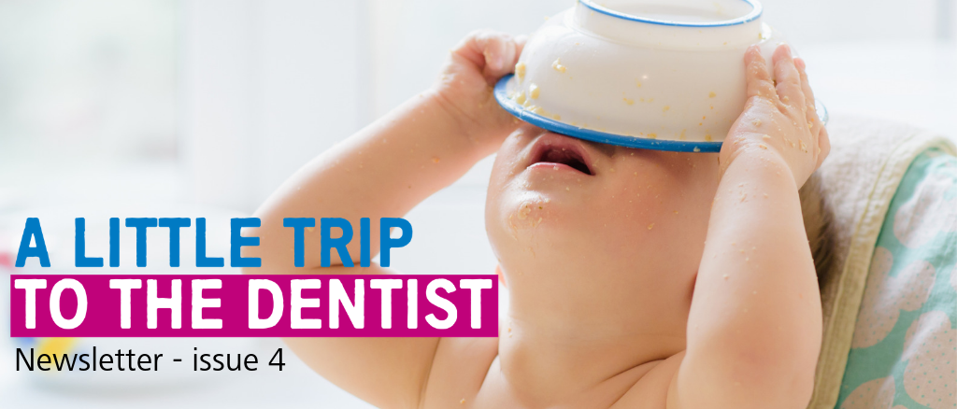
Welcome to the fourth edition of our newsletter, all about A Little Trip To The Dentist. These updates aim to let you know about the fantastic work going on across the West Midlands and how you can get involved.

Janet’s intro
A Little Trip To The Dentist is a simple concept, but one which seems to have resonated really well with our wider health systems. We’ve seen support for the campaign from CCGs, hospital trusts, GP practices, nurses, doctors, pharmacists, public health professionals and commissioners, to name a few.

One of the main aims of this initiative, other than to increase the numbers of very young children visiting the dentist of course, was to bring dental health to the top of the healthcare agenda. From what we can see and from the feedback we’ve been receiving, we’re more than achieving this so once again I’d like to say thank you to everyone who has shown their support.

Despite launching as a West Midlands campaign, lots of other areas right across the country have also shown an interest in developing something similar. We’re currently planning how we might roll it out across the entirety of the Midlands, so do keep an eye out in October when we’ll be sharing more.

For now it’s business as usual and our fourth toolkit is all about the close relationship between weaning and good oral health. We understand that the transition to solid foods isn’t always prescriptive, but we also recognise that it comes with opportunities to begin healthy habits early, ultimately reducing the risk of tooth decay.

Our resources this month offer useful tips for parents to help them wean healthily and safely, with oral health in mind. These are conversations we’d encourage more health professionals to have with patients, so do use what you need as you need to. If you think there is more you might need to help you do that, then please do let us know using the details at the end of this newsletter. We’re also keen, as ever, to hear your feedback, comments and thoughts so do get in touch.

Janet Clarke
Chair – West Midlands Local Dental Network, NHS England and NHS Improvement – Midlands

New #ALittleTripToTheDentist web page
To make it easier for you to access all of our resources which have been developed during the course of our campaign, we’ve now launched a new page on the NHS England website. This new section allows you to download all of our previous toolkits, newsletters and additional resources, as well as giving you access to a library full of photos, infographics and more.

We’ll be updating the page monthly with all of the latest information and materials, so do be sure to check back in. If you have your own resources which you think would make a good addition to the page email them to james.tomlinson1@nhs.net

Our latest theme

This month we’re focusing on safe, healthy and happy weaning and the relationship this has with good oral health. Weaning (sometimes called complementary feeding) is when babies are first introduced to solid foods and it usually starts when they are around six months old.

At the beginning, how much a baby eats is less important than getting them used to the idea of eating. Giving them a variety of foods alongside breast or formula milk, which provides most of the nutrients they’ll need, will help set them up for a lifetime of healthier eating, which will mean better general health and a reduced risk of tooth decay.

Weaning top tips

Top tweets

We’re looking for case studies
Do you know of a patient or family who has a story to tell around dental care? Or have you been doing some work in your practice or organisation and want to share it more widely?
We’re always looking for people stories which demonstrate the importance of A Little Trip To The Dentist. We’d love to tell your story so do get in touch even if you’re not sure how newsworthy a story might be, feel free to drop us a line! Email james.tomlinson1@nhs.net.

Training and development
VSM Healthcare is hosting two modules all about oral health care for very young children. Once complete, you will receive an ECPD certificate.
Module 2a http://vsmhealthcare.com/starting-well-module-2a-ecpd/
Module 2b https://vsmhealthcare.com/starting-well-module-2b-ecpd/
There are two videos you can watch for free which give you some basic knowledge around children’s oral health. One was developed by HENRY and the other by the West Midlands Local Dental Network at NHS England.
Health Education England has teamed up with the Royal College of Surgeons to develop a 20-minute e-learning course, all about oral health for children. Anyone is welcome to complete the training, including teachers, nurses, GPs and the general public.
There is also dedicated training available for pharmacy teams on the Centre for Pharmacy Postgraduate Education website.
Claire Stevens, spokesperson for the British Society of Paediatric Dentistry, has written an article for BDJ Team about how to examine a child under two.
Get in touch
If you have anything you’d like to add to our next newsletter, or you’d like to share some of the good work going on in your area, don’t hesitate to get in touch. You can email james.tomlinson1@nhs.net or call the NHS England & NHS Improvement – Midlands Communications team on 0113 825 1757.

