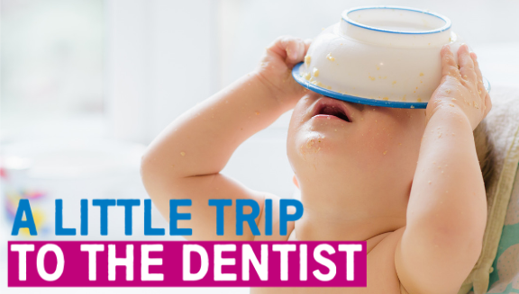
Toolkit 4 – Safe, healthy and happy weaning
In this document you’ll find a host of materials designed to help you support A Little Trip To The Dentist, a children’s oral health campaign developed by NHS England and NHS Improvement - Midlands, in partnership with Public Health England.
We need you to share these important messages with staff, patients, families and other key stakeholders, so please do adapt and use any resources as you see fit.
We would also encourage you to share this information with other organisations or teams who you think might want to deliver A Little Trip To The Dentist in their area too.
July’s theme
Each month our campaign takes on a new theme which runs alongside the core messaging around the importance of babies taking a little trip to the dentist even before their first teeth come through. Past themes have included sugar and oral health during pregnancy.
This month we’re focusing on safe, healthy and happy weaning and the relationship this has with good oral health. Weaning (sometimes called complementary feeding) is when babies are first introduced to solid foods and usually starts at around six months old.
At the beginning, how much a baby eats is less important than getting them used to the idea of eating. Giving them a variety of foods alongside breast or formula milk, which provides most of the nutrients they’ll need, will help set them up for a lifetime of healthier eating, which will mean better general health and a reduced risk of tooth decay.

Statistics
- Children are consuming on average two to three times more than the recommended amount of sugar
- Across England, only around 21% of children under two have had their teeth checked by an NHS dentist – with many areas in the West Midlands much lower
- A quarter of five-year-olds have already experienced some level of tooth decay, with an average of three or four teeth affected
- It’s estimated that around 12% of children in England may have decay in their teeth by as early as three-years-old
- A child in England has a rotten tooth removed in hospital every 10 minutes
- A recent study by the University of Birmingham shows that only 3% of children in England have visited the dentist before their first birthday.
How you can help
These resources provide lots of ways for you to support A Little Trip To The Dentist in your area. You are also encouraged to adapt materials for your own use as you wish.
Included in this toolkit:
- Social media content – for use on your personal or organisation’s social media channels
- Newsletter / website articles – to share via your internal communications channels or on your corporate websites. These can also be adapted for blog posts or longer social media posts
- Accompanying resources – you’ll find a host of accompanying resources available to you too, including photos to go alongside your communications, graphics, posters, email footers and more
- Useful links – again, to accompany your communications you can use any of the useful links we have provided at the end of the toolkit. This includes videos, sources of further information and much more
If you are from a dental practice, you can also use this toolkit to promote the availability of free NHS appointments for babies and children at your surgery.

Social media content
Below you will find content for use on Twitter and Facebook channels. Please feel free to adapt and amend as required for your audience, or simply copy and paste the below on to your pages. You may also use the following as inspiration to create your own content.
Note: please use photographs you have appropriate consent for, or use the images supplied alongside this toolkit.
Tweet pack
Tweet | Image
Safe, healthy & happy weaning is one of the first stepping stones towards good oral health, alongside #ALittleTripToTheDentist before first teeth come through. Get helpful advice on how to wean: https://www.nhs.uk/conditions/pregnancy-and-baby/solid-foods-weaning/ @NHSMidlands
Stick to single vegetables and fruits when you first begin weaning your baby. Don’t add sugar or give them sugary foods as it can cause tooth decay. You can get more advice on how best to take care of your baby’s mouth by taking #ALittleTripToTheDentist. @NHSMidlands | 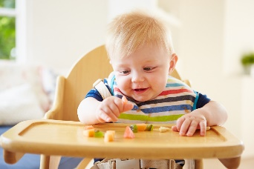
When weaning your baby, it can be tempting to sweeten the deal by adding sugar or honey. Babies don’t need sugar so giving it to them increases their risk of tooth decay. Honey also contains bacteria which can make babies seriously ill. #ALittleTripToTheDentist @NHSMidlands
When you start introducing solid foods to your baby, avoid adding sugar to foods to keep their new teeth healthy. Take #ALittleTripToTheDentist even before teeth come through to get them used to regular check-ups. Find a local NHS dentist: www.nhs.uk/service-search @NHSMidlands | 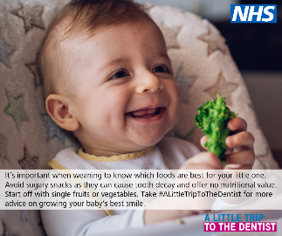
Protecting your baby’s teeth starts before they have them. Never offer anything but milk or water in a bottle, introduce a free-flowing cup from 6 months and don’t dip dummies in anything sweet or sugary. Get more advice with #ALittleTripToTheDentist @NHSMidlands | 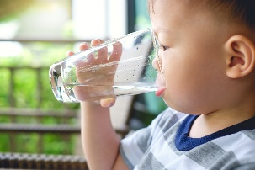
If a baby sucks drinks from a bottle teat or spout, it means the drink spends more time in contact with their teeth which can lead to dental problems. Introduce free-flow cups as soon as possible to reduce the risk of tooth decay. #ALittleTripToTheDentist @NHSMidlands
Instead of using pre-made food to wean your baby, try making it yourself. It’s easier than you think and you know exactly what’s in it. If you have to use ready-made food, check labels carefully and avoid those high in sugar. #ALittleTripToTheDentist @NHSMidlands
It can be confusing knowing when and how to start introducing solid foods to your baby. Start4Life is there to guide you through the healthy weaning journey. Take a look: https://www.nhs.uk/start4life/weaning #ALittleTripToTheDentist @NHSMidlands
A child in England has a rotten tooth removed in hospital every 10 minutes. This decay can largely be prevented simply by taking #ALittleTripToTheDentist regularly and even before teeth come through. Find a local NHS dentist: www.nhs.uk/service-search @NHSMidlands | 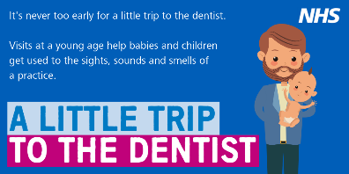
Less than 1 in 5 under 2s have taken #ALittleTripToTheDentist, with even less having visited before 1. Early visits are vital in helping babies get used to the sights, sounds and smells of a practice. Find a local NHS dentist: www.nhs.uk/service-search @NHSMidlands | 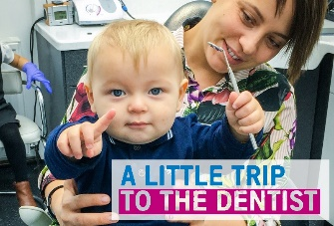
Babies don’t need teeth to take #ALittleTripToTheDentist. Early visits give parents the opportunity to get useful advice on how best to care for their baby’s mouth and helps them get used to check-ups. Find a local NHS dentist: www.nhs.uk/service-search @NHSMidlands | 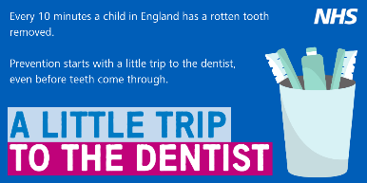
When weaning your baby, they may make a funny face but that doesn’t mean they don’t like it. They’re just getting used to new tastes and textures. It can take 10 tries or more for them to get used to new foods. #ALittleTripToTheDentist @NHSMidlands | 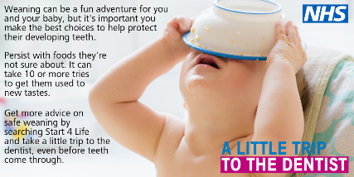
Encourage your baby to sip from a cup with their meals instead of a bottle. Open or free-flow cups without a teat help your baby learn to sip and is better for their teeth. #ALittleTripToTheDentist @NHSMidlands
When you are weaning your baby don’t forget their daily vitamin A, C and D supplements. Find out more on the Start4Life website, including useful information on caring for your baby’s mouth. https://www.nhs.uk/start4life/baby/baby-vitamins/ #ALittleTripToTheDentist @NHSMidlands
It’s estimated that around 12% of children have some tooth decay by as early as 3 yrs. #ALittleTripToTheDentist regularly and before teeth come through can help spot issues before they have chance to get worse. Find a local NHS dentist: www.nhs.uk/service-search @NHSMidlands
The messier the better when it comes to weaning your baby. Playing with, touching and tasting food gets them used to new textures and flavours. Take #ALittleTripToTheDentist with your little one for more advice on healthy weaning and preventing tooth decay. @NHSMidlands | 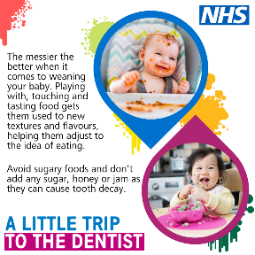

Facebook posts
Post one
When you first start weaning your baby at around six months old, they only need a small amount of solid food, once a day and at a time that suits you both. You can start with single vegetables and fruits, making sure any cooked food has cooled right down before you give it to them. Include vegetables that aren’t so sweet, such as broccoli or cauliflower to get them used to a range of tastes. Remember, babies don’t need sugar added to their food as it can cause tooth decay and other health problems and watch out for hidden salt (sodium) and sugar in processed food. #ALittleTripToTheDentist can help you learn more about how best to care for your baby’s mouth. Find out more about weaning: https://www.nhs.uk/start4life/weaning
Post two
Weaning has a close relationship with oral health, so it’s important you think about your baby’s teeth when giving them solid foods. It can be tempting to try and sweeten fruits or vegetables with sugar, but this can cause tooth decay and other health problems. Keeping foods sour helps babies get used to a range of tastes. Babies don’t need sugar so giving it to them increases their risk of tooth decay. Honey also contains bacteria which can make babies seriously ill. You can get more advice on how to care for your little one’s mouth by taking #ALittleTripToTheDentist. Find one local to you: www.nhs.uk/service-search
Post three
Up to six months, a baby just needs breast milk or an appropriate first infant formula milk. It’s at around the six-month mark that they are likely to show signs that they are ready for solids alongside their usual feed. These signs include sitting up and holding their head steady, picking up food or objects and moving them to their mouth, and swallowing. Make sure when you do start weaning that you avoid sugary foods and drinks as they can damage their developing teeth. Take #ALittleTripToTheDentist even before their teeth develop to get useful advice on how best to care for their mouths. Find out more about safe weaning: https://www.nhs.uk/start4life/weaning
Post four
When giving your little one solid food, you can offer them sips of water from an open or free-flow cup. Using a cup without a teat will help them learn how to sip and is better for your baby’s teeth, as liquid flows slowly through a teat which means it will be in contact with them for longer. If they are younger than six months, it’s important to sterilise the water by boiling it first then letting it cool right down. Sweet drinks like squash, fizzy drinks, milkshakes and fruit juice often have lots of sugar, so avoid these to help prevent tooth decay – even baby and toddler drinks can contain sugar. Take #ALittleTripToTheDentist for more advice on caring for gums, teeth and mouths.
Post five
#ALittleTripToTheDentist regularly with your baby even before their teeth come through is vital in starting healthy routines early. Not only can they double check everything is developing as it should be and keep an eye out for any issues, but it gets babies used to the sights, sounds and smells of a practice making later appointments much smoother. It’s very unlikely they will need treatment and often a dentist might not even get to look in their mouth, but it’s still a good opportunity to get advice and ask any questions you might have. Find a local NHS dentist: www.nhs.uk/service-search

Sharing with local media
If you’re interested in speaking to your local media about the work you’re doing around children’s oral health, make sure you let us know by emailing england.memedia@nhs.net. We’re keen to work with you to get the story out there and can help you write a press release, contact newspapers or broadcasters near you and shape your story. You can also speak to your organisation’s communications team for further advice.

Website / newsletter articles
Intranet / internal newsletters
The following article can be uploaded to intranets or shared via internal newsletters. Its aim is to get healthcare professionals thinking about oral health and healthy weaning when working with families. Feel free to adapt and amend as appropriate for your audiences.
Healthy weaning is closely linked with good oral health, so it’s important parents understand how to get the most from introducing their baby to solid foods, to protect their developing teeth.
The transition to solids can be a tricky and sometimes confusing for families, but there are a host of useful NHS guides and tips out there to help them through their weaning journeys. It’s important health professionals also get familiar with this information to help parents along the way too.
One of the most important things to remember is that babies don’t need salt or sugar added to their food. Salty foods aren’t good for kidneys and sugar can cause tooth decay. To begin with, babies should be introduced to single vegetables and fruits, including those which aren’t so sweet to ensure they get used to a range of flavours and textures.
Where a baby might be struggling with sour or more plain flavours, parents can try mixing in sweeter fruits such as bananas to help make it more palatable.
An open or free-flow cup should also be introduced at the earliest opportunity, as drinking through a teat means liquid flows more slowly and is in contact with teeth for longer - plus the muscles developed during sipping are the same ones used for talking.
Taking a little trip to the dentist, even before babies’ first teeth come through, is also vital in developing positive oral health routines and protecting from tooth decay. Do encourage any families you might be working with to get registered and to visit regularly.
You can find more information on weaning on the NHS website. You can also go online for resources dedicated to early trips to the dentist which you can use to spread the word in your area.
ENDS

Website / external newsletters
This can be added to your corporate websites or included in external newsletters to show your organisation is supporting the campaign. It is aimed at patients and families, encouraging them to think about oral health and healthy weaning early. You are welcome to adapt and amend as appropriate for your audiences.
Did you know tooth decay can start as soon as your baby’s first tooth starts to come through? That’s why it’s really important that you take a little trip to the dentist as early as possible, even before teeth come through, and you ensure weaning is done safely and with oral health in mind.
Caring for your baby’s teeth and transitioning to solid foods are closely linked, as the types of food you introduce your baby to early on can affect the foods they prefer later in life.
One of the most important things to remember is that babies don’t need salt or sugar added to their food. Salty foods aren’t good for their kidneys and sugar can cause tooth decay. If a baby gets too used to sweeter tastes, it could be harder to get them to eat other flavours.
To begin with, babies should be introduced to single vegetables and fruits. Where your baby might be struggling with sour or plain flavours, you could try mixing in a small amount of sweeter fruit, such as a banana, to help make it more palatable.
An open or free-flow cup should also be introduced at the earliest opportunity, as drinking through a teat means liquid flows more slowly and is in contact with teeth for longer – plus the muscles developed during sipping are the same ones used for talking.
Taking a little trip to the dentist, even before their teeth come through, is also vital in developing positive oral health routines and protecting against decay. Make sure you get registered as soon as possible and visit regularly – your dentist can also give you more useful advice on teething, weaning, toothbrushing and more.
For more information on weaning, take a look at Start4Life on the NHS website.
ENDS

Accompanying resources
This section lists accompanying resources you can use alongside other promotion of A Little Trip To The Dentist. If you can’t find the resource you need from the following list, please let us know by emailing james.tomlinson1@nhs.net.
Posters
There are a selection of posters to choose from which you can print locally to display in your area. You can find these on the NHS England Midlands website.
Screen graphics
We also have four unique screen graphics to be displayed on TV screens in your area. These have been created for display on wide screen displays but if you need a different size, ratio or file type, please let us know.
Photos & graphics
There is a large selection of photos and graphics available for you to use with your communications and activities.
Briefings
We can provide briefings for senior managers explaining the background of the campaign and how it was developed. The NHS England and NHS Improvement – Midlands team is also happy to come along to team meetings to discuss how you might be able to support the campaign in your area.
Videos
You can find a playlist of videos related to A Little Trip To The Dentist here. We’re always looking for opportunities to create more like this, so do get in touch if you have any ideas or are interested in getting involved.
Links to other resources
Below are a number of additional resources for you to use in your activities.

Resource | Info | Notes
NHS website – how sugar affects our health & Change4Life sugar resources | Valuable information on sugar and the impact it can have on health, including tooth decay, weight and tips to cut down.
British Dietetic Association – sugar facts | Lots of information around sugar and how to tell if it’s in foods.
Public Health England’s ‘Top Tips for Teeth’ | Resources to help you to communicate good oral health messages to parents in manageable chunks. | You will need to register for a Campaign Resource Centre account to download these resources.
Video: Oral Health Awareness for babies | Produced by NHS England West Midlands’ Local Dental Network, this short, cartoon video aims to highlights the benefits of good oral health and dental care from birth. | To be shared via social media or in any family facing communications.
Video: How to brush your baby’s teeth (6 months to 7 years) | This is a 2 minute NHS video introduced by a health visitor showing a parent brushing a baby’s teeth.
Start4Life baby pages | The Start4Life baby pages provide information about parenthood, from breastfeeding to vaccinations.
Start4Life feeding your baby leaflet | This leaflet helps parents understand the benefits of breastfeeding, how to do it and other useful information. | Useful to download and share with parents
Video: Growing up with healthy teeth | A 20 minute video from HENRY all about what we can do to help children grow up with healthy teeth. | Useful for staff training or to be shared via social media or in patient-facing communications.
Healthy Start | Parents can check if they are eligible for Healthy Start, which can provide free vouchers to spend on milk, plain fresh and frozen fruit and vegetables, and free vitamins.
PHE: Promoting a healthier weight for children, young people and families | Provides advice around consistent messaging for communicating around healthy weight for children, young people and families. Includes infographics and training tools, as well as a video around child obesity.

Upcoming themes
August – Healthy weight and healthy teeth
September – Tooth brushing for the very young
Contact details for the campaign
James Tomlinson, Communications and Engagement Officer, NHS England and NHS Improvement – Midlands, james.tomlinson1@nhs.net
NHS England and NHS Improvement – Midlands Communications team, england.memedia@nhs.net

