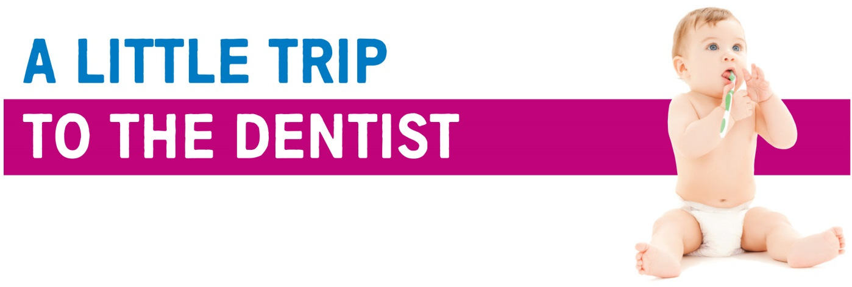
March 2019 | Issue 1
Welcome to the first edition of our monthly newsletter, all about ‘A Little Trip To The Dentist’. These updates aim to let you know about the fantastic work going on across the West Midlands and how you might be able to get involved.

Message from Janet Clarke
Here at NHS England West Midlands, we’re keen to do what we can to improve the health of people right across our region, starting with the youngest in our population.

Some of you may already know about our new campaign, but for those of you who don’t, please allow me to introduce to you, ‘A Little Trip To The Dentist’. The campaign aims to encourage parents and carers to visit a dentist with their babies early, even before their first tooth has come through.
Every 10 minutes a child in England is hospitalised to have a rotten tooth removed. Tooth decay is one of the leading causes of hospital admission for children, which is why we’re working to encourage healthy mouth routines from the start of a baby’s life, to try and reduce these numbers. We know that only around 21% of zero to two year olds in England are going to a dentist and in parts of the West Midlands the figure is much lower.

Over the next few months, we’ll be providing regular updates on all things campaign-related alongside a handy toolkit which gives you and your teams the resources you will need to get behind it. From articles to share with patients, to content for your social media channels, there are plenty of ways you can get involved.

In this newsletter, we’ll also be giving you information on relevant events or training opportunities, good news stories from across the region and much more.

We look forward to giving out some special awards to dental surgeries that give their full support to the campaign – so do keep an eye out for that!

We’re always keen to hear your ideas or suggestions, so if you have any thoughts or other ways we can spread the word, please do get in touch with us using the contact details at the end of this newsletter.

Janet Clarke
Chair – Local Dental Network, NHS England West Midlands

Campaign Introduction
Every 10 minutes a child in England is admitted to hospital to have a rotten tooth removed. That’s why NHS England West Midlands is working to address this by increasing the number of new parents taking their little ones to the dentist before their first tooth comes through, with a new campaign, ‘A Little Trip To The Dentist’.

Hospitals, pharmacies and health and early years professionals such as dentists, GPs, health visitors and paediatric practitioners across the West Midlands are being encouraged to get behind the campaign to raise awareness of the importance of oral health in order to reduce the number of children needing treatment.

Preventing tooth decay starts by paying a visit to the dentist before a baby’s first tooth comes through. Being seen at a young age means dentists can check everything is developing as it should be and they can help families learn good mouth routines early on.

Depending on how a baby is feeling, the dentist may not always be able to see in their mouth. That’s okay as there are plenty of other benefits to early check-ups. Dentists can provide valuable advice and tips on how to maintain healthy gums, teeth and mouths throughout key stages in a baby’s development.

This contact time also ensures young children feel comfortable with the dental team preventing nervousness later in life.

‘A Little Trip To The Dentist’ will have a monthly theme focusing on different aspects of oral health for mums and babies, including maintaining a healthy mouth in pregnancy, sugar, weaning, healthy weight and tooth brushing.

As well as the public-facing campaign, there will be work going on with dentists and other health and early years professionals to keep them updated on how to best care for very young children and families.

In your area you may find there are other people to work with to support the campaign. Local authority oral health leads, Local Dental Committee members, Community Dental Services and health and early years professionals may be interested in working together.

Training and Development
There are lots of resources available for free to help teams learn more about oral health for babies and children.

The Faculty of Dental Surgery at the Royal College of Surgeons has teamed up with Health Education England to develop a 20 minute e-learning course, Children’s Oral Health Advice For All, which is now on the e-Learning for Health website. The course is aimed at early years practitioners, teachers, nurses, GPs, as well as the general public.

There are also two great videos available to view for free on children’s oral health which can be useful for training people who work with babies, young children and their families.

The Growing Up With Healthy Teeth film developed by HENRY is 20 minutes long and includes lots of information about healthy eating, sugar and tooth brushing. There is a strong focus on tips to change family behaviour.

NHS England West Midlands’ Local Dental Network has created this short, cartoon video which aims to highlight the benefits of good oral health and dental care from birth.

For pharmacy teams Children’s Oral Health training is available on the Centre for Pharmacy Postgraduate Education website.

Dates for your Diary
You can use these dates as a reason to talk about ‘A Little Trip to the Dentist’. We’ll be providing you with materials you can use, but if you wanted to plan an event, you could schedule it to coincide with one of the days below:
Wednesday 20 March – World Oral Health Day
Sunday 31 March – Mother’s Day
Sunday 7 April – World Health Day
Monday 6 to Sunday 12 May – National Weaning Week
Sunday 12 May – National Children’s Day

Case Studies
We’re looking for case studies to help tell our story. Specifically, we’re looking for families whose children needed dental treatment which could have been avoided had they gone to the dentist in the early stages of their development. Alternatively, we would love to speak to a family who did go to the dentist and managed to get useful advice to prevent a potential problem from developing.

Josie O’Connell, mum of twins, Atticus and Finn (pictured below), has already given her backing to the campaign. When her twins were born, Atticus, had lots of complications which meant he required open heart surgery at just a few days old.

Thankfully, he’s much better now but Josie talks about how she’s even more grateful for the opportunities she has to give him and Finn the best start in life.

She said: “If I’m honest, I didn’t think about dental care for my twins until I started getting involved in this campaign. New parents can really feel under pressure to remember so many different things, so it’s no surprise that mouths can be forgotten about until a child actually has teeth. If a little trip to the dentist is all it takes to reduce their risk of complications, it’s absolutely something I’m happy to do.”

Have you got some news, an event or update for us?
If you have any comments, questions, suggestions or additions for next month’s newsletter, we’d love to hear from you. Whether you’ve found a great case study; have increased the number of under twos you’re seeing at your practice, promoted the campaign amongst the families you see or have a relevant event you think your colleagues might be interested in, let us know. You can contact james.tomlinson1@nhs.net or call the NHS England West Midlands Communications team on 0113 825 0646.

Competition

We’re looking for the practice or setting that’s really embraced the campaign! Upload photographs of your area displaying the campaign materials to your twitter account saying why you’re backing it and tag us in @NHSMidlands and we’ll choose the best. The winner gets a certificate and a feature in our next issue!

If you don’t have a twitter account, email your photo to james.tomlinson1@nhs.net.

