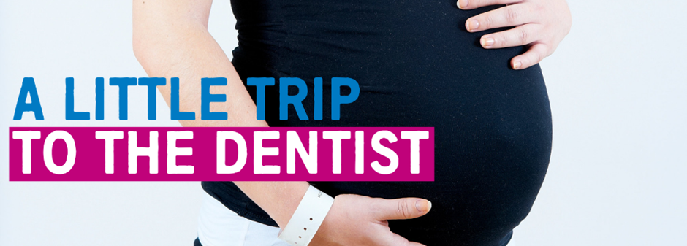
April 2019 | Issue 2
Welcome to the second edition of our newsletter, all about ‘A Little Trip To The Dentist’. These updates aim to let you know about the fantastic work going on across the West Midlands and how you might be able to get involved.

Successful launch for ‘A Little Trip To The Dentist’
Firstly I’d like to say a huge thank you to everyone who has supported our ‘little’ campaign since its launch last month. We’ve been absolutely bowled over by the sheer amount of interactions and posts on social media, and it’s been lovely to see the posters going up in your practices right across the West Midlands. Don’t forget to keep posting with #ALittleTripToTheDentist and tag us using @NHSMidlands.

We were especially proud to have been featured on BBC Midlands Today, where you may have seen Eddie Crouch, member of our Local Dental Network, talking about the campaign and why it’s so important babies are seen by a dentist as soon as possible, as well as Anita Kundra, a Wednesbury dentist who you’ll hear more from later in this newsletter. They were joined on the programme by a family whose eldest child suffered from tooth decay at a young age and benefitted from seeing a dentist – a perfect example of what this campaign is all about.

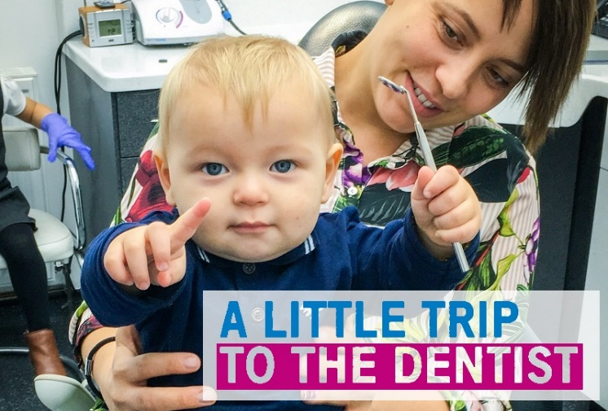
‘A Little Trip To The Dentist’ has been a labour of love for the project team at NHS England and Public Health England for quite some time and we’re very pleased to have finally got to a position where we’ve been able to share that hard work with you. We have an opportunity now to use this momentum to really drive forward these important messages, and the part you and your teams play is vital in making a difference for the children and families in our region.

April sees the campaign take on a whole new theme, as we encourage families to start thinking about oral health even before their babies arrive. There’s lots of ways expectant parents can prepare for a little trip to the dentist and it’s equally important that mums-to-be look after their own mouths too. You’ll find more about the theme in the rest of this newsletter and in the campaign toolkit. If you haven’t received the toolkit or would like specific resources, contact james.tomlinson1@nhs.net.

Please do continue to support the message where you can - be that via your online channels, by simply displaying a poster or however else you think you can help us get the word out. You can also let us know how it’s been going in your area – perhaps you’ve seen more babies than usual or you’ve created an eye catching display, whatever it is we want to hear about it! There may even be a little prize in it for you…

Janet Clarke
Chair – Local Dental Network, NHS England West Midlands

From the dentist’s mouth - Anita Kundra
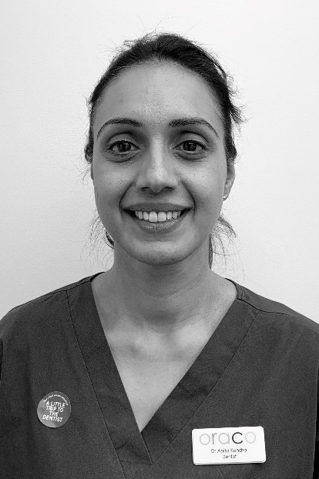
“I’m lucky to have a wonderful team at oraco that really values opportunities to reach beyond our clinical work to try and effect change in the population we serve. Between us, we’ve seen too many children with varying levels of decay, much of which could have been prevented had we seen them earlier.

“‘A Little Trip To The Dentist’ struck us as a fantastic campaign idea from the moment we volunteered to get involved. We’d been plugging away in our surgeries for a long time trying to get families to think about oral health sooner, so to finally have something to badge it up as so parents could really understand the message is very welcome.

“Our initial involvement saw me and one of our dental nurses stepping in front of the camera to appear in photographs for the campaign. We’d managed to source two families who both had children at about the right age who were also willing to be involved, and we had a great afternoon posing for pictures which were used on the posters we’re now displaying in our practices.

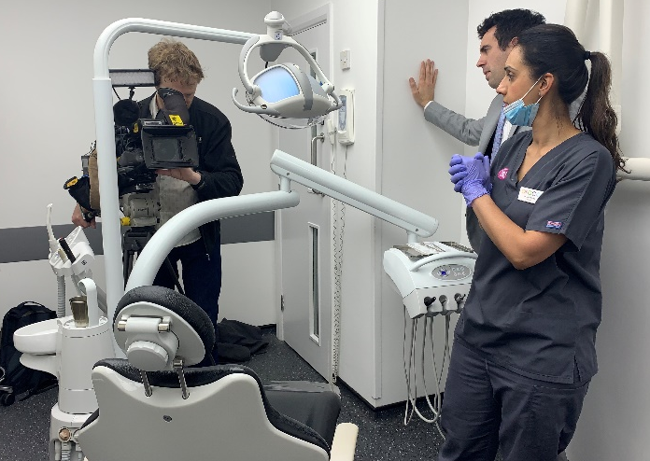
“During our conversations with the Communications team at NHS England, we’d been told there was a chance we may be called on to take part in media coverage if there was any interest. Next thing we knew, the BBC were at the surgery with a big camera in tow and I was to appear on BBC Midlands Today that evening!

“The idea of having someone film you doing your every day job is quite daunting, but once the cameras were rolling it was actually quite good! The scariest part was being interviewed, but I just had to remember that the journalist was there to do a positive piece about the campaign and the work we’re doing to support it, so he wasn’t going to ask anything I didn’t already know the answer to.

“I’d highly recommend more dental practices get behind the campaign and, where there is opportunity, to work with the communications team to help spread the word. It was incredibly rewarding and has given us a deeper understanding of the work which goes on behind the scenes.”
Dr Anita Kundra
Dentist, oraco

Our latest theme

The latest theme for ‘A Little Trip To The Dentist’ is all about looking after teeth during pregnancy. Some women get swollen and sore gums during pregnancy, often as a result of the hormonal changes their body goes through. That’s why it’s vital mums-to-be keep on top of their own oral health routines by regularly paying a little trip to the dentist.

Getting in to the habit of going to an NHS dentist will not only ensure expectant parents are taking care of their own mouths, but will help prepare for when their baby arrives. These visits provide opportunities to ask questions about a whole range of topics from breastfeeding to dummies and much more!
It’s also a chance for practice staff to continue to build positive relationships with families. Parents with a positive impression of a dental surgery will be more inclined to take their babies for a check-up as soon as possible.

Questions you might get asked

Parents have a lot to think about in the build up to welcoming their new addition and in the weeks following. We’ve listed some frequently asked questions and their answers below to help inform your conversations with families.

Q: Is it safe to have a dental check-up while pregnant?
A: Yes, it’s actually recommended. Hormonal changes can make mums-to-be more prone to gum disease and other dental issues, so it’s important to continue regular visits.

Q: At what point in my pregnancy should I see a dentist?
A: There isn’t a particular point at which you should see a dentist, but if your last visit was more than six months ago or you’re experiencing any issues you should get an appointment. Don’t forget, dental check-ups are free for pregnant women and new mums up to a year after your baby’s birth.

Q: What will my dentist need to know about my pregnancy?
A: They will need to be made aware that you are pregnant and when your due date is. They will also need to know what medication you might be on, if you have any specific medical conditions or if your pregnancy is high risk.

Q: What if I need treatment? Are they safe while pregnant?
A: A dentist will only offer treatment if it’s safe to do so. If an x-ray is required, your dentist will decide whether it’s best to take the x-ray straight away or delay it until after the baby is born.

Q: How can I prevent oral health issues during pregnancy?
A: It’s important to continue your usual healthy routines, including brushing twice a day, cleaning between your teeth (e.g. flossing), visiting the dentist and limiting sugary foods. If you suffer from morning sickness, rinse your mouth out with plain water after each episode. This will help prevent the acid in your vomit attacking your teeth. Do not brush your teeth straight away as they will be softened by the acid from your stomach. Wait about an hour before doing so.

Q: I recently had my baby, what can I do to take care of their mouth before teeth come through?
A: Take a little trip to the dentist! Your dentist can make sure everything is developing normally and give useful advice on breastfeeding, weaning and establishing good dental routines from an early age. Even if they don’t get to look in your baby’s mouth, early trips help them get used to the sights, sounds and smells of a practice.

Q: What should I do when my baby starts teething?
A: There are lots of things you can try to help make your baby more comfortable during teething. Teething rings can give them some relief and distract them from any pain. If they’re six months or older, you could try giving them raw fruit or vegetables to chew on under supervision. If teething is making your baby dribble more than usual, gently wiping their face may help prevent a rash.

Q: Their teeth are starting to come through – when should I start brushing them?
A: Start brushing your baby’s teeth with fluoride toothpaste as soon as their first milk tooth breaks through. Use a tiny smear of toothpaste for babies and toddlers up to three-years-old, and a pea-sized amount for children aged three to six years. You can find more tooth brushing tips on the NHS website.

Dental teams may want to refer to Delivering Better Oral Health for further information e.g. for appropriate concentrations of fluoride in toothpaste or pictures of appropriate amounts of toothpaste. These could be used as a visual aid with parents and carers.

Q: Should I give my baby a dummy?
A: It’s fine to give your baby a dummy but avoid using them after 12 months of age. Using dummies after this can encourage an open bite, which is when teeth move to make space for the dummy. They can also affect your child’s speech development. Discourage them from talking or making sounds with a dummy or their thumb in their mouth, and don’t dip dummies in anything sweet, such as sugar or jam.

Twitter corner
We’ve seen lots of organisations right across the West Midlands getting behind ‘A Little Trip To The Dentist’. Here are just some of our favourite tweets from the last month. Don’t forget to use #ALittleTripToTheDentist and tag us @NHSMidlands when tweeting!

Training and development
VSM Healthcare is hosting two modules all about oral health care for very young children. Once complete, you will receive an ECPD certificate.
Module 2a http://vsmhealthcare.com/starting-well-module-2a-ecpd/
Module 2b https://vsmhealthcare.com/starting-well-module-2b-ecpd/
There are two videos you can watch for free which give you some basic knowledge around children’s oral health. One was developed by HENRY and the other by the West Midlands Local Dental Network at NHS England.
Health Education England has teamed up with the Royal College of Surgeons to develop a 20-minute e-learning course, all about oral health for children. Anyone is welcome to complete the training, including teachers, nurses, GPs and the general public.
There is also dedicated training available for pharmacy teams on the Centre for Pharmacy Postgraduate Education website.
Claire Stevens, spokesperson for the British Society of Paediatric Dentistry, has written an article for BDJ Team about how to examine a child under two.

Dates for your diary
You’re encouraged to show your support for ‘A Little Trip To The Dentist’ whenever you can, but if you’d like an excuse to talk about it why not use one of the following awareness events?

Monday 6 to Sunday 12 May – National Weaning Week
Monday 13 May to Thursday 13 June – National Smile Month
Tuesday 14 May – National Children’s Day
Wednesday 15 May – International Day of Families

Winner!
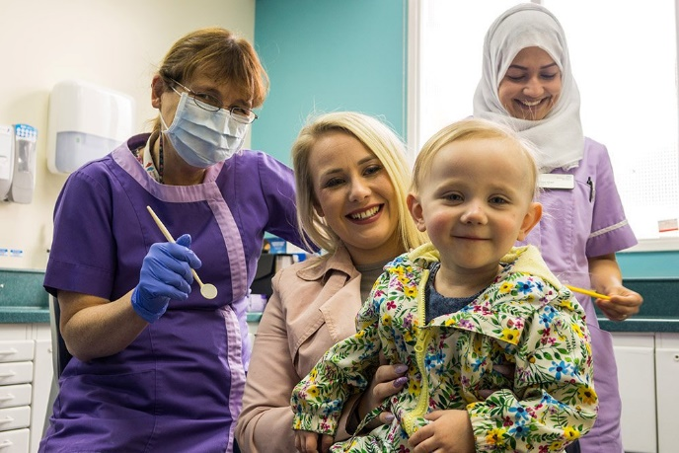
Our colleagues at Birmingham Women’s and Children’s NHS Foundation Trust have really got behind the campaign, sourcing their very own case study complete with this wonderful picture. Two-year-old Emmie-Rose was referred to Birmingham Children’s Hospital after her local dentist spotted some cavities. Simply taking a little trip to the dentist means she’s avoided potential further decay and pain having now been helped by the expert team.

Do you have a particularly impressive display in your dental practice or have you been using social media innovatively to help spread the message? We want to hear about it! Send us your pictures on Twitter @NHSMidlands or tag us in your tweets. The best of the bunch will receive a shiny certificate to display in your area.

Get in touch

If you have anything you’d like to add to our next newsletter, or you’d like to share some of the good work going on in your area, don’t hesitate to get in touch. You can email james.tomlinson1@nhs.net or call the NHS England & NHS Improvement – Midlands Communications team on 0113 825 1757.

