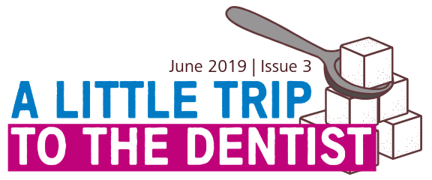
Welcome to the third edition of our newsletter, all about ‘A Little Trip To The Dentist’. These updates aim to let you know about the fantastic work going on across the West Midlands and how you might be able to get involved.

Janet’s intro
A Little Trip To The Dentist has gone from strength to strength since its launch in March, with support from all over the West Midlands and beyond. We’re really pleased with how it’s being received, but we understand that our work isn’t done until we start to see a change in the number of children accessing dentists.

The University of Birmingham conducted a study looking at how many children in England have visited the dentist across the country before their first birthday. The results showed that just three per cent of these children have had a check-up. While disappointing, this number certainly isn’t surprising and really illustrates why this campaign is so important and why we need as many people as possible to support it in their areas.
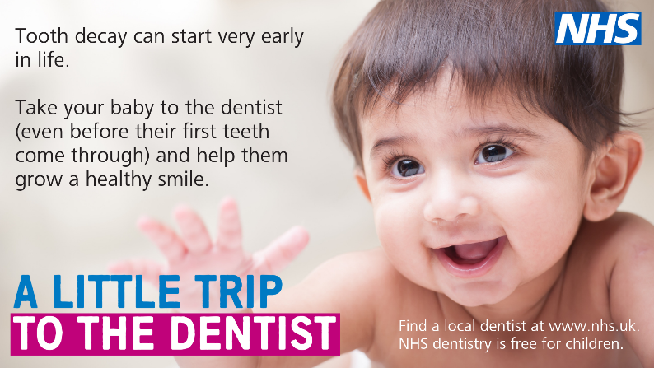
Here in the West Midlands, we’re keeping an eye on our statistics in the hope that we might see some positive movement over the coming weeks and months. If you’ve noticed an increase in the number of parents bringing their children to your practice do let us know as we’d love to share your experience with our colleagues so we can try and replicate it elsewhere.

We’re also really keen to make sure we’re engaging with you effectively and giving you the tools you need to help us get the results we’re aiming for. A few of you have already fed back that you’d like some materials which can be used on screens in waiting areas, so we went away and created some assets which you’ll find in this month’s toolkit. This feedback is really helpful in making sure the campaign continues to be fit for purpose and accommodates your needs – so keep the ideas coming using the contact details at the end of this newsletter.

Finally, we’d like to say another big thank you to those of you who have already given your backing to A Little Trip To The Dentist. We are seeing all of your social media activity and are getting interest at a national level, as well as from other regions in England. It would be great if we in the West Midlands could be the trailblazers. This month’s theme is sugar so there should be plenty of opportunities to help get the message out.

Janet Clarke
Chair – West Midlands Local Dental Network, NHS England and NHS Improvement – Midlands

Birmingham nursery supports #ALittleTripToTheDentist
If you follow us on Twitter @NHSMidlands (and if you’re not we’d love it if you did), you will hopefully have spotted a series of videos which we’ve been sharing throughout National Smile Month. The short films star the deputy manager of a local nursery and the dad of an incredibly smiley two-year-old girl.

The videos cover a variety of topics including advice for parents, highlights of the work the nursery do around oral health and much more. You can find a full playlist of the videos on YouTube, so please do give them a watch and share them where you can. Thank you to The Elms Day Nursery, Vicki Wall, Iestyn Williams and everyone else involved in getting us access to film the videos.

We’re always looking for more opportunities to put together short videos related to the campaign. If you have any ideas for a film or would like to be involved in the future, please do get in touch using the contact details at the end of this newsletter.

Our latest theme

Our focus for June is all about sugar and the impact it can have on not just teeth, but our health in general – even at a young age. Eating too much sugar can cause weight gain and leads to tooth decay. From the very start it’s easy to give babies too much sugar as lots of ready-made foods and drinks contain a large amount. Free sugars are those added to food or drinks, including biscuits, buns, confectionary, flavoured yoghurts, breakfast cereals and squashes. They’re also in honey, syrups, nectars and unsweetened fruit juices, fruit purees and smoothies.

Throughout the next month we’ll be debunking some of the myths around sugar, offering tips on how to recognise sugars on food labels and how we can cut down and suggesting some alternatives for young children – all while continuing to encourage regular trips to the dentist. If you have any sugar related facts, suggestions or stories, do let us know.

Case study – Keevah and sugar
When mum of two Shardae was told by her dentist that her eldest daughter Keeva would need treatment for tooth decay, it was a shock to say the least. As a dental nurse, Shardae was very aware of the dangers of too much sugar or poor dental routines having seen countless children whose problems could’ve been avoided had they gone to the dentist earlier. But it can be really difficult as a busy parent to keep an eye on things even when you know about sugar and oral health.

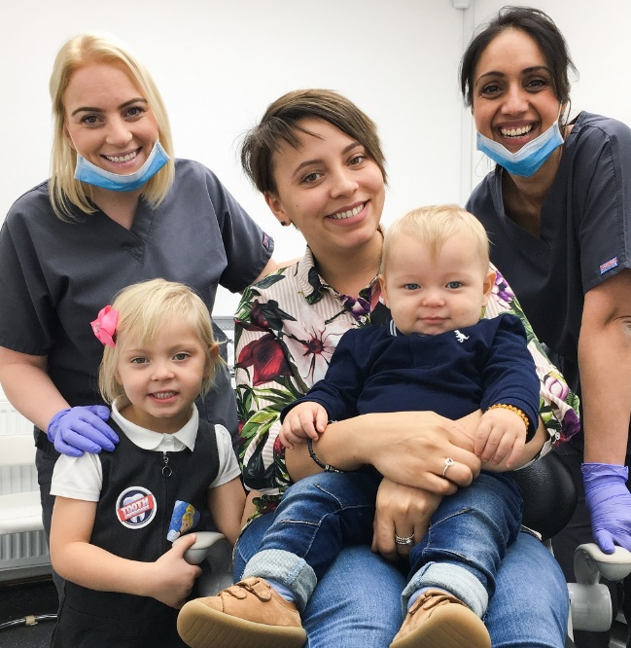
Thankfully, she’d been regularly attending the dentist with Keeva since she was around one-year-old, so when these problems did start to emerge it was nipped in the bud early on. It quickly became apparent that the cause of Keeva’s decay was eating a small amount of sweets regularly.

What Shardae thought was an innocent treat every day or two was having a severe effect on her daughter’s teeth. She very quickly began to cut out excess sugar from her diet and took her youngest son Kaceson to the dentist at just weeks old, to make sure the same issues didn’t happen to him.

Shardae said: “I’m so relieved we made the decision to take Keeva to the dentist relatively early, so these issues could be spotted before they had chance to get any worse. In hindsight, I don’t think it’s ever too early for a child to go get a check-up as it’s helped me get the knowledge I needed for my son as he goes through those early months and years. The advice I’ve had has meant I can prevent Kaceson having any issues, rather than needing treatment later on.”

Sugar quiz

There are plenty of ways you can engage with your patients and families around A Little Trip To The Dentist - from setting up ‘guess how much sugar’ games in your area, to encouraging visitors to take part in our sugar quiz. Our short quiz tests participants’ knowledge on all things sugar – from the amount young children should be consuming per day to how many calories are in just one cube. Some of the answers may surprise you!

You can find a PDF file attached to the email you received this on, or you’re welcome to get in touch with james.tomlinson1@nhs.net if you’d like it in a different format. Alternatively, feel free to craft your own quiz or activity in your area – but be sure to let us know about it. We’d love to share the good work going on right across the West Midlands.

Social media corner

Training and development
VSM Healthcare is hosting two modules all about oral health care for very young children. Once complete, you will receive an ECPD certificate.
Module 2a http://vsmhealthcare.com/starting-well-module-2a-ecpd/
Module 2b https://vsmhealthcare.com/starting-well-module-2b-ecpd/
There are two videos you can watch for free which give you some basic knowledge around children’s oral health. One was developed by HENRY and the other by the West Midlands Local Dental Network at NHS England.
Health Education England has teamed up with the Royal College of Surgeons to develop a 20-minute e-learning course, all about oral health for children. Anyone is welcome to complete the training, including teachers, nurses, GPs and the general public.
There is also dedicated training available for pharmacy teams on the Centre for Pharmacy Postgraduate Education website.
Claire Stevens, spokesperson for the British Society of Paediatric Dentistry, has written an article for BDJ Team about how to examine a child under two.

Dates for your diary
You’re encouraged to show your support for ‘A Little Trip To The Dentist’ whenever you can, but if you’d like an excuse to talk about it, why not use one of the following awareness events?

Monday 13 May to Thursday 13 June – National Smile Month
Sunday 16 June – Father’s Day

Get in touch

If you have anything you’d like to add to our next newsletter, or you’d like to share some of the good work going on in your area, don’t hesitate to get in touch. You can email james.tomlinson1@nhs.net or call the NHS England & NHS Improvement – Midlands Communications team on 0113 825 1757.

