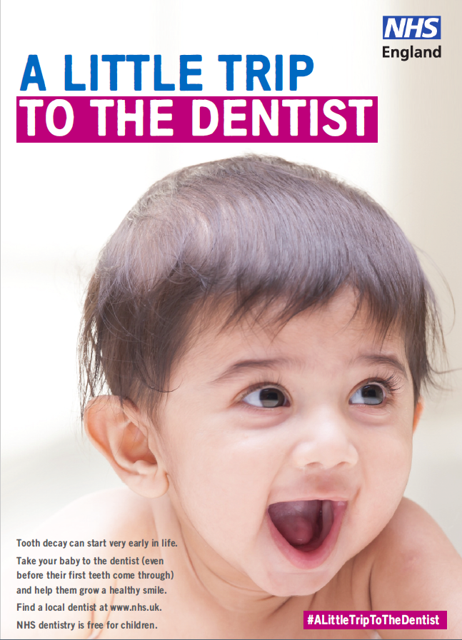
A Little Trip to the Dentist Campaign Toolkit
This toolkit will give you the resources you need to deliver ‘A Little Trip to the Dentist’ – a brand new NHS England campaign to encourage families to take their babies to a dentist.
We hope you will take part in the campaign, and we will continue to send everything you need on a monthly basis.
You might know that despite NHS dental visits being free for babies and children:
- only around 21% of children under two in England are having their teeth checked by an NHS dentist
- In many parts of the West Midlands this rate is much lower
- Nationally a quarter of five year olds already have tooth decay with an average of three or four teeth affected
- around 12% of children may have decay in their teeth by the age of three
- every 10 minutes a child in England has a rotten tooth removed in hospital.
By the age of five many children could already have tooth decay, many of whom may only have been to the dentist when they are in pain or the decay is already so severe they need to have teeth removed.
We want parents and carers to take their babies to the dentist sooner rather than later, even before their first teeth come through.
An early dental visit is more than looking in a baby’s mouth:
- families get information, advice and support for caring for teeth when they come through
- the dentist can look out for problems at a young age
- dentists and their teams can help families get the best from tooth brushing, advise on sugar, healthy eating and drinking, teething and also offer preventative treatments.
A little trip to the dentist also helps them to get used to the sights, sounds and smells of a dental practice which is vital in ensuring children feel comfortable in that environment as they grow older.
How to get involved
We will provide you with all the materials to run the campaign in your practice. Each month you will receive a toolkit which contains:
- social media content
- a media release to send to your local newspaper
- articles for newsletters and website
- photographs for social media, newsletter and website
- links to similar campaigns you can use
- contact details.
If you work in a dental practice, you can also use this toolkit to promote the availability of free NHS appointments for babies and children.
The main aim of the campaign is to increase the number of nought to two year olds accessing NHS Dentistry in the West Midlands.
The main message of the campaign is:
Help your baby to grow their best smile and prevent tooth decay by taking a little trip to the dentist even before their first teeth come through.
Each month the toolkit will be based on themes including Starting Early, Healthy Mouth in Pregnancy, Babies and Sugar, Weaning, Healthy Weight and Tooth Brushing.
This toolkit includes:
- Website / newsletter article
- Template press release
- Facebook post
- Twitter pack
- Link to resources such as posters and leaflets to be downloaded and made available in waiting rooms and community settings
- Contact details.

Month One – Starting Early
Website / Newsletter article
This article is to be used on websites or in newsletters. Please add practice or area specific information if appropriate.
NOTE: please use the images included in this toolkit.
A Little Trip to the Dentist
Every 10 minutes a child in England is admitted to hospital to have a rotten tooth removed.
Tooth decay can start very early and cause pain, sleepless nights and days off work and school so starting babies’ healthy dental routines early is key to preventing decay, and it can begin with a little trip to the dentist even before their first teeth have come through.
Depending on how a baby is feeling, the dentist may not always be able to see in their mouth. That’s okay as there are plenty of other benefits to early check-ups.
Families can get advice on keeping gums, teeth and mouths healthy at key stages in a baby’s development such as moving onto solids or moving onto cups and teething. Dentists can give tips on getting the best from tooth brushing, advise on sugar, healthy eating and drinking and also offer treatments to prevent decay. They can also advise when a baby’s first teeth might come through and what to expect when they do.
Not only that, but a little trip to the dentist helps babies and young children get used to the sights, sounds and smells of a dental practice. This is vital in making sure they feel comfortable at the dentist as they grow older.
Seeing an NHS dentist is free for babies as well as for children and young people under 18, pregnant women and mums who have had a baby in the last 12 months.
Families can book a little trip to the dentist at a local practice. Your local dental practice can be found on www.nhs.uk
ENDS

Template press release
This press release is for you to add in your local details and send to any local media contacts you have. If you are unsure as to who they might be, you can contact your CCG’s communications team if you are a GP practice or other provider. Dental practices contact james.tomlinson1@nhs.net.
Note: send with the images included in this toolkit.
Has your baby been on A Little Trip To The Dentist?
NAME OF DENTAL PRACTICE, GP PRACTICE, PHARMACY, TEAM OR SETTING in AREA is encouraging parents and carers to take their babies to see the dentist early, even before their first teeth come through.
Every 10 minutes a child in England is admitted to hospital to have a rotten tooth removed. Tooth decay can start very early causing pain, sleepless nights and days off nursery or school and work for parents, and often it can be prevented with a little trip to the dentist.
Even if they don’t manage to look in a baby’s mouth, dentists can provide valuable advice and tips on how to maintain healthy gums, teeth and mouths throughout key stages in their development. They can also give tips on getting the best from tooth brushing, advise on sugar, healthy eating and drinking and also offer treatments to prevent decay. Bringing babies to the dentist early helps them to get used to the sights, sounds and smells of a dental practice, which is vital in making sure they are comfortable in a dental practice as they grow older.
INSERT NAME AND TITLE OF PRACTITIONER, at INSERT TEAM OR SETTING NAME, said: “We want our babies to have the very best possible start in life in all areas of their health, including their mouths. It’s easy to reduce the risk of tooth decay and start healthy routines early, simply by taking your baby on a little trip to the dentist. Babies and children are seen for free at NHS dentists, as well as pregnant women and new mums for a year after birth, so it is really important parents and carers book appointments even before first teeth start to come through.”
Parents can find their local dental practice at www.nhs.uk
ENDS

Facebook post
To be used on your Facebook page – please add in your own surgery, setting or team’s details as appropriate.
Note: use the images supplied in this toolkit.
Post one
Every 10 minutes a child in England has a rotten tooth removed in hospital due to preventable tooth decay. Taking a little trip to the dentist with your baby even before their teeth come through can help to develop healthy mouth routines as early as possible.
Don’t forget, children are seen free at NHS dentists, as well as pregnant women and new mums for a year after birth, so take them on a little trip to the dentist. Find a local dental practice at: www.nhs.uk.

Post two
Taking a little trip to the dentist with your baby even before their teeth come through can help to develop healthy mouth routines as early as possible. And you get valuable tips on keeping mouths, teeth and gums healthy.
Don’t forget, children are seen free at NHS dentists, as well as pregnant women and new mums for a year after birth, so take them on a little trip to the dentist. Find a local dental practice at: www.nhs.uk.

Post three
Baby has no teeth? Dentists can show you how to get the best from tooth brushing, advise on sugar, healthy eating and drinking and offer treatments to prevent against decay when their teeth do come through.
Taking your baby early gets them used to the sights, smells and sounds of the dental practice making sure they are comfortable at the dentist as they grow older. Take a little trip to the dentist for free. Find a dental practice at www.nhs.uk

Twitter Pack

These tweets are a good starting point for you to use on your own Twitter channels.
Note: use the images supplied in this toolkit.
Every 10 minutes a child in England has a rotten tooth removed in hospital due to preventable tooth decay. #ALittleTripToTheDentist even before your baby’s first tooth comes through can help them to keep their mouths, gums and teeth healthy. Find a local NHS dentist: www.nhs.uk
All it takes is #ALittleTripToTheDentist with your baby even before their teeth come through to get top tips on looking after mouths, teeth and gums in key stages of your baby’s development. Find a local dentist: www.nhs.uk
Help your little one grow their very best smile by taking #ALittleTripToTheDentist – children are seen free at NHS dentists. Find a local dental practice at: www.nhs.uk
The Start4Life website and @NHS_Parents have lots of top tips for a healthy start for you and baby: https://bit.ly/2dZ4nsI #ALittleTripToTheDentist

Make sure you’re getting your baby off to a healthy start with breastfeeding by following these helpful tips: https://bit.ly/2n2kVVi #ALittleTripToTheDentist

Links to resources for download
Below are a number of links to resources where you can download posters and booklets to display in your practice and give to patients.

Resource | Info | Link | Notes
Public Health England’s ‘Top Tips for Teeth’  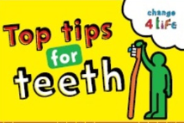 | Resources to help you to communicate good oral health messages to parents in manageable chunks. | https://campaignresources.phe.gov.uk/resources/campaigns/69-top-tips-for-teeth | You will need to register for a Campaign Resource Centre account to download these resources. It is free and easy to do and will give you access to all of Public Health England’s campaigns.
Video: Oral Health Awareness for babies  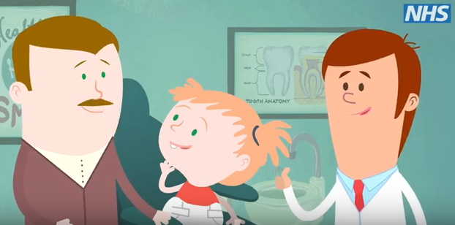 | Produced by NHS England West Midlands’ Local Dental Network, this short, cartoon video aims to highlights the benefits of good oral health and dental care from birth. | https://www.youtube.com/watch?v=-wJ_vMydc8g | To be shared via social media or in any family facing communications.
Video: How to brush your baby’s teeth (6 months to 7 years)  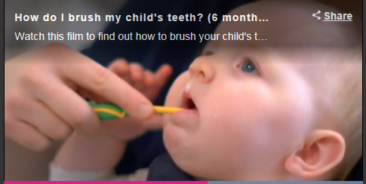 | This is a 2 minute NHS video introduced by a health visitor showing a parent brushing a baby’s teeth. | https://www.nhs.uk/video/pages/how-do-i-brush-my-childs-teeth.aspx
NHS pregnancy and baby guide | This site includes helpful tips for pregnant women both during pregnancy and after birth. It includes lots of information from vaccinations to feeding, teething and tantrums. | https://www.nhs.uk/conditions/pregnancy-and-baby/
Start4Life baby pages | The Start4Life baby pages provide information about parenthood, from breastfeeding to vaccinations. | https://www.nhs.uk/start4life/baby
Start4Life feeding your baby leaflet | This leaflet helps parents understand the benefits of breastfeeding, how to do it and other useful information. | https://www.unicef.org.uk/babyfriendly/baby-friendly-resources/breastfeeding-resources/off-to-the-best-start/ | Useful to download and share with parents
Start4Life weaning hub | Tips for successful weaning for babies. The site has useful videos and includes safe weaning and recipe ideas. | https://www.nhs.uk/start4life/weaning | Useful to share with parents and carers
Video: Growing up with healthy teeth | A 20 minute video from HENRY all about what we can do to help children grow up with healthy teeth. | https://www.henry.org.uk/videos/healthyteeth | Useful for staff training or to be shared via social media or in patient-facing communications.
Healthy Start | Parents can check if they are eligible for Healthy Start, which can provide free vouchers to spend on milk, plain fresh and frozen fruit and vegetables, and free vitamins. | https://www.healthystart.nhs.uk/

Awareness Days
If you want other reasons to talk about babies taking a little trip to the dentist below are relevant awareness days you could organise activity on.
16 – 22 March: Nutrition and Hydration Week
20 March: World Oral Health Day
7 April: World Health Day
6 -12 May: National Weaning Week
12 May: National Children’s Day
13 May – 13 June: National Smile Month and pharmacy campaign on 0-5s oral health
Upcoming themes
April – Looking after mouths during pregnancy
May – Babies and sugar
June – Weaning and teeth
July – Healthy weight and healthy teeth
August – Tooth brushing for the very young
Contact details for the campaign
James Tomlinson, Communications and Engagement Officer, james.tomlinson1@nhs.net
NHS England West Midlands Communications team, england.memedia@nhs.net, 0113 825 0646

