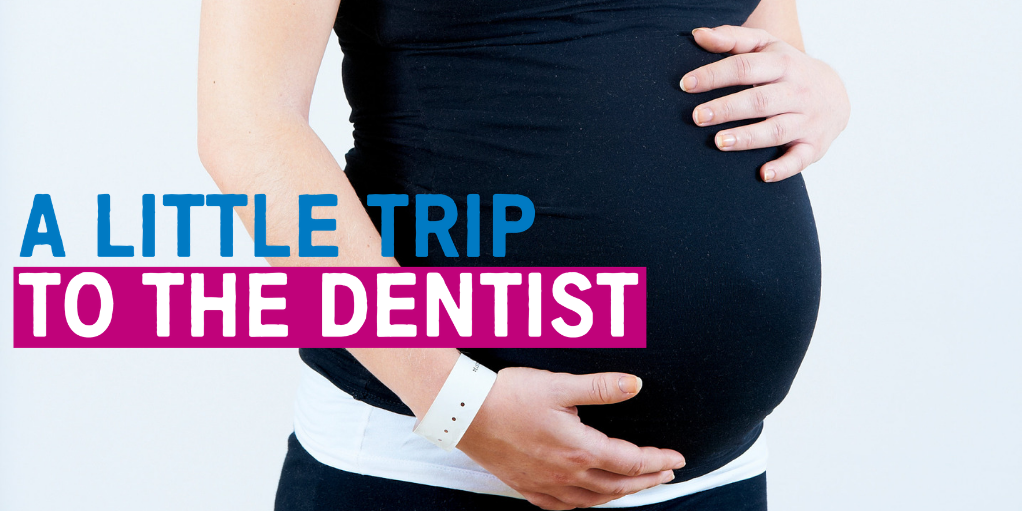
A Little Trip to the Dentist Campaign Toolkit
This toolkit will provide the resources you need to deliver ‘A Little Trip To The Dentist’, in line with its latest theme which is all about oral health during pregnancy and in the early days of babies’ lives.
The campaign was developed in partnership between NHS England and Public Health England in the West Midlands. Ultimately, it aims to increase the number of families taking their babies to a dentist before their first teeth come through.
Your support is invaluable in helping us share these important messages, many of which we hope will be relevant to your staff, patients/families and other stakeholders. Feel free to share this information with other organisations or teams if you think it might be of interest.
Key statistics / background
NHS dental visits are free for babies and children, but there are still worrying statistics across the country and in the West Midlands:
- Only around 21% of children under two in England are having their teeth checked by an NHS dentist
- In many parts of the West Midlands this rate is much lower including in Birmingham, Walsall, Wolverhampton, Coventry, Sandwell and Dudley.
- Nationally a quarter of five year olds already have tooth decay with an average of three or four teeth affected
- Around 12% of children may have decay in their teeth by the age of three
- Every 10 minutes a child in England has a rotten tooth removed in hospital.
By the age of five many children could already have tooth decay, many of whom may only have been to the dentist when they are in pain or the decay is already so severe they need to have teeth removed.
We want parents and carers to take their babies to the dentist sooner rather than later, even before their first teeth come through.
An early dental visit is more than looking in a baby’s mouth:
- Families can get information, advice and support for caring for teeth when they come through
- The dentist can look out for problems at a young age
- Dentists and their teams can help families get the best from tooth brushing, advise on sugar, healthy eating and drinking, teething.
A little trip to the dentist also helps them to get used to the sights, sounds and smells of a dental practice which is vital in ensuring children feel comfortable in that environment as they grow older.
Our latest theme
The theme for the campaign over the next few weeks is all about the importance of good oral health during pregnancy and developing routines in the early days of babies’ lives. Some women get swollen and sore gums during pregnancy, often as a result of the hormonal changes their bodies go through.
Getting in to the habit of going to an NHS dentist will not only ensure expectant parents are taking care of their own mouths, but will help them prepare for when their baby arrives. These visits provide opportunities to ask questions about a whole range of topics from breastfeeding to dummies and much more!
It’s also a chance for practice staff to continue to build positive relationships with families. Parents with a positive impression of a dental surgery will be more inclined to take their babies for a check-up as soon as possible.
How to get involved
We will provide you with all the materials to run the campaign in your practice. Each month you will receive a toolkit which contains:
- Social media content
- A media release to send to your local newspaper
- Articles for newsletters and website
- Photographs for social media, newsletter and website
- Links to similar campaigns you can use
- Contact details.
If you work in a dental practice, you can also use this toolkit to promote the availability of free NHS appointments for babies and children.
Social media content
Below you will find content for use on both Twitter and Facebook channels. Please feel free to adapt and amend as required for your audience, or simply copy and paste the below on to your pages. You may also use the following as inspiration to create your own content.
Note: please use photographs you have appropriate consent for, or use the images supplied alongside this toolkit.
Tweet pack
Every 10 minutes a child in England has a rotten tooth removed due to preventable tooth decay. #ALittleTripToTheDentist before your baby’s first teeth come through can help keep mouths, gums and teeth healthy. Find a local NHS dentist: www.nhs.uk @NHSMidlands
Help your little one grow their very best smile by taking #ALittleTripToTheDentist – children are seen free at NHS dentists. Find one local to you: www.nhs.uk @NHSMidlands
#ALittleTripToTheDentist before your baby’s teeth come through is a great opportunity to get useful advice on looking after mouths, teeth and gums. Find a local NHS practice: www.nhs.uk @NHSMidlands
It’s important babies and young children take #ALittleTripToTheDentist regularly so they can get used to the sights, sounds and smells of a practice. The more comfortable they are, the smoother check-ups will be later in life. @NHSMidlands
It’s perfectly safe for pregnant women to go to the dentist for a check-up. The hormonal changes pregnancy can bring can make you more prone to gum disease and other dental issues, so it’s important to continue regular visits. #ALittleTripToTheDentist @NHSMidlands
If you’re pregnant and suffering from morning sickness, make sure you rinse your mouth out with plain water after each episode. This helps protect your teeth from the acid in your stomach. #ALittleTripToTheDentist @NHSMidlands
There’s lots to remember when you’re expecting a new baby, but don’t let oral health slip to the bottom of your list. Regular visits to the dentist as your little one grows will help develop and maintain healthy routines. #ALittleTripToTheDentist @NHSMidlands
Taking #ALittleTripToTheDentist with your baby? Even if a dentist doesn’t get to look in their mouth, it will help them get used to the sights, sounds and smells of a dental practice. @NHSMidlands
Pregnant women are seen for free by NHS dentists, and for a year following their baby’s birth. Take #ALittleTripToTheDentist as early as possible after your little one arrives to get a check-up yourself and to get useful advice on healthy dental routines. @NHSMidlands
Some women are more prone to gum disease and other dental issues during pregnancy, due to the hormonal changes your body goes through. Make sure you stay on top of your oral health with #ALittleTripToTheDentist. @NHSMidlands

Facebook posts
Post one
Every 10 minutes a child in England has a rotten tooth removed due to preventable decay. Taking a little trip to the dentist with your baby, even before their teeth come through, can help you develop healthy dental routines as early as possible. Don’t forget, children are seen for free at NHS dentists, as well as pregnant women and new mums for a year after birth. Find a local NHS dentist at www.nhs.uk.
Post two
Are you expecting? It’s perfectly safe (and recommended) for you to visit the dentist. The hormonal changes your body is going through can make you more susceptible to gum disease or other dental issues. Simply taking a little trip to the dentist as soon as possible will help you get some useful advice on how best to care for your teeth. You’ll also be able to start preparing for developing healthy routines for your little one once they arrive. Find a local NHS dentist at www.nhs.uk.
Post three
Taking your baby to the dentist early gets them used to the sights, smells and sounds of a dental practice. The more comfortable they are in that environment, the easier it will be to have check-ups when they get older. Children are seen for free at NHS dentists, so find a local surgery and take #ALittleTripToTheDentist: www.nhs.uk
Post four
There’s lots to remember when you’re expecting, but it’s never too early to start thinking about dental care for your little one. Book an appointment as early as possible after your baby arrives. While your dentist might not get to look in their mouth, these visits will help them get used to the sights, sounds and smells of a practice, making them feel more comfortable later in life. Find a local practice at www.nhs.uk.
Post five
Are you pregnant and suffering from morning sickness? It’s important you rinse your mouth with plain water after each episode. This will help prevent the acid in your vomit from attacking your teeth. Don’t brush your teeth straight away either, as they will be slightly softer after being sick. Wait about an hour before doing so. You can get more tips like this by taking #ALittleTripToTheDentist. Find a local practice: www.nhs.uk.

Template press release
You are welcome to share the campaign with local media using the following press release as a starting point. Feel free to amend according to the specific work going on in your area, or simply copy, paste and replace with your details. If you are a GP practice, you can ask for support with speaking to the media by contacting your CCG’s Communications team. Dental practices can contact james.tomlinson1@nhs.net in the NHS England Communications team.
Pregnant women and babies encouraged to take A Little Trip To The Dentist
Babies and mums-to-be are being encouraged to have regular check-ups at the dentist, as part of an NHS campaign.
[Insert name of practice, team or organisation] in [insert area] is showing its support for ‘A Little Trip To The Dentist’ by asking more expectant parents to start thinking about oral health as soon as possible.
Every 10 minutes a child in England is admitted to hospital to have a rotten tooth removed. Only around one in five under two year olds have visited a dentist, with some areas of the West Midlands experiencing even worse rates.
Simply visiting a dentist before a babies’ first teeth come through can be the difference between developing healthy routines early and needing treatment later in life. It provides an opportunity for families to ask any questions they might have and for oral health practitioners to give some useful hints and tips.
It also allows young children to get used to the sights, sounds and smells of a practice, making later check-ups much easier and more comfortable for them.
The campaign, titled ‘A Little Trip To The Dentist’ hopes that by raising awareness of the importance of visiting the dentist at a young age, more children will begin to attend and the number of those admitted to hospital for extractions will begin to decrease.
Pregnant women are encouraged to keep up with their regular dental appointments as well, as often the hormonal changes a woman goes through can result in an increased risk of gum disease or other issues.
[Insert name and job title of health professional] at [insert name of practice, team or organisation] said: “Good oral health is important for everybody, but especially young babies. Across the country a quarter of five-year-olds already have tooth decay, with an average of four or five teeth affected. Taking a little trip to the dentist before teeth come through is a simple, easy and effective way of getting the right advice on how to best look after mouths as they develop, helping to avoid the need for treatment.”
Babies and children are seen for free at NHS dentists, as well as pregnant women and new mums for a year after birth, so it’s important to book an appointment as soon as possible. Parents can find a local NHS dentist at www.nhs.uk.
ENDS
Website / newsletter articles
The following articles have been prepared for you to share in your newsletters or on websites. One is aimed at patients and families, while the other can be shared with staff. You are welcome to add information specific to your practice or organisation.
Patient / family-facing article
Take a Little Trip To The Dentist to help prevent tooth decay
Are you an expectant parent or have a very young baby? We’re encouraging you to take a little trip to the dentist so you can get the support you need to develop good dental routines as early as possible.
Every 10 minutes a child in England is admitted to hospital to have a rotten tooth removed, and only around one in five under twos have visited the dentist. By making an appointment early, even before teeth come through, you can get the advice you need to help make sure this doesn’t happen to your child.
Dentists can give you advice on keeping gums, teeth and mouths healthy at key stages in your baby’s development, such as moving on to solids or cups and teething. You can also get advice on how best to brush their teeth, sugar and healthy diets, weaning and more.
Not only that, but the earlier a baby starts having check-ups, the more comfortable they’ll be in that environment as they grow older.
We’d also advise pregnant women to keep up their dental routines, as often the hormonal changes your body goes through can increase your risk of gum disease or other issues.
Seeing an NHS dentist is free for babies and children or young people under 18, pregnant women and mums who have had a baby in the last 12 months.
You can find a local NHS practice by visiting www.nhs.uk.
Ends

Internal article
NHS campaign encourages more families to take A Little Trip To The Dentist
We’re proud to be showing our support for a new NHS campaign in the West Midlands, which is encouraging more families and pregnant women to take A Little Trip To The Dentist as early as possible.
Every 10 minutes a child in England is admitted to hospital to have a rotten tooth removed, and only around one in five under twos have visited the dentist. The campaign is advising parents to make appointments for their babies early, even before teeth come through, to ensure they get the advice they need to develop healthy routines as soon as possible.
While a dentist might not get to look inside a baby’s mouth, these visits can help the family get used to the sights, sounds and smells of a practice, making later check-ups easier and more comfortable.
Pregnant women are also being encouraged to keep up with their regular visits, as the hormonal changes a woman goes through can increase their risk of gum disease or other issues. It also allows a dentist to help parents-to-be prepare for the arrival of their baby, giving useful advice on how to give them the very best start.
Seeing an NHS dentist is free for babies and children or young people under 18, pregnant women and mums who have had a baby in the last 12 months. Families can find a local NHS practice by visiting www.nhs.uk.
Ends
Links to resources for download
Below are a number of links to resources where you can download posters and booklets to display in your practice and give to patients.

Resource | Info | Link | Notes
Public Health England’s ‘Top Tips for Teeth’  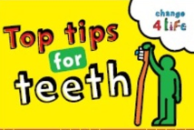 | Resources to help you to communicate good oral health messages to parents in manageable chunks. | https://campaignresources.phe.gov.uk/resources/campaigns/69-top-tips-for-teeth | You will need to register for a Campaign Resource Centre account to download these resources. It is free and easy to do and will give you access to all of Public Health England’s campaigns.
Video: Oral Health Awareness for babies  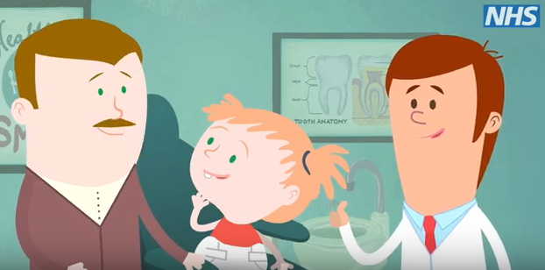 | Produced by NHS England West Midlands’ Local Dental Network, this short, cartoon video aims to highlights the benefits of good oral health and dental care from birth. | https://www.youtube.com/watch?v=-wJ_vMydc8g | To be shared via social media or in any family facing communications.
Video: How to brush your baby’s teeth (6 months to 7 years)  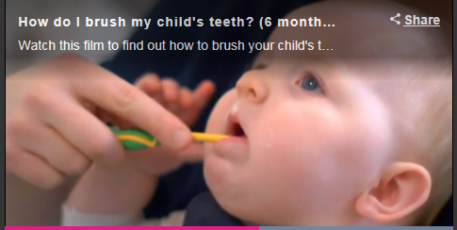 | This is a 2 minute NHS video introduced by a health visitor showing a parent brushing a baby’s teeth. | https://www.nhs.uk/video/pages/how-do-i-brush-my-childs-teeth.aspx
NHS pregnancy and baby guide | This site includes helpful tips for pregnant women both during pregnancy and after birth. It includes lots of information from vaccinations to feeding, teething and tantrums. | https://www.nhs.uk/conditions/pregnancy-and-baby/
Start4Life baby pages | The Start4Life baby pages provide information about parenthood, from breastfeeding to vaccinations. | https://www.nhs.uk/start4life/baby
Start4Life feeding your baby leaflet | This leaflet helps parents understand the benefits of breastfeeding, how to do it and other useful information. | https://www.unicef.org.uk/babyfriendly/baby-friendly-resources/breastfeeding-resources/off-to-the-best-start/ | Useful to download and share with parents
Start4Life weaning hub | Tips for successful weaning for babies. The site has useful videos and includes safe weaning and recipe ideas. | https://www.nhs.uk/start4life/weaning | Useful to share with parents and carers
Video: Growing up with healthy teeth | A 20 minute video from HENRY all about what we can do to help children grow up with healthy teeth. | https://www.henry.org.uk/videos/healthyteeth | Useful for staff training or to be shared via social media or in patient-facing communications.
Healthy Start | Parents can check if they are eligible for Healthy Start, which can provide free vouchers to spend on milk, plain fresh and frozen fruit and vegetables, and free vitamins. | https://www.healthystart.nhs.uk/

Awareness Days
If you want other reasons to talk about babies taking a little trip to the dentist below are relevant awareness days you could organise activity on.
6 -12 May: National Weaning Week
12 May: National Children’s Day
13 May – 13 June: National Smile Month and pharmacy campaign on 0-5s oral health
Upcoming themes
June – Babies and sugar
July – Weaning and teeth
August – Healthy weight and healthy teeth
September – Tooth brushing for the very young
Photos and graphics
If you have received this toolkit without accompanying images, please contact the Communications team on the contact details below. Alternatively, you are welcome to use your own images provided you have appropriate consent. You can also request the NHS England consent form using the details below.
Contact details for the campaign
James Tomlinson, Communications and Engagement Officer, james.tomlinson1@nhs.net
NHS England – Midlands Communications team, england.memedia@nhs.net, 0113 825 0646

