Welcome to the October (and final) edition of our A Little Trip To The Dentist newsletter. These updates aim to let you know how you can get involved with the excellent work going on across the West Midlands area.

Our final introduction
Firstly, you may already know that Janet Clarke has now stepped down from her position as Chair of the West Midlands Local Dental Network, NHS England and NHS Improvement – Midlands. We are incredibly grateful for the hard work and commitment Janet put in during her time in the role, and we hope you’ll join us in wishing her all the very best for the future.

It seems fitting as we bid farewell to Janet, who has been instrumental in developing A Little Trip To The Dentist, that we share our final West Midlands focused toolkit ahead of our regional rollout across the entire Midlands later this year. We’ve been so grateful for the support the campaign has received and we’d like to say a huge thank you on behalf of Janet and the whole team for your continued backing.

Our final toolkit is a good one which we can all relate to, as it focuses on teething and toothbrushing. Teething is a painful process, for both parents and babies, and instilling good teeth-cleaning techniques from an early age is vital in ensuring positive routines are developed from the moment teeth start to come through.

The stats speak for themselves with as many as a quarter of five-year-olds having already experienced some level of tooth decay, with an average of three or four teeth affected. Much of this could potentially be avoided if parents were aware of some key oral health messages as their baby develops.

When babies begin teething, its best to encourage a regular teeth-cleaning routine which includes the brushing of gums – twice daily – once, last thing at night, before bed and on one other occasion, during the day.

This can be achieved by ensuring they are always supervised by an adult when brushing their gums and teeth, using only a smear of toothpaste (one that contains fluoride) and making sure toothpaste isn’t eaten or licked directly from the tube.

You’ll find plenty more advice like this in the toolkit which accompanies this newsletter. Don’t forget, you can find all of our toolkits and materials on the NHS England website.

Once again, please accept our most sincere thanks and do look out for the next phase of A Little Trip To The Dentist over the coming months.

Anna Hunt and Mary Tomson
Consultants in Dental Public Health, Public Health England

Our latest theme

This month we’re focusing on the link between teething and toothbrushing and how starting good teeth-cleaning habits early on can help the promotion of good oral health for life. Encouraging little ones to brush their gums – twice daily – should be an integral part of the teething process as soon as their first teeth come through.

More resources
Following on from the success of last month’s graphics, we have created some more for you to use, including a Teething Chart which is compatible for use on Twitter and Facebook.

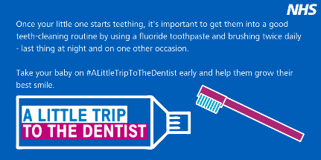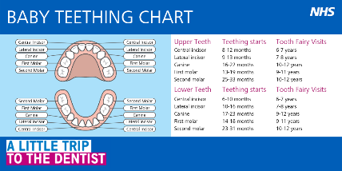

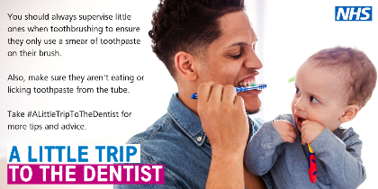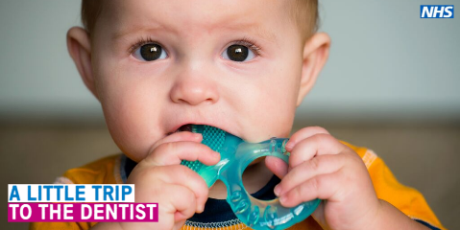

Twitter corner

Training and development
VSM Healthcare is hosting two modules about oral health care for very young children. Once complete, you will receive an ECPD certificate.
Module 2a http://vsmhealthcare.com/starting-well-module-2a-ecpd/
Module 2b https://vsmhealthcare.com/starting-well-module-2b-ecpd/
There are two free videos which give you basic knowledge around children’s oral health. One was developed by HENRY and the other by the West Midlands Local Dental Network at NHS England.
Health Education England has teamed up with the Royal College of Surgeons to develop a 20-minute e-learning course, all about oral health for children. Anyone is welcome to complete the training, including teachers, nurses, GPs and the general public.
There is also dedicated training available for pharmacy teams on the Centre for Pharmacy Postgraduate Education website.
Claire Stevens, spokesperson for the British Society of Paediatric Dentistry, has written an article for BDJ Team about how to examine a child under two.

Get in touch
If you have anything you’d like to add to our next newsletter, or you’d like to share some of the good work going on in your area, don’t hesitate to get in touch. You can email james.tomlinson1@nhs.net, Communications and Engagement Manager for NHS England & NHS Improvement – Midlands.

