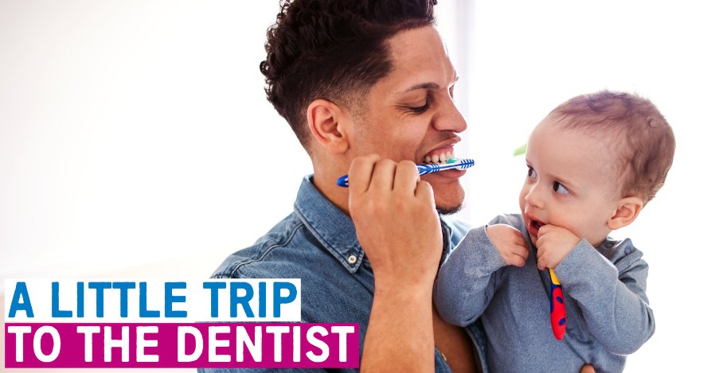
Toolkit 6 – Teething and Toothbrushing
This toolkit includes materials you can use to support A Little Trip To The Dentist in your area. Focusing on children’s oral health, this campaign has been developed by NHS England and NHS Improvement (Midlands) in partnership with Public Health England.
To ensure its success, we hope that you will share and promote these key messages with appropriate audiences, including staff, patients, families and anyone else you think might find it useful. If these resources aren’t quite hitting the mark, please feel free to adapt them.
October’s theme
This month we are exploring teething and toothbrushing for very young children, while continuing to highlight the importance of dental check-ups, even before babies’ first teeth come through. Emphasising good toothbrushing routines early encourages positive oral health outcomes later on in life.
When babies begin teething, its best to encourage a regular teeth-cleaning routine which includes brushing of their gums twice daily – once, last thing at night before bedtime and on one other occasion during the day.
Getting babies into good toothbrushing routines, encourages good oral health. Ways in which this can be achieved include parents brushing their babies’ teeth and gums (called ‘supervised toothbrushing’) up to the age of 7, using only a smear of toothpaste (one that contains fluoride) and making sure children don’t eat or lick toothpaste from the tube. It’s important to ‘spit don’t rinse’ after brushing, as rinsing will wash away the fluoride toothpaste and reduce its benefit.
The first toolkit for the campaign, which was shared earlier this year, in March, was focused at Starting Early and included messages around looking after mouths, teeth and gums. The materials for this toolkit can be found on the NHS England website. You are welcome to use these alongside this month’s toolkit, as much of the messaging goes side-by-side.
Statistics
- Across the country, only around one in five under twos have had their teeth checked by a dentist
- In the West Midlands, most areas have attendance rates in this age group of up to 5% under the national average (21%)
- As many as a quarter of five-year-olds have already experienced some level of tooth decay, with an average of three or four teeth affected
- Estimates suggest that around 12% of children in England may have decay in their teeth by as early as three-years-old
- A child in England has a rotten tooth removed in hospital every 10 minutes
- A recent study by the University of Birmingham shows that only 3% of children in England have visited the dentist before their first birthday.
How you can help
The following communications materials can help you support A Little Trip To The Dentist in your organisation or local area. Feel free to adapt and make any necessary amends for your own use.
Included in this toolkit:
- Social media content – for use on your personal or organisation’s social media channels including a tweet pack and suggested Facebook posts – these can also be adapted if your organisation has other social media accounts
- Newsletter and website articles – articles to share via your internal and staff communications channels or on your organisation’s public-facing website. These can be adapted for blog posts or longer social media posts as required
- Accompanying resources – you’ll find a host of accompanying resources available to you too and links to these are provided below. They include photos and visual resources to use in addition to your communications messaging (graphics, posters, email footers, etc.)
- Useful links – again, to accompany your communications activity you can use any of the useful links we have provided towards the end of the toolkit. This includes videos, sources of further information and more.
If you are from a dental practice, you can also use this toolkit to promote the availability of free NHS appointments for babies and children at your surgery.

Social media content
Below you will find content for use on your social media channels. Please feel free to adapt and amend as required for your audience, or simply copy and paste the below. You may also use the following as inspiration to create some of your own content.
Note: please use photographs you have appropriate consent for, or use the images supplied alongside this toolkit.
Tweet pack
Tweet | Image
When toothbrushing with your little one, it's important to use only a smear of fluoride toothpaste, as this helps prevent and control tooth decay. Did you know it’s okay to use adult strength toothpaste? For more helpful tips, take your baby on #ALittleTripToTheDentist #NHSLongTermPlan @NHSMidlands | 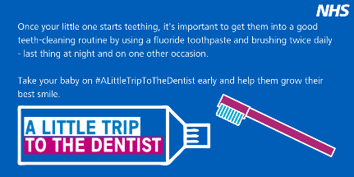
Make sure you help your little one when they start brushing their teeth. It’s important they are supervised as they won’t have the coordination to brush properly on their own. For more tips, visit: https://www.nhs.uk/conditions/pregnancy-and-baby/teething-tips/  or take #ALittleTripToTheDentist #NHSLongTermPlan @NHSMidlands | 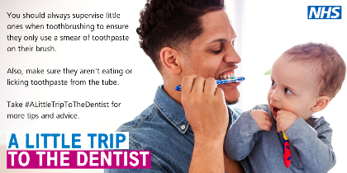
Every 10 minutes a child in England has a rotten tooth removed, make sure your baby isn’t one of them. Start a regular teeth-cleaning routine as soon as their first teeth come through. Take #ALittleTripToTheDentist for more advice during the teething stages and beyond. #NHSLongTermPlan @NHSMidlands | 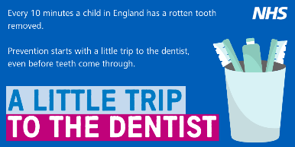
A sign of teething is when babies start chewing on their fingers. You can give them healthy things to chew on, such as raw fruit and vegetables. Avoid sugary foods as they cause tooth decay, even if your child only has a few teeth. For more teething tips, take #ALittleTripToTheDentist or visit: https://www.nhs.uk/conditions/pregnancy-and-baby/teething-tips/ #NHSLongTermPlan @NHSMidlands
Here’s a rough guide to give you some idea of when your baby’s teeth will come through. For more tips on teething, visit: https://www.nhs.uk/conditions/pregnancy-and-baby/teething-tips/ or take #ALittleTripToTheDentist #NHSLongTermPlan @NHSMidlands | 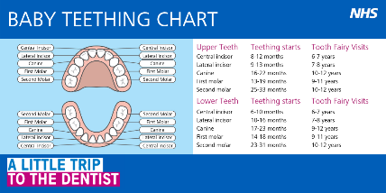
It’s never too early to take your little one to the dentist. Go on #ALittleTripToTheDentist with your baby even before teeth come through to get advice on teething and toothbrushing. You can find a local dental practice here: https://www.nhs.uk/Service-Search/Dentists/LocationSearch/3 #NHSLongTermPlan @NHSMidlands | 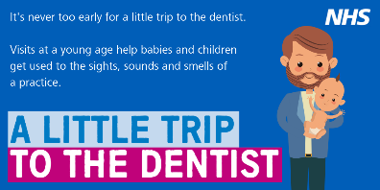
Once your little one starts teething, its important to get them into a good teeth-cleaning routine. Supervising them when toothbrushing, brushing twice daily for at least two minutes and going on #ALittleTripToTheDentist should help look after their growing smile. #NHSLongTermPlan @NHSMidlands
After brushing your baby’s teeth, don’t rinse their mouth or give them a drink immediately. This will wash away the fluoride toothpaste and reduce its benefit. Remember they only need a smear of toothpaste and never let them eat or lick it from the tube. Find a local dental practice here: https://www.nhs.uk/Service-Search/Dentists/LocationSearch/3 and take #ALittleTripToTheDentist #NHSLongTermPlan @NHSMidlands
Teething rings give your baby something safe to chew, help ease discomfort and distract from pain. Some can be cooled first in the fridge, which may help soothe your baby's gums. Never put a teething ring in the freezer, it could damage their gums. For more teething tips, take #ALittleTripToTheDentist or visit: https://www.nhs.uk/conditions/pregnancy-and-baby/teething-tips/ #NHSLongTermPlan @NHSMidlands | 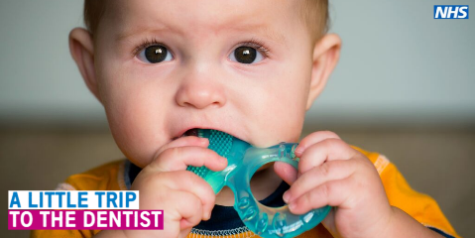
As soon as your baby starts teething, take them on #ALittleTripToTheDentist to prevent the need for treatment in the future. For more teething tips, visit: https://www.nhs.uk/conditions/pregnancy-and-baby/teething-tips/ #NHSLongTermPlan @NHSMidlands | 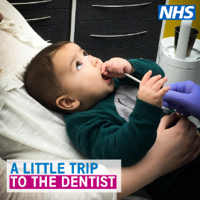
It’s rare but did you know that some babies are born with their first teeth? Most babies will develop their baby teeth over time and this chart gives a rough guide of when to expect their teeth to erupt and fall out. Take your baby on #ALittleTripToTheDentist to help them grow their best smile. #NHSLongTermPlan @NHSMidlands | 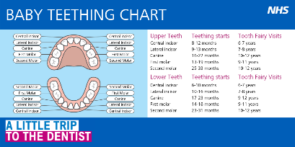
It's recommended that you try non-medical options for teething first, such as a teething ring, instead of using teething gels. Gels contain a mild local anaesthetic and are only available from pharmacies. For more information visit: https://www.nhs.uk/conditions/pregnancy-and-baby/teething-tips/ or take #ALittleTripToTheDentist #NHSLongTermPlan @NHSMidlands

Facebook Posts

Facebook Post | Image
When your little one starts teething, it’s best to start toothbrushing straight away to get them into a good teeth-cleaning routine. Using only a smear of fluoride toothpaste is advised as doing so helps prevent and control tooth decay. Did you know it’s okay to use adult strength toothpaste for your baby’s teeth? For more toothbrushing tips and techniques, take your baby on #ALittleTripToTheDentist @NHSMidlands #NHSLongTermPlan
Make sure you supervise your little one once they are ready to start brushing their teeth. It’s important to only use a smear of toothpaste and you should brush their teeth for at least two minutes. Never let them eat or lick toothpaste directly from the tube. For more teeth-cleaning tips, visit: https://www.nhs.uk/Service-Search/Dentists/LocationSearch/3 and take #ALittleTripToTheDentist @NHSMidlands #NHSLongTermPlan
Teething rings provide a safe alternative for your baby to chew on instead of their grubby fingers. They also help to ease discomfort and distract your little one from any pain. Some can be cooled first in the fridge, which may help soothe your baby's gums. Never put a teething ring in the freezer, it could cause damage to their gums. Alternatively, you could try giving them raw fruit or vegetables. For more teething tips, take #ALittleTripToTheDentist or visit: https://www.nhs.uk/conditions/pregnancy-and-baby/teething-tips/ @NHSMidlands #NHSLongTermPlan
It’s very rare, but did you know that some babies are born with their first teeth? Most will develop their baby teeth over time and this teething chart helps give you a rough guide of what to expect and when. For more tips on teething, visit: https://www.nhs.uk/conditions/pregnancy-and-baby/teething-tips/ or take your baby on #ALittleTripToTheDentist as soon as they start teething to help them grow their best smile. @NHSMidlands #NHSLongTermPlan
Every 10 minutes a child in England has a rotten tooth removed, make sure your baby isn’t one of them by looking after their oral health even before their teeth come through. Starting a regular teeth-cleaning routine as soon as possible sets them up for life. Take #ALittleTripToTheDentist for more advice during the teething stages or visit: https://www.nhs.uk/conditions/pregnancy-and-baby/teething-tips/ to find out more. @NHSMidlands #NHSLongTermPlan

Sharing with local media
If you’re interested in speaking to local media about the work you’re doing around children’s oral health, make sure you let us know so we can work collaboratively. Drop us an email at: england.memedia@nhs.net. We’re keen to get the story out there and can help you write a press release, contact print and broadcast media near you and share more on A Little Trip To The Dentist. For further advice, you can also contact your organisation’s communications team.
Website / newsletter articles
Intranet / internal newsletters
The following article can be uploaded to your organisation’s intranet or shared with staff via internal newsletters. Its aim is to get healthcare professionals thinking about healthy weight management and oral health when working with families and young children. Feel free to adapt and amend as appropriate for you see fit.
A Little Trip To The Dentist
Teething can be a difficult time, not just for babies, but for parents as well. Finding the best ways to comfort little ones while keeping their new teeth healthy can be tough for families to balance in the early months of a baby’s life.
That’s why we’re backing NHS England and NHS Improvement’s campaign, A Little Trip To The Dentist. This month we’re focusing on how parents and babies can get the most out of toothbrushing as soon as their teeth start to come through and offering tips on how to manage teething.
Healthcare professionals, regardless of specialism or job title, are invaluable in helping families through early stages. Our patients and families often look to you to share effective techniques to get them and their little ones into good teeth-cleaning habits.
Brushing teeth for at least two minutes with only a smear of fluoride toothpaste as soon as teeth come through helps encourage good dental hygiene habits for later in life. Using a toothpaste containing a minimum of 1000ppm fluoride is advised, adult strength options are also fine to use.
As well as good teeth-cleaning routines and techniques, taking a little trip to the dentist, even before babies’ first teeth arrive, is important for the prevention of tooth decay in early childhood. So please do spread the message and continue to encourage families to make regular visits to the dentist.
You can find more top tips on teething and toothbrushing on the NHS website. You can also visit the NHS England and NHS Improvement website to find more campaign resources available for your own use.
ENDS
Website / external newsletters
This can be added to your organisation’s external websites or included in external newsletters to show your organisation is supporting A Little Trip To The Dentist. This is aimed at patients and families, encouraging them to think about oral health and helping their babies maintain a healthy weight. Please make any required amendments as appropriate for your audiences.
A Little Trip To The Dentist
Hopefully you’ve heard all about the importance of A Little Trip To The Dentist, even before babies’ teeth come through. But did you know effective toothbrushing can start as soon as teeth start to appear?
A good teeth-cleaning routine can be established from the moment a baby’s first tooth comes through. This includes smearing a fluoride toothpaste onto a small toothbrush – adult strength toothpastes are completely fine to use – and making sure children are always supervised by a responsible adult when brushing their own teeth.
Children and babies are also offered the same advice as adults – to brush twice a day – once just before bedtime, and once at any other point in during the day. Getting your little one into a regular teeth-cleaning routine early will help prevent tooth decay and the need for dental procedures as they get older.
You can also take your baby on a little trip to the dentist, even before first teeth begin to come through, to get them comfortable with the sights, sounds and smells of a dental practice environment. Making regular visits to the dentist is important when developing positive oral health routines to better prevent tooth decay later in life. The advice a dentist can offer on toothbrushing and teething will contribute to a healthy start in life for your little one.
You can find a local dentist here and more information on teething is available on the NHS website.
ENDS

Accompanying resources
This section lists accompanying resources you can use alongside other promotion of A Little Trip To The Dentist. If you can’t find the resource you need from the following list, please let us know by emailing james.tomlinson1@nhs.net.
Posters
There are a selection of posters to choose from which you can print locally to display in your area. You can find these on the NHS England Midlands website.
Screen graphics
We also have four unique screen graphics to be displayed on TV screens in your area. These have been created for display on wide screen displays but if you need a different size, ratio or file type, please let us know.
Photos & graphics
There is a large selection of photos and graphics available for you to use with your communications and activities.
Briefings
We can provide briefings for senior managers explaining the background of the campaign and how it was developed. The NHS England and NHS Improvement – Midlands team is also happy to come along to team meetings to discuss how you might be able to support the campaign in your area.
Videos
You can find a playlist of videos related to A Little Trip To The Dentist here. We’re always looking for opportunities to create more like this, so do get in touch if you have any ideas or are interested in getting involved.
Links to other resources
Below are a number of additional resources for you to use in your activities.

Resource | Info | Notes
NHS website – how sugar affects our health & Change4Life sugar resources | Valuable information on sugar and the impact it can have on health, including tooth decay, weight and tips to cut down.
British Dietetic Association – sugar facts | Lots of information around sugar and how to tell if it’s in foods.
Public Health England’s ‘Top Tips for Teeth’ | Resources to help you to communicate good oral health messages to parents in manageable chunks. | You will need to register for a Campaign Resource Centre account to download these resources.
Video: Oral Health Awareness for babies | Produced by NHS England West Midlands’ Local Dental Network, this short, cartoon video aims to highlights the benefits of good oral health and dental care from birth. | To be shared via social media or in any family facing communications.
Video: How to brush your baby’s teeth (6 months to 7 years) | This is a 2-minute NHS video introduced by a health visitor showing a parent brushing a baby’s teeth.
Start4Life baby pages | The Start4Life baby pages provide information about parenthood, from breastfeeding to vaccinations.
Start4Life feeding your baby leaflet | This leaflet helps parents understand the benefits of breastfeeding, how to do it and other useful information. | Useful to download and share with parents
Video: Growing up with healthy teeth | A 20-minute video from HENRY all about what we can do to help children grow up with healthy teeth. | Useful for staff training or to be shared via social media or in patient-facing communications.
Healthy Start | Parents can check if they are eligible for Healthy Start, which can provide free vouchers to spend on milk, plain fresh and frozen fruit and vegetables, and free vitamins.
PHE Promoting a healthier weight for children, young people and families | Provides advice around consistent messaging for communicating around healthy weight for children, young people and families. Includes infographics and training tools, as well as a video around child obesity.
PHE Child Oral Health: applying All Our Health | This guide is part of ‘All Our Health’, a resource which helps health and care professionals prevent ill health and promote wellbeing as part of their everyday practice. The information will help front-line health and care staff use their trusted relationships with patients, families and communities to promote the benefits of good oral health for children.
PHE Child Oral Health All Our Health elearning | This is a bite-sized session to give health and care professionals an overview of child oral health - including key evidence, data and signposting to trusted resources to help prevent illness, protect health and promote wellbeing
Promoting healthy weight in children, young people and families: A resource to support local authorities | This resource aims to support local authorities, Clinical Commissioning Groups, NHS providers, and voluntary and community sector organisations by providing in one document the latest evidence, resources and data to encourage a systematic approach to creating local environments that promote healthy weight in children.
HM Government. Childhood Obesity. A Plan for Action. | Plan to significantly reduce England’s rate of childhood obesity within the next ten years.
PHE Childhood Obesity: applying All Our Health | This guide is part of ‘All Our Health’, a resource which helps health professionals prevent ill health and promote wellbeing as part of their everyday practice. The information below will help frontline health and care staff use their trusted relationships with patients, families and communities to promote the benefits of a healthier weight and reduce childhood obesity.
Brush DJ  App Store  Google Play | This is a free app developed by a dentist which helps anyone of any age brush their teeth for 2 minutes using music on their smartphone or tablet.

Campaign expands region wide
The campaign is due to expand across the Midlands region as we prepare to launch wider from October 2019.
Contact details for the campaign
NHS England and NHS Improvement – Midlands Communications team, england.memedia@nhs.net

