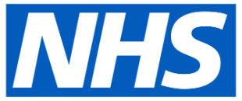
Dental Care Pathway: COVID-19 Response
PLEASE NOTE THAT URGENT DENTAL CARE SITES ARE ONLY FOR URGENT DENTAL CASES
