Making how to access dental care and treatment more clear
Feedback from members of the public and the dental profession tells us that we need to make it more clear how and where people access information on treating a variety of dental problems.
The aim is to manage expectations of what the NHS 111 service can deliver for people who need routine appointments, as well as helping them find that information quickly.
We have developed social media messaging and assets as well as posters.
We would be grateful if you would share on your social media networks or on your web pages.
Also, can you print out posters and use in waiting rooms, clinics and other areas where members of the public gather.
This is the first stage of dental communications we are planning and will forward others as they become available.
If you have any queries about the messaging or designs, please contact england.midlandsengagement@nhs.net
If your query is about dental care in the East Midlands please contact england.em-pcdental@nhs.net

For the West Midlands please contact england.dental-westmidlands@nhs.net

A poster to advise people what they should do if they have toothache. The web link advises on next steps if the pain continues. | 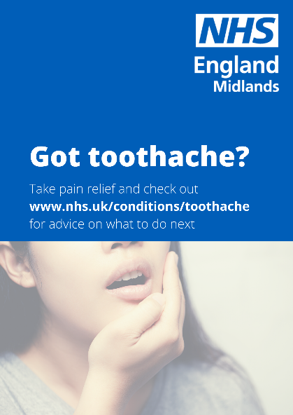 | Please print and display or use on your website
A poster to advise people with an abscess how to find out more. The website advises on next steps. | 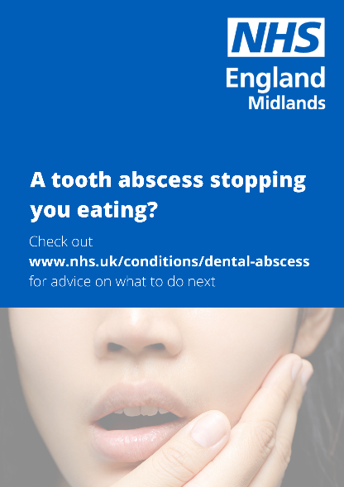 | Please print and display or use on your website
A poster advising the process if someone has lost a filling or chipped a tooth. | 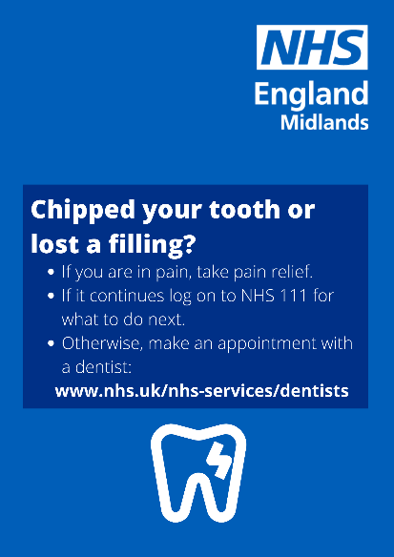 | Please print and display or use on your website
A poster advising how to find a dentist for a routine dental appointment | 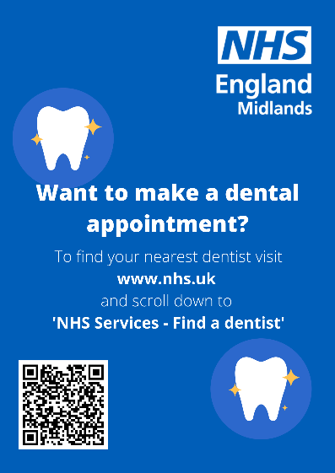 | Please print and display or use on your website
A choice of two posters describing how antibiotics are not the answer to toothache | 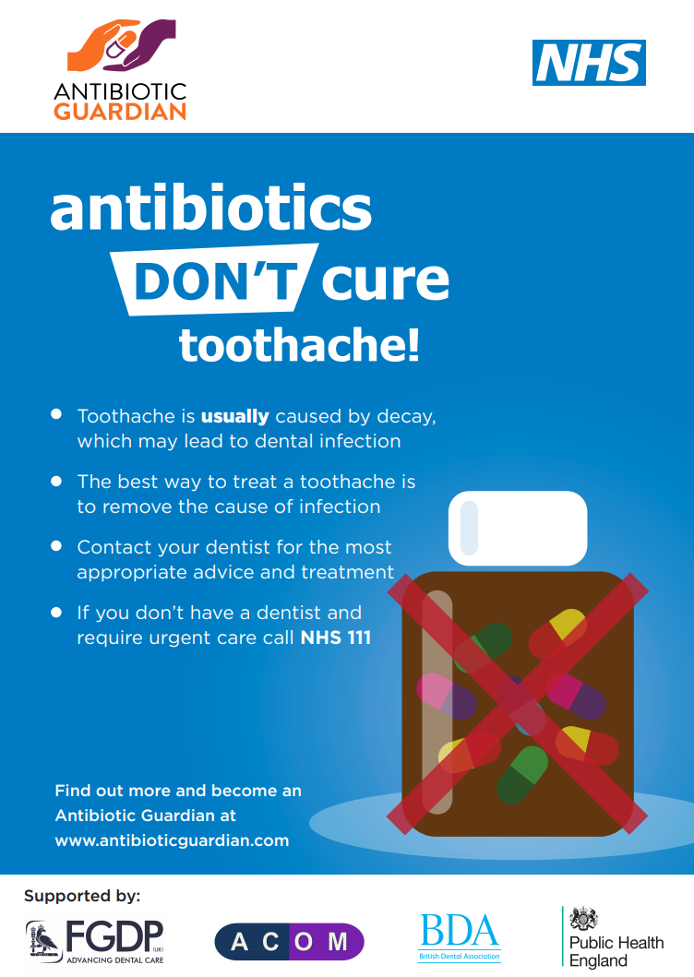 | Please print and share
 | 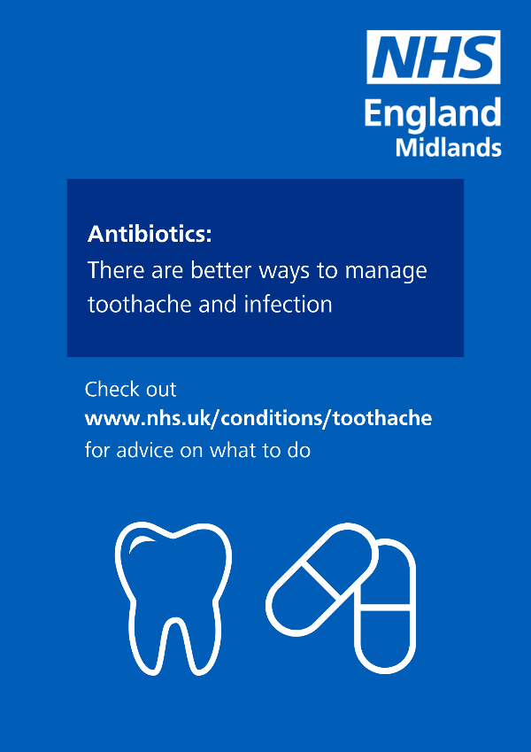

Social media – Please use these on your own channels. They are currently formatted for Twitter, but others can be made available.
 | 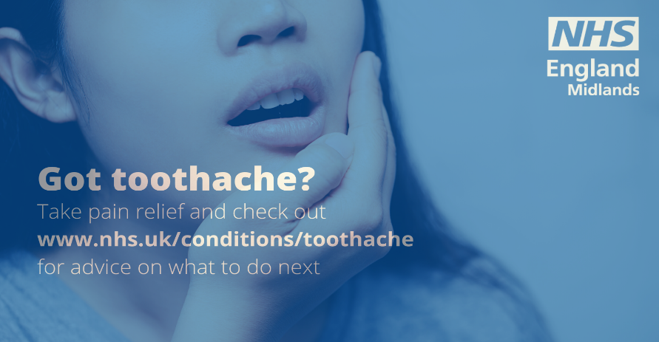 | If you have toothache try taking some pain relief tablets to see if it helps. If the pain persists then go to www.nhs.uk/conditions/toothache  for advice on what to do next
 | 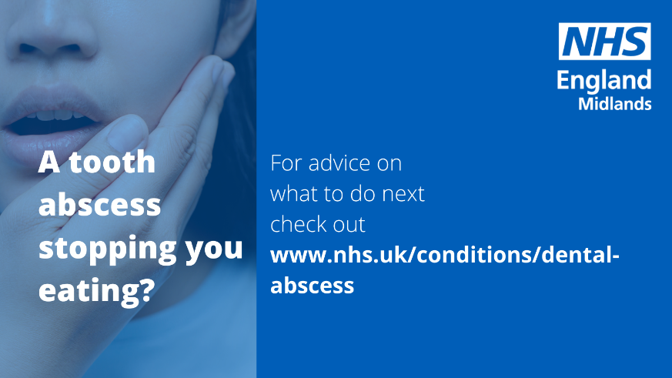 | If you have a tooth abscess that is causing you pain and stopping you from eating, go to www.nhs.uk/conditions/dental-abscess for advice on what to do next
 | 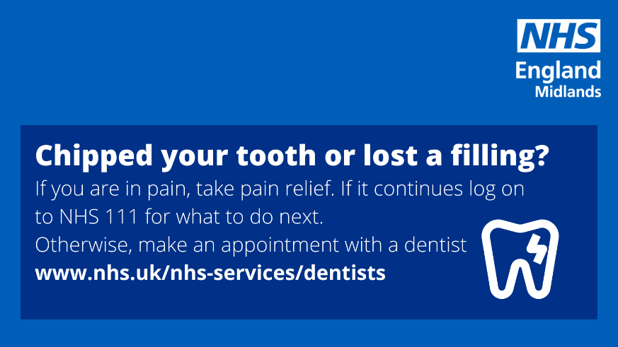 | Losing a filling or chipping a tooth can be painful. If so, take some pain relief and if this continues, go to https://111.nhs.uk/ for advice on what to do next.  If it is not painful, make a routine appointment with a dentist  https://www.nhs.uk/nhs-services/dentists/
 | 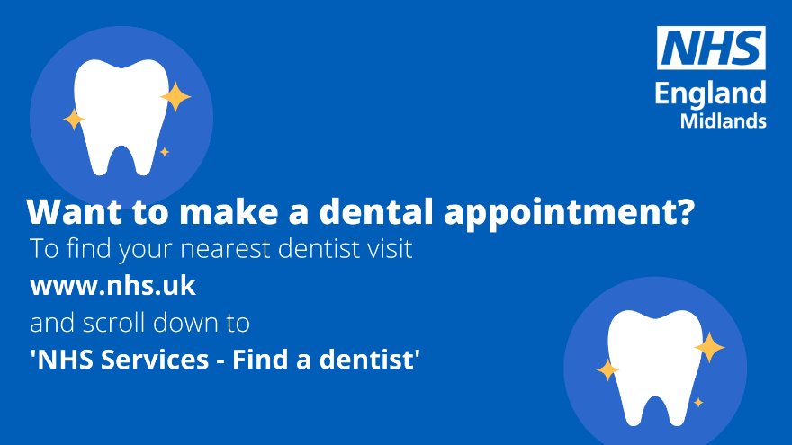 | To make a routine dental appointment, you can use our website to find those dentists nearest to you.  https://www.nhs.uk/service-search/find-a-dentist
 | 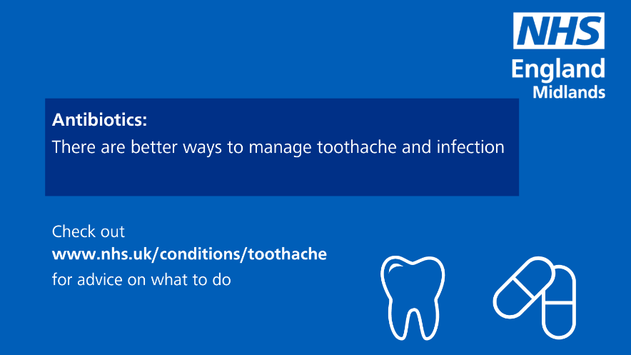 | A dentist needs to examine your mouth and decide the cause of the pain. Painkillers will help manage pain caused by tooth decay and this may be best treated with a filling. Antibiotics are only needed when you have infection, swelling and a temperature.
 | 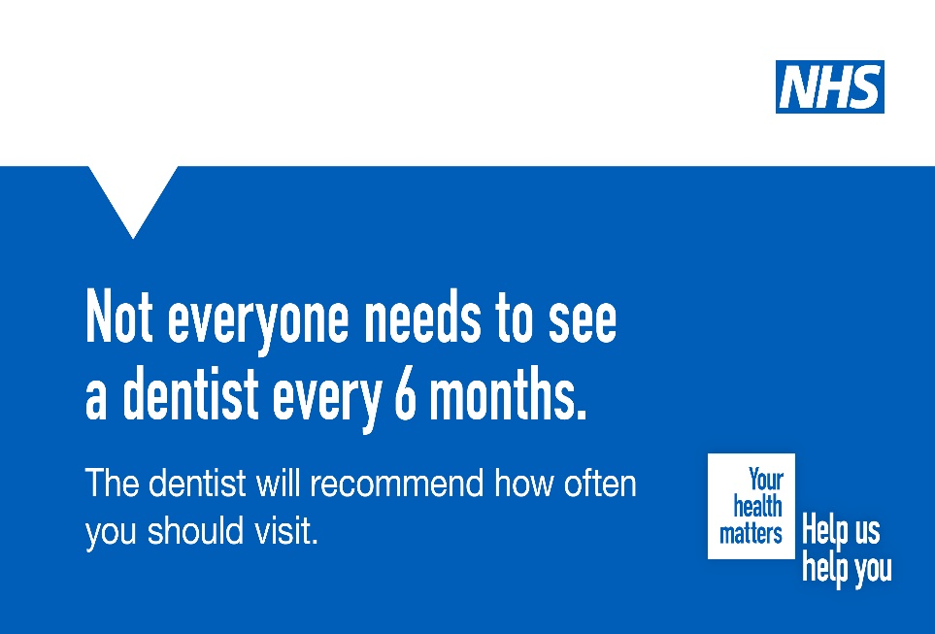 | Our priority is to make sure people who have dental problems and other groups of people who need extra care such as children, are seen quickly and often.  This means your check up might be up to every two years if you have a healthy mouth.

