August 2023

EAST MIDLANDS SCREENING AND IMMUNISATION BULLETIN
PLEASE CASCADE TO ALL relevant STAFF, INCLUDING GPS, PRACTICE NURSES, ADMIN AND RECEPTION STAFF

screening and immunisation team
The East Midlands Screening and Immunisation Team (SIT) cover all counties in the East Midlands region. Each area has its own allocated screening and immunisation coordinator.
Please see attached organogram for details:

Immunisation

gENERAL iMMUNISATION
Cold chain management - please see attached vaccine incident guidance which is helpful to use in the event of a cold chain incident. Vaccine incident guidance: Responding to errors in vaccine storage, handling and administration (publishing.service.gov.uk). Appendix’s A and B on pages 42-44 are particularly useful.
When a cold chain error occurs, prior to disposing of any vaccines the SIT team should be informed via the generic inbox and stability information of all vaccines involved in the incident should be sought:
- LLR and Northamptonshire - stability information can be sought from the LRI on medicines.info@uhl-tr.nhs.uk or Tel: 0116 2586491 as well as individual manufactures.
- Lincolnshire, Derbyshire and Nottinghamshire – individual manufacturers should be contacted.
Please ensure any vaccine wastage is reported on Immform website at Intranet Portal - Logon (phe.gov.uk)

Vaccine Misinformation
The National Institute for Health and Care Research (NIHR) has published an article on vaccine misinformation and strategies to tackle this: How to tackle vaccine misinformation: what works and what doesn’t?

Vaccine supply – nasal flu
All flu vaccines for the 2023/24 children’s flu programme will be available to order by NHS providers in England via UKHSA’s ImmForm website. The 2 vaccines available, indicative ordering dates and the groups these vaccines should be ordered for are shown in the table below. At present these timings remain subject to change and plans for vaccination sessions should take account of this.

Vaccine | Manufacturer | Available to order for | Anticipated order date
Fluenz® Tetra (LAIV) | AstraZeneca | - All children from 2 years of age to school year 11; and  - Children in clinical risk groups aged 2 to <18 years* | Early September
Cell Based Quadrivalent Influenza Vaccine (QIVc) | Seqirus | - Children in clinical risk groups aged 6 months to <2 years  - All other eligible** children aged 2 to <18 years for whom LAIV is unsuitable | Early September
*Unless LAIV clinically contraindicated or otherwise unsuitable. ** Children from 2 years of age to school year 11, and children in clinical risk groups aged 2 to <18 years.

SHINGLES VACCINATION PROGRAMME
Changes to the Shingles programme will be effective from 1st September 2023 based on recommendations from the JCVI:
All newly eligible individuals will be offered 2 doses of the non-live shingles vaccine Shingrix® instead of Zostavax®. The eligibility for the immunocompromised and immunocompetent cohorts will change to allow individuals to be protected at an earlier age.
Immunocompromised cohort
From 1 September 2023 all immunocompromised individuals aged 50 years and over (with no upper age limit) will be eligible for vaccination.
Immunocompetent cohort
The eligible age for immunocompetent individuals will change from 70 to 60 years of age for the routine cohort, in a phased implementation over a 10-year period.
Stage 1  (5-year duration) | 1 September 2023 to 31 August 2028 | Those who reach age 65 or 70 years during this period should be called in on or after their 65th or 70th birthday
Stage 2  (5-year duration) | 1 September 2028 to 31 August 2033 | Those who reach age 60 or 65 years during this period should be called in on or after their 60th or 65th birthday
Ongoing routine offer | 1 September 2033 onwards | Those turning 60 years of age should be called in on or after their 60th birthday
Further information about the changes and links to patient facing and practitioner resources can be found here: Introduction of Shingrix® vaccine for the whole programme and expansion of eligible cohorts letter - GOV.UK (www.gov.uk). The updated Green Book chapter 28a and the healthcare practitioner information and guidance to support the Shingrix programme including e-learning and a training slide are available on the Shingles vaccination guidance for healthcare practitioners webpage.
The UKHSA delivered a webinar on the changes to the Shingles programme from 1st September via MS Teams which can be found here Link for webinar recording.

Vaccine update – GOV.UK
The latest Vaccine Updates are available here: Shingles special addition - Vaccine update: issue 340, July 2023, shingles special edition - GOV.UK (www.gov.uk). HPV special addition - Vaccine update: issue 339, June 2023 - HPV special - GOV.UK (www.gov.uk)
It is recommended that all health care professionals involved in vaccination subscribe to the vaccine update. Vaccine updates can be subscribed to here: Public Health England (govdelivery.com)

Enquiries
Contact details for immunisation queries
- Any routine immunisation (Section 7A) enquiries or incidents (including cold chain & vaccine incidents) should be sent to the East Midlands Immunisation Clinical Advice Service (EMICAS) generic inbox england.emids-imms@nhs.net
- All ImmForm queries should be emailed to: Helpdesk@immform.org.uk or 0207 183 8580.
- All healthcare worker flu queries should be emailed to: HCWvac@phe.gov.uk
- All practice payment queries should be emailed to: england.gp-contracting@nhs.net

Patient Group Directions
Patient group directions are available on our website at: NHS England — Midlands » East Midlands Screening and Immunisation Team (SIT). In the past month the following new PGDs have been cascaded to practices:
- Zostavax – valid from 1st September 2023
- Shingrix -- valid from 1st September 2023
- Seasonal Influenza – adult and child - valid from 1st September 2023
Please ensure you are always using the most up to date version of any PGD. For any queries regarding PGDs please contact our generic inbox.

Screening

Diabetic EyE Screening
As of the beginning of October 2023 Diabetic Eye screening will be converting to a different screening frequency model called 'Intervals'. This means patients without pathology for 2 consecutive years will only be screened every 2 years instead of annually, until such a time that they have pathology.
This change is important for GPs and other healthcare workers to know about as patients may feel they are receiving less care and subsequently may need support and information regarding this. E.g., informing them that national research has been done about bi-annual screening models regarding patients without pathology, and this has little or no effect on clinical care.
If there are any queries or concerns from primary care about this model of screening, please approach the programme manager for your area.
Greater Nottingham DESP
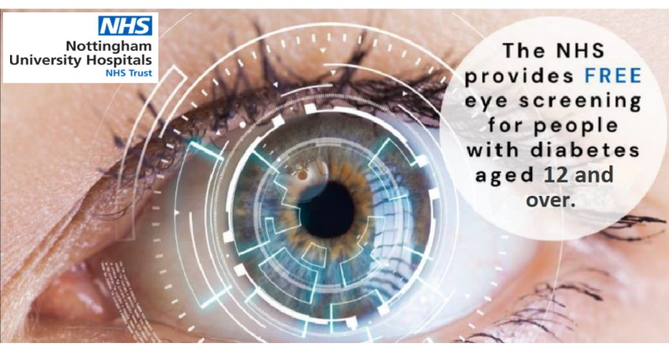
To increase an uptake of annual Diabetic Eye Screening across Greater Nottingham region we would like to share our GNDESP poster with all the practices. The poster lists locations of all our clinics as well as our contact details. Please expect to receive the printed poster around August- September, we would appreciate if it can be displayed in your waiting areas.
The data on persistent not-attendance will be shared with those surgeries that are falling below our targeted 95% of annual screening attendance, in hope that together we can reduce the health inequalities in Diabetic Eye Screening.

Cervical Screening
The information below has already been communicated to GP practices via the Primary Care Bulletin.
The revised ‘Good practice guidance for sample takers’ programme guidance is now published: NHS Cervical Screening Programme – Good practice guidance for sample takers - GOV.UK (www.gov.uk)
Originally published in 2011, the guidance has undergone a complete re-write to reflect developments in the NHS Cervical Screening Programme. The purpose of the guidance is to support cervical sample takers and enhance practice by providing key information in one place.
The guidance has been designed to:
- Set out roles and responsibilities of GP practices and sample takers involved in the NHS Cervical Screening Programme.
- Ensure consistency in sample taking practice.
- Promote good practice that is consistent with national policy and programme guidance in key areas to help to mitigate risk around sample taking incidents.
- Promote equality of access to cervical screening.
- Outline the training requirements for sample takers.
- Outline the audit and documentation requirements for sample takers.
- Offer practical advice on some of the issues that may arise during a cervical screening appointment.
All cervical screening sample takers are encouraged to access and read the publication.
Open Exeter:
A new tab has been added to the log in page which gives users the ability to search the Primary Contact and Access Control Managers (ACM) for their organisation prior to logging in to Open Exeter. The Help pages within Open Exeter have also been updated.

eNQUIRIES
Adult Screening Programme (AAA/Bowel/Breast/Cervical/DES) enquiries should be sent to: england.em.screening@nhs.net

COntact Details
GENERIC EMAIL FOR QUERIES RELATING TO SCREENING OR ROUTINE IMMUNISATIONS
IMMUNISATION | ENGLAND.EMIDS-IMMS@NHS.NET
SCREENING | ENGLAND.EM.SCREENING@NHS.NET
CHILDHOOD INFORMATION SERVICES (CHIS)
LINCOLNSHIRE | LHNT.ChildHealthSouth@nhs.net Tel: 01522 308986
LEICESTERSHIRE | lpt.ChildHealthRecords@nhs.net Tel: 0116 295 3989
NORTHAMPTONSHIRE | Kettering.ch@nhs.net Tel: 03000 273555
DERBY AND DERBYSHIRE | AGCSU.DerbyshireChildHealth@nhs.net
NOTTS AND NOTTINGHAMSHIRE | Nottingham City: NCP.NottinghamChildHealth@nhs.net Tel: 0115 8834340  Nottinghamshire County: Nottscountychildhealth@nottshc.nhs.uk Tel: 0115 8440561
SCHOOL AGED IMMUNISAITON SERVICE (SAIS)
LINCOLNSHIRE | lhnt.sais@nhs.net 01522 572950
LEICESTERSHIRE | Leicestershire Partnership NHS Trust: 0300 3000 007
NORTHAMPTONSHIRE | Imms.nhft@nhs.net 0800 170 7055 (option 5)
DERBY AND DERBYSHIRE | DCHS immunisation team (north):  Telephone: 01246 252953 or email: DCHST.immunisationteam@nhs.net  DCHS immunisation team (south and city):  Telephone: 01283 707178 or email: DCHST.immunisationteam@nhs.net
NOTTS AND NOTTINGHAMSHIRE | Nottinghamshire Healthcare Foundation Trust: 07902 182032 SAIS@nottshc.nhs.uk

Useful Documents
- A poster for display in clinical areas is attached as a separate document promoting our generic email.
- UPDATED May 2023: Incomplete or uncertain immunisation schedule: Vaccination of individuals with uncertain or incomplete immunisation status - GOV.UK (www.gov.uk)
- The Green Book – Immunisation Against Disease - Immunisation against infectious disease - GOV.UK (www.gov.uk)

