November 2023

EAST MIDLANDS SCREENING AND IMMUNISATION BULLETIN
PLEASE CASCADE TO ALL relevant STAFF, INCLUDING GPS, PRACTICE NURSES, ADMIN AND RECEPTION STAFF

screening and immunisation team
The East Midlands Screening and Immunisation Team (SIT) cover all counties in the East Midlands region. Please see attached organogram for details:

Immunisation

gENERAL iMMUNISATION
Cold chain management - please see attached vaccine incident guidance which is helpful to use in the event of a cold chain incident. Vaccine incident guidance: Responding to errors in vaccine storage, handling, and administration (publishing.service.gov.uk). Appendix’s A and B on pages 42-44 are particularly useful.
When a cold chain error occurs, prior to disposing of any vaccines the SIT team should be informed via the generic inbox and stability information of all vaccines involved in the incident should be sought:
- LLR and Northamptonshire - stability information can be sought from the LRI on medicines.info@uhl-tr.nhs.uk or Tel: 0116 2586491 as well as individual manufactures.
- Lincolnshire, Derbyshire, and Nottinghamshire – individual manufacturers should be contacted.
Please ensure any vaccine wastage is reported on Immform website at Intranet Portal - Logon (phe.gov.uk)

COntacting EMICAS
To enable us to respond to your queries in a timely manner we would ask that you always include your surgery name and address in the body of your emails. We record our contact with you for audit purposes and including your surgery name and address will mean we do not need to send you an email asking this question therefore delaying providing you with an answer to your query.

COVid-19 &Influenza seasonal campaign
Covid
Cold chain and vaccine incident reporting The COVID-19 vaccination incident reporting SOP is to be withdrawn as part of processes to integrate COVID-19 vaccination into ‘business as usual’. However keen-eyed healthcare professionals will notice that the Vaccine incident guidance: responding to vaccine errors - Vaccine incident guidance: responding to vaccine errors - GOV.UK (www.gov.uk) still contains wording that the guidance is not applicable to COVID-19 vaccines.
While updated guidance is awaited, please continue to report all clinical cold chain and vaccine incidents for COVID-19, flu, and all other routine immunisations to your friendly local ICAS team and follow their process for expert advice, investigation and/or action: england.emids-imms@nhs.net
Flu
The UKHSA has published the following guidance to support practitioners delivering the Flu programme:
Flu vaccination programme 2023 to 2024: information for healthcare practitioners - GOV.UK (www.gov.uk)
The document “Standard Responses on LAIV” has been produced to support SAIS providers with delivery of the Flu programme in schools. Some of the information it contains may be of use to practitioners working in GP practice, delivering LAIV to 2/3yr old cohort.

Vaccine update – GOV.UK
The latest Vaccine Updates are available here: Flu special addition - Vaccine update: issue 342, September 2023, flu special edition - GOV.UK (www.gov.uk). It is recommended that all health care professionals involved in vaccination subscribe to the vaccine update. Vaccine updates can be subscribed to here: Public Health England (govdelivery.com)

Enquiries
Contact details for immunisation queries:
- Any routine immunisation (Section 7A) enquiries or incidents (including cold chain & vaccine incidents) should be sent to the East Midlands Immunisation Clinical Advice Service (EMICAS) generic inbox england.emids-imms@nhs.net
- All ImmForm queries should be emailed to: Helpdesk@immform.org.uk or 0207 183 8580.
- All practice payment queries should be emailed to: england.gp-contracting@nhs.net

Patient Group Directions
Patient group directions are available on our website at: NHS England — Midlands » East Midlands Screening and Immunisation Team (SIT). Please ensure you are always using the most up to date version of any PGD. For any queries regarding PGDs please contact our generic immunisation inbox.
The updated PGD and National Protocol for COVID-19 (5 – 17 years of age) v3.00 have now been published.
PGD link: Coronavirus » Patient Group Directions (PGDs) for COVID-19 vaccines (england.nhs.uk)
National Protocol link: National protocol for COVID-19 mRNA vaccine (5 to 17 years of age) - GOV.UK (www.gov.uk)
As the National Protocol has been given Ministerial approval and the NHSE PGD is signed off by the medical director, organisational sign off is not required for use in England. However, providers should not amend or add to the clinical content of the documents. Only section 7 of both documents is editable.
The new updated PGDs for Hep A, Hep AB and Hep B have been uploaded to our website and will take effect from 31 October 2023. Please note that previous versions should be archived from this date, in accordance with NHS record keeping policy.

Screening

Cervical Screening
Some general information reminders to all sample takers which have been communicated previously:
Open Exeter
- ALL sample takers should be using the pre-populated Open Exeter (OE) sample request forms with the preferred format being the A5 (2009) single copy version.
- Individual access issues to the Open Exeter system should try to be resolved as soon as possible, persistent non-compliance in use of the pre-printed OE HMR101 form is monitored and reported on by the Laboratory due to the risks it introduces which include incorrect future recall management and length of time the patient will wait to receive their result.
PCN samples
- Samples taken at a PCN clinic must clearly state this on the HMR101 request form, and clearly state the registered GP as the sample must be booked into the GP at the Laboratory.
- A comment will be added to the result report stating the sample was taken at a PCN clinic.
- The report will be sent to the patients’ GP irrespective of where the sample has been taken and it is vital that the GP can identify where that the sample was taken.
- Sample takers should ensure there is a failsafe system in place so they can assure themselves that a result has been received for every sample taken and that appropriate action is taken where necessary.
Contact details
- General cervical screening enquiries: Laboratory - 01332 789307 / 789311 (8am-5pm) dhft.cytology@nhs.net
- Sample Taker Database queries: uhdb.cytologystdatabase@nhs.net
Newsletters
East Midlands Cervical Screening Administration Service (CSAS) October 2023 newsletter.
Derby Laboratory - Cervical Screening Taker Newsletter

Diabetic Eye Screening
Greater Nottingham Diabetic Eye Screening
To change your appointment or to discuss any concerns you may have please telephone
0115 919 4411 (Mon-Fri 8:15-16:00), Email EyeScreening@nuh.nhs.uk,
Find us on Twitter / X - NUH Diabetic Eye Screening Programme
To book or change your appointment online scan the QR code:
(You will receive a PIN when you are due for your appointment)
Two-year recalls
Diabetic Eye Screening Programmes in England are adopting a 24-month recall period for lower risk individuals.

Breast Screening
Lights, Camera, Action! North Derbyshire & Chesterfield Breast Screening Service on
BBC East Midlands Today
Well done to the amazing team at North Derbyshire & Chesterfield’s Breast Screening Service who were on BBC East Midlands Today on 19.10.23 to promote Breast Cancer Awareness Month.
Staff talked passionately about the importance of breast screening and there was a personal account from a Breast cancer survivor thankful for mammogram - BBC News
The number of women attending breast screening in the East Midlands has decreased in recent years. In the region between April 2018 and 2019, 74% of women invited for screening accepted but from April 2022 to 2023 it dropped to 62.6%. North Derbyshire and Chesterfield have one of the highest uptake in the East Midlands since Covid, but they would like it to be higher.
North Derbyshire & Chesterfield’s Breast Screening Service also worked hard to promote Breast Cancer Awareness Month on site at Chesterfield Royal Hospital where they had a breast cancer information stand on various dates throughout October. Photo below from left to right shows: Ami Pashley, Breast Failsafe Officer; Emily Moulds, Trainee Breast Nurse Consultant; and Katie Angulo, Breast Screening Programme Manager. Keep up the good work!
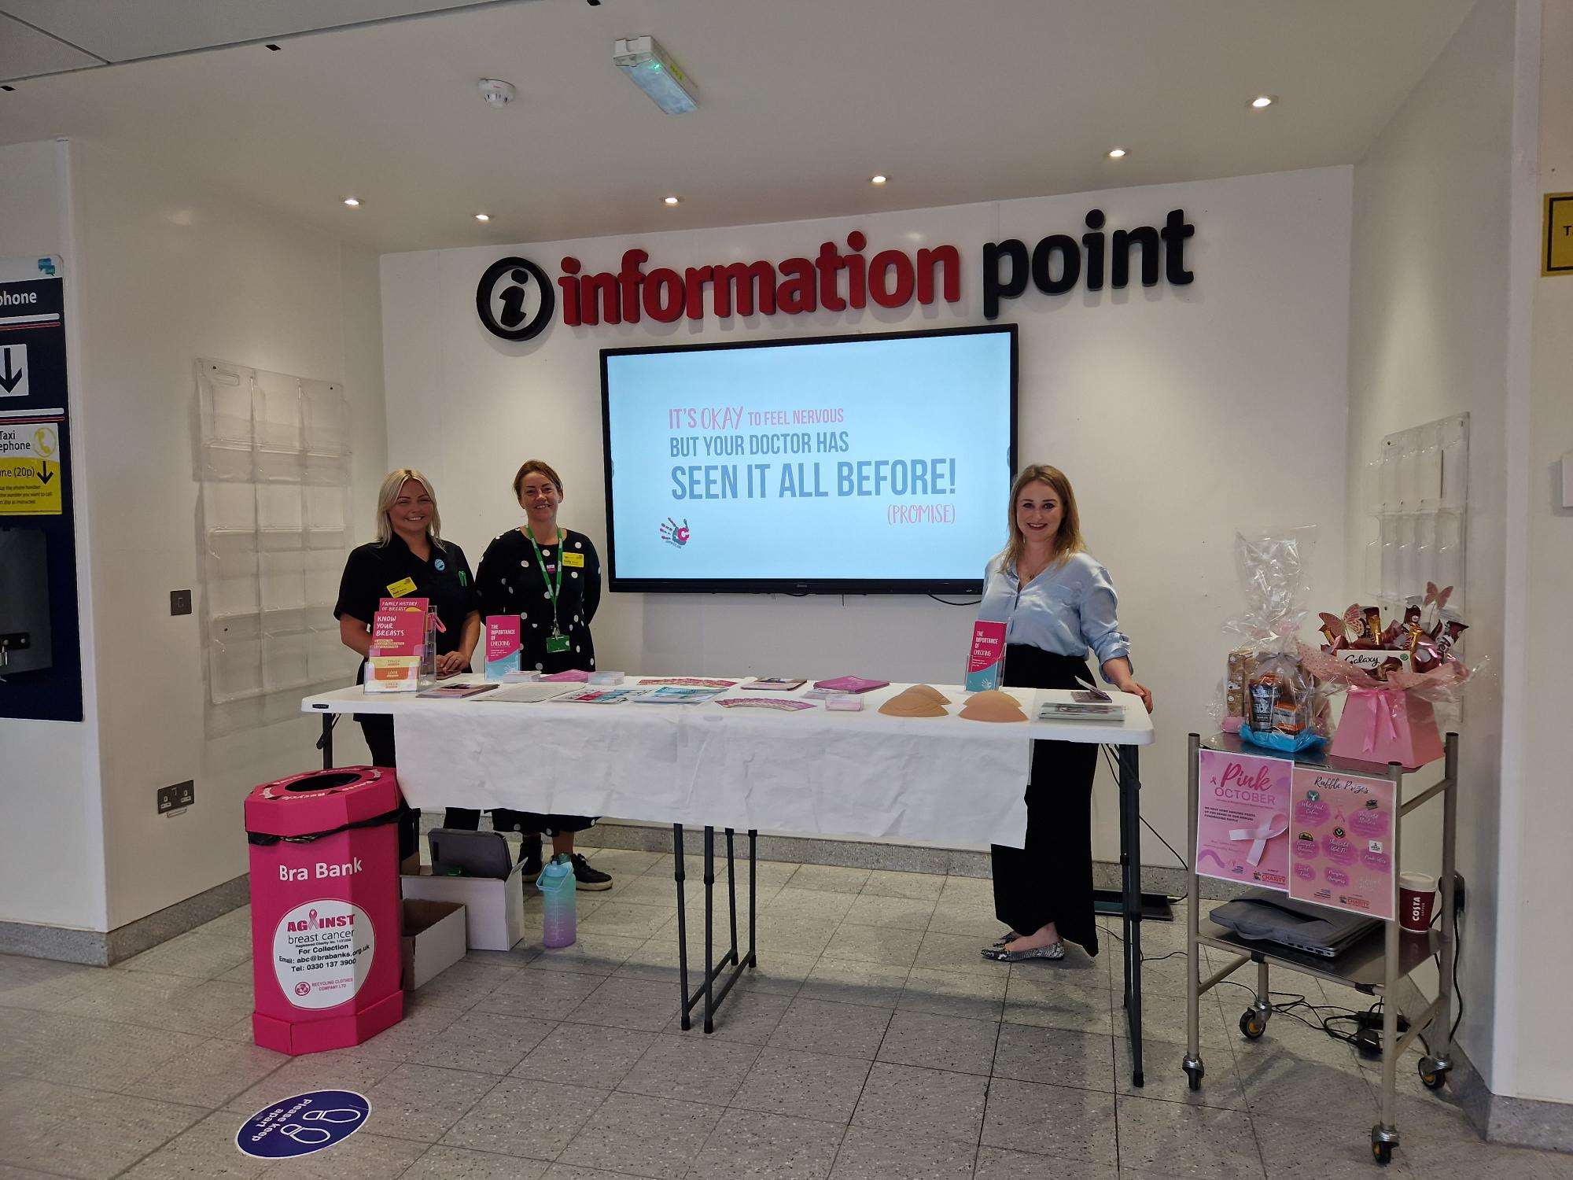

eNQUIRIES
Adult and ANNB Screening Programme enquiries should be sent to: england.em.screening@nhs.net

COntact Details
GENERIC EMAIL FOR QUERIES RELATING TO SCREENING OR ROUTINE IMMUNISATIONS
IMMUNISATION | ENGLAND.EMIDS-IMMS@NHS.NET
SCREENING | ENGLAND.EM.SCREENING@NHS.NET
CHILDHOOD INFORMATION SERVICES (CHIS)
LINCOLNSHIRE | LHNT.ChildHealthSouth@nhs.net Tel: 01522 308986
LEICESTERSHIRE | lpt.ChildHealthRecords@nhs.net Tel: 0116 295 3989
NORTHAMPTONSHIRE | Kettering.ch@nhs.net Tel: 03000 273555
DERBY AND DERBYSHIRE | AGCSU.DerbyshireChildHealth@nhs.net
NOTTS AND NOTTINGHAMSHIRE | Nottingham City: NCP.NottinghamChildHealth@nhs.net Tel: 0115 8834340  Nottinghamshire County: Nottscountychildhealth@nottshc.nhs.uk Tel: 0115 8440561
SCHOOL AGED IMMUNISATION SERVICE (SAIS)
LINCOLNSHIRE | lhnt.sais@nhs.net 01522 572950
LEICESTERSHIRE | Leicestershire Partnership NHS Trust: 0300 3000 007
NORTHAMPTONSHIRE | Imms.nhft@nhs.net 0800 170 7055 (option 5)
DERBY AND DERBYSHIRE | immunisations.derbyshire@intrahealth.co.uk Tel: 0333583397 Option 5
NOTTS AND NOTTINGHAMSHIRE | immunisations.nottinghamshire@intrahealth.co.uk Tel: 0333583397 Option 4

Useful Documents
- A poster for display in clinical areas promoting our immunisation clinical advice service:

- UPDATED September 2023: Incomplete or uncertain immunisation schedule: Vaccination of individuals with uncertain or incomplete immunisation status (publishing.service.gov.uk)
- UPDATED September 2023: Immunisation cohorts and providers for 2023/24:

- The Green Book – Immunisation Against Disease - Immunisation against infectious disease - GOV.UK (www.gov.uk)

