Midlands Specialised Commissioning (Acute and Pharmacy) Health Inequalities Strategy

2023-2025

Produced in partnership by the West Midlands Specialised Commissioning Joint Committee, the East Midlands Specialised Commissioning Joint Committee, and NHS England – Midlands

Version 1.0, 5 February 2024

Table of Contents
1. Foreword 2
2. Executive Summary 4
3. Introduction 5
3.1 What are health inequalities? 5
3.2 Health inequalities in specialised services 5
3.3 Specialised services in the Midlands 8
3.4 Wider policy context 11
4. Health inequalities strategy 13
4.1 Principle 1: Restore NHS services inclusively 14
4.2 Principle 2: Mitigate against digital exclusion 16
4.3 Principle 3: Ensure datasets are complete and timely 17
4.4 Principle 4: Accelerate preventative programmes 18
4.5 Principle 5: Strengthen leadership and accountability 19
5. Implementing this strategy 21
5.1 Core20PLUS5 22
5.2 Health Equity Assessment Tool (HEAT) 23
5.3 Midlands health equity framework for specialised services 24
5.4 Intervention decay model 24
5.5 Anchors and social value approach 25
6. Monitoring progress 27
Which groups to measure? 27
Which indicators to measure? 27
Which actions to take? 28
7. References 29
8. Appendices 30
8.1 Appendix A: Strategy engagement and consultation 30
8.2 Appendix B: Midlands health equality framework for specialised services 31
8.3 Appendix C: Six strategic anchor areas 32
8.4 Appendix D: Local Case Studies 33
8.5 Appendix E: Core20PLUS5 39

- Foreword
Where someone lives, who they are, and what their background is, should not influence either a person’s ability to access healthcare, their experience, or their outcomes following treatment. Working to reduce health inequalities by ensuring NHS services meet the needs of our communities is one of the central tenets of the NHS Constitution, NHS Long Term Plan and the 2022 Health and Care Act. It is therefore imperative that we embed these principles across all elements of our work.
With £23 billion spent annually on specialised services in England, and £4 billion of this on patients living in the Midlands, this represents a significant portion of the NHS overall budget. Despite this, the relationship between specialised services and health inequalities has not previously been fully described. Because of the resources and expertise needed to deliver these services, they are often limited to a small number of clinicians and locations and are also accessed by patients at the end of long and complicated referral pathways. These factors combine to present a particular risk of exacerbating health inequalities.
Priority has understandably often focused on addressing health inequalities further upstream such as access to GPs and Primary Care. However, if we are to realise our vision of “exceptional quality healthcare for all; ensuring equitable access, excellent experience and optimal outcomes”, we must focus on all parts of the patient journey. To give an example, we know that people from lower socio-economic groups have fewer options for home dialysis, poorer survival rates on dialysis and lower rates of kidney transplants.
The Midlands strategy, which spans our 11 ICBs, 6 million people and more than 40 NHS Provider Trusts, highlights the features specific to specialised services that drive health inequalities and sets out our approach to addressing these health inequalities. As we move towards delegation of specialised services and greater integration with ICBs, this strategy represents a real opportunity to realise the benefits of delegation and joining up of specialised pathways at local level; it is an ambition we must realise if we are to close the inequalities gap.
This strategy document has been developed in collaboration with NHS England Health Inequalities team, commissioners, pharmacy leads, business intelligence support, public health representatives, planners, and ICB leads. It represents our joint commitment to ensuring everyone gets high-quality specialised care regardless of their socio-economic status, ethnicity, geography, or other characteristics. This sets a clear direction to galvanise action for our commissioners and clinicians as we continue to adapt to the evolving needs of our local communities.

Professor Bola Owolabi
Director of Health Inequalities, NHS England

Matthew Day
Regional Director of Specialised Commissioning and Health and Justice, NHS England – Midlands

David Melbourne
Chief Executive of NHS Birmingham and Solihull Integrated Care Board, and Chair of the West Midlands Specialised Commissioning Joint Committee

David Sissling
Chair of Leicester, Leicestershire and Rutland Integrated Care Board, and the East Midlands Specialised Commissioning Joint Committee

- Executive Summary
As part of the redesign of health and care in England, the responsibility for commissioning some specialised services is in the process of being delegated to Integrated Care Boards (ICBs). One of the key reasons for this delegation is to support efforts in reducing health inequalities arising from the planning and delivery of services. Specialised services differ from other types of healthcare in several ways; they often serve relatively small numbers of people, are restricted in how they can be delivered due to only a small number of providers having the necessary expertise, and they are often accessed at the end of complex and multi-stage referral pathways. For these reasons, their potential for helping to reduce health inequalities are not always recognised fully. We have developed this strategy with the aim of helping to address such perceptions and support commissioners during the current period of change and beyond, to design and deliver services that maximise equity of outcome for patients.
Underpinning this strategy are 5 key principles, which align with national NHS planning guidance. These were chosen to support the dovetailing of this strategy with existing workplans, and are:
- Restore NHS services inclusively
- Mitigate against digital exclusion
- Ensure datasets are complete and timely
- Accelerate preventative programmes
- Strengthen leadership and accountability
Recognising that specialised acute and pharmacy services cover a range of workstreams, we recommend approaches to delivering on each principle that are applicable across services. With each service area facing a unique set of circumstances and challenges, these recommendations are intended to be flexible and adapted by commissioners to meet the needs of the specific patient population they serve. We therefore also highlight 5 frameworks which can be used to help understand the potential impact specialised services have on health inequalities, to support a systematic approach to delivering this strategy.
- Introduction
  - What are health inequalities?
Health inequalities are the unfair and avoidable differences that exist in health across the population, and between different groups within society. They are not random, and they are not inevitable. They are a product of social, governmental, and healthcare systems (Dahlgren & Whitehead, 1991).
Although a great deal of health inequality results from the circumstances in which one grows, lives, and works (Hood et al., 2016), known as the wider determinants of health, there is a major role for healthcare services in the Midlands in reducing inequality. 50 years ago, Julian Tudor Hart identified the Inverse Care Law; to paraphrase, that those who are in direst need of medical care are least likely to receive it, and those in least need of medical care find it easiest to access. (Hart, 1971)

  - Health inequalities in specialised services
There are multiple steps between a patient developing a condition and their resulting health outcome. The route by which they receive a formal diagnosis, their referral through to the appropriate service(s), type of treatment and level of adherence that they can maintain, all impact on this. Inequalities can, and do, exist at each stage along this pathway. The complex nature of many specialised services provides multiple opportunities for inequalities to arise and become embedded for the people and populations that use them (Figure 1). For example, people from ethnic minority backgrounds in the UK wait between 168 and 262 days longer for a kidney transplant than the White population (Kidney Research UK, 2019) which could be illustrated in the intervention decay model (Figure 1) as a gap between Receive treatment and Optimal treatment.
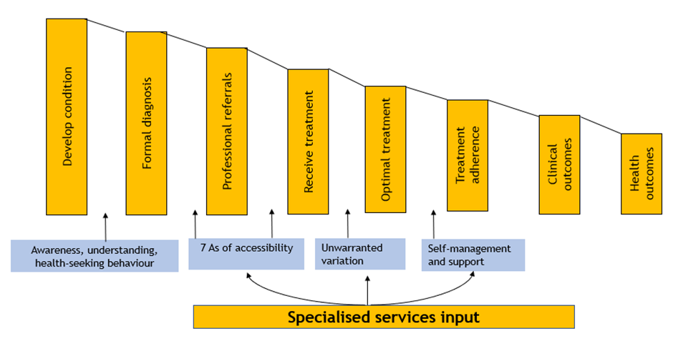
Figure 1: Intervention decay model – how inequalities can arise during a patient’s journey through specialised service pathways

It is also well evidenced that certain people are often at greater risk of experiencing these inequalities than the general population. This leads to populations with particular characteristics experiencing lower quality of care and developing poorer health outcomes:
- Low socio-economic status. This includes unemployment, income level, and living in an area of deprivation.
- Having protected characteristics. For example, these include age, sex, race, disability.
- Belonging to an inclusion health group. This term describes those who are socially excluded. They often experience overlapping risk factors for poor health. These groups include people who experience homelessness, drug and alcohol dependence, migrants and asylum seekers, Gypsy, Roma and Traveller communities, sex workers, people in contact with the justice system and victims of modern slavery.
- Living in a certain geographical area. For example, people from certain urban, rural, or isolated areas may experience poorer health outcomes than those in other areas.

Furthermore, these characteristics often overlap leading to complex intersectionality and requiring a coordinated approach to addressing inequalities (Figure 2). Programmes at national and local level have achieved substantial reductions in health inequalities (Barr et al., 2017). To achieve this, allocation of resource must be done based on need. One-size-fits-all “equal” services are liable to lead to unequal health outcomes (Carey et al., 2015). Service pathways must therefore be adapted to those who are at risk of poorer health outcomes because of their circumstances or characteristics.

Figure 2: Intersection of groups that experience health inequalities
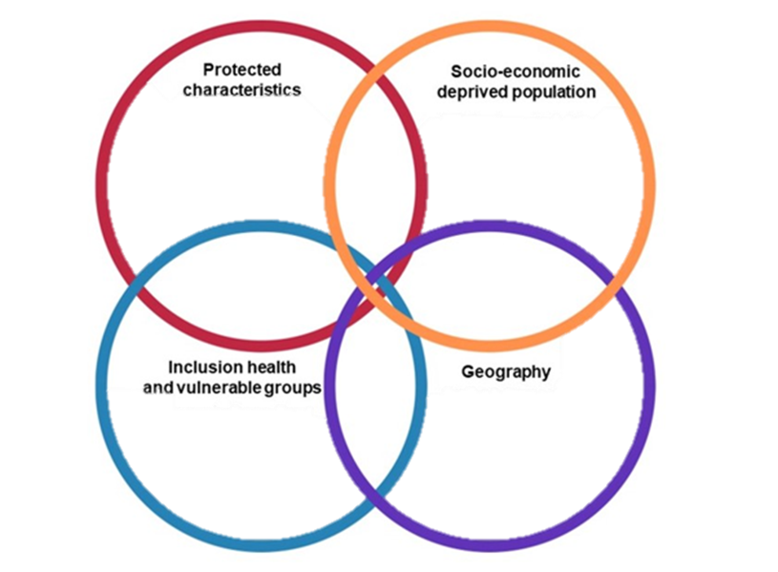

  - Specialised services in the Midlands
Specialised services, such as those for rare congenital diseases, kidney dialysis and chemotherapy, are used by relatively small numbers of people who often have a different demographic profile to the general population. It is therefore important to consider and understand these population profiles, to ensure that services effectively meet the needs of their users. Failing to recognise these differences risks undermining the best efforts of commissioners and providers to reduce health inequalities.
This section provides an overview of some of the key demographic characteristics and specialised service activity, patient profile and spend. However, detailed investigation of individual services is required to ascertain where health inequalities in access, experience and outcomes exist.
Age
Midlands specialised services are more likely to treat those at the early and late stage of the life course than regular secondary care services. Over half of all specialised activity relates to adults aged 50-84, with there also being a significant portion of activity related to children and young people aged 0-15 (Figure 3).
Figure 3: Proportion of patient activity by age for overall secondary care services and Midlands provider specialised services

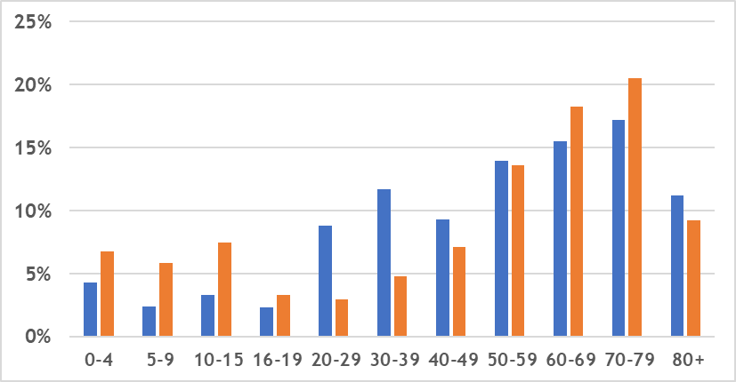

Source: SUS inpatient and outpatient tables, Apr-22 to Mar-23

Ethnicity
Taking into account differences in age structure, people from Asian/Asian British, Black or Black British and other ethnic groups are more likely to be patients receiving specialised commissioned services in the Midlands than those from a White background. Estimates of rates from other ethnic groups are very high, although this should be interpreted with caution given it is based on small absolute numbers (Figure 4).
Figure 4: Age-standardised patient rate for specialised commissioned Midlands providers by ethnicity, per 1,000 population 22/23
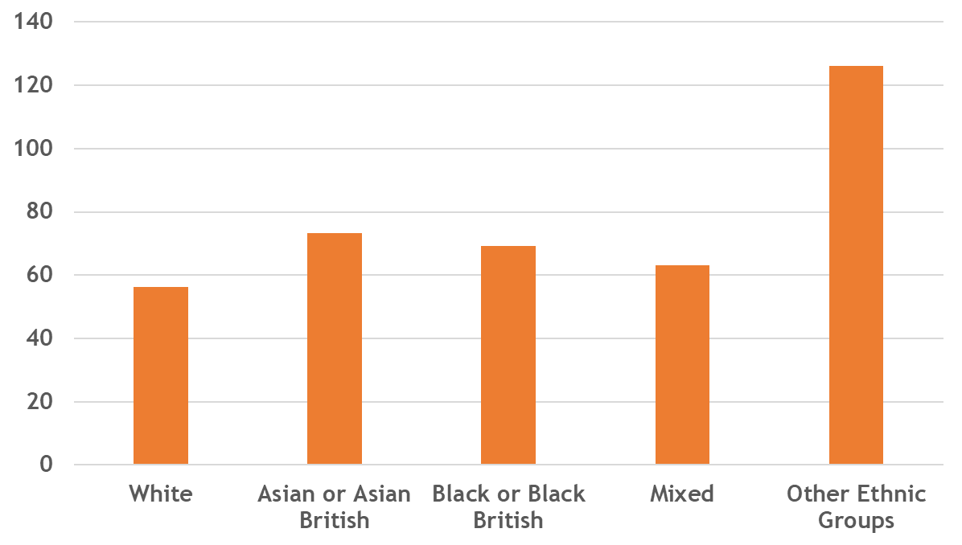

Source: SUS inpatient and outpatient tables, Apr-22 to Feb-23. Patients will be counted twice if both an inpatient and outpatient

Variation exists when care is split by elective and emergency activity (Figure 5). Those from an Asian/Asian British background are 60% more likely to receive emergency care than those from a White background, despite elective rates being similar.

Figure 5: Age-standardised patient ratios for elective and emergency spec comm activity for Midlands providers, by ethnicity
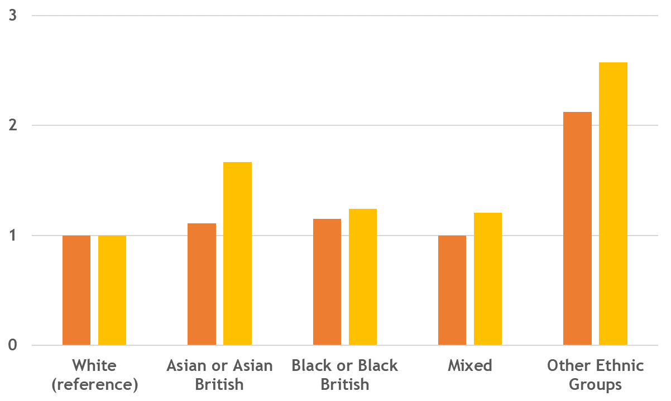

Source: SUS inpatient and outpatient tables, Apr-22 to Feb-23

Deprivation
There are differences by deprivation in specialised commissioning spend. Taking into account different age profiles, spend on patients living in the first and second most deprived deciles is respectively two-thirds and one-third higher than those living in the least deprived decile (Figure 6).

Figure 6: Age-standardised cost ratios for specialised commissioning Midlands providers by IMD postcode decile (1 = most deprived, 10 = least deprived)

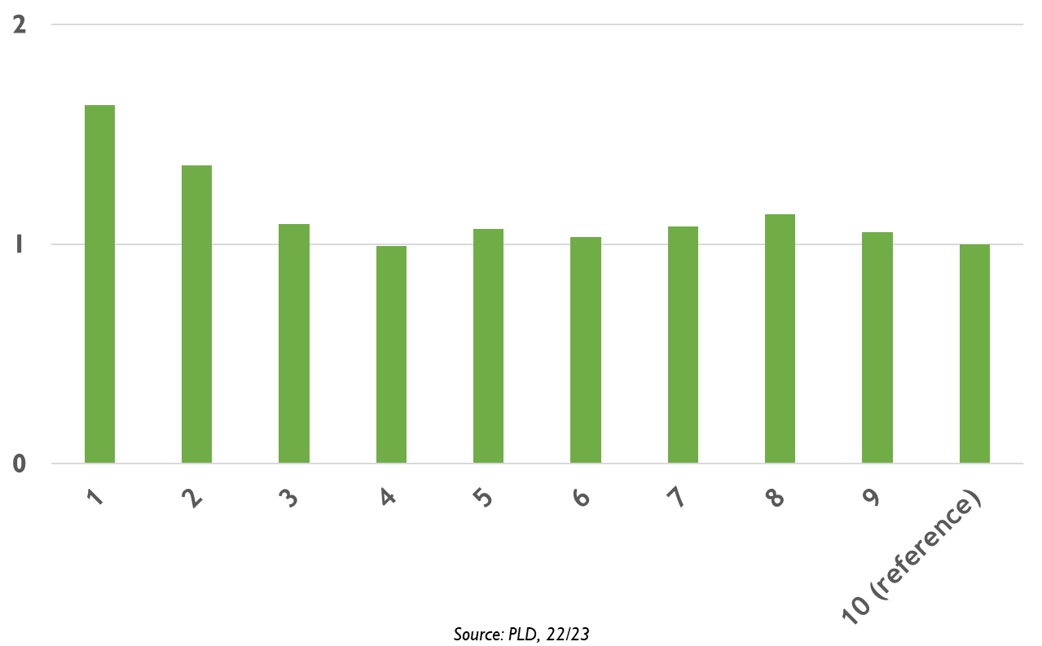

Source: PLD, 22/23

  - Wider policy context
Delegation
Specialised services are prescribed in law and usually involve treating patients with rare or complex conditions. They are determined by:
- The number of individuals who require the service
- The cost of providing the service or facility
- The number of people able to provide the service or facility

As part of the redesign of health and care in England, responsibility for commissioning some specialised services is in the process of being delegated to Integrated Care Boards (ICBs). From April 2023, NHS England have been jointly working with ICBs on 59 specialised services, including neonatal, renal and specialist cardiac services, as well as specialised cancer and radiotherapy services. From April 2024, subject to delegation processes being complete, services previously solely commissioned by NHS England – Midlands will be divided into three groups:
- Services commissioned by ICBs
- Services that may be delegated in future but will remain an NHS England commissioning responsibility in 2024
- Services where commissioning responsibility will be retained by NHS England

Reducing health inequalities is one of the core purposes of this delegation. The Roadmap for integrating specialised services within Integrated Care Systems report, published in May 2022, sets out a triple aim of “improving quality, reducing inequalities, and improving value”. These are underpinned by NHSE’s Core20PLUS5 approaches (see section 5.1).
This is also set out in the broader 22/23 mandate for NHS England, for which Objective 4 is to “embed a population health management approach within local systems, stepping up action to prevent ill health and tackle health disparities.” Within Objective 4 is a more specific mandate to “ensure that national and local plans include measurable ambition setting out how healthcare disparities are to be tackled, in relation to access to and experience of NHS services, and to health outcomes.”
The Health and Care Act 2022 increased the legal obligations on ICBs to reduce health inequalities. It not only set out that ICBs “must…have regard to the need to reduce inequalities between persons with respect to their ability to access health services”, but also “reduce inequalities between patients with respect to the outcomes achieved for them by the provision of health services” (emphasis added).
The strategy also links with the regional objective on health inequalities for specialised commissioning pharmacy in the Midlands, as set out below:
Objective: Enable access of appropriate high-cost drugs to reduce health inequalities.
Value: Midlands NHS England region maintains a high standard for access to existing and new therapies and ensures equity of access to high-cost drugs.
Aims:
- To ensure consistent use of shared care arrangements across the region.
- To ensure new drugs are introduced and used effectively,
- To audit to ensure timely uptake.

- Health inequalities strategy
The vision for the specialised commissioning health inequalities strategy mirrors the National Healthcare Inequalities Improvement Programme. This is well established across the NHS and focuses on the elements of health inequalities over which the NHS has the greatest control. These include healthcare access, experience, and outcomes.
Underpinning the vision are five principles for reducing health inequalities that have previously been set out in national NHS planning guidance (Figure 7). ICSs already have detailed health inequalities strategies in place that incorporate this vision and principles. A wide range of stakeholders have been involved in the development of this strategy as set out in Appendix A.
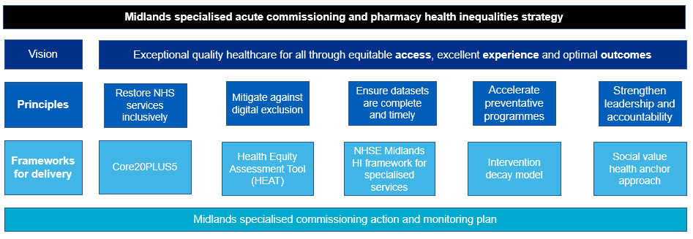
Figure 7: Overview of the Midlands Specialised Commissioning (Acute and Pharmacy) Health Inequalities Strategy

  - Principle 1: Restore NHS services inclusively
Current position
Waiting lists, put under pressure during the COVID-19 pandemic, remain high across specialised and non-specialised services, with those facing health inequalities particularly affected. Clearing the specialised elective backlog with maximum short-term efficiency is likely to increase health inequalities, as services identify easier-to-treat patients first. Easier-to-treat populations are often also those in better health, resulting in longer waits for those with the greatest need.
Health inequalities impact assessments are also completed at national level ahead of policy change or implementation. These are relatively light touch in nature and do not consider regional and local variations in population. This indicates a gap in identifying health inequalities.
Future position
- Take an equity-based approach to prioritising service restoration, as set out in the Midlands health equality framework for specialised services (Appendix B). This may include analysis of patients who are indicated for treatment but not on waiting lists, which will require working with colleagues across local authorities and NHS organisations. To achieve this, providers and commissioners will need to ensure datasets are robust (as outlined in Section 4.3) so that they understand the demographic profiles of those on waiting lists.
- Commissioners will take a structured approach ensuring changes in service delivery take health inequalities into account, by using health equity tools. Any significant new service development, policy implementation or service specification review should be accompanied or informed by a recent HEAT assessment (Section 4.2). The proposal’s impact on health equity will form part of assessing whether these developments are approved.
- Providers have an opportunity to support the tackling of health inequalities by employing tools highlighted in section 5, including the Health Equity Assessment Tool. This will help ensure that the services they provide work for their populations.
- One issue with health equity audits is that they are not always reviewed to assess ongoing effectiveness. Specialised commissioning HEAT assessments will be reviewed at regular intervals to assess the impact on health inequalities and to adapt delivery plans as necessary.

  - Principle 2: Mitigate against digital exclusion
Current position
19% of the Midlands population are classed as being limited users of digital services. (Good Things Foundation, 2022) As more and more health services move to digital approaches, the consequences of poor digital literacy for health also become greater. However, this shift also provides opportunities to increase accessibility of services for those who live a long way from specialised centres or have limited access to transport options.
Future position
- Commissioners will work with services to monitor and evaluate the impact of video and telephone appointments on access, experience, and outcomes.
- Developing equity-first digital pathways so that new interventions and changes to operating models increase accessibility for those with lesser access to services.
- Where face-to-face options are required, ensure that costs incurred to families in using services are minimised, developing schemes where necessary or using existing schemes such as the Healthcare Travel Costs Scheme.
- Introducing culturally sensitive digital solutions that work for traditionally digitally excluded populations.
- Services will implement the NHS England Digital Inclusion Framework, which is expected to be published in August 2023.

  - Principle 3: Ensure datasets are complete and timely
Current position
Having complete and timely data enables decision-makers to make judgements on where unfair differences in access, experience and outcomes exist. This in turn ensures that evidence-based interventions for reducing health inequalities are effective and appropriately targeted. Data completeness from specialised services declined during the COVID-19 pandemic but is in a recovery phase.
The duty on commissioners and providers is then to make use of the data gathered to identify and act on health inequalities.
Future position
- Providers and commissioners will understand the data on personal characteristic that they currently collect, enabling them to set a baseline for data completeness.
- Specialised providers and commissioners will make it a priority to improve data completeness relating to groups who may experience health inequalities. Specific indicators will be developed to monitor data completeness for gender, ethnicity, postcode (from which IMD can be derived), and disability. Where numerically possible, ethnicity reporting will include sub-categories (e.g. Arab, Chinese rather than reporting Other).
- Providers and commissioners will work with local public health teams to develop approaches to identify those in inclusion health groups (e.g. those experiencing homelessness, those with substance misuse issues, sex workers) so that their access, experience and outcomes relating to specialised services can be assessed and improved.
- Enhance the role of knowledge and intelligence specialists in reducing specialised health inequalities. In the new model of commissioning specialised services, adequate business intelligence resources will be allocated towards developing knowledge and intelligence specialists who can support health equity audits, with prioritisation for the service areas in section 4 and where there is existing national or local evidence of health inequalities.
  - Principle 4: Accelerate preventative programmes
Current position
Although the majority of specialised services do not have a preventative function (beyond providing a tertiary preventative role in preventing secondary complications of conditions and deterioration of condition), prevention in its broader sense can still contribute to reducing health inequalities in specialised services.
It is well established that many conditions that lead to use of specialised services can be exacerbated by the socio-economic circumstances an individual finds themselves in, or by modifiable behavioural risk factors. Delegation of commissioning responsibility to ICBs can support specialised services to prioritise these broader NHS aims as well as non-specialised services.
Future position
- Specialised services should be fully committed to the Long Term Plan prevention ambitions (for example, to offer tobacco dependence services to every inpatient, to make use of Alcohol Care Teams) and to continually improve their role in these pathways.
- Where possible, specialised services signpost towards and make referrals to services that support socio-economic determinants of health e.g. cost-of-living support services or Citizens Advice Bureau.
- Consider the links between screening programmes and specialised services, ensuring that referrals are equitably managed.

  - Principle 5: Strengthen leadership and accountability
Current position
The delegation of specialised services is leading to the development of new leadership and governance structures. Health inequalities is to be embedded in these new structures from their inception.
Future position
- Identifying and reducing health inequalities must form part of contract management and quality processes. To that end, all new specialised service contracts should include Schedule 2N, a non-mandatory Schedule that can be used to set out actions that parties will take in reducing inequalities in access, experience, and outcomes from services.
- Commissioners will apply Net Zero, health equity, and social value in the procurement of goods and services (outlined in Procurement Policy Note (PPN) 06/20), which involves weighting at least 10% of a procurement towards broader social value delivery beyond the specific scope of the contract (see Appendix C for details).
- Impact on health equity will form a central part of the integrated business planning and priority setting process for specialised commissioning for both ICSs and NHS England – Midlands. It will be important to make links with ICS and ICB Health Inequalities leads on specialised commissioning.
- Named ownership for health inequalities is important for strengthened leadership and accountability. To that end, the strategy will be jointly owned by named leads at NHS England and lead ICBs. They will work closely with other ICB and provider SROs for health inequalities, providing leadership for the strategy’s delivery.
- The responsible Board for the strategy will be the East and West Joint Committees, which comprise representatives from ICBs and NHS England - Midlands. They will receive regular updates on the strategy and support its progress.
- The specialised commissioning team will offer regular opportunities to share challenges and good practice on health inequalities across specialised commissioned service.

- Implementing this strategy
Specialised services cover pathways for a broad range of conditions. Whilst encouraging the application of this strategy to all areas of specialised commissioning, we therefore advocate initially prioritising the following service areas:
- Severe asthma (East Midlands). This is a Core20PLU5 clinical priority for children and young people.
- Haemoglobinopathy (West Midlands). The APPG on Sickle Cell and Thalassaemia report No One’s Listening (All Party Parliamentary Group for Sickle Cell and Thalassaemia, 2021) highlighted the role of racism in the negative attitudes and poor health outcomes for sickle cell patients, which overwhelmingly affects people with African or Caribbean heritage.
- Neonatal and Maternity Services (East and West Midlands). Reducing inequality is a key improvement aim for the perinatal programme.
- Adult Critical Care (East and West Midlands). Reducing inequality is a key programme improvement aim.

These four areas were jointly identified as acute specialised service priorities for the Midlands for 2023/2024 by NHS England, ICBs and providers. Two examples of where work has already been effectively undertaken to reduce health inequalities locally are highlighted in Appendix D.
To support the implementation of this strategy when aligning it to these pre-existing priorities, we have highlighted five key frameworks. Some of these can be used to help identify health inequalities and others support action that reduces the gap. We know that patients have a vital part to play in helping to design services that meet their needs, and so co-production with communities is key when applying these frameworks.
Action plans with named leads will be developed. We recommend this be led by commissioners in conjunction with providers, for programmes of care. This strategy will sit within existing governance structures for Specialised Commissioning in the Midlands, with the West and East Joint Committees as the responsible bodies.

  - Core20PLUS5
Core20PLUS5 is a national NHS England approach to drive action to reduce healthcare inequalities at both national and system level. The approach defines a target population – the ‘Core20PLUS’ – and identifies ‘5’ focus clinical areas for adults and 5 focus clinical areas for children requiring accelerated improvement (Appendix E).
This framework will be incorporated into the work of specialised commissioning teams in reducing health inequalities as it provides a common language across NHS England and ICBs and a focus on certain population groups, as set out below.
Core20
The most deprived 20% of the national population as identified by the national Index of Multiple Deprivation (IMD). The IMD has seven domains with indicators accounting for a wide range of social determinants of health. Actions to identify and support the Core20 group are set out in section 4.3 and section 6.
PLUS
PLUS population groups are identified at local or sub-regional level depending on local populations. They include all other populations groups who may experience health inequalities, as set out in Figure 2. Actions to identify and support these groups are set out in section 4.3.
5
There are 5 clinical priorities for adults and 5 clinical priorities for children and young people, which set out specific goals to work towards in these areas. Whereas some of these overlap with specialised commissioning service priorities (e.g. for children and young people “Asthma” – address over-reliance on reliever medications and; decrease the number of asthma attacks), some of the clinical priorities have less relevance for specialised services.
Further information on the Core20PLUS5 approach to tackling health inequalities can be found on the NHS England website.
  - Health Equity Assessment Tool (HEAT)
The Health Equity Assessment Tool (HEAT) provides a systematic approach to identifying and addressing health inequalities within a service area, care pathway or programme of work. It requires a time commitment of at least a year and analyst, service lead and commissioner buy-in. An outline of the process is shown in Figure 8.
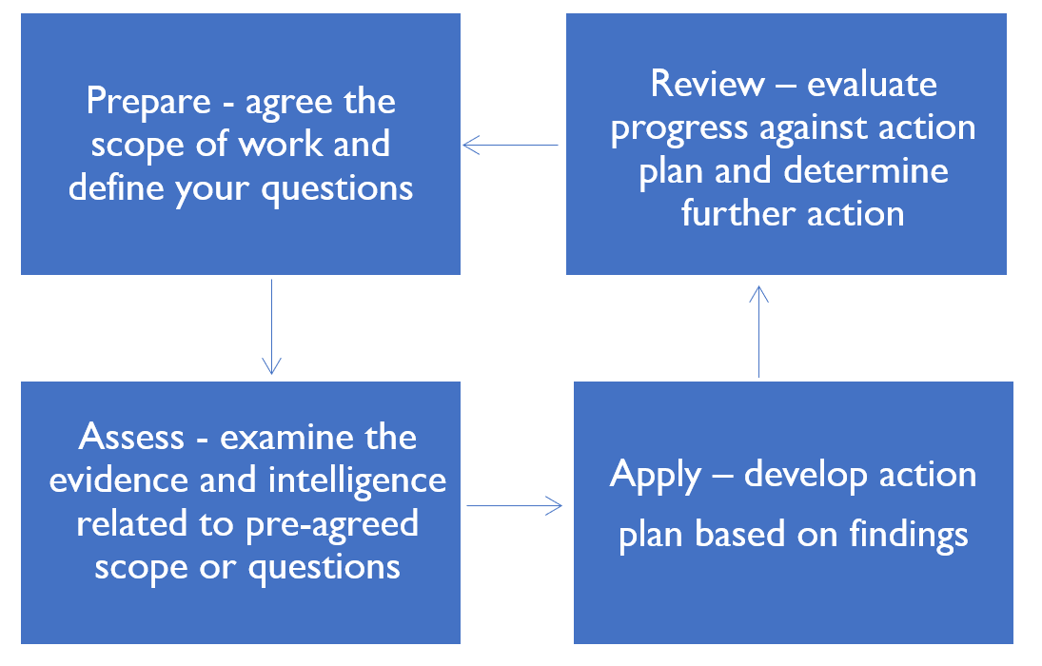
Figure 8: HEAT cycle

It is extremely important to commit to using an entire cycle of the tool. This includes committing to assessing progress against a monitoring plan at 6 or 12 months. A systematic review found that 56 of 60 identified health equity audit cycle only completed part of the health equity audit cycle (Daalen et al., 2021) meaning only 4 instances were found of where organisations or systems went back to determine what effect their analysis and action plan had on health inequalities. Encouragingly, all 4 programmes completing an entire cycle found at least some improvement in health equity when they re-evaluated their services.
Free online training on how to use the HEAT tool is available on the E-learning for Healthcare platform, with further information available on the GOV.UK website.

  - Midlands health equity framework for specialised services
Although inequalities have been described for specific specialised services, there does not appear to be a broad approach to tackling health inequalities across specialised services. Using a literature review and stakeholder consultation, we have developed a framework that highlights how common features of specialised services can lead to health inequalities, and possible ways of identifying and reducing these health inequalities (Appendix B). This can be modified to suit the specific needs of programmes of care or individual services.

  - Intervention decay model
Figure 9 depicts intervention decay in the context of specialised services, including the point at which specialised services can intervene. It illustrates how, at each stage of the care pathway, certain population groups face exposures in wider society, and can have poorer access, experience, or outcomes of care, that compound to ultimately result in inequalities in health outcomes. The greater decay in effectiveness in intervention for those who face disadvantage is because they are less likely to:
- Recognise risks or illness, or have someone close to them recognise risks and illness
- Be able to access initial advice, support and referral
- Receive optimal treatment that meets their specific needs
- Have the personal, social and community assets for management and recovery

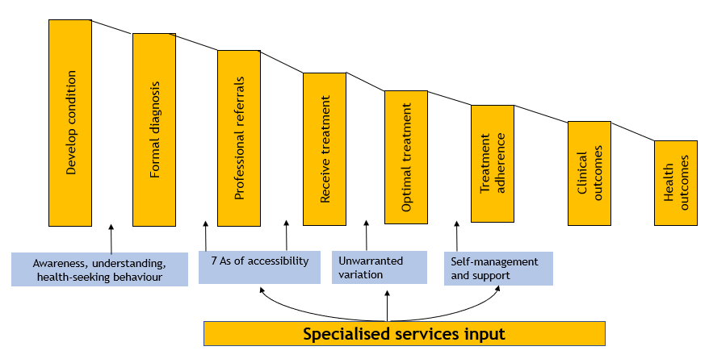
Figure 9: Intervention decay model (specialised services)
Source: Adapted from C. Bentley

In this example, there are multiple points of intervention that could be considered to reduce health inequalities; those whose risk factors are not managed, those receiving sub-optimal primary treatment, and those who either cannot access specialised treatment or who receive sub-optimal specialised treatment.

  - Anchors and social value approach
Direct service delivery is not the only way to maximise the budget of the Midlands specialised commissioned services on health inequalities. Its resources and influences can also be used to maximise social, economic and environment impact.
£23 billion (one-sixth of the total NHS budget) is spent on specialised services, which is approximately the same as Amazon’s total UK revenue (Amazon UK, 2022). Spend at this scale has huge economic, environmental, and social consequences that go far beyond the medical services provided.
The majority of specialised services funding goes to large hospital trusts, who have crucial roles to play as anchor institutions. Anchor institutions are institutions that – alongside their main function – play a significant role in their local area through being:
- large employers of local people
- big purchasers of goods and services
- owners of important plots of local land
- geographically fixed to that particular area
This is relevant to the NHS’s role as a healthcare provider as people’s living and working conditions are hugely influential determinants of health.
Acting as an anchor institution will include focusing on the environmental impact of services, providing “good” jobs that promote health through secure well-paid employment, or focusing on the supply chain of specialised services to ensure purchasing is from organisations who positively impact the local environment and economy. This is set out further in Appendix C.
Specialised service commissioners will work with providers to ensure that this is considered in specialised services. They will apply Net Zero, health equity, and social value in the procurement of goods and services (outlined in Procurement Policy Note (PPN) 06/20) (NHS England, 2022) which involves weighting at least 10% of a procurement towards broader social value delivery beyond the specific scope of the contract.

- Monitoring progress
Measuring impact on inequality is not straightforward, because it requires comparison between several sub-populations.

Which groups to measure?
- Access, experience, and outcomes of those in Core20 (the 20% most deprived population by IMD) compared to the other 80% of the population.
- It is possible to look at access, experience, and outcomes using the relative index of inequality. The relative index of inequality provides a single measure of how all deprivation deciles compare to one another.
- Access, experience, and outcomes of patients by:
  - Ethnicity
  - Geography
  - Gender
- Access, experience, and outcomes of other PLUS groups. The relevant groups are likely to vary from pathway to pathway.

Which indicators to measure?
Individual pathways should be mapped out in the health equity assessment phase, which should identify where along the pathway. In the report “Strategies to reduce inequalities in access to planned hospital procedures” the following metrics along the pathway are proposed that relate to access:
- Referral rates
- Outpatient Did Not Attend (DNAs) and cancellation rates
- Referral to treatment conversion ratios
- Mean waiting times
- Treatment DNA and cancellation rates
- Treatment rates
- Emergency admissions whilst waiting

For pharmacy, this will include other metrics relating to access to medicines, such as pick-up/refill rates, completion of prior approval forms and other indicators.
Experience measures might include:
- Qualitative interviews with patients and staff
- Length of stay
- Patient survey scores
- Complaints data

Outcome measures might include:
- Quality of life measures
- Treatment success rates
- Disease progression measures
- Survival rates

Which actions to take?
Action plans with named leads will be developed. Their progress will regularly be reported through existing governance structures for Specialised Commissioning in the Midlands.

- References
All Party Parliamentary Group for Sickle Cell and Thalassaemia. (2021). No One’s Listening: . Https://Www.Sicklecellsociety.Org/No-Ones-Listening/.

Amazon UK. (2022). Amazon’s Economic Impact in the UK for 2021. Https://Www.Aboutamazon.Co.Uk/News/Job-Creation-and-Investment/Amazons-Economic-Impact-in-the-Uk-for-2021.

Barr, B., Higgerson, J., & Whitehead, M. (2017). Investigating the impact of the English health inequalities strategy: time trend analysis. BMJ, 358, j3310. https://doi.org/10.1136/bmj.j3310

Carey, G., Crammond, B., & De Leeuw, E. (2015). Towards health equity: a framework for the application of proportionate universalism. International Journal for Equity in Health, 14(1), 81. https://doi.org/10.1186/s12939-015-0207-6

Daalen, K. R. van, Davey, F., Norman, C., & Ford, J. A. (2021). Health equity audits: a systematic review of the effectiveness. BMJ Open, 11(11), e053392. https://doi.org/10.1136/bmjopen-2021-053392

Dahlgren, G., & Whitehead, M. (1991). Policies and strategies to promote social equity in health. Background document to WHO-Strategy paper for Europe. Institute for Futures Studies.

Good Things Foundation. (2022). Building a Digital Nation.

Hart, J. T. (1971). The inverse care law. The Lancet, 297(7696), 405–412
.
Hood, C. M., Gennuso, K. P., Swain, G. R., & Catlin, B. B. (2016). County Health Rankings: Relationships Between Determinant Factors and Health Outcomes. American Journal of Preventive Medicine, 50(2), 129–135. https://doi.org/10.1016/j.amepre.2015.08.024

Kidney Research UK. (2019). Kidney Health Inequalities in the UK: An agenda for change.

NHS England. (2022). Applying net zero and social value in the procurement of NHS goods and services.

- Appendices
  - Appendix A: Strategy engagement and consultation

- Monthly: working group made up of NHS England and ICBs from East and West Midlands
- January 23 – Midlands Acute Specialised Commissioning Group
- January 23 – Healthcare public health team meeting
- January 23 – Specialised pharmacy team meeting (internal NHS England)
- February 23 – Midlands Specialised Acute and Pharmacy Working Group
- April 23 – Informal discussions with provider trusts
- April 23 – Midlands Acute Specialised Commissioning team meeting
- May 23 – Midlands High Cost Drugs Pharmacy Network
- June 23 – Midlands Health Inequalities Network
- June 23 – Clinical Commissioning Executive Forum
- July 23 – Planning, Delivery and Value Group
- July 23 - Midlands Acute Specialised Commissioning Group

  - Appendix B: Midlands health equality framework for specialised services
Common feature of specialised services | Possible mechanism for increasing health inequalities | Possible mechanisms for reducing health inequalities | Affects access (A), experience (E) or outcomes (O)
Often at end of a multiple-stage referral pathway | Those from lower socio-economic backgrounds and with some protected characteristics are potentially less likely to understand the referral system and advocate for specialist treatment (A)  Conversely, those facing health inequalities may be more likely to require some specialised services if health issues are inequitably resolved earlier in the care pathway (E, O) | - Decision aids/coaches for consultations  - Variable referral thresholds based on population groups  - Waiting list prioritisation  - Targeted outreach to those less likely to attend  - Culturally competent communication on pathways for specialist treatment | A, E, O
Often small number of providers based in a small number of locations | Those who are long distances away from specialist centres and those with reduced funds or access to transport are less likely to be able to make the journeys required to access the service. This may be compounded by cross-system patient flows (A)  If they are able to access the service, they may not be able to make appointments with the same frequency, or the toll of attending appointments may have a more significant impact on their wider lives (employment, caring duties, relationships etc) (E, O) | - Inclusion of Schedule 2N Health Inequalities Action Plan  - Telephone and video appointments  - Subsidising travel e.g. through HTCS or bespoke schemes  - Out-of-hours appointment  - Community participatory research with patients and clinicians on impact of travel arrangements  - New satellite provider hubs | A, E, O
New high-cost technologies often approved by NICE/NHS England and rapidly rolled out | 90-day rollouts of new technologies and medicines recommended in NICE TA leaves scope for variation in:  - How and if new medicines/new indications are introduced  - Timeframes for introduction of newly commissioned medicines/indications  - Accessibility of new medicines (A, E, O) | - Analysis and amendment of local policies and formularies  - Analysis of local prescribing and dispensing by location and by patient subgroup  - Reminder/follow up systems for prescriptions  - Analysis of regional pharmacy datasets to review access and timely expenditure, including action planning | A, E, O
Often high-intensity and complex patient adherence to treatment required | Those with low health literacy and lower physical and social resources for adherence (e.g. for complex medicines storage and usage) may find it more difficult to understand and adhere to treatment and self-care regimes, worsening outcomes (E, O) | - Review of literature provided to patients  - Fuller support for patients before and after treatment  - Analysis of self-reporting adherence and pick-up/refill rates  - Qualitative research with patients and clinicians | E, O
Multi-morbid patients requiring multidisciplinary input | Co-ordination of care across professional specialties and groups may be more difficult if relying on patients with English as an additional language, or low health literacy, to co-ordinate between professional teams and relay information (E, O) | - Research into standard operating procedures to investigate the implicit role of the patient  - Consideration of how to support patients to access advocacy and support for their own care (co-produced delivery models) | E, O
Transition arrangements | Following welcome advances in treatment and life expectancy for certain conditions (e.g. congenital heart conditions) several conditions are seeing much higher volume transition from paediatric to adult services) (A, E O) | - Analysis of transition data by patient subgroup  - Research into cultural competency of adult services receiving greater volumes of those moving from paediatric services | A, E, O

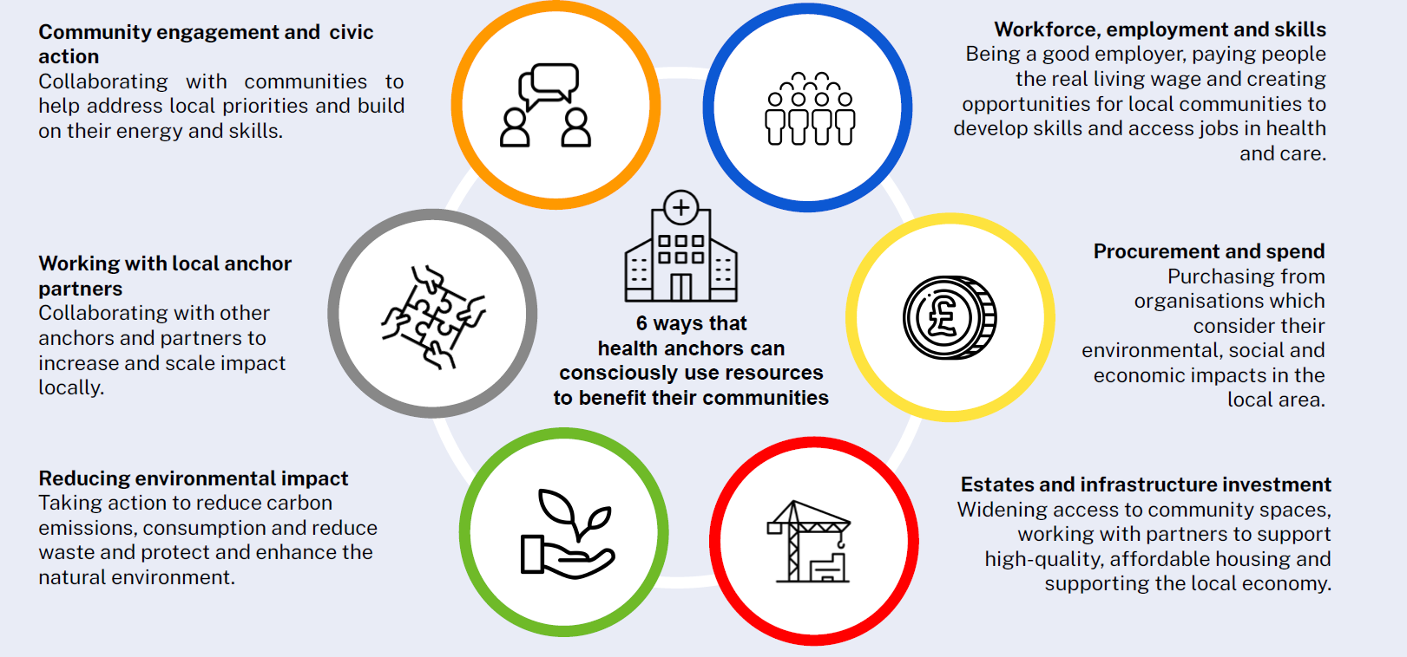
  - Appendix C: Six strategic anchor areas
  - Appendix D: Local case studies

Case Study: Access to High Cost Drugs – Crizanlizumab for the prevention of sickle cell crises in sickle cell disease

Background
Haemoglobinopathies have been identified as a priority area for specialised services in the West Midlands. One of these conditions is sickle cell disease (SCD), which disproportionately affects individuals of African, Caribbean, and other black ethnicities, leading to unique challenges and disparities in healthcare outcomes. Health inequalities often intersect with other social determinants of health, such as housing, education, employment, and discrimination. Understanding and addressing these interconnected factors are vital in promoting health equity for individuals with sickle cell disease. In the Midlands there are higher concentrations of black populations in larger cities and in the Stoke on Trent area, which significantly overlap with the 20% most deprived postcodes (Figure 10). The region has 14% of the registered sickle cell population in the UK.
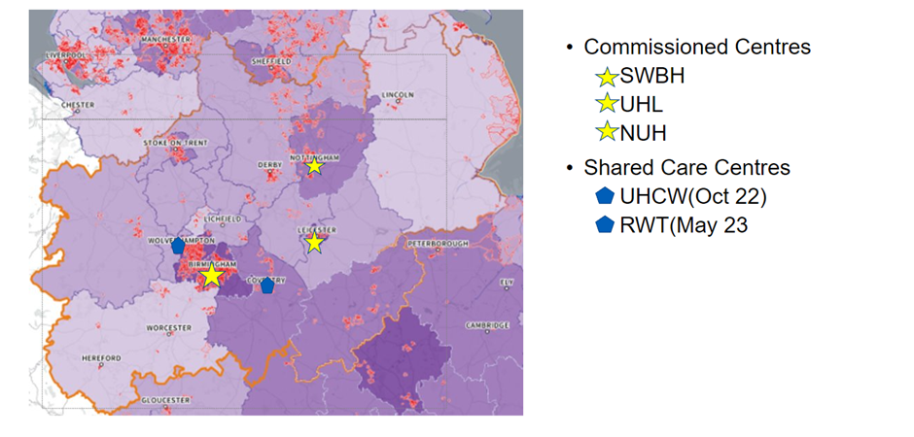
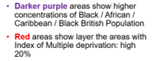
Figure 10: Centres providing crizanlizumab in the Midlands
Addressing health inequalities also involves ensuring equitable access to new innovative treatments, including novel medicines such as crizanlizumab. NICE recommends the use of crizanlizumab as a treatment option for prevention of sickle cell crises, setting out clear eligibility criteria for its use.

Approach
NICE estimate that 300- 500 patients are likely to be treated with crizanlizumab nationwide per year, which equates to approximately 42-70 patients in the Midlands. Blueteq initiation and spend data was analysed to understand actual uptake across the region and crizanlizumab was found to have been used to treat 37 patients from February 22 to June 23. This is lower than expected by NICE.
Crizanlizumab was commissioned from 1st February 2022 (SSC2337) through the following Specialist Haemoglobinopathies Teams in the Midlands (Figure 1): Sandwell and West Birmingham Hospitals (SWBH), University Hospital Leicester (UHL) and Nottingham University Hospitals (NUH). SWBH developed Shared Care Agreements to increase access to prescribing and administration across the West Midlands. Clinicians at commissioned centres were asked to comment on current patient numbers, proposed numbers of future patients and any barriers to prescribing.

Findings
It was found that potential barriers to prescribing include:
- Day case capacity issues (drug administration should be within hospital setting)
- Patient suitability for crizanlizumab
  - Other medication options preferred (oral)
  - Ability to travel for monthly injections
  - Ability to commit to monthly injections
- Patient hesitancy
  - Stopping due to lack of efficacy.
  - Stopping due to side effects.

Several clinicians described the initial outcome data from the STAND trial which indicates no statistical difference between crizanlizumab and placebo in reducing sickle cell crises, and potential for higher rates of treatment related side effects. NICE has advised though that the managed access agreement will continue unless it is withdrawn from market, loses regulatory approval from the MHRA or if the company advises that updating the NICE guidance would be futile. It is understood treatment is planned for fourteen additional patients 23/ 24 and this will depend on the factors described above.
This work was presented at the regional HCD Pharmacy Forum where other drugs were discussed for review.

Impact
Specialised Commissioning Pharmacy has committed to integrate a Health Inequalities approach into commissioning of high cost drugs (HCDs) in the Midlands. This case study shows how they are acting on their health inequalities priorities, which include gathering data, engaging with providers and system partners, reviewing shared care arrangements to ensure new drugs, and ensuring policies are introduced in a timely manner. Through undertaking this review of crizanlizumab, the team have a better understanding of its pattern of uptake across the region, to support ongoing service planning. The team will review the uptake of crizanlizumab in six months. and continue to embed equitable access to HCDs into their business as usual processes.

Case study: Severe asthma and access to biologics in the Midlands

Background
There is a strong link between respiratory health and inequality. Socio-economic status, air pollution, smoking status, housing, ethnicity, occupation, and access to care are all drivers of disparities in incidence and outcomes.
Of the estimated 200,000 patients with severe asthma in the UK, modelling suggests that around 55,000 are eligible for biologic therapy. Before the national Accelerated Access programme, which seeks to get new healthcare innovations to patients faster, only 10,000 patients (~20%) were accessing this therapy.
The specialised commissioning team worked with others to analyse prescribing rates. They found there were likely to be low numbers of patient on biologics according to need in several areas of the Midlands (Table 1). This helped to inform the Midlands Accelerated Access Projects, two of which are detailed below.
Table 1: Biologic prescribing rates and proxy underlying need in the Midlands
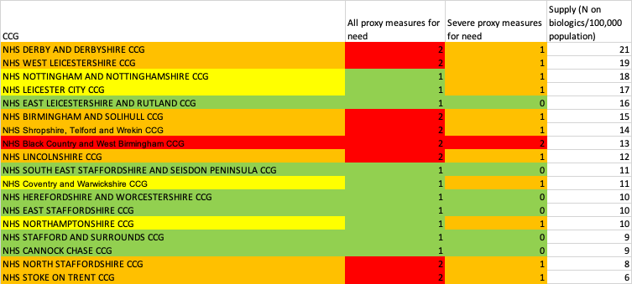 Green/yellow/orange/red indicates gradient of disparity between proxy need and biologics prescribing, with red showing the largest discrepancy

University Hospitals of North Midlands (UHNM) project

Approach
- Carried out case finding of uncontrolled asthma, using the SPECTRA tool which supports identification of severe asthma
- Delivered patient and staff education through dedicated Asthma Nurse Educators
- Simplified the referral process, adapting the referral form for easier use

Impact
Project implementation was followed by greatly increased numbers of patients receiving biologics, in a catchment area with high socio-economic deprivation (Figure 11). In 2023, the project was recognised by the European Respiratory Society (ERS) and the British Thoracic Society (BTS) for its work in this area. There are future plans to improve use of biologics in three Primary Care Networks where over 50% of patients registered at practices live in the most deprived 20% of postcodes.
Figure 11: Total number of patients receiving asthma biologics through UHNM
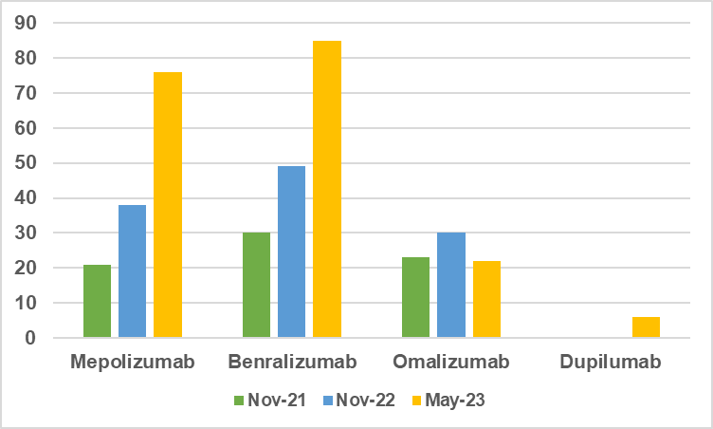

Nottingham University Hospitals NHS Trust project

Approach
- Used AstraZeneca Respiratory Outcomes mapping tool to show low rates of biologic prescription in Lincolnshire, Mid-Nottinghamshire, and Nottinghamshire West
- Piloted a community asthma nurse role in Lincolnshire, due to its widely dispersed rural population, to mitigate the difficulty of travelling to hospital appointments, and also used SPECTRA case-finding tool
- Prioritised Mid-Nottinghamshire and Nottingham West for case-finding using an eHealthscope tool, and as a result a number of patients from these areas were referred to secondary care for consideration of biologics.
- Ran educational session for GPs
- Increased pharmacists capacity in secondary care, including for up-front adherence checks

Impact
The rate of biologic approvals rose 40% from baseline, and the waiting time from referral to biologic initiation has reduced by 131 days from baseline. The SPECTRA and eHealthscope search tools uncovered 1,351 patients with uncontrolled asthma who may otherwise have gone unnoticed.
Many patients that were picked up by case-finding benefited through optimisation of their basic asthma management, including asthma education, inhaler technique and adherence. Many patients improved following these interventions and did not go on to need a biologic agent. This was particularly noticeable in Lincolnshire following in-person reviews carried out by community asthma nurses.

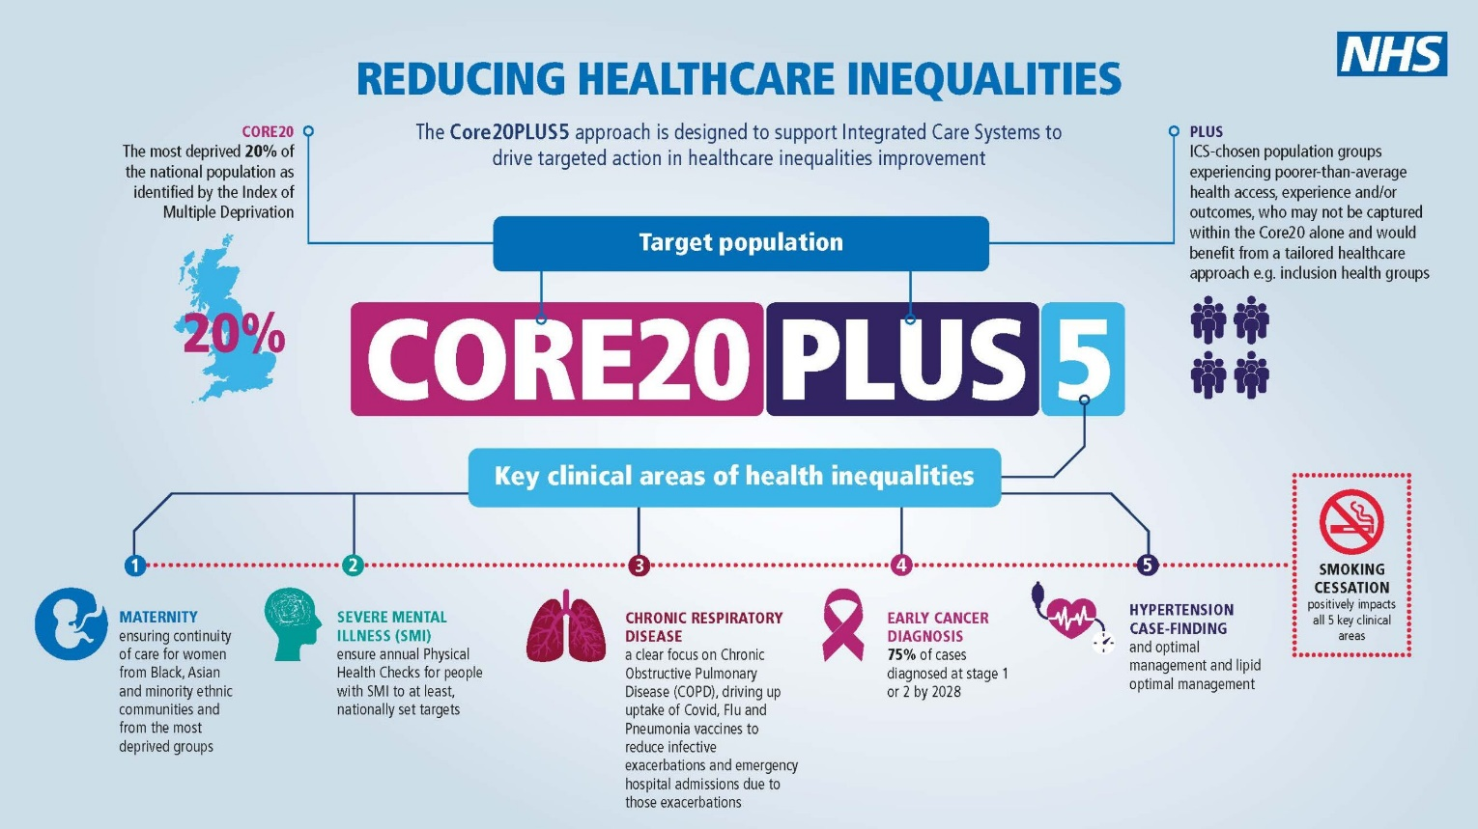
  - Appendix E: Core20PLUS5
