2-3s pharmacy offer

Channel | Copy | Asset / Alt text / SharePoint
Social Media | For the first time, parents can now get their 2 and 3 year olds vaccinated at our pharmacy.  It’s quick, safe and effective. Protect your child this winter.  Pop in to book your appointment | 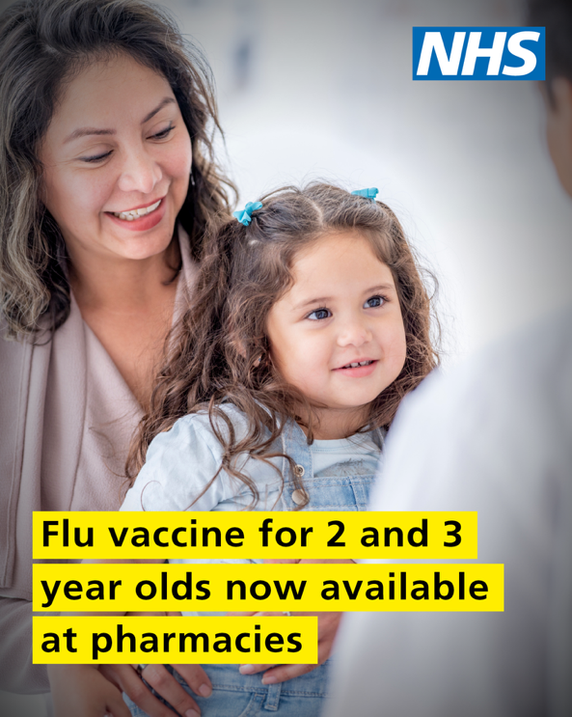
Leaflet for nurseries and playgroups | For the first time, parents can now get their 2 and 3 year olds vaccinated at local pharmacies.  Flu isn’t just a heavy cold – it can make young children seriously unwell, sometimes badly enough to need hospital care.  Vaccination is the best way to protect them. It’s safe, effective and often given as a quick, painless spray up the nose. We also have non porcine injections available.  Pop in to xxx pharmacy at xxxxx to talk it over with us and to book your appointment. | 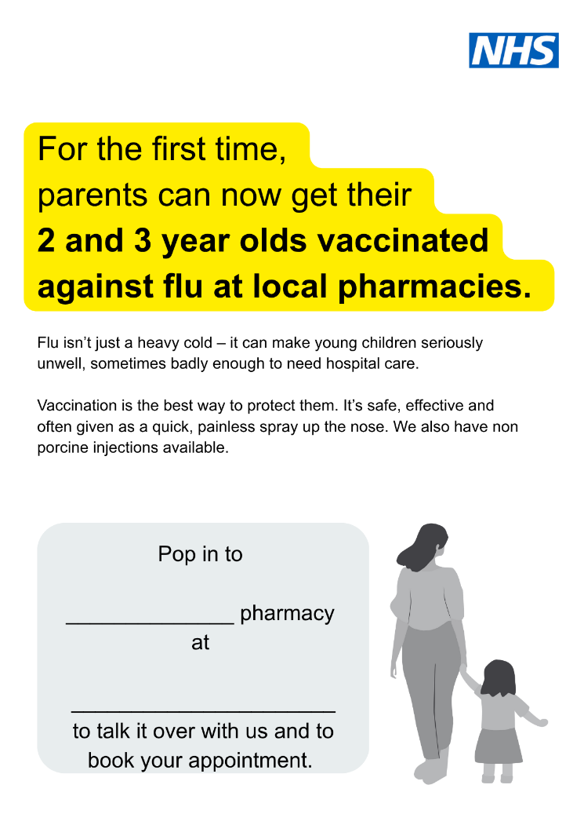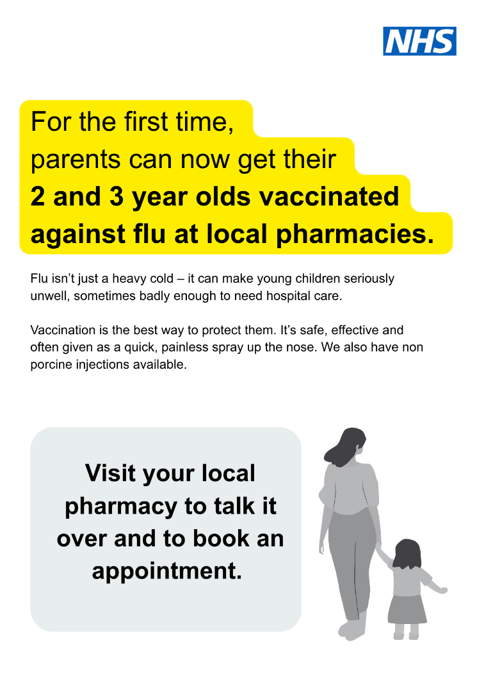  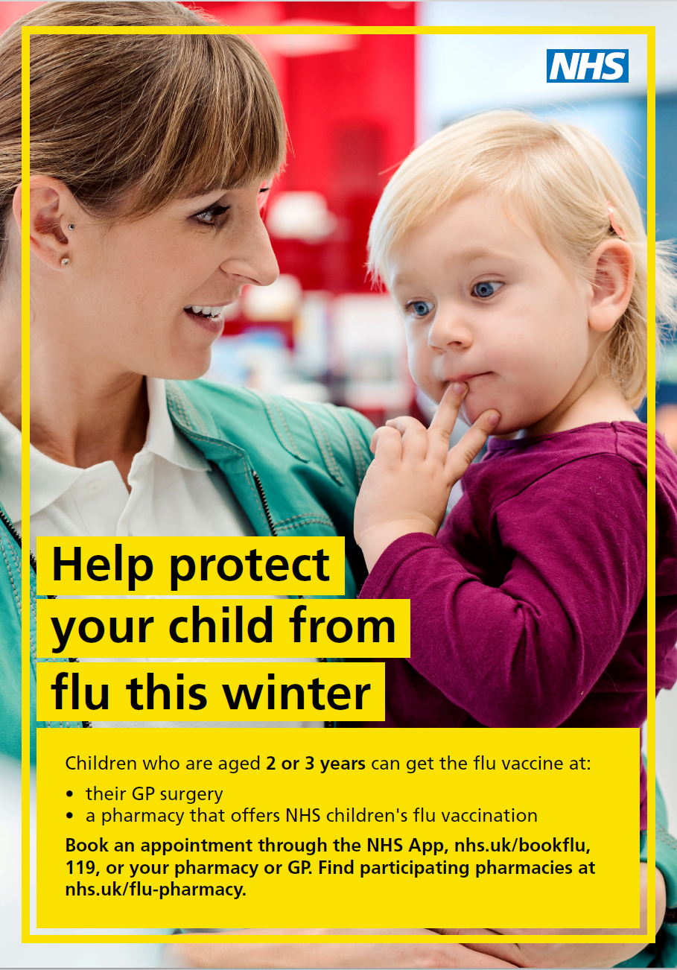  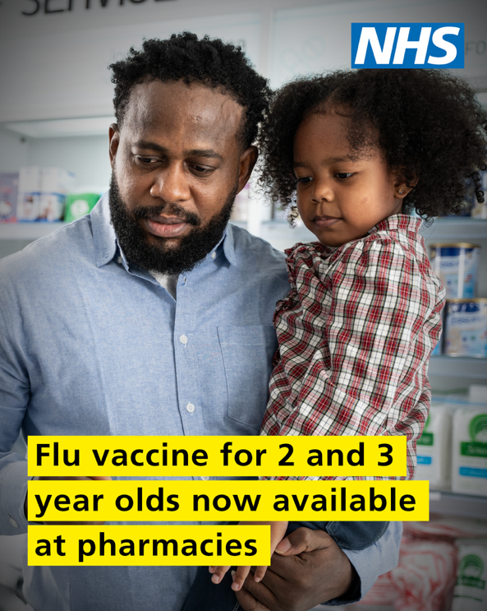
Letter to playgroup leads/ nursery managers / mother and children groups | Flu cases and hospitalisations are on the rise with transmission among younger children driving an earlier start to the flu season.  Flu can make children very unwell, and the flu vaccination is the best way to protect your child from becoming seriously ill.  Here at xxxx Pharmacy we now offer the flu vaccination to any child aged two and three years. Typically this will be quick, painless spray up the nose but we also have non porcine injections available.  Vaccination is safe and effective and will be available as long as stocks last.  We would encourage parents to pop in and talk it over with us and then book a vaccination appointment as soon as possible. | 