Parent/Carer of <Patient Name>
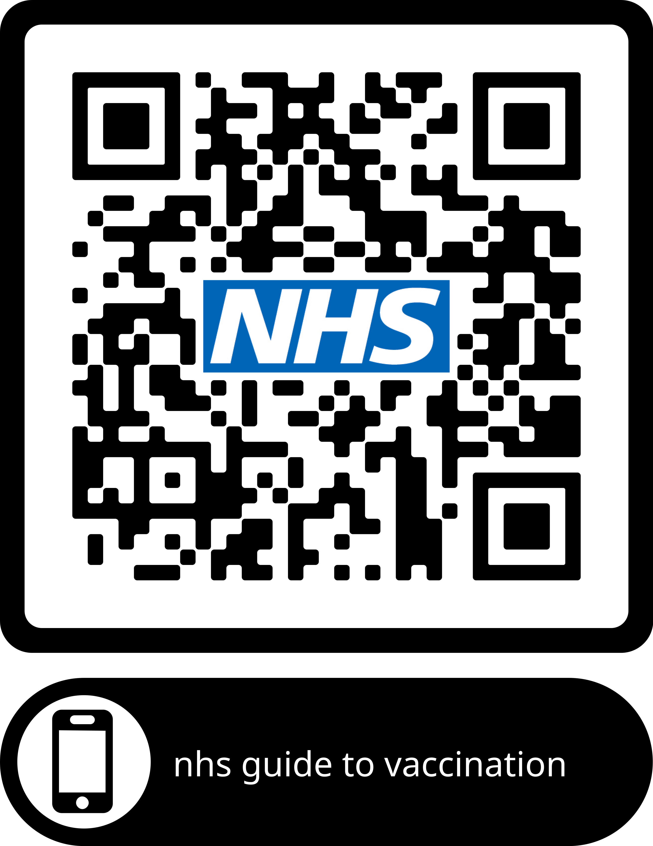
Patient address

Dear Parent/Carer of …………………….
Date of Birth: dd/mm/yyyy
NHS Number: xxx xxx xxxx

 | Your child’s routine vaccines are now due  Please contact your Doctor’s Practice to make an appointment  <name of practice> & <Tel no>  Appointment Date…………………………………………………….  Time…………………………………………………….
 | Your Doctor recommends these vaccines as they help to protect against serious illnesses.  Most children have these vaccines at this age.
  Vaccines due | Diseases protected against
   | For Information about NHS vaccinations and when to have them please click on Vaccinations at www.nhs.uk  or scan the QR code at top of page.  Questions? Please speak to your practice nurse, doctor or health visitor
 | Please bring your child’s Red Book to the appointment if possible.

Yours sincerely,

