
May 2026

EAST MIDLANDS VACCINATION TEAM BULLETIN

PLEASE CASCADE TO ALL relevant STAFF, INCLUDING GPS, PRACTICE NURSES, ADMIN AND RECEPTION STAFF

practice nurse webinar
The NHSE East Midlands Vaccination Team would like to invite you to a webinar:
Getting It Right: Addressing Common Vaccination Queries in General Practice
This will be jointly presented by the NHSE vaccination team and the Improving Immunisation Uptake Team (SCW CHIS). Presentations will focus on common queries we receive into our clinical advice service (ICAS), operational issues and best practice advice.

If you are interested in joining us for the webinar on 16th June 2026 at 12:30-13:15, please complete the form at the link below to register and an electronic invite will be sent to you approx. 1 week before the event. If you have any questions, please send them to england.midlandsvaccs@nhs.net


https://forms.cloud.microsoft/e/xK65n7LsXr?origin=lprLink

menitorix vaccine and pgd expiry
Please be aware that the Hib/Men C PGD expired on 30.04.26, and this will not be renewed due to the cessation of the manufacturing of this vaccine, and removal from the national immunisation schedule. We now urge practices to check their vaccine fridges, as we have been notified by ImmForm that all national stock has been exhausted and any batches of this vaccine still in circulation have any expiry date in line with the PGD.
Please remove any excess stock and destroy in line with medicines management policy. This wastage should then be reported on ImmForm as a stock incident.

The pentavalent vaccine
The pentavalent vaccine is no longer available for use in the UK as stocks were exhausted following the removal from the routine childhood imms schedule when it was replaced by the Hexavalent vaccine in August 2017. However, other countries do still use a pentavalent vaccine, but this contains different vaccine components to the one which used to be available in the UK. This at times, seems to be causing some confusion and means that immunisation records are updated incorrectly for movers in. The pentavalent vaccine offered abroad includes:
Diphtheria, Tetanus, Hib, Hep B and Pertussis. It does not include the Polio component. Sometimes the polio component will have been given as a separate OPV, if this is the case, in line with the incomplete/uncertain algorithm: https://assets.publishing.service.gov.uk/media/6980e6b8ec71a16669612e40/UKHSA_13259_Algorithm_immunisation_status_Febuary_2026__A4_Landscape__WEB.pdf any doses of OPV given after April 2016, will need to be replaced with an IPV containing vaccine to ensure protection of all three polio types.
Please be aware of this when recording and assessing the need for catch-up vaccinations.

Varicella and Feedback surveys
The Varicella Green Book chapter has now been updated and published on GOV.UK: Varicella: the green book chapter - GOV.UK
Feedback Surveys
The UKHSA are still collating feedback for HPV, Men ACWY and Td/IPV. Feedback from each of these surveys will help to shape future publications. These surveys take 5-10 minutes to complete, please see individual links below:
- HPV User Survey
- MenACWY User Survey
- Td/IPV User Survey

Elearning for health - pgd training
This training module on eLearning for Health has been developed by the NHS Specialist Pharmacy Service (SPS) and was updated March 2026. The aim of this programme is to support healthcare professionals and organisations who are considering, developing, authorising and using patient group directions (PGDs) to deliver healthcare services in line with legislation and NICE medicines practice guideline (MPG2).
Whether you are a commissioner or a provider, this programme can support you. It outlines the legislation and guidance supporting appropriate and legal PGD use; it considers when PGDs should not be used and which other legal mechanisms would be more appropriate. The learning signposts learners to a wealth of resources, including the SPS website which contains supporting guidance, answers to frequently asked questions and to relevant national guidance. Access it here: https://portal.e-lfh.org.uk/ to learn when PGDs can be used in practice as an appropriate mechanism to support the safe and timely supply and/or administration of medicines.

Infant immunisations and eight week baby check

The routine immunisation schedule has been developed to ensure that clinically all vaccinations are given at appropriate times to provide protection against infections before eligible individuals reach an age at which they are at increased risk from vaccine preventable diseases. Any vaccinations given outside the specified timeframe may be less effective for the patient and may require re-vaccination at a later stage. As advised in the Green Book https://assets.publishing.service.gov.uk/media/622faef9d3bf7f5a83369a4b/Greenbook-chapter-11-11Mar22.pdf
We have been made aware of some instances where appointments for babies, who are due their primary immunisations, have been delayed because of a misunderstanding by staff, that the six-to-eight-week infant check needs to be performed by a GP before a baby can be immunised. Please note that this is not the case.
“Delaying primary infant immunisations beyond eight weeks risks leaving babies unprotected against serious infections that can be very severe in the very young, such as whooping cough. The six-to-eight-week baby check is not required as part of the assessment for immunisation, and so the eight-week primary immunisations should never be delayed because of any delay in carrying out this examination”. - The Green Book Chapter 11.
We have also been informed of cases where GPs have given vaccinations at the 8-week check and have delegated inputting onto the child records to other staff members, causing a delay with record keeping. In line with the Green Book recommendations “Accurate, accessible records of vaccinations given are important for keeping individual clinical records, monitoring immunisation uptake and facilitating the recall of recipients of vaccines, if required”.
Therefore, in accordance with the GP contract, all immunisation records should be updated ideally at the time of vaccination or within 48 hours of a vaccine being administered.

maternal rsv good new story
The maternal vaccination programme is offered to women from 28 weeks of pregnancy to protect newborns. UKHSA have now released the results of a study, which has shown that the RSV maternal vaccine is cutting baby hospital admissions by up to 85%.
The full details from this report can be found at the link below:
RSV maternal vaccine cuts baby hospital admissions by up to 85% - GOV.UK

New IIU Team Masterclass Sessions now available

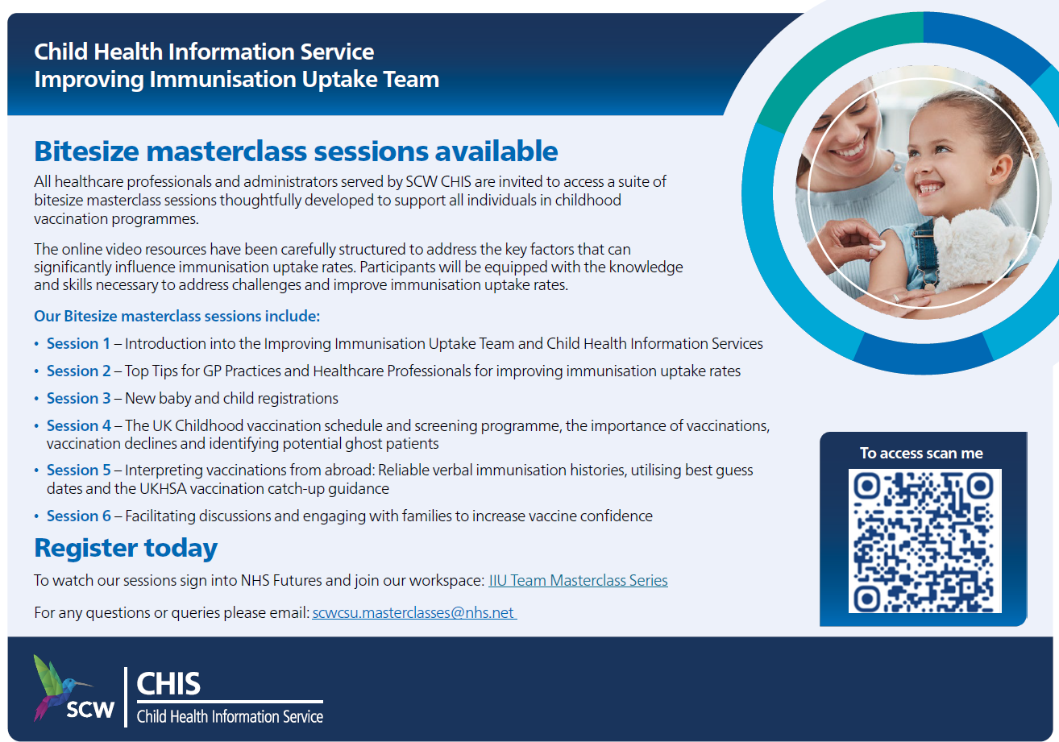

Issuing and Accessing Patient Group Directions (PGDs)
The Vaccination Team is responsible for providing all current Patient Group Directions (PGDs) pertaining to routine immunisation programmes. It is essential to obtain PGDs directly from the team, as PGDs accessed from the UK Health Security Agency (UKHSA) website may not have regional authorisation. The Vaccination Team will ensure PGDs are distributed to providers well ahead of any expiry dates, allowing ample time for implementation and compliance.
Patient Group Directions are also available on the NHS England Midlands website: NHS England — Midlands » East Midlands Screening and Immunisation Team (SIT) and It is important to always use the most up-to-date version of any PGD. For questions or concerns regarding PGDs, or any other legal mechanisms, please direct enquiries to the EMICAS inbox. england.imms@nhs.net

vaccine update – GOV.UK
Please note - all “Vaccine Updates” are available here: https://www.gov.uk/government/collections/vaccine-update
The latest edition was published on 16th April 2026: https://www.gov.uk/government/publications/vaccine-update-issue-370-march-2026/vaccine-update-issue-370-march-2026
And includes:
- details of the updates to the Human Medicines Regulations
- updates to Green Book chapters
- routine and non-routine vaccine supply
You can view and download a PDF copy for free from Find Public Health Resources using the product code: 1265469TEN001
It is recommended that all health care professionals involved in vaccination subscribe to the vaccine update. Please access this link to activate a subscription: https://public.govdelivery.com/accounts/UKHPA/subscribers/new?preferences=true

COLD CHAIN and vaccine incident MANAGEMENT
As part of NHS England, the East Midlands Vaccination Team are responsible for commissioning and performance managing the routine immunisation programmes. This includes ensuring safe and effective delivery of these programmes. Because of this any cold chain and vaccine incident should be reported directly to the team at: england.imms@nhs.net .
NHSE would like to improve its response to incidents, and this relies on accurate and timely reporting by providers because occasionally incidents may require a wider public health response. Please see below the correct processes for incident reporting in our area:
Reporting cold chain incidents
On identifying a potential incident, the Vaccination Team should be contacted as soon as is practicably possible on the same day that the incident is discovered to discuss and for advice re next steps.
- If categorised as a cold chain incident the team will advise re next steps. If patients have been vaccinated with affected stock a cold chain incident form will be issued to the provider, to be completed and returned within 10 days.
- Depending on the severity of the cold chain incident you may be advised to contact the vaccine manufacturers for information about vaccine stability and further use of.
- The team will keep a record of the incident, actions and outcome for audit and monitoring purposes. An incident reference number will be allocated.
- Depending on the severity of the cold chain incident, vaccine manufacturers may advise that vaccines have maintained stability and are still safe to use “off label”, this means that the vaccines are still within their licence.
- Do not discard any vaccines prior to discussing with the Vaccination Team. If any vaccines are wasted because of the incident, then this wastage should be reported on to ImmForm, this will then generate a cost invoice to the team. If no vaccines are wasted, then there is no requirement to report on ImmForm.

The use of “off label” vaccines
- Not all cold chain interruptions will result in the need for vaccines to be destroyed. When storage temperatures have varied a little for a short period of time, some vaccines can tolerate this fluctuation and the safety of the vaccine and way in which it works may not be affected.
- In this instance the vaccines can still be used “off label” this means that the vaccine is still licensed but it is being used in a different way to that stated within the licence (i.e. out of recommended temperature ranges (+2 ° to +8 ° C) The “off label” use of vaccines is determined by what is known about the vaccine from information provided by the manufacturer, the World Health Organisation and from special stability studies. NHS England, UKHSA, and the vaccine manufacturer will advise on whether the vaccine can still be used.
- Using vaccines “off label” is not a way of saving money, it is a waste of public money to throw away expensive vaccines unnecessarily, also to have to delay vaccination could put a patient at risk of a serious infection.
The decision to allow “off label” use will only be taken if the vaccine is still considered to be safe and effective. It is recognised that the ultimate decision in each practice to use vaccines “off label” rests with the lead clinician, however the Vaccination Team fully endorse this practice.
Reporting vaccine incidents
- On identifying a vaccine incident, the Vaccination Team should be contacted as soon as is practicably possible on the same day that the incident is discovered to discuss and for advice re the next steps.
- Once confirmed the team will issue a vaccine incident form to the provider, which should be completed and returned within 10 days.
- The Vaccination Team will assess the incident to ascertain what steps have been taken to ensure patient/staff safety and if there are any further actions to be taken by them or the provider.
- The Vaccination Team will keep a record of the incident, actions and outcome for audit and monitoring purposes. An incident reference number will be allocated.
- Depending on the degree of risk to patients/personnel involved it may be necessary for the team to escalate as a “serious incident”, in which case the serious incident protocol would then be followed.
For further information the UKHSA publication Vaccine incident guidance: Responding to errors in vaccine storage, handling and administration includes sections about Duty of Candour and incident management.

Useful Documents
- A poster for display in clinical areas promoting our immunisation clinical advice service:
- UPDATED December 2025: The Routine Childhood Immunisation Schedule:
Routine childhood immunisations schedule from January 2026

- UPDATED February 2026: Incomplete or uncertain immunisation schedule:
https://assets.publishing.service.gov.uk/media/6980e6b8ec71a16669612e40/UKHSA_13259_Algorithm_immunisation_status_Febuary_2026__A4_Landscape__WEB.pdf

- UPDATED September 2025: Immunisation cohorts and providers for 2025/26
- The Green Book – Immunisation Against Disease - Immunisation against infectious disease - GOV.UK (www.gov.uk)

THE Vaccination TEAM
The East Midlands Vaccination Team cover all counties in the East Midlands region.
Contact details for immunisation queries:
- Any routine immunisation (Section 7A) enquiries or incidents (including cold chain & vaccine incidents) should be sent to the East Midlands Immunisation Clinical Advice Service (EMICAS) generic inbox england.imms@nhs.net
Please include your practice ODS code in the email title, when contacting EMICAS, for us to appropriately record and audit queries and incidents. Failure to do so may result in a delay in answering your query.
- All ImmForm queries should be emailed to: Helpdesk@immform.org.uk or 0207 183 8580.
- All practice payment queries should be emailed to: GP Contracting EMids:
nnicb-nn.eastmidlands-pcgp@nhs.net

OTHER COntact Details

CHILD HEALTH INFORMATION SERVICES (CHIS)
LINCOLNSHIRE | scwcsu.Lincs.chis@nhs.net Tel: 0300 561 0234
LEICESTERSHIRE | scwcsu.LLRMovementsteam.chis@nhs.net Tel: 0300 561 0234  scwcsu.LLRchildhealthrecords.chis@nhs.net Tel: 0300 561 0234  scwcsu.LLRbirthsregistrationteam.chis@nhs.net Tel: 0300 561 0234
NORTHAMPTONSHIRE | scwcsu.northants.chis@nhs.net Tel: 0300 561 0234
DERBY AND DERBYSHIRE | scwcsu.derbyshire.chis@nhs.net Tel: 0300 561 0234
NOTTS AND NOTTINGHAMSHIRE | Nottingham City - scwcsu.nottscity.chis@nhs.net Tel: 0300 561 0234  Notts County - scwcsu.nottscounty.chis@nhs.net Tel: 0300 561 0234  Bassett Law - scwcsu.Bassetlaw.chis@nhs.net Tel: 0300 561 0234
SCHOOL AGED IMMUNISATION SERVICE (SAIS)
LINCOLNSHIRE | lhnt.sais@nhs.net 01522 572950
LEICESTERSHIRE | Leicestershire Partnership NHS Trust: 0300 3000 007
NORTHAMPTONSHIRE | Imms.nhft@nhs.net 0800 170 7055 (option 5)
DERBY AND DERBYSHIRE | immunisations.derbyshire@intrahealth.co.uk Tel: 03333583397 Option 5
NOTTS AND NOTTINGHAMSHIRE | immunisations.nottinghamshire@intrahealth.co.uk Tel: 03333583397 Option 4

