
June 2026

EAST MIDLANDS VACCINATION TEAM BULLETIN

PLEASE CASCADE TO ALL relevant STAFF, INCLUDING GPS, PRACTICE NURSES, ADMIN AND RECEpTION STAFF

Getting it right: addressing common vaccination queries in general practice WEBINAR
The NHSE East Midlands Vaccination Team would like to invite you to a webinar:
Getting It Right: Addressing Common Vaccination Queries in General Practice
This will be jointly presented by the NHSE vaccination team and the Improving Immunisation Uptake Team (SCW CHIS). Presentations will focus on common queries we receive into our clinical advice service (ICAS), operational issues and best practice advice.

If you are interested in joining us for the webinar on 16th June 2026 at 12:30-13:15, please complete the form at the link below to register and an electronic invite will be sent to you approx. 1 week before the event. If you have any questions, please send them to england.midlandsvaccs@nhs.net


https://forms.cloud.microsoft/e/xK65n7LsXr?origin=lprLink

Routine immunisations
A training slide set on co-administration of vaccines for older adults is now available to download via the weblink below. Please see under “routine immunisation schedules”.
https://www.gov.uk/government/collections/immunisation#routine-immunisation-schedules

university approached research study
Caterina Manconi, a medical student at Brunel University London is conducting a low-risk, university ethics-approved research study exploring healthcare professionals’ experiences of addressing parental vaccine hesitancy in childhood vaccination programmes.
Ethics approval reference: 51113-MA-Sep/2025-54651-2
The study involves a short Microsoft Teams interview (approximately 30 minutes) with flexible scheduling, and participants receive a £15 Love2Shop voucher as a thank you for their time. There is no requirement to identify or contact patients directly. For further details about how to take part in this study, please refer to the poster below:

EAST MIDLANDS CANCER ALLIANCE – DRIVING PROGRESS IN HPV VACCINATION UPTAKE – THANK YOU TO PRACTICES FOR SUPPORTING THE HPV PROGRAMME

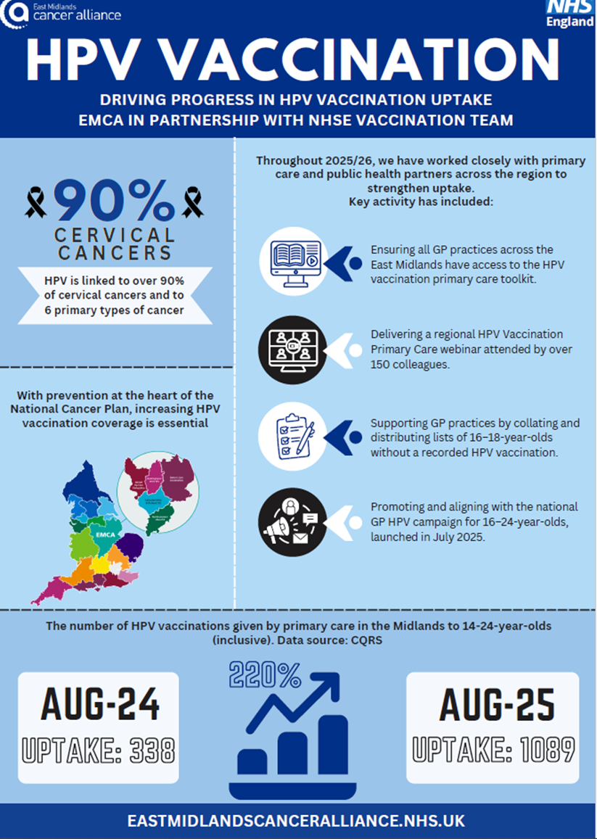

clinical advice regarding parents refusing mmrv vaccine
As requests from parents for MMR instead of MMRV continue to cause confusion, we are re-sharing the UKHSA briefing published in February 2026 to support practitioners.
Please note - This is not the norm but “pragmatic advice in the small number of instances where parents still decline MMRV after appropriate advice has been given, and the clinician is concerned that the child remains vulnerable to other infections”. This is a national briefing and not related to a specific region.
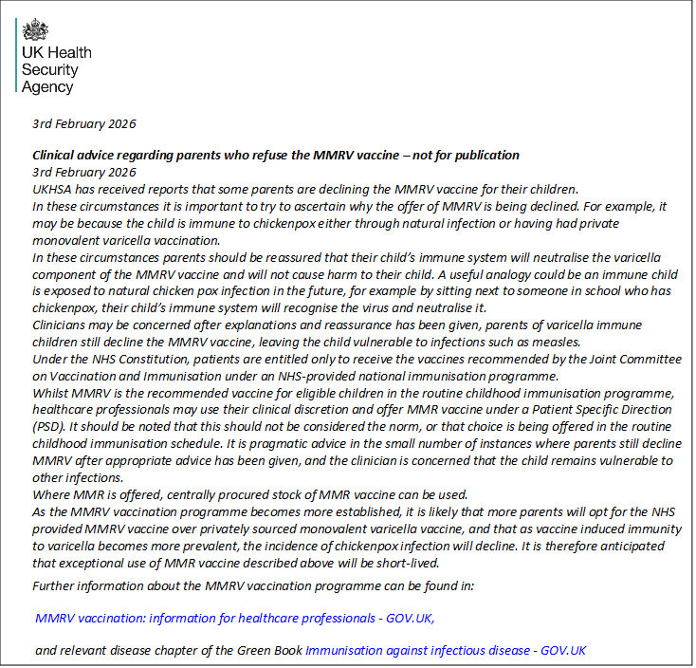

IMPORTANT Information - Priorix tetra mmrv vaccine
Concerns have been raised nationally that the Priorix-Tetra 10-pack carton presentation in which the lyophilised vaccine vials within the carton may not be readily visible upon opening the pack and may be overlooked during preparation. This has resulted in reports of the vial being missed and diluent only being administered (vaccine not reconstituted). GSK, in agreement with the Medicines and Healthcare products Regulatory Agency (MHRA), have now released this information below:
All those involved in administering Priorix-Tetra vaccine should be aware of the requirement for reconstitution (by mixing the lyophilised antigen with the supplied sterile water diluent) immediately before administration:
Key Messages
- Priorix-Tetra is supplied as a lyophilised vaccine vial and a separate pre-filled syringe containing solvent (diluent). The vaccine must be reconstituted with the supplied solvent immediately prior to administration.
- GSK have received reports about the Priorix-Tetra 10-pack carton presentation in which the lyophilised vaccine vials within the carton may not be readily visible on opening the pack.
- The lyophilised vaccine vial may be overlooked during preparation, which could result in a medica on error in which only diluent is administered (i.e., vaccine not reconstituted
- This has been identified in all packs currently used in the UK childhood immunisation programme.
- To ensure correct preparation, remove any cardboard protective covering from inside the multi-pack cartons and ensure both the pre-filled syringe and lyophilised vaccine vial are located and used for reconstitution prior to administration.
- If instructions are not followed, the packaging design may conceal lyophilised vaccine vials within the carton/inner packaging; these vials can be missed during preparation, resulting in administration of diluent only.
- GSK assessment indicates that the diluent (water for injection) itself poses no harm to the patient. The risk arises from the absence of vaccination against measles, mumps, rubella and varicella following this administration error.

Issuing and Accessing Patient Group Directions (PGDs)
The East Midlands Vaccination Team is responsible for providing all current Patient Group Directions (PGDs) pertaining to routine immunisation programmes. It is essential to obtain PGDs directly from the team, because PGDs accessed from the UK Health Security Agency (UKHSA) website do not have regional authorisation. The team will ensure PGDs are distributed to providers well ahead of any expiry dates, allowing ample time for implementation and compliance.
Patient Group Directions are also available on the NHS England Midlands website: NHS England — Midlands » East Midlands Screening and Immunisation Team (SIT). It is important to always use the most up-to-date version of any PGD.
For questions or concerns regarding PGDs, or any other legal mechanisms, please direct enquiries to the EMICAS inbox. england.imms@nhs.net

vaccine update – GOV.UK
Please note - all “Vaccine Updates” are available here: https://www.gov.uk/government/collections/vaccine-update
The latest edition was published on 16th April 2026
https://www.gov.uk/government/publications/vaccine-update-issue-370-march-2026
And includes:
- details of the updates to the Human Medicines Regulations
- updates to Green Book chapters
- routine and non-routine vaccine supply
You can view and download a PDF copy for free from Find Public Health Resources using the product code: 1265469QEN001. It is recommended that all health care professionals involved in vaccination subscribe to the vaccine update. Please access this link to activate a subscription: https://public.govdelivery.com/accounts/UKHPA/subscribers/new?preferences=true

COLD CHAIN MANAGEMENT
As part of NHS England – East Midlands, the Vaccination Team are responsible for commissioning and performance managing all the routine immunisation programmes. This includes ensuring safe and effective delivery of these programmes. Because of this any cold chain and vaccine incidents should be reported directly to the team.
Please see below for the correct process for cold chain incident reporting in our area:
- On identifying a potential incident, the Vaccination Team should be contacted via the EMICAS inbox england.imms@nhs.net as soon as is practicably possible on the same day that the incident is discovered, to discuss next steps.
- The reporting email should contain full details about the incident and evidence of temperature breach/timeframe where possible.
- If categorised as a cold chain incident by the team the next steps will be outlined in the email response from them, and you will be given a reference number. If full details have been provided completion of an incident form will be required only if patients have been vaccinated with affected stock.
- Depending on the severity of the cold chain incident you may be advised to contact the vaccine manufacturers for information about vaccine stability and further use.
- The team will keep a record of the incident, actions and outcome for audit and monitoring purposes.
- Depending on the severity of the cold chain incident, vaccine manufacturers may advise that vaccines have maintained stability and are still safe to use “off label”, this means that the vaccines are still within their licence.
- Do not discard any vaccines prior to discussing with the Vaccination Team. If any vaccines need to be destroyed because of the incident, then this wastage should be reported on to ImmForm, as a stock incident, which will then generate a cost invoice to the team. Please note - If no vaccines are wasted, then there is no requirement to report on ImmForm.
The use of “off label” vaccines
- Not all cold chain interruptions will result in the need for vaccines to be destroyed. When storage temperatures have varied a little for a short period of time, some vaccines can tolerate this fluctuation and the safety of the vaccine and way in which it works may not be affected.
- In this instance the vaccines can still be used “off label” this means that the vaccine is still licensed but it is being used in a different way to that stated within the licence (i.e. out of recommended temperature ranges (+2 ° to +8 ° C) The “off label” use of vaccines is determined by what is known about the vaccine from information provided by the manufacturer, the World Health Organisation and from special stability studies. NHS England, UKHSA, and the vaccine manufacturer will advise on whether the vaccine can still be used.
- Using vaccines “off label” is not a way of saving money, it is a waste of public money to throw away expensive vaccines unnecessarily, also to have to delay vaccination could put a patient at risk of a serious infection.
The decision to allow “off label” use will only be taken if the vaccine is still considered to be safe and effective. It is recognised that the ultimate decision in each practice to use vaccines “off label” rests with the lead clinician, however the Vaccination Team fully endorse this practice.

Useful Documents
- A poster for display in clinical areas promoting our immunisation clinical advice service:
- UPDATED March 2026: The Routine Childhood Immunisation Schedule:
https://assets.publishing.service.gov.uk/media/6929ccb59c1eda2cdf034301/UKHSA_13284_Complete_Immunisation_schedule_children_born_on_or_before_30_June_24_11_WEB.pdf
- UPDATED May 2026: Incomplete or uncertain immunisation schedule:
https://assets.publishing.service.gov.uk/media/69fb33b34fb0713aa63ea51c/UKHSA_13572_Algorithm_immunisation_status_2026__A4_Landscape__01_WEB.pdf

- UPDATED September 2025: Immunisation cohorts and providers for 2025/26
- The Green Book – Immunisation Against Disease - https://www.gov.uk/government/collections/immunisation-against-infectious-disease-the-green-book

THE vaccination team
The East Midlands Vaccination Team cover all counties in the East Midlands region.
Contact details for immunisation queries:
- Any routine immunisation (Section 7A) enquiries or incidents (including cold chain & vaccine incidents) should be sent to the East Midlands Immunisation Clinical Advice Service (EMICAS) generic inbox england.imms@nhs.net
Please include your practice ODS code in the email title, when contacting EMICAS, for us to appropriately record and audit queries and incidents. Failure to do so may result in a delay in answering your query.
- All ImmForm queries should be emailed to: Helpdesk@immform.org.uk or 0207 183 8580.
- All practice payment queries should be emailed to: GP Contracting EMids: nnicb-nn.eastmidlands-pcgp@nhs.net

OTHER KEY COntact Details

CHILD HEALTH INFORMATION SERVICES (CHIS)
LINCOLNSHIRE | scwcsu.Lincs.chis@nhs.net Tel: 0300 561 0234
LEICESTERSHIRE | scwcsu.LLRMovementsteam.chis@nhs.net Tel: 0300 561 0234  scwcsu.LLRchildhealthrecords.chis@nhs.net Tel: 0300 561 0234  scwcsu.LLRbirthsregistrationteam.chis@nhs.net Tel: 0300 561 0234
NORTHAMPTONSHIRE | scwcsu.northants.chis@nhs.net Tel: 0300 561 0234
DERBY AND DERBYSHIRE | scwcsu.derbyshire.chis@nhs.net Tel: 0300 561 0234
NOTTS AND NOTTINGHAMSHIRE | Nottingham City - scwcsu.nottscity.chis@nhs.net Tel: 0300 561 0234  Notts County - scwcsu.nottscounty.chis@nhs.net Tel: 0300 561 0234  Bassett Law - scwcsu.Bassetlaw.chis@nhs.net Tel: 0300 561 0234
SCHOOL AGED IMMUNISATION SERVICE (SAIS)
LINCOLNSHIRE | lhnt.sais@nhs.net 01522 572950
LEICESTERSHIRE | Leicestershire Partnership NHS Trust: 0300 3000 007
NORTHAMPTONSHIRE | Imms.nhft@nhs.net 0800 170 7055 (option 5)
DERBY AND DERBYSHIRE | immunisations.derbyshire@intrahealth.co.uk Tel: 03333583397 Option 5
NOTTS AND NOTTINGHAMSHIRE | immunisations.nottinghamshire@intrahealth.co.uk Tel: 03333583397 Option 4

