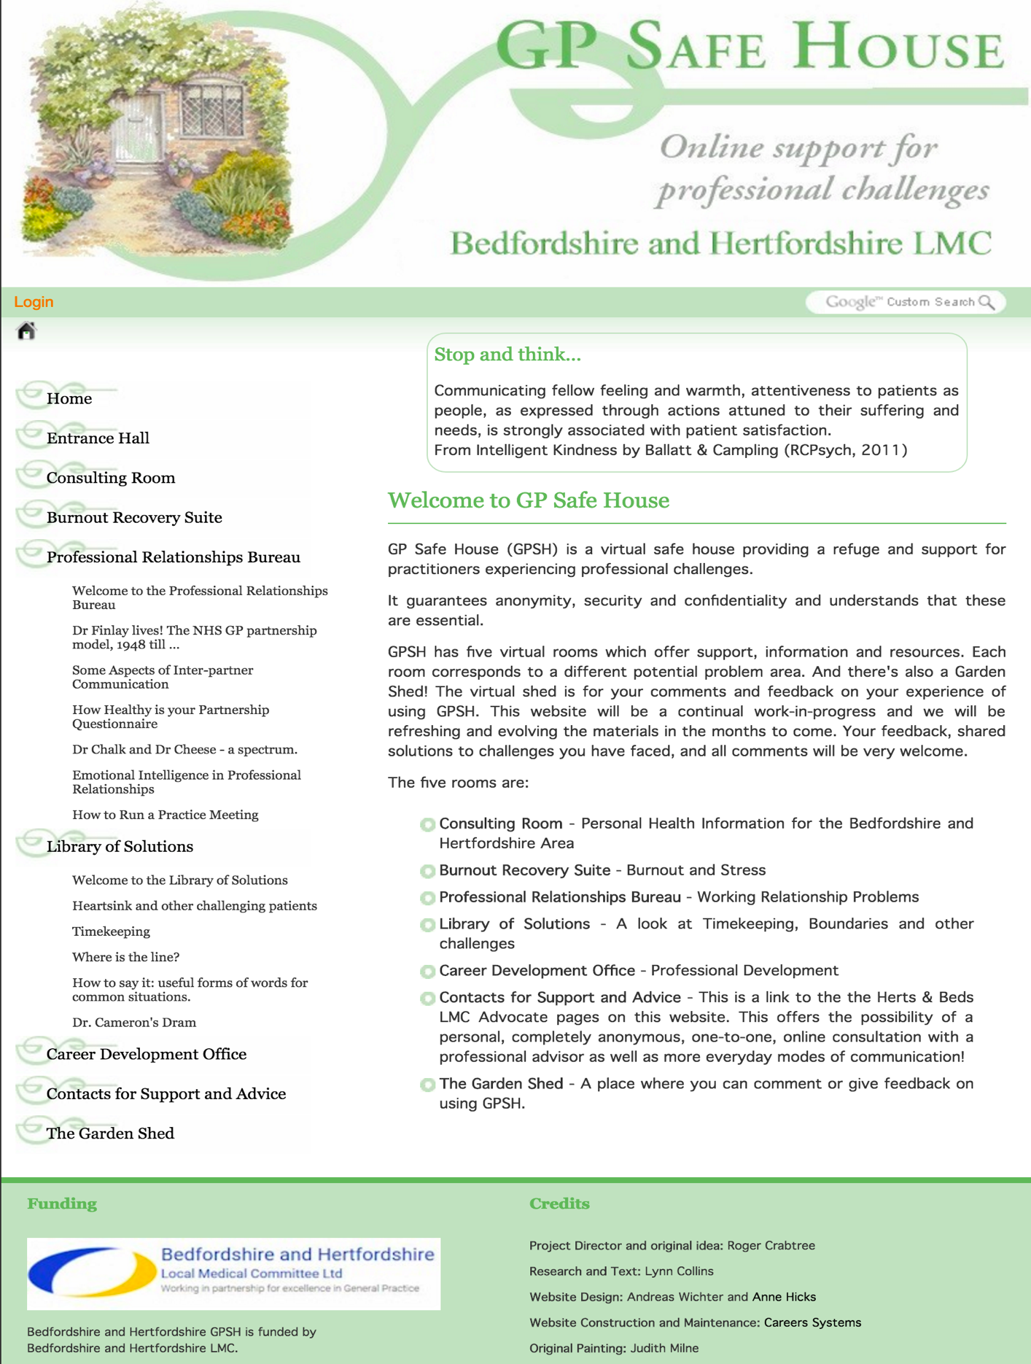

This invaluable resource is available for Beds and Herts GPs and is provided by the LMC. All GPs will have been sent log in details (most of the site is password protected) but if needed passwords can be re-requested from the LMC office. The site also allows GPs to anonymously ask for contact from an ‘advocate’ who can then provide advice and support.

