THE GREATER MANCHESTER RESPIRATORY IMPROVEMENT FRAMEWORK
DRAFT
(2019-2024)

Version | DRAFT
Date | 31st October 2019
Document Authors | Gareth Lord - Programme Manager – H&SCP (SCN) Gareth.lord@nhs.net  Jennifer Hoyle – Clinical Lead – H&SCP (SCN) – Jennifer.Hoyle@pat.nhs.uk  Murugesan Raja – Primary Care Advisor – H&SCP (SCN) - murugesan.raja@nhs.net
Developed by | GM Respiratory SCN and wider stakeholders
Version | First version
Intended Audience | Clinicians, commissioners and managers involved in improving care for people with respiratory disease.
The purpose of this document | This purpose of this report is to set out the vision to improve the health of people living in Greater Manchester (GM) with or at risk of respiratory disease over the next 5 years. This report outlines the newly proposed GM Respiratory Improvement Framework; it’s priorities, scope and initiatives.

Contents
1.0 BACKGROUND AND CONTEXT 4
2.0 FORMATION OF THE FRAMEWORK 4
2.1. THE GM RESPIRATORY STEERING GROUP 4
2.2. VISION AND MISSION 6
2.3. PRIORITIES 6
2.4. THEMES 6
2.5. SCOPE (ALL AGES) 6
2.6. WIDER CONSULTATION 6
3.0 GM RESPIRATORY IMPROVEMENT FRAMEWORK 7
4.0 NATIONAL AND REGIONAL LINKS 13
5.0 RESPIRATORY IMPROVEMENT FRAMEWORK PRIORITIES 13
5.1 EARLY DETECTION AND IMPROVED DIAGNOSIS 13
5.2 HELPING TO PREVENT INFLUENZA AND SUBSEQUENT PNUEMONIA 14
5.4 HELPING TO REDUCE TOBACCO ADDICTION 14
5.5 REDUCING AVOIDABLE PRESENTATIONS TO HOSPITAL 15
6.0 METRICS AND DATA 16
7.0 APPENDICIES 17

BACKGROUND AND CONTEXT

Respiratory disease is medical term that encompasses respiratory infections (influenza, bacterial pneumonia), chronic diseases (asthma, chronic obstructive pulmonary disease (COPD)) and uncontrolled cell growth (lung cancer). Although some diseases can be mild and self-limiting for example; the common cold, many are often life threatening.
Acute respiratory infections are the most common chronic disease in children worldwide and the leading overall cause of death in developing countries. Chronic diseases such as COPD are the 4th leading cause of death worldwide, and lung cancer remains the leading cause of cancer death. Given the increase in population, prevalence and the numbers at risk, respiratory disease continues to pose a growing problem for health and health and social care services.
This is particularly so in GM where respiratory disease is second only to circulatory disease when it comes to unwarranted variation on total spend, bed occupancy and non-elective admissions. GM has one of the highest rates in the country for emergency admissions in children with lower respiratory tract infections. And as for adults with chronic obstructive disease, the picture is equally as stark. Some areas of GM have more than twice the national average emergency admissions and almost double the national mortality rate. Prescribing expenditure and smoking prevalence remain higher than relative peers and uptake of preventative vaccines low.
Following initial scoping work carried out by the GM HSC Partnerships (theme 3 workstream) the Strategic Clinical Network (SCN) and NHS Rightcare, it was concluded there are many challenges with respiratory disease and despite existing initiatives:
- It was unclear if the main challenges were being addressed and;
- It was clear that current and planned initiatives could be co-ordinated more effectively

In 2018, the Executive Lead for Quality in the GM Health and Social Care Partnership (GM HSCP) gave the mandate to the Strategic Clinical Network (SCN) to begin work identifying what needed to be done in addition to what is already being done (or planned to be done) across GM and to outline what a GM Respiratory Improvement Framework might look like through clinical consensus.

FORMATION OF THE FRAMEWORK

2.1. THE GM RESPIRATORY STEERING GROUP
In June 2018, the SCN began liaising with a wide range of respiratory stakeholders and set up a GM Respiratory Steering Group consisting of clinicians, commissioners, Taking Charge leads, Public Health and patient/public representation (refer to membership in appendix 1).
The aims being to:
- Identify GM priorities based on the biggest impact
- Review existing initiatives against the priorities
- Propose (where necessary) a set of new initiatives where there are gaps/opportunities and to;
- Make recommendations as how-to co-ordinate respiratory initiatives more effectively.

The following diagram outlines the governance structure used during this process.
Fig. 1 Early governance structure
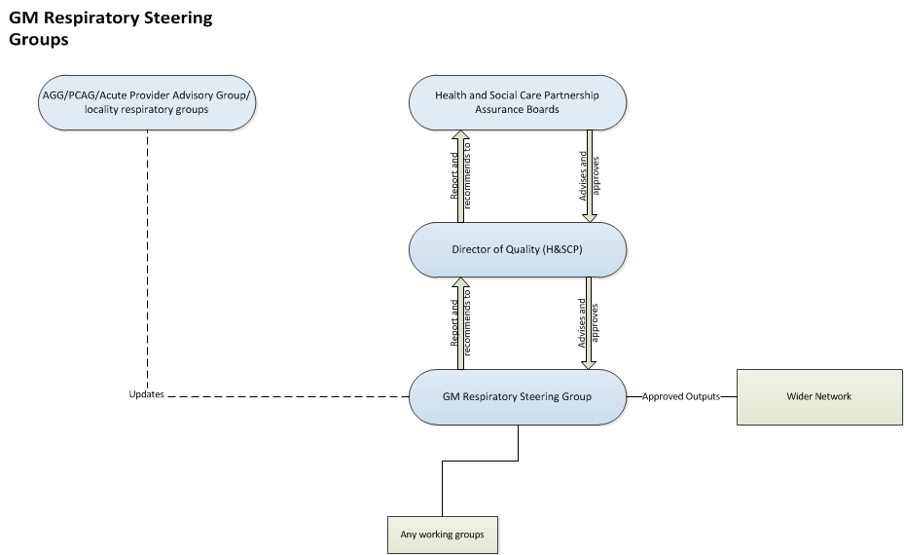

To ensure cohesion of parallel programmes, the SCN linked with leaders of existing initiatives and fused the planning of workstreams either via the GM Respiratory Steering Group or though supporting task and finish groups. Examples of this include; bringing together the Make Smoking History, and CURE programme leads with local respiratory clinical leads to discuss tobacco addiction; involving population health, public health and local clinicians to discuss seasonal influenza and involving a variety of separate but inter-related workstreams such as those for Children and Young People, Cardiovascular, Frailty, Mental Health, and Cancer as part of ongoing conversations.
Other partners have so far included Health Innovation Manchester, NHS England/Improvement, NHS Rightcare, The British Thoracic Society and the British Lung Foundation either as part of an ongoing dialogue or as a symbiotic partnership to serve the same common ambition(s).
For full interdependencies refer to appendix 2.

Following a collective evaluation of the data, and a range of professional opinions, the GM Respiratory Steering Group agreed the following:

  - VISION AND MISSION
Our vision is “to empower the people of Greater Manchester to improve their lung health.”
We will do this by; maximising education opportunities, providing early preventative interventions, improving early detection and diagnosis and supporting those with more severe illness with timely patient and family focussed support.
  - PRIORITIES
- Improving early detection and diagnosis
- Helping to prevent influenza and subsequent pneumonia
- Helping to reduce tobacco addiction
- Preventing/reducing avoidable hospital presentations
  - THEMES
Themes are consistent with other clinical disciplines
Prevention; early detection and quality diagnosis; community-based support; planned care; unplanned care and end of life care
  - SCOPE (ALL AGES)
Influenza, pneumonia, COPD, asthma, and people with or at risk of other lung diseases affected by smoking, influenza that could benefit from improved self-management.
  - WIDER CONSULTATION
Assisted by several task and finish groups, the GM Respiratory Steering Group worked up a set of proposed initiatives that could address the vision and priorities.
These proposed initiatives, along with the priorities were then put forward for wider consultation on Friday 30th November 2018 as part of a GM respiratory stakeholder event; an event attended by more than 100 people from across the system. There was general approval of both the priorities and the initiatives. Although, some of the newly proposed initiatives were later revised to take in to account broader stakeholder views, developments within the task and finish groups, proposals in the NHS Long Term Plan and agreed actions from the North West Respiratory Improvement Event.
The combination of existing initiatives and newly proposed initiatives form the GM Respiratory Improvement Framework.

GM RESPIRATORY IMPROVEMENT FRAMEWORK

Fig 2. GM RESPIRATORY IMPROVEMENT FRAMEWORK ON A PAGE
GM Respiratory Improvement Framework
 | Focus |  |  | Focus |  |  | Focus |  |  | Focus
Early detection and improved diagnosis | PC | SC | Influenza and pneumonia | PC | SC | Tobacco addiction | PC | SC | Avoidable presentations to hospital | PC | SC
Newly proposed initiatives
Population provision of Quality Assured Spirometry | ✓ |  | Influenza/pneumonia vaccines in OP clinics |  | ✓ | GM approach to Primary Care (joint work with population health/Make Smoking History) | ✓ |  | Education model for those living with breathlessness as part of best practice pathway | ✓ | ✓
Opportunistic detection (pilots) | ✓ | ✓ | Explore point of care testing |  | ✓ |  |  |  | Education sessions (pilots) | ✓ | ✓
Case finding\cleaning registers | ✓ |  | Pathways to manage pneumonia | ✓ |  |  |  |  | Exploration of effective patient reviews + discharge bundle | ✓ | ✓
Existing initiatives
Lung Cancer Screening | ✓ | ✓ | Seasonal vaccination programme | ✓ |  | CURE Roll out |  | ✓ | CYP Preventing Avoidable Admission pilots |  | ✓
 |  |  |  |  |  | Make Smoking History | ✓ |  | CYP Asthma Care Pathway Standards | ✓ | ✓
 |  |  |  |  |  | Local smoking cessation services | ✓ | ✓ | CYP Community Nursing Teams | ✓
 |  |  |  |  |  |  |  |  | Virtual clinics | ✓
 |  |  |  |  |  |  |  |  | Digital solutions e.g. MyCOPD | ✓
 |  |  |  |  |  |  |  |  | Provision of oxygen |  | ✓
 |  |  |  |  |  |  |  |  | Community pharmacy inhaler technique | ✓
PC - Primary Care |  |  | Purple - cancer programmes; Red - Make Smoking History; Green - CYP programmes;
SC - Secondary Care |  |  | Light blue - HinM programme; Grey locality programmes; Orange - Theme 3; Dark blue - Theme 2

FIG. 3. FRAMEWORK WITHIN THE THEMES
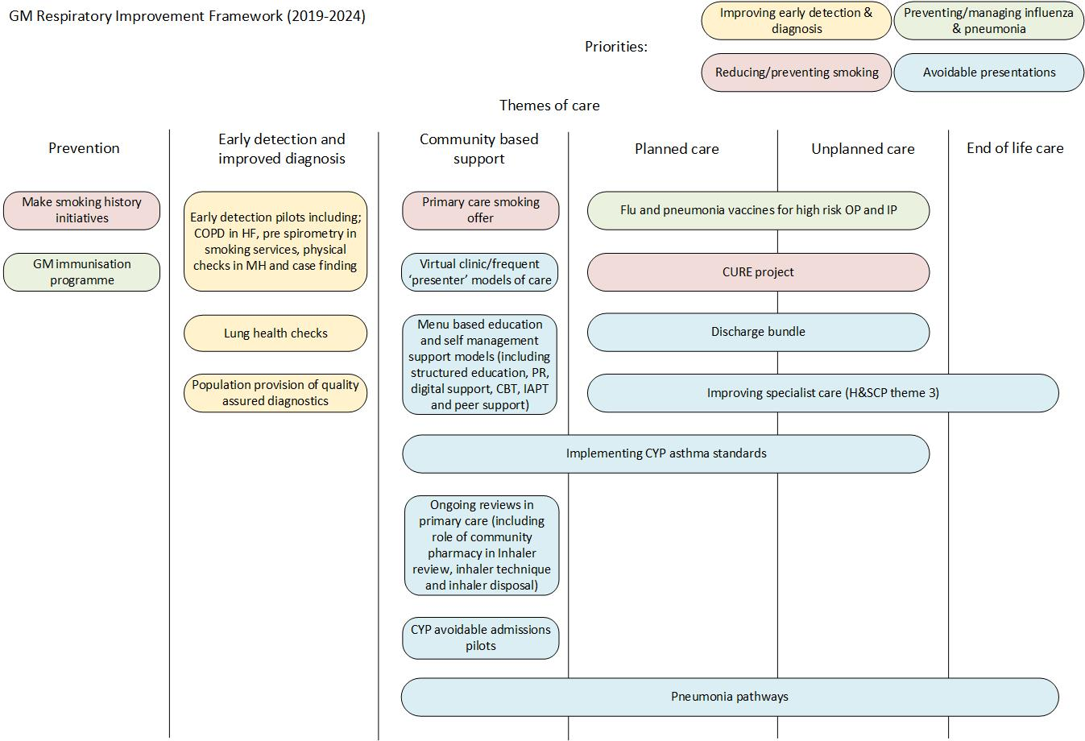
Fig 4. How the GM Framework aligns with the NHS Long Term Plan
GM RIF Priorities | NHS LTP Priorities | GM plans
Improving early detection and diagnosis | Improving early detection and diagnosis | *Agree strategic approach to QAS to improve diagnosis followed by implementation  *Roll out lung health checks  *Proof of concept of opportunistic testing
Helping to prevent influenza and subsequent pneumonia | Improving the management of community acquired pneumonia | *Unpicking challenges with pneumonia and exploring best practice pathways, risk scoring  *Opportunistic influenza and Pneumonia vaccines in secondary care where previously not received
Helping to reduce tobacco addiction | Helping to reduce tobacco addiction | *Roll out of Ottowa model (CURE) in secondary care  *Develop GM primary care offer to support people to quit smoking  *Support localities using training packages to standardise support
Preventing/reducing avoidable hospital presentations | Pulmonary Rehabilitation/structured education | *Agree GM education model  *Gap analysis, and recommendations to improve local services for breathlessness that includes PR (but not limited to) followed by implementation  *Explore early education taster sessions  *Roll out of digital solutions  *Roll out COPD discharge bundle
 | Receiving and using the right medication | *Evaluate alternative means to support ongoing patient reviews  *Community pharmacy medication/inhaler advice, technique and disposal  *Virtual clinics  *Asthma standards/admission avoidance care bundle  *Improving specialist care (theme 3)
Key: Blue text – alignment to LTP objectives, Black text - additional to LTP objectives

Fig. 5 How new proposals align with existing proposals
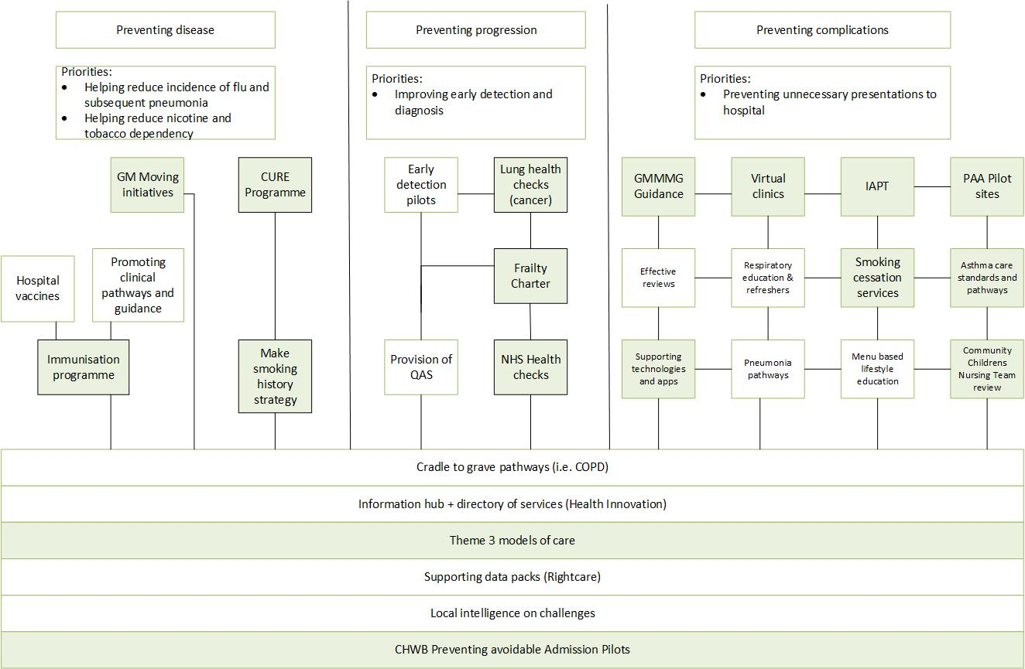
White boxes – newly proposed initiatives; green boxes existing
The GM Respiratory Improvement Framework is a GM collaborative endeavour that will combine innovative means to detect, diagnose, and treat people with respiratory conditions, with strategic recommendations and pathways that act as a precursor to intuitive models of care. The framework will focus on the interventions that have the most value (refer to fig. 7 as an example) and it will continue to work toward the ambition set out in the Taking Charge plan to have 580 fewer respiratory deaths by 2021.
Fig. 6 System architecture and approach
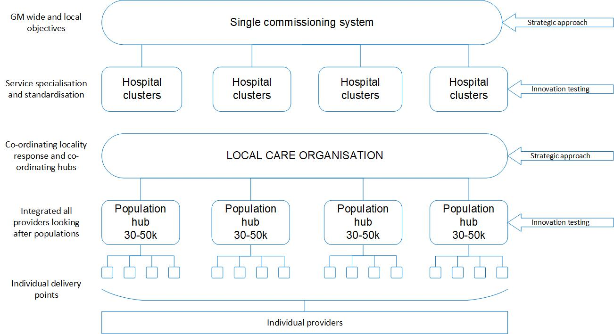
Fig 7. COPD Value pyramid
*Not specific to COPD
Increasing Value

Source: London Respiratory Network with The London School of Economics (2013 report) QALY= quality-adjusted life year

Although the framework preceded the publication of the NHS Long Term Plan, the principles and objectives are aligned (refer to fig.5), and the timescales have since been adjusted to compliment those set out by the national team (refer to appendix 3).
To co-ordinate delivery against the objectives, the framework will set out a strategic focus that precedes GM level planning and delivery. This is to enable the GM system to ‘prepare’ its assets and align thinking ahead of local and national targeted investment (refer to fig. 8). The frameworks strategic work is intended to outline the vision in each priority, describe the ideal clinical models of care and offer evidence and recommendations as to how localities could meet the ideal. The strategic work will also aid consistency and set out markers that aim to reduce unnecessary variation against the agreed priorities.
The strategic work will:
- Describe methods of prevention in relation to respiratory disease and options for local delivery
- Describe options to enable the early detection of respiratory diseases
- Describe a model and options for improving the diagnosis of respiratory diseases
- Describe education models and options for delivery
- Describe self-management models of care and options for delivery
Refer to appendix 4 as an example as to how this work will support GM level pathways.
Fig. 8. Process for GM deliverables
Strategic approach
SCN (on behalf of GM HSCP) + Taking Charge Leads + other GM leads

Governance
Refer to governing groups in appendix 2

Planning and delivery
Locality assets, + GM partners and assets that include Health Innovation Manchester, AQUA, 3rd sector etc.

Whilst the strategic work will describe the ‘what?’, and the ‘why?’, it should be noted that it will only offer suggestion as to ‘how?’ the ideal can be met. Ultimately, it will be up to each locality to decide how they can best meet the ideal service provision outlined as it’s recognised that localities will not all be starting from the same baseline(s).

NATIONAL AND REGIONAL LINKS

The GM Respiratory Improvement Framework is closely linked with regional and national operations to ensure continued delivery against the objectives and developments that emerge from the NHS Long Term Plan. This includes links to the national CVD-Respiratory Programme Board, and membership on the Regional Boards.
As a result, GM will be at the forefront in the key spreading of best practice nationally that includes; opportunistic influenza vaccines, respiratory structured education, lung health checks and the CURE project.

RESPIRATORY IMPROVEMENT FRAMEWORK PRIORITIES

The GM Respiratory Improvement Framework priorities were identified on the basis of their impact, and the detriment caused to the wider health economy. The rationale and objectives for each priority are as follows:
  - EARLY DETECTION AND IMPROVED DIAGNOSIS
Evidence suggests that around 25% of people on general practice COPD registers in the UK do not meet the diagnostic criteria for COPD. This means 1 in 4 people on COPD registers (that’s around 17,000 in GM) may be receiving inappropriate and expensive therapies they do not need. Much of this misdiagnosis is due to spirometry failing to meet the essential quality standards. In fact, 1 in 5 people in GM have a diagnosis of COPD (around 13,600) and not even had spirometry testing, and in many cases the spirometry provided was not quality assured.
Perhaps more significantly, there are thousands of people in GM who have COPD but are undiagnosed. NHS RightCare estimate this to be around 19,000.
Misdiagnosis or late diagnosis can result in unnecessary complications, disease progression, late presentation, avoidable acute admissions and premature mortality.
Our aim in GM is to improve early detection and diagnosis starting with COPD and asthma.
We plan to do this using a combination of strategic and innovative way that include:
- Using opportunistic means to identify patients early (e.g. pre-spirometry/risk stratification in places where people who are high risk present)
- Testing the most effective detection and intervention pathways (e.g. comparing primary care follow ups with secondary care from screening programmes) and;
- Providing localities with options to support the provision of quality assured spirometry, case finding, and opportunistic detection

2019/20 and beyond

The lung health screening programme and a number of early detection pilots are currently under way. Recommendations for adoption and implementation will continue in to 2020/21; with any significant advantages being included and described in early detection models.

By March 2020, it is planned commissioners will be in receipt of a desired diagnostic service model that offers quality assured spirometry and FeNO testing to local populations.

  - HELPING TO PREVENT INFLUENZA AND SUBSEQUENT PNUEMONIA
Seasonal influenza and pneumonia have considerable impact on both health and healthcare services in winter months and result in over a quarter of annual respiratory non-elective admissions (26.78%). Seasonal trends in admissions show children tend to get influenza earlier between October and December with influenza admissions later peaking in December and January when the temperature has dropped and the virus has spread to the elderly (over 65’s). The latter cohort often having multi-morbidity and some degree of frailty, consequently have long lengths of stay because of developing complications such as pneumonia.
Yet despite our efforts to protect people through vaccination, uptake of the vaccine is reported as lower than 76% in the elderly and around 53% across other at-risk groups across GM.
Our aim in GM is to help prevent the spread of seasonal influenza and subsequent pneumonia by supporting population health and local clinicians.
We plan to do this using a combination of strategic and innovative ways that include:
- Testing the effectiveness and practicality of offering influenza and pneumococcal vaccine to high risk groups in outpatient clinics and inpatients for those that have not already had them.
- Recommending the materials required to support local clinicians in diagnosis and treatment (e.g. pathways, and point of care testing)

2019/20 and beyond

The GM screening and immunisation programme will continue to promote seasonal influenza vaccines through various engagement, media and local campaigns that include targeting high risk groups such as 2 – 3-year olds. In addition, the schools programme will offer the influenza vaccine in children aged 4 to 11 years.

From 2019, opportunistic influenza vaccines will be offered to people with known respiratory conditions in secondary care across GM where previously not provided. In the meantime, provision of the influenza vaccine in secondary care is being explored for other high-risk cohorts to increase protection and reduce spread.
  - HELPING TO REDUCE TOBACCO ADDICTION
Smoking is understood to be the main cause of disease such as COPD, being responsible for around 9 in every 10 cases. To put these figures in perspective, of the 68,000 known cases of COPD in GM, around 61,200 are likely attributable to tobacco addiction and this does not include those with COPD that remain undiagnosed.
COPD is just one of many conditions attributed to tobacco addiction (cancer and cardiovascular disease amongst others). Estimates of smoking prevalence vary depending on source, but sources agree that although there is a reduction in prevalence over time, most areas in GM remain above the national average (QOF estimates 19.9% prevalence - 2.3% higher than the national average in people aged 15 years or over). Reducing tobacco addiction, radically reduces the risks of chronic diseases such as COPD and exacerbation of others that include asthma.
Our aim is to reduce tobacco addiction in GM by supporting new and existing initiatives that help people stop smoking using both primary and secondary care services.
We plan to do this using a combination of strategic and innovative ways that include:
- Developing and rolling out various training packages to support the workforce and promotional campaigns to support people wanting to quit.
- Rolling out our secondary care offer (CURE) across all GM sites and;
- Developing a GM primary care offer
2019/20 and beyond

In 2017, GM launched its tobacco free GM strategy ‘Make Smoking History’ and has since extended smoke free spaces across the city region, developed e-learning training packages to aid the GM clinical workforce, and embarked on a new smoke free pregnancy programme that transforms whole system support to help mothers and babies become smoke free. Our secondary care smoking support offer (referred to as the CURE project) first commenced in Wythenshawe Hospital in October 2018 and it is planned that within 2019/20 it will be rolled out to a further 6 hospital sites. There is a plan to roll this out to the remaining GM acute hospitals by the end of 2020, however this is reliant on GM Cancer receiving appropriate funding to support this. In the meantime, clinical leadership from the SCN, CURE and the Make Smoking History Team have begun developing a GM approach to improve our primary care offer, this model is expected to be proposed in 2021.
  - REDUCING AVOIDABLE PRESENTATIONS TO HOSPITAL
According to NHS Rightcare, GM is currently spending over £15million more on non-elective admissions for Respiratory than their lowest 5 peers. Some areas of GM are among the highest in the country for asthma emergency admissions in those under 19 years. Non-elective admissions for COPD are equally problematic with one area having more than double the national average rate (887 per 100,000 compared with 417 across England) and almost double the mortality rate - despite having lower than average prevalence.
Whilst many of these presentations are necessary due to severe exacerbations, clinical intelligence suggests many frequent attenders are thought to be avoidable through effective self-management and early intervention.
Evidence for self-management is strong especially for educational programmes (Pulmonary Rehabilitation - PR), vaccinations, smoking cessation and inhaler technique but rates of compliance are far lower than desired. This is particularly the case with PR which is currently aimed at moderate to severe cases of COPD and has an average attendance rate of 15% in GM.
Our aim is to reduce avoidable clinical presentations by improving education and self-management support.
We plan to do this using a combination of strategic and innovative means that include:
- Mapping cradle to grave pathways of care of which to tie in all initiatives
- Proposing models for effective delivery (e.g. education packages, digital solutions, primary care reviews and managing complex patients) and;
- Testing the effectiveness of models of care (e.g. introductory education sessions for the newly diagnosed, alternative ways to review patients in primary care)

2019/20 and beyond

To reduce avoidable presentations to hospital there several workstreams have already occurred at a GM level. Since 2018, localities have adopted elements of the preventing avoidable admissions care bundle for children and young people. Elements include; the adoption of pathways for asthma, community children’s nursing teams, rapid access clinics, GP to paediatrician phonelines, and standardising observation and assessment unit protocols. Three localities have adopted variations of the ‘virtual clinic’ model, that aim to review the management of complex patients and provide learning for both primary and secondary care clinicians. One in seven community pharmacies now offer a review of inhaler technique and the North West COPD Joint Collaborative have looked at ways localities can adopt the COPD discharge bundle more effectively.

With regards to education, new short early education sessions offered to those newly diagnosed with COPD in two localities. Seven out of the ten GM localities have now adopted the digital self-help tool MyCOPD for patients with higher disease severity. We have began scoping the services offered to those living with breathlessness and by March 2020 it is planned GM commissioners will be in receipt of a gap analysis, an education model and options for delivery.

It is proposed that for the period 2020-21, there be a specific framework focus on avoidable presentations to hospital that explores options for wider adaptation of virtual clinic models, opportunities for alternative ways to conduct respiratory reviews, addressing the challenges with pneumonia, exploring the concept of multi-morbidity lifestyle education programmes and continued service improvement to aid the adoption of the COPD discharge bundle.

6.0 METRICS AND DATA

Data will be integral to monitoring our collective success. Some extensive baselining has already been carried out by NHS Rightcare, Theme 3 and GMEC SCN although further baselining may be required post programme approval. This may include, for example; mapping locality provision of services against recommended pathways and standards or other innovative ways to measure progress. Some aspects of the programme will be difficult to measure directly such as ‘avoidable presentations to hospital’ and the exact contributing factor in admission/emergency department avoidance given these are often multifaceted. However, general trends and supportive metrics as outlined in appendix 5, will prove useful indicators.

7.0 APPENDICIES

APPENDIX ONE – GM RESPIRATORY STEERING GROUP MEMBERSHIP
Name | Title | Organisation
Jennifer Hoyle (Chair) | Consultant and secondary care clinical lead for SCN and Theme 3 | Pennine
Murugesan Raja | GP and primary care clinical lead for the SCN | Oldham
Peter Elton | Clinical Director | SCN
Gareth Lord | Programme Manager | SCN
Catherine Tickle | Commissioning Manager | Bury
Jen Riley | Commissioning Manager | Bolton
Judith Strobl | Joint Acting Director of Public Health / Consultant in Public Health (Healthcare) | Public Health Oldham
Adele Graham | Commissioning Manager | Oldham CCG
Sue Mason | Respiratory Nurse Practitioner | Pennine
Heather Palmer | Commissioning Manager | Tameside
Martina Mcloughlin | Commissioning Manager | Manchester
Brooks Kenny | Commissioning Manager | Trafford
Amy Shaw | Specialist Pulmonary Rehabilitation Physiotherapist | Trafford
Dr Nawar Bakerly | Respiratory Consultant | Salford
Sandra Dermott | Respiratory Nurse, Royal Albert Infirmary | Wigan
Gillian Greenhough | Consultant | Right Care
Sonia Andrade | SCN Network Manager | SCN
Christine Khiroya | Nurse Consultant, Senior Screening and Immunisation Manager, Greater Manchester | Theme 1
Rachel Nobel | Assistant Director of Strategy (Provider lead theme 3) | MFT
Paul Lynch | Programme lead theme 2 | Theme 2
Joanne Burton | Service improvement manager | North Care Alliance/Pennine
Rebecca Towns | Chest Consultant | Oldham Care Organisation /Northern Care Alliance
Roy Dudley-Southern | Patient Representative | Manchester
Jay Hamilton | Programme lead | Health Innovation Manchester
Liz Benbow | Project lead | Smoking Strategy
Nadia Baig | Director of commissioning | Oldham CCG
Jay Mangan | Commissioning Manager | Wigan CCG
Luci Maguire | Commissioning Manager | Oldham CCG
Kamal Ibrahim | Consultant in Respiratory Medicine/Lead for COPD and pulmonary rehabilitation as well as pleural diseases | Bolton
Steve Gaduzo | GP | Stockport
Steve Doyle | GP | Rochdale
Alex Vincent | Project Lead | TU - H&SCP
Farrah Ifran Khan | Project Lead | Health Innovation Manchester
Lisa Williams or Katie Merrick | Representative | British Lung Foundation
Sarah Morton | Interim Programme Director for Urgen Care | Trafford CCG
Christine Walters | Theme 3 Programme Lead | H&SCP Theme 3
Andrea Crossfield | Programme lead for tobacco dependency | Theme 1
Karen O'Brien | Controlled Drugs Accountable Officer | H&SCP
George NG Man Kwong | Chest Consultant | Oldham Care Organisation /Northern Care Alliance
David Allen | Consultant | MRI
Kate Kinsey | Community Pharmacy | H&SCP
Sam Bolton | Programme Manager | Childrens and Young People
Binita Kane | Clinical Lead (Consultant) | Health Innovation Manchester

APPENDIX TWO – FULL INTERDEPENDENCES
Networks | Cohorts | Supporting Bodies | Initiatives
- Cancer  - Children and Young People  - Cardiovascular  - Mental Health  - Frailty  - Maternity  - Diabetes  - Dementia  - Palliative and End of Life Care  - General Medicine | - Consultants  - Specialist Nurses  - Allied Health Professionals  - Social workers  - Pharmacists  - Clinical Support Services  - General Practitioners  - Practice Nurses  - Community nurses  - Public Health  - Patient’s, Carers and the Public  - Management  - Executives and Directors | - NHS Rightcare  - Health Innovation Manchester  - British Thoracic Society  - British Lung Foundation  - Pharmaceutical industries  - GM Transport | - Screening and immunisation programmes  - Make Smoking History  - GM CURE Programme  - GM Moving  - Transport Emissions Strategy  - Clean Air Strategy  - IAPT for Long term conditions  - Social prescribing  - Health Innovations COPD Programme  - Inhaler technique  - Lung Cancer Screening  - Frailty Charter  - NHS Health Checks  - LHCRE
Organisations:
Health and Social Care Partnership
NHS England
Acute hospital providers
CCG’s / Local Care Organisations
Community Services
Specialist Services
NWAS
Social Care
Governing Groups (as appropriate) that include:
Health and Wellbeing Board
Provider Federation Board
GM Primary Care Board
GM GP Board
Joint Commissioning Board
Senior Management
Partnership Executive Board
Children’s Health and Wellbeing Board
Directors of Operations
Directors of Commissioning
Directors of Finance
Taking Charge themes 1 – 5

APPENDIX THREE - NHS ENGLAND KEY MILESTONES (NHS Long Term Plan) – May 2019

APPENDIX FOUR – GM COPD PATHWAY AND HOW INITIATIVES SUPPORT IT
Aided by specialist care work and virtual clinics
Discharge bundle; specialist care (theme 3); pneumonia pathways
Exploring alternative reviews in primary care with community pharmacy; virtual clinics
Make smoking history /CURE/screening and immunisation
Menu based education and self management support models including PR, digital, taster sessions, IAPT, CBT and peer support
Lung health screening and early detection pilots
Population provision of quality assured diagnostics

APPENDIX FIVE – METRICS TO MEASURE SUCCESS
Priorities and draft proposals | Expected outcomes | Metrics
Early detection and improved diagnosis  Provision of QAS  Early detection through case finding, spirometry in clinics and smoking support services and through lung cancer screening | Improved diagnosis  Increase in prevalence and those with a diagnosis using spirometry  Increase in the numbers of clinicians accredited with spirometry, decrease in unnecessary pharma-therapies (in those misdiagnosed), increase in inhaler therapies of those newly diagnosed through early detection  Increased smoking support rates (from newly diagnosed) | % COPD/asthma prevalence  % COPD diagnosed with spirometry  Number of staff accredited for QAS / neighbourhood coverage of QAS  Numbers newly diagnosed through lung screening or early detection pilots  % accessing smoking support services
Influenza and pneumonia  Immunisation screening programme that now includes  Influenza vaccine in high risk OP clinics, plus;  Pneumococcal vaccine in OP clinics + pneumonia pathways | Increase in uptake of preventative vaccines; decrease in influenza and pneumonia in those more vulnerable; reduced admissions with flu and pneumonia; reduced incidence of pneumonia | % uptake of flu vaccine in high risk groups  % uptake of pneumococcal vaccine in high risk groups  Admissions for influenza + bed days  Admissions for pneumonia + bed days  Incidence of seasonal influenza  Incidence of pneumonia
Tobacco addiction  CURE roll out  Primary care approach to smoking support  Training / smoking in pregnancy/ smoke free spaces | Reduced prevalence in tobacco addiction; increased uptake in smoking support services; increased quit rates; reduced exacerbations and disease severity | Smoking prevalence  Pharmaceutical cost  % people with a smoking status  % offered smoking support  % accessing smoking support  % 12 week quit rates  Map of local smoking services
Avoidable presentations to hospital  Menu based model of education,  Avoidable admissions care bundle  Discharge bundle  Virtual clinics  Digital solutions  Pneumonia pathways  Improved specialist care | Reduced avoidable presentations to hospital; increased uptake in PR; increased follow up appointments following hospital discharge; increased uptake in psychological therapies; increased awareness of COPD; increased uptake to smoking cessation services; increased uptake of preventative vaccines; reduction in expensive therapies (step down meds via virtual clinic) | Admissions where COPD/Asthma primary diagnosis  A&E attendances (respiratory)  PR/education referral  PR/education attendance  PR/education completion  Pharmaceutical therapies use and cost  Follow up appointment following hospital discharge  Uptake of CBT  % Annual COPD review  % Inhaler technique reviewed  %FEV1 checked  % MRC checked  Qualitative feedback on education sessions  MyCOPD license  Virtual clinic models adapted (coverage)

NHS Right Care – North Region Right Care Respiratory Insight Pack for GM
PHE Fingertips
British Thoracic Society
NHS Rightcare GM Respiratory insight pack
North Region RightCare Respiratory Insight Pack – Greater Manchester
PHE Fingertips
PHE Fingertips
Overview of COPD in GM (v1)

