Intersectionality
Intersectionality is a concept for understanding how aspects of a person's identities combine to create different and multiple discrimination and privilege.
Examples of these aspects are gender, race, sexuality, religion, disability or age.
There are many other intersectionality identities in addition to the protected characteristics.
Intersectionality identifies multiple factors of advantage or more commonly disadvantage & may be both empowering and oppressing.
For example, a trans woman who is also disabled might not face discrimination due to her separate protected characteristics but because of combination of the two or more factors.
Intersectionality is described by those affected as:
“standing in the middle of the road being hit by cars from many & unexpected sides”
We often only think about the most obvious or visual characteristic while not considering the individual holistically.
It is represented in different ways
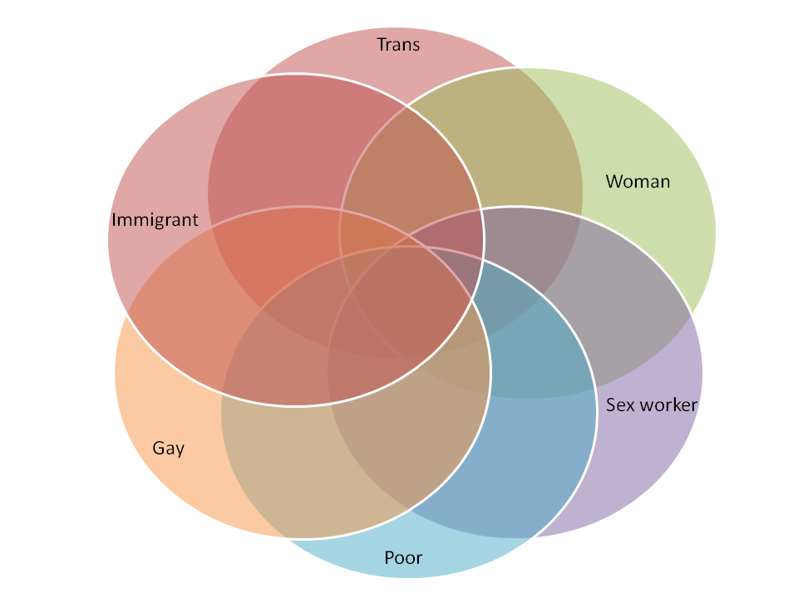

You can find out more at:
equality-network.org
Diversity Matters: intersectionality & Women’s representation in the USA & UK. Evans. E (2016)

