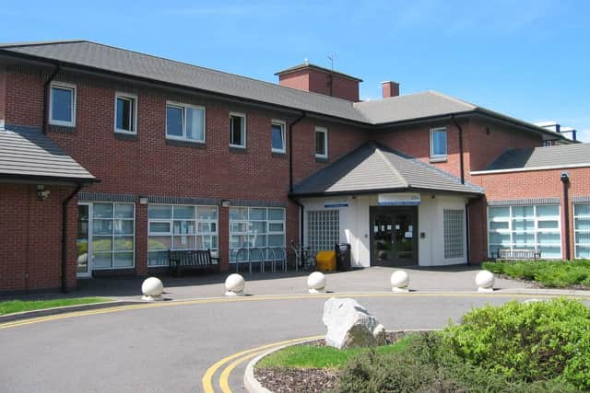
Project:
Improvements to taxi authorisation at UHMBT
Organisation:
University Hospitals of Morecambe Bay Foundation Trust (UHMBT)
Key contact and email:
Tom Lloyd, Head of Facilities UHMBT, Tom.lloyd@mbht.nhs.uk
Dren Begaj, UHMBT Digital Services Lead, dren.begaj@mbhci.nhs.uk

What was the issue?
It was found that the taxi booking process within UHMBT had insufficient oversight and was prone to creating unnecessary taxi use, and therefore additional cost for the organisation. Due to the geography of the trust, there is a high need to transfer both patients and staff between sites. The existing process required staff to telephone switchboard to make bookings, with no need for formal authorisation. While switchboard operatives would record details of all bookings on a spreadsheet, their role was solely to execute the booking, rather than to challenge its rationale. All taxi costs were coded to the facilities budget.

What action was taken?
A transport steering group was established, led by the Chief Operating Officer. From this, a taxi steering sub-group was established, chaired by the Head of Facilities.
Based on the Microsoft SharePoint platform, a new booking and authorisation platform was created to manage all taxi bookings across UHMBT. It replicates the two-stage approval process used for purchase orders across the trust. Staff submit taxi requests via an online form capturing journey details (name, destination, reason for travel). Requests are then routed to divisional budget holders via emails and Microsoft Teams notification for secondary authorisation prior to the booking request being forwarded to switchboard. Out-of-hours and in emergencies, direct taxi requests can still be made via switchboard, but these will require retrospective divisional approval to maintain oversight.
What was the Delivering a Net Zero NHS benefit?
A reduction in monthly taxi usage of up to 30% has been achieved following the launch of the new system in July 2025. Monthly taxi bookings have come down to 250-280 individual bookings, from previously over 350 per month.

What are the wider benefits?
A reporting suite has been developed by the BI team which allows the trust to more accurately track the number of journeys, journey patterns and use between different divisions.
Rather than utilising an external provider, the eventual solution was developed in-house at no additional cost, only using licenses and applications already owned by the trust through Microsoft 365. Being based on the Microsoft SharePoint platform, this solution could be replicated by other trusts across the North West and nationally.
As part of launching the new booking system, taxi services were re-tendered for each of the three key sites across UHMBT. This allowed for inclusion and consideration of social value offered by taxi companies, as well as the composition of their vehicle fleets, with considerations given to the number of electric/hybrid vehicles.
In the six months of full implementation, there have not been any clinical incidents or concerns reported. Switchboard staff are reported to be pleased with the implementation, especially with a clearer authorisation process.

