Activity:
Westmorland General Hospital Innovation & improvement work to reduce energy consumption
Organisation:
Morecambe Bay NHS Foundation Trust
Key contact and email:
David Sanderson - david.sanderson@mbht.nhs.uk
What was the issue?
Westmorland General Hospital (WGH) underwent innovation and improvement work in early 2025, installing supporting network and associated infrastructure to host Internet of Things (IoT) based occupancy, utilisation, smart lighting, energy and environmental monitoring devices.
Key improvement measures taken included installation of environmental sensors and smart lighting systems, building management system integration, occupancy sensors and drone use to detect roof leaks and thermal loss.
What action was taken?
For the smart lighting technologies installed at Westmorland, the ISTL system was chosen, as it offered different connectivity types and technical protocols the hospital required, including EnOcean, a power harvesting system allowing wireless devices to operate without a battery. The system is able to detect ambient lighting conditions and adjust its colour temperature dynamically. The smart lighting units are also able to house environmental sensors, reducing installation, material and maintenance costs in the longer term, with the ability to add further sensors in the future as needed.
Installed environmental sensors can be used to measure and support estate, facility, environmental and utility services. This includes measuring room occupancy and utilisation, energy usage, lighting, temperature, humidity, noise, air quality and carbon dioxide. Data from these sensors is overlayed on digital maps of facilities to provide location-specific data, audit, location, utilisation and flow type information and insights.
Drones were used at WGH and across several Lancashire and South Cumbria sites for survey work, including roof and roof leak inspections, mapping buildings for thermal loss and helicopter landing zone simulations. In a single day, a drone was able to take 2700 images of WGH and stitch them together to create a cohesive view of the building, identifying and pinpointing issues, their causes and scope for remediation. The drone pictures were also used to create a digital site of the map, which in conjunction with the sensor data, will support development of a “digital twin” of the hospital to support future IoT implementation.
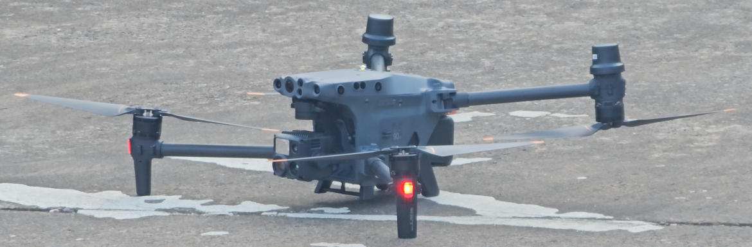
What was the Delivering a Net Zero NHS benefit?
The overall measures have targeted an energy cost reduction upwards of 10%. Smart lighting contributes to this by being able to be consistently monitored, allowing a more predictive and preventative maintenance cycle.
Data from environmental sensors has been used to produce two new dashboards, allowing the estates and energy management teams to understand and analyse clinical impacts of environmental changes at a granular level, including effects on length of stay, patient recovery times and infection prevention control. Some of the installed sensor devices, such as the air quality sensors, are capable of energy harvesting, reducing (or eliminating) power demand, as well as infrastructure, mechanical and electrical work costs.
Use of drones for external mapping (approx. £3,000), comes at greater value for money and is less complex and impactful on the environment than hiring contractors for scaffolding work (£50,000+ depending on complexity of operation), which would also cause wide-reaching disruptions to day-to-day operations at the hospital site.
The digitalisation of estates and facility services is a key step in building towards long-term sustainability across WGH and positive examples from this site will be used across Lancashire and South Cumbria.
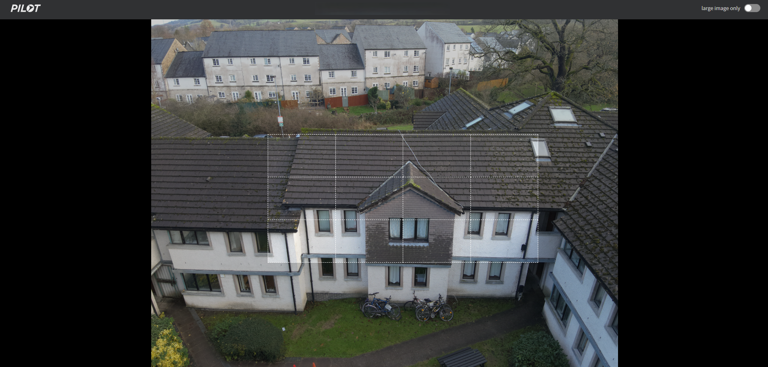
What are the wider benefits?
Smart lighting is able to synchronise lighting with peoples’ circadian rhythms to enhance wellness, reduce stress and support productivity. This improves occupant comfort and experience of the site for both employees and patients.
Environmental data will be fed into the Lancashire and South Cumbria Secure Data Environment (SDE), allowing it to be utilised for clinical research and other use cases. Sensing occupancy and utilisation in NHS facilities helps to visualise asset performance, as well as improve safety and security across the site. Further combining physical and digital services provides actionable data and allows for real-time detecting and monitoring of demand to support existing and planned future capabilities across WGH.
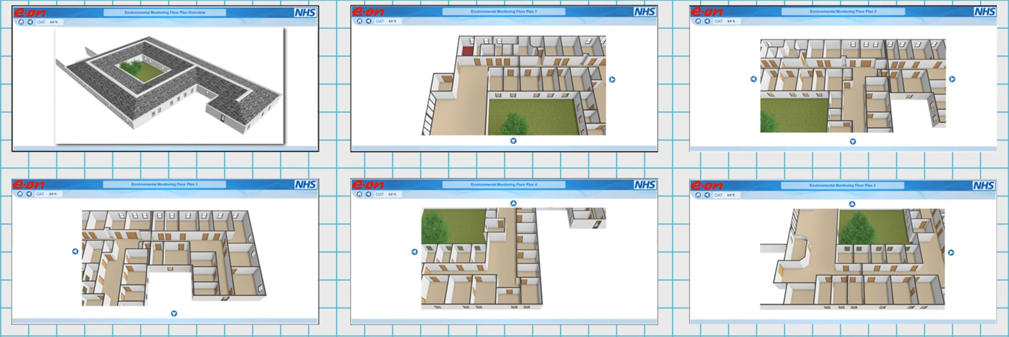
Link for further information:
For an introduction to IoT technology, the supporting infrastructure required and potential applications for the NHS see An Introduction to Internet of Things - Future Connectivity - FutureNHS Collaboration Platform
More information on the installation of the smart technology at Morecambe Bay: Smart Buildings — The Lister Alliance
More information on the wider plans for smarter health spaces, energy efficiency and carbon reduction across Lancashire and South Cumbria ICB Supporting smart health spaces across Lancashire and South Cumbria — The Lister Alliance

