Project:
Care Closer to Home: Transforming Paediatric Cancer Care across the North West
Organisation:
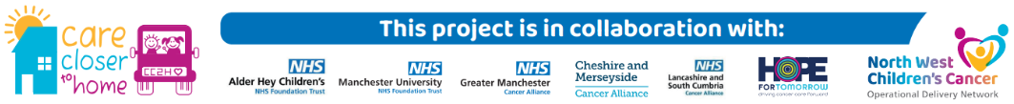
North West Children’s Cancer Operational Delivery Network in partnership with Alder Hey Children’s Hospital NHS FT & Royal Manchester Children's Hospital (Manchester Foundation Trust).
Key contact and email:
Charlotte Lloyd, Quality Improvement Lead Nurse, NWCCODN Charlotte.Lloyd@mft.nhs.uk
Generic email: info.nwccodn@mft.nhs.uk

What was the issue?
Children, young people and their families across the North West of England and North Wales face significant travel challenges to access specialist cancer care. Unlike adults, children and young people who are being treated for cancer must journey further to access the specialist centres, Alder Hey Children’s Hospital or Royal Manchester Children’s Hospital, with families often travelling hundreds of miles for treatment. These journeys can place considerable time and financial pressures on families, with recent data from Young Lives vs Cancer showing that in the North West the average monthly travel cost was £245, and the average one-way journey was 54 miles.
What action was taken?
The North West Children’s Cancer Operational Delivery Network (ODN) submitted a service development bid and are working in partnership with Alder Hey Children’s NHS Foundation Trust & Royal Manchester Children’s Hospital to deliver a Care Closer to Home project. This has been funded by the three Cancer Alliances in the North West; Cheshire & Merseyside, Greater Manchester and Lancashire & South Cumbria.
The Care Closer to Home project explores models of delivery in the home setting and through a ‘Mobile Cancer Care Unit’ to deliver children’s cancer treatment, bringing chemotherapy and other care directly into patients’ homes or closer to their home. We hope to transform how children and young people with cancer receive treatment, reducing travel, stress, and time away from home, school, and family life, whilst complementing existing services provided by the Specialist Hospitals, local Paediatric Oncology Shared Care Units and Children’s Community Nursing Teams.
We are continuously evaluating the project utilising mixed method approaches, combining quantitative and qualitative data collection methods. We are assessing the practicality, suitability, feasibility and sustainability of the model within Paediatric Oncology.
Spotlight on the Home Care Phase:
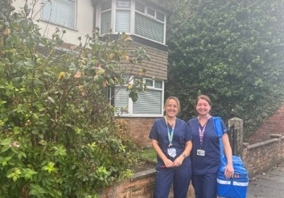
Specialist Oncology Nurses from Alder Hey’s Children’s Hospital, have been visiting children and families across Cheshire, Merseyside and North Wales directly in their homes, delivering chemotherapy and supportive treatments that would normally be administered within the hospital setting. The selected scope has been identified via the clinical teams and determined appropriate for delivery in the home setting. The project is working on a slightly reduced workforce than initially planned; 0.88WTE instead of 2.0 WTE. From 20.11.25 – 31.03.26 they have offered a 2-day service, covering approximately 41 shifts.

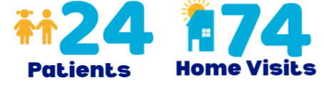

What was the Delivering a Net Zero NHS benefit?
This project will drastically reduce travel distances and requirements for families. Analysis of the home care phase has shown that families have ‘saved’ a total of 4,261 travel miles.
Delivering care at home reduces overall travel through journey planning of NHS teams - rather than each family making return journeys from hospital to home. Additionally, digital and telephone triage reviews can prevent unnecessary journeys. As this is currently a pilot, the fleet of vehicles in use are personal ones belonging to staff, but future iterations of this project may see the procurement of a dedicated fleet of low emission / electric vehicles.

What are the wider benefits?
The new treatment model will generate considerable savings to families, who will have lower travel requirements to attend specialist care settings. The early stages of the project have shown families have reportedly saved a minimum of £1,183 (self-reported by questionnaire with ~50% response rate).
Reducing lengthy travel to specialist outpatient centres will improve the well-being of both children undergoing treatment and their families. It is also estimated that wait times at clinics for treatment will be reduced considerably, an issue raised as critical to improving their care experience by children themselves.
Where are we now?
Evaluation of Home Care Model: We are currently evaluating the Home Care element of the project and reflecting on the process. The main purpose of evaluating the project is to understand the feasibility of delivering cancer care closer to home for children within the region. To gather findings, collate feedback (service user & professionals) and generate evidence to feed into obtaining funding for making care closer to home sustainable within Paediatric Oncology across the NW, if successful. Furthermore, the evaluation will generate learning around quality improvement for service development. The questions are aiming to answer include:
- Can cancer care be delivered to CYP in the home?
- Can cancer care be delivered to CYP in a mobile unit?
- Do children and families find this care delivery acceptable or preferable?
- Do staff find this care delivery acceptable or preferable?
- Are any safety issues identified?
- How does implementation of this model affect overall costs, potential savings, return on investment, and resource efficiency compared to existing alternatives?

Deliver using Mobile Cancer Care Unit: We are pleased to have recently introduced a Mobile Cancer Care Unit (MCCU) which was hired from Hope For Tomorrow Charity (Jan26-Jul26) and is being shared between Alder Hey Children’s Hospital and Royal Manchester Children’s Hospital. By using the MCCU we can increase the scope of interventions delivered directly to children’s communities, including providing pre-treatment bloods, symptom management, chemotherapy, and central venous access care. The MCCU will go out to assigned locations (May, June and July 2026) across the region, once the orientation, training, familiarisation and mobilisation on hospital sites has been successfully completed.

Link for further information:
https://www.nwchildrenscancerodn.nhs.uk/care-closer-to-home/
https://www.bbc.co.uk/news/articles/cwy60elzyv5o

