Project: Increasing Biodiversity and Staff Connection to Nature within University Hospitals Morecambe Bay Foundation NHS Trust
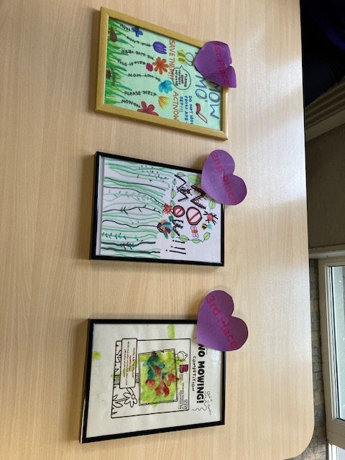

No Mow Poster Competition Winners

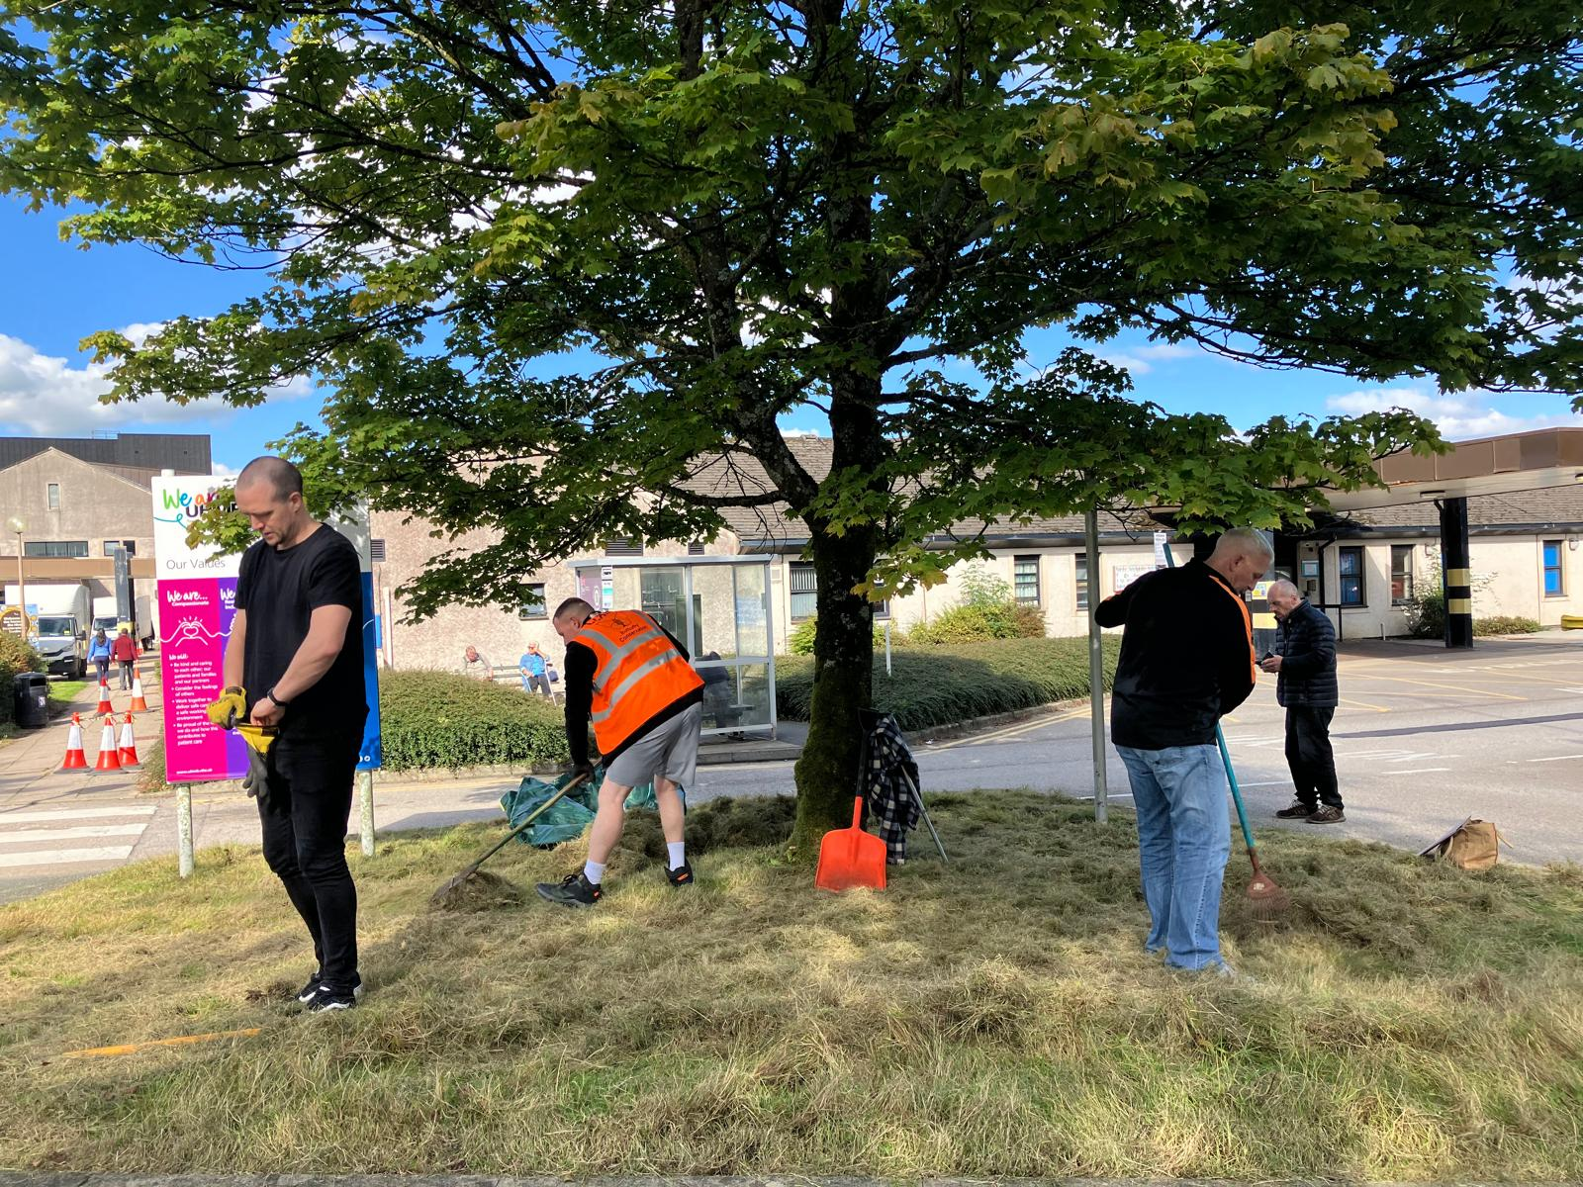

The Well Communities and volunteers at Westmorland General Hospital

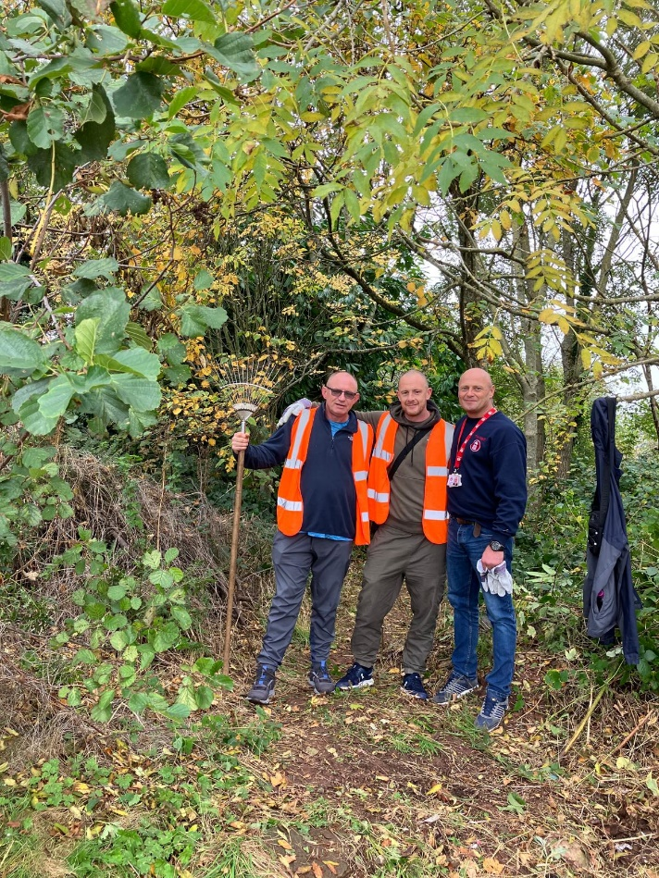

Work on new Nature Reserve at Furness General Hospital

Organisation: University Hospitals of Morecambe Bay NHS Foundation Trust

Key contact and email: Claire Harris - claire.harris@naturalengland.org.uk

What was the issue?

There was an opportunity to improve biodiversity across the three main University Hospitals of Morecambe Bay NHS Foundation Trust sites and to make better use of hospital grounds to support the health and wellbeing of staff, patients, visitors and local residents. The sites included areas of grassland, meadow, scrub and rough grassland that could be enhanced for wildlife while also helping people connect with nature.

What action was taken?

Work has taken place across the Trust’s three hospital sites to improve grassland biodiversity through plug planting, seed application, raking off summer growth and the introduction of an agreed no-mow plan. Plug plants were donated by Arnside and Silverdale National Landscape. Across two hospital sites, 500 trees have been planted and maintained through the NHS Forest scheme, with a further 250 trees planned for Lancaster.

Bird boxes, bat boxes, a hedgehog house, bee hotels and swift boxes have been created and installed across the sites. Some were made by estates staff as part of a wellbeing day, while others were built by members of The Well Communities and volunteers. The project also worked with Morecambe Bay Hospital Charity to run a no-mow sign competition involving children from hospital wards and local scout and guide groups, with the winning design made into signs for use across the hospital sites.

At Furness General Hospital, a nature reserve is being created on land at the edge of the hospital. A footpath has been cut through species-rich meadow, scrub and rough grassland to encourage staff, patients, visitors and local residents to use the area and notice the wildlife living there. Partners are also working to promote the reserve and encourage use for health and wellbeing. An i-Naturalist project is planned so staff can record the nature they see on the hospital grounds.

What was the Delivering a Net Zero NHS benefit?

Nature, climate change and health are interconnected issues, with shared challenges and solutions.
The project supports a Greener NHS by improving the biodiversity and resilience of NHS green spaces, increasing tree cover and embedding nature recovery within the Trust’s Green Plan.

The project has delivered tangible environmental improvements, including 500 trees planted and maintained, with a further 250 planned, alongside enhanced grassland management and habitat creation across hospital grounds. Tree planting contributes to carbon sequestration over time, improves habitat value and supports a more climate-resilient hospital environment.
What are the wider benefits?

The project has increased awareness of the importance of hospital grounds for nature and created new opportunities for staff, patients, visitors, volunteers and local residents to connect with green space, supporting health and wellbeing.

The project has also strengthened partnerships between UHMBT, Natural England, One Lancashire and South Cumbria Together, The Well Communities, Active Cumbria, Morecambe Bay Hospital Charity, NHS Forest, The Bay: A Blueprint for Recovery project, Lancaster City Council’s Community Wings Project and Arnside and Silverdale National Landscape.

Volunteer days have supported community involvement, enabled staff to see the project first-hand, and helped build confidence with hospital estates colleagues. Future work may help influence grounds maintenance practices, including opportunities to reduce mowing and manage areas more positively for nature.

Link for further information:

Greener NHS :: Case studies

