Project: Rewilding of Fairfield Hospital Grounds
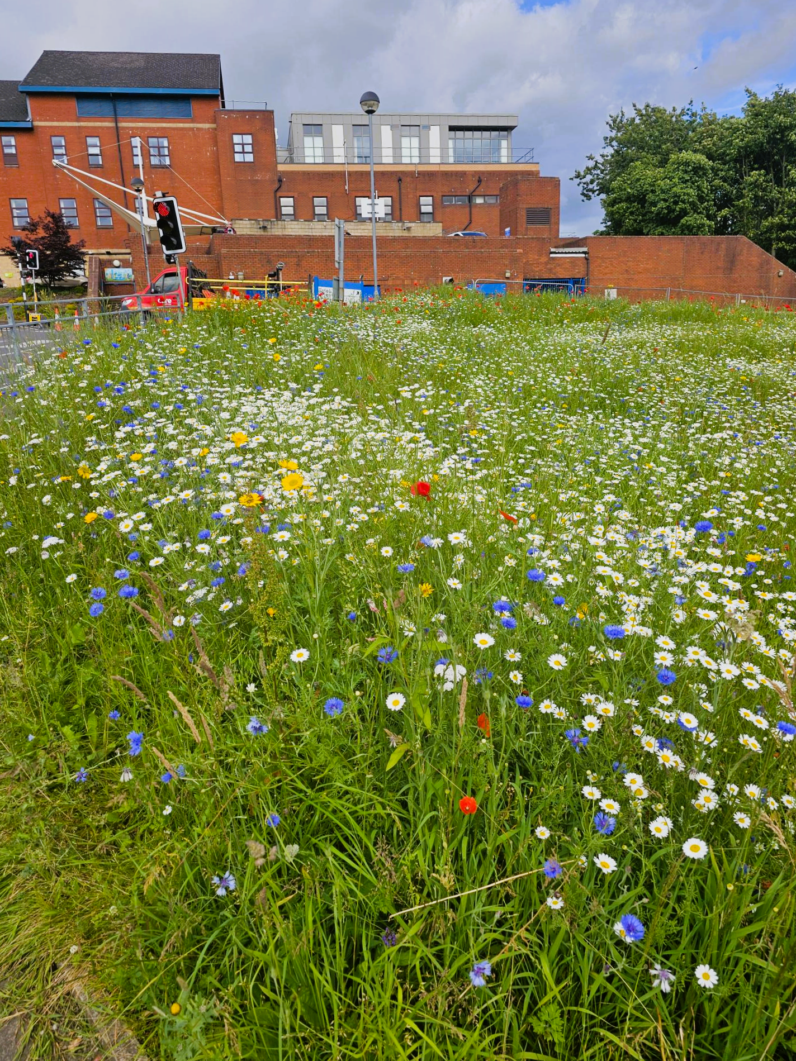
Organisation: Northern Care Alliance

Key contact and email:
Emma Heinicke – Fundraising Officer – NorthCare Charity.
emma.heinicke@nca.nhs.uk
Claire Drury – RHS project lead.
clairedrury@rhs.org.uk
What was the issue?
It is recognised that there is a decline in nature and biodiversity internationally and in the UK. In response, the Greater Manchester Combined Authority declared a biodiversity emergency in 2022. Access to natural spaces is also important for improving both physical and mental health, and nature-based solutions increase resilience to the impacts of climate change. The NHS is one of the largest landowners in Greater Manchester and can support the nature recovery agenda.
Fairfield Hospital is in a semi-rural setting and has large areas of green space which had little biodiversity, such as grass verges with limited native planting.
What action was taken?
NorthCare Charity, the official charity partner of the Northern Care Alliance (NCA) NHS Foundation Trust, supporting patients, families, and staff across Bury, Oldham, Rochdale, and Salford by funding innovative equipment, education, research and wellbeing activities, secured a £40,000 grant from the Greater Manchester Green Spaces Fund which they supplemented with match funding. The Fairfield team commissioned the Royal Horticultural Society to provide expert advice on increasing biodiversity on site and making nature more accessible. The charity also led a group of over 40 volunteers (including local school children and corporate partners) in planting bulbs.
The team enhanced 9,174m² of green space, planted 13,000+ bulbs and 190 trees, and created three specialised gardens for wildlife, well-being, and education. The Education Garden has learning circles, mud kitchens, an accessible path, and bug hotels made from reclaimed timber, which can be utilised by staff, patients, and an adjoining nursery school. Children from Fairfield Primary school were also involved in the project and painted bird boxes, which have been installed around the Fairfield site. A Bog Garden was created to manage water, provide sustainable urban drainage, and create habitat for local wildlife. The Peace Garden enhanced an existing space in a quieter area of the hospital site, where staff, patients and visitors can sit and feel calmer.
The project will continue to improve the green space on and near the site further and increase access to nature for everyone.
“At the Northern Care Alliance, we believe wellbeing is essential to great care. Our partnership with RHS and NorthCare Charity on the Fairfield rewilding project shows what’s possible when we combine expertise and community spirit. These gardens aren’t just green spaces – they’re places where patients, visitors, and colleagues can pause, recharge, and feel connected to nature. We’re proud of what’s been achieved and committed to continuing this work to make our sites healthier, more sustainable, and more welcoming for everyone. Thank you to RHS and NCA colleagues for you hard work on the project.”
Catherine Wilkinson, NCA Director of Finance
What was the Delivering a Net Zero NHS benefit?
Improved green space across the site supporting local biodiversity, improved resilience to the risk of surface water flooding from the bog garden development. Potential improvements to local air quality through increasing the number of trees.
What are the wider benefits?
The green spaces have been created to be accessible to patients, staff, visitors, and the public, offering educational and well-being opportunities through connection with nature, whilst improving habitats. The project acts as a hub for green social prescribing, researchers have found that just spending between 20 and 90 minutes in nature is beneficial for mental health, lowering levels of stress, anxiety and depression. People are more likely to get ‘out and about’ in these improved gardens increasing exercise and physical health. Additionally, studies have found that surgery patients need less pain medication and recover faster if they are able to see nature, rather than just buildings. As well as these health and wellbeing benefits, green spaces can reduce the impacts of climate change; as well as reducing flood risk, they also counter urban heat island effects through natural shading. Trees and plants also absorb and store carbon dioxide from the atmosphere, helping to reduce greenhouse gases.
'Every time I walk through one of the RHS NHS Wellbeing Gardens on our wider programme, I’m reminded why we do this work and work with such inspirational partners such as NorthCare Charity and the Northern Care Alliance Trust. These spaces aren’t just about planting flowers; they’re about planting hope. I’ve seen staff take a deep breath and visibly relax, patients find a moment of peace, and colleagues reconnect surrounded by greenery. These gardens offer something truly special: a place to pause, reflect, and feel cared for. They’re a quiet but powerful reminder that wellbeing matters and that nature can help us enhance our wellbeing, together. The partnership work at Fairfield has been nothing short of truly inspirational. I want to recognise the outstanding contributions of Emma Heinicke, whose work through NorthCare Charity drives these projects forward, and Catherine Wilkinson, whose strategic leadership at Fairfield Hospital has been pivotal. Their dedication and ability to turn vision into reality have been truly transformative.'
Victoria Shearing, RHS Wellbeing Garden Programme Manager
Link for further information:
Rewilding Fairfield Hospital for Everyone | Greater Manchester Environment Trust
Update - Our 'Rewilding Fairfield' Project :: NorthCare Charity

