Project: Stockport NHS Blood Sciences – My Green Lab Gold certification
Organisation: Stockport NHS Foundation Trust
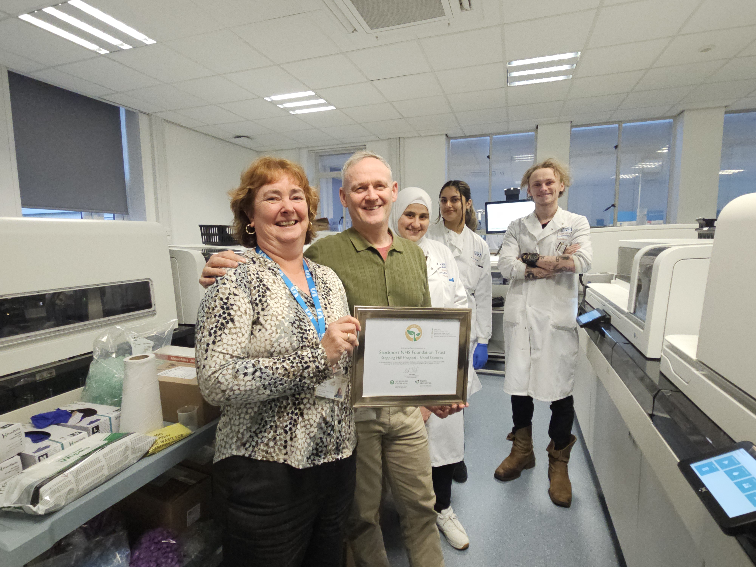
Key contact and email: Elaine Taylor, PathologyEnquiries@stockport.nhs.uk
What was the issue?
Hospital laboratories are amongst the largest consumers of energy and resources in the NHS – using up to 10 times more energy than office spaces. Without embedded sustainability practices, this results in high carbon emissions, energy use, waste, and costs impacting both the environment and working conditions for staff.
The Blood Sciences Laboratory, consisting of the Biochemistry and Haematology teams, wanted to take a structured approach to tackle this through saving energy and reducing the waste in their department.
What action was taken?
The Blood Sciences Laboratory teams underwent a rigorous evaluation to achieve My Green Lab Gold certification in October 2025 – an internationally recognised standard for sustainable laboratory operations. This achievement was made possible through a collaboration with Siemens Healthineers, who supported the certification process.
The process began in March 2025 with a jointly delivered kick-off meeting with laboratory staff, the Sustainability team, and Siemens Healthineers where an energy saving focus was established. Unlike private laboratories, hospital laboratories run 24-hours a day – however not all equipment is required all the time, so an opportunity was identified to make significant cost and carbon savings through safely switching off equipment when not in use.
Other practices embedded into daily operations across the 6-month accreditation period included introducing recycling into the department, adding new signage to wastewater points, and promoting sustainable travel for staff. The certification also served to affirm steps already in place across the trust, such as the use of unbleached paper.
The ambition for the teams is to continue their sustainability journey and progress to higher levels of My Green Lab certification in future.

What was the Delivering a Net Zero NHS benefit?
The overall environmental sustainability of laboratory practices within the Blood Science Laboratory has improved, with impacts from changes made saving over 3 tonnes of carbon dioxide equivalent emissions each year. As staff are more engaged in this area, the sustainability projects and carbon savings are expected to increase. This supports the delivery of the Stockport NHS Foundation Trust Green Plan.
What are the wider benefits?
- Collaboration with Siemens Healthineers leveraged expertise and resources, highlighting how cross-sector partnerships can drive environmental change.
- Savings of over £2,000 per year have been made as a result of the sustainability changes within the laboratory.
- Provided opportunity to connect and work with colleagues across the trust which wouldn’t normally.
- Staff working on the certification have found the projects interesting and rewarding, increasing levels of job satisfaction.
Link for further information
News Details - Stockport NHS Foundation Trust
Accelerating Sustainability in Scientific Research | My Green Lab

