Scheme: Stop Idling campaign
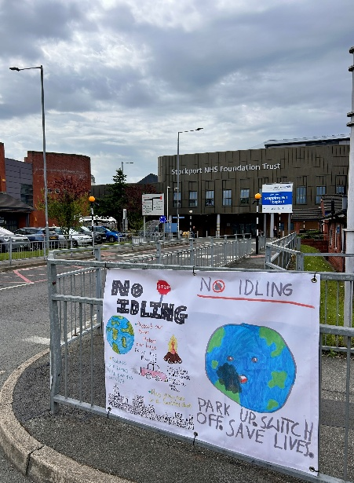
Organisation: Stockport NHS Foundation Trust

Key contact and email: Jennifer Lea, Emergency Medicine Consultant, Jennifer.Lea@stockport.nhs.uk

What was the issue?
Car idling, an illegal practice where a stationary vehicle is left running, was identified as a major source of unnecessary air pollution and fuel waste at the hospital, particularly around the emergency department and in car parks.
Poor air quality contributes to 1,200 early deaths each year in Greater Manchester and affects everyone, with children, older people, and those experiencing long term health conditions most at risk. Key pollutants include nitrogen oxides and particulate matter (PM2.5), from vehicle exhaust fumes, which can exacerbate health conditions such as asthma and cardiovascular conditions.
What action was taken?
Stockport NHS Foundation Trust emergency department staff worked with teachers from local Halliard Trust schools to organise a poster competition for pupils to spread the message that car idling is harmful to both health and the environment. Over 50 bright and colourful entries were received from schools including Upton Priory Primary School in Macclesfield, and Lower Park Primary School in Poynton.
The children who created the fantastic winning entries received hampers which were presented by staff from the Stepping Hill Hospital emergency department team.
The winning posters were transformed into external banners and displayed from 18th June 2026 (Clean Air Day) outside the emergency department, the ambulance bays and the patient and visitors’ car parks to discourage idling.

What was the Delivering a Net Zero NHS benefit?
The project increased education and awareness around environmental issues and the health impacts for schoolchildren, encouraging engagement and action through the poster competition. The banners demonstrate the link between planet and health to drive behaviour change in drivers towards the healthier and more sustainable choice of not idling, reducing levels of air pollution across the site. As the posters are designed by schoolchildren, drivers are encouraged to consider the impacts of their choices on future generations.
What are the wider benefits?
Reduced levels of air pollution from car idling, particularly around the emergency department, will help keep staff and patients safer – particularly those with respiratory and cardiovascular conditions. Additionally, through engaging with local schools, this strengthened the Trust’s work as an anchor organisation.
Link for further information:
Primary school poster competition targets car idling and supports environment - Stockport NHS Foundation Trust
Home | Clean Air Greater Manchester

