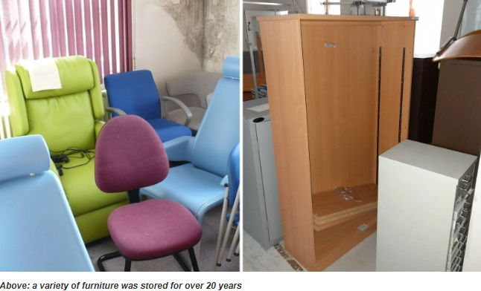
Scheme: WARP-IT Furniture and equipment reuse across Lancashire and South Cumbria NHS Trusts
Add a photo if available
Organisation: Lancashire & South Cumbria NHS Trusts
Key contacts and email: Allison Sathiyanathan, Net Zero Project Manager, NHS Lancashire & South Cumbria ICB, allison.sathiyanathan@nhs.net and Sian Fisher, Waste Minimisation Officer, One Lancashire & South Cumbria, Sian.Fisher@LTHTR.nhs.uk.
What was the issue?
Across hospital Trusts in Lancashire and South Cumbria, usable furniture, equipment, and supplies were often stored for long periods, disposed of prematurely, or unnecessarily replaced with new purchases. This was largely due to staff lacking a simple way to view what was already available or needed elsewhere within the Trust.
This created avoidable procurement costs, wasted storage space, increased health and safety risks from clutter, and added carbon emissions from buying, transporting and disposing of items. At East Lancashire Hospitals Trust, for example, unwanted items had built up in storage for more than 20 years, showing the scale of the problem and the need for a more systematic reuse approach.
What action was taken?
To address this, the Trusts introduced WARP-IT, an online reuse platform that allows staff to list, find and claim surplus resources such as furniture, equipment and office supplies. After an initial pilot at Lancashire Teaching Hospitals, the approach was rolled out more widely across the region because it proved it could save money while reducing waste and carbon. Trust leads shared learning across organisations, sustainability and waste teams were trained to embed reuse into procurement and estates processes, and staff awareness campaigns helped build participation. Logistics teams and Waste Managers also supported practical delivery through initiatives such as “Warp It Wednesdays”, helping move items efficiently to new users across sites.
What was the Delivering a Net Zero NHS benefit?
The project reduced demand for new products, cutting emissions associated with manufacture, transport and disposal. Up to January 2026, the regional programme has prevented 369 tonnes of CO₂ emissions and diverted 110 tonnes of waste¹. Reusing items locally meant hospital teams could meet operational needs without generating the full carbon impact of purchasing new goods. The scheme also supported circular economy principles within NHS Green Plans.

What are the wider benefits?
The Initiative improved stewardship of public resources, by January 2026 the regional programme had saved more than £900,000, helping direct more funding towards frontline care rather than unnecessary replacement purchases¹.
The initiative also improved space management, removed long-standing storage backlogs and lowered health and safety risks linked to cluttered areas and made it easier for staff to source items quickly.
The programme strengthened collaboration between procurement, estates, sustainability and logistics teams, while donations of surplus items to local charities extended the social value of the scheme into the wider community. Staff engagement has also grown, helping build a stronger culture of reuse across the participating Trusts.
Link for further information:
1 Hospital Trusts in Lancashire and South Cumbria save over £900,000 and slash waste through reuse

