Medical History  □ T1DM □ T2DM □ Other  □ Retinopathy □ Nephropathy  □ P.Neuropathy □ PVD  □ ↑ BP □ ↑ ACR  □ IHD □ CVA  □ Previous amputation □ ↑ Lipids  □ Smoker  □ Patient information leaflet given |  |  | MDT members present  Diabetes ________________  Orthopaedics ________________  Vascular ________________  Podiatry ________________  Radiology ________________  Microbiology ________________  DSN ________________  Date_________ |  |  | Patient Details  Name:  RQ No:  NHS No.  Date of Birth:
Medication |  |  | Laboratory results  □ HbA1c ________ □ eGFR________  □ ACR ________ □ CRP ________  □ Chol ________ □ LDL/HDL_____  □ Hb ________ □ WCC________  □ MRSA colonised □ Y □ N □ NK  □ Ulcer Sig. +ve result ________  Sample type □Superficial □Deep □Intraop. □Tissue Bx |  |  | Foot Assessment  Ulcer  Deformity Skin/nail abnormal  Footwear assessed  Charcot | R  Y N  □ □ □ □  □ □ □ □  □ □ | L  Y N  □ □ □ □  □ □ □ □  □ □
SINDBAD Ulcer Classification  - Site  - □ Forefoot  - □ Mid/Hind foot  - Ischemia  - □ Pedal blood flow intact: at least one pulse palpable  - □ Clinical evidence of reduced blood flow  - Neuropathy  - □ Protective sensation intact  - □ Protective sensation lost  - Bacterial infection  - □ None  - □ Present  - Area  - □ Ulcer < 1cm²  - □ Ulcer ≥ 1cm²  - Depth  - □ Ulcer confined to skin & subcutaneous tissue  - □ Ulcer reaching muscle, tendon or deeper  Total Score |  |  |  | Score  0  1  0  1  0  1  0  1  0  1  0  1 | Right Left Left Right  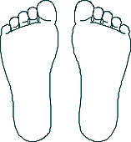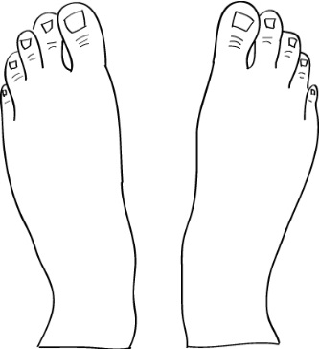  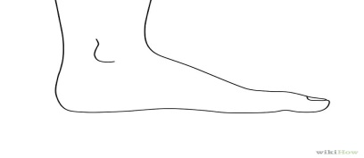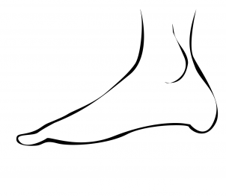  Medial  Lateral
Foot Imaging  X-ray Foot  MRI Foot  Arterial Doppler  CT Angiogram | R  Y N  □ □ □ □  □ □  □ □ | L  Y N  □ □ □ □  □ □ □ □ | Comments |  |  | Podiatry/Footwear & other advice
Diabetes & CV management |  |  | Orthopaedic/Vascular management |  |  | Microbiology management
Outpatient Record sheet
5

