

North West Coast Strategic Clinical Network

**Information Strategy 2017**



North West Coast Strategic Clinical Network & Senate

**First published:** November 2017

Prepared by: Jason Gladwin - Network Quality Improvement Lead for Data [Jason.gladwin@nhs.net](mailto:Jason.gladwin@nhs.net)

Input from: Kathy Collins – Senior Clinical Network Manager Cancer Palliative & End of Life Care

**Derived from:** A review of Information Support Services within NWC SCN.

**Review Date:** April 1st 2019

|  |  |
| --- | --- |
| Version: FINAL | Version 1.0 |
| Date: | 16/11/2017 |
| Intended Audience: | NWC SCN Team and Interested Stakeholders |

**Information Strategy 2017**

**Contents Page**

What? Why? Where? When? How? 4

Executive Summary 5

The importance of information 6

Background 7

Main ambitions of strategy 7

Information team structure 8

Strategic aim of the team 9

Key roles and responsibilities 9

Information processes 11

Information governance processes for obtaining data 13

The two way process 15

Responsibilities of those requesting information 15

Data quality 17

Links with other organsiations 18

Achieving the ambitions of the strategy 19

**What? Why? Where? When? How?**

**Executive Summary**

Since it’s conception, NWC SCN has had an internal information support function but the function has never been organized or appropriately structured. The has led to grey areas as to what exactly the information support covers and what it does not. Information has been requested in different ways and sometimes with people making requests without a specific idea of what it is they want or need.

In order for information to most appropriately used and not wasted, there needs to be a primary objective. As NWC SCN is a quality improvement service it makes sense that this objective would be to support the improvement in quality of care by providing evidence of change and evidence to support the need to change. To achieve this objective, the information support function needs structure in terms of people and process.

This strategy outlines the structure needed to achieve this objective and highlights the strengths of having them in place. These include outlining the people required; the skills needed; the responsibilities of both information support and the wider team. It also suggests a standard way to help people think about what information they need, if it is already available, what they have to do to request it and later checking it. Within the team, logging the requests, understanding the demand, working with those requesting information and the need for trading skills is also mentioned as well as providing a minimum standard of data quality.

To build on these structures, it is proposed the team explore links within clinical networks and explore the potential in obtaining different sources of information.

The strategy ends with the proposed next steps that help communicate this strategy and build on the foundations established within it.

**NWC SCN’s Information Team’s mission:**

*‘To support the improvement in quality of care by providing evidence of change and evidence to support the need to change’*

**The importance of information**

The SCN is an organisation designed to improve quality, improve health outcomes and address unacceptable variations in healthcare services. In order to establish what improvements need to be made, the SCN must first understand the present service provided, establish the desirable service of the future and recommend or implement the changes required to bridge the gap.

SCN’s do not house any NHS patient administration systems (PAS) and consequently have to source the data they require through other means.

Data obtained by the Information team and subsequent findings form one critical element of the case for change (alongside clinical evidence and patient experience) and highlights the extent of a service problem and therefore the change required. Findings from key data also form the baseline by which measures can later evaluate quality improvement.

However, it should be noted that data itself only captures the recorded facts about a service or event. It is the amalgamation of data in the right context that provides information and the concise and appropriate collection of information in a way that makes it useful that forms knowledge. Without this knowledge – selective change could not occur.

**Figure 1: The Business Intelligence & Analytics Maturity Model**

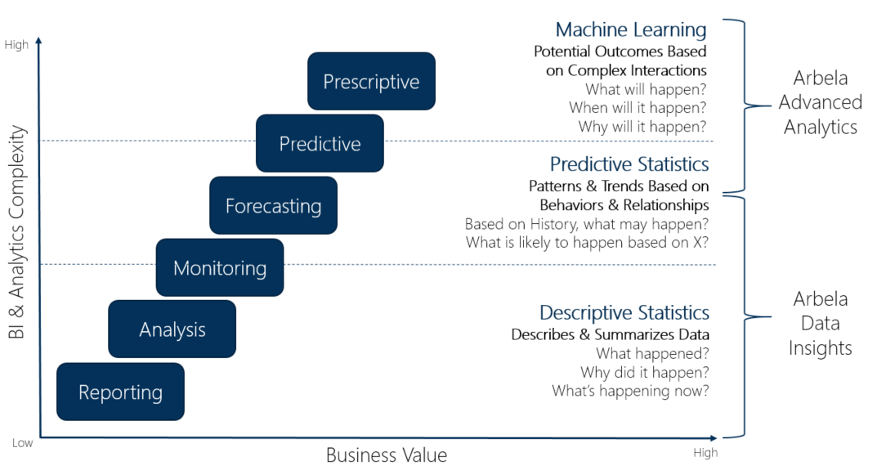

**Background**

Since the formation of the NWC SCN in 2015, the role of informatics has never been clearly defined. This is due to a number of factors such as ambiguity of job descriptions, different perceptions of what it is an analyst does, different information needs and changes in roles and responsibilities. As a result, what is being asked of the support is substantial and varies considerably. Furthermore, the network does not have the resources it once had; demand is much higher than supply. This information strategy will cover the findings and the solutions put forward to support the SCN moving forward.

**Ambitions of this strategy**

* Develop and establish a clear identity for the NWC SCN Information Team
* Clarify Roles and Responsibilities on Information Management in the SCN
* Outline a Governance Structure
* Establish a Data Quality Process
* Outline how the Information Support Team plan to support the business function of the organisation
* Reduce the risks of Information Management within the SCN
* Suggest ways to improve information in the future

**Information team structure**

A recent review of the information needs within the network highlighted the large array of skills were required to produce the demand including; collation, interrogation, analytical, technical, organisational and presentational.

There should be a minimum of at least 1 Information Support Manager from each clinical network. This would allow a wider breadth of skills; reduce the possibility of over demand and sole ownership and improve data quality.

**Fig.1 The proposed virtual information team structure:**



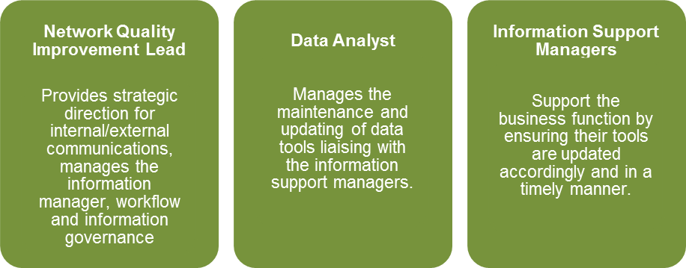

**Strategic aim of the information team**

The responsibilities of the network quality improvement lead should primarily focus on information that directly supports project and programme specific outcomes for their clinical network.

This could mean that the network quality improvement lead will be required to check their data and tools to ensure no errors exist when updates or ad hoc data requests have been made to the information team. This will reduce the risk to projects in terms of data quality.

The responsibilities of the data analyst is to ensure that data is maintained, updated and the quality is of a high standard. The responsibilities of the information support managers within each clinical network is to ensure that a person with good knowledge of data and tools within that team can take over and manage the tool if required hence making it a virtual information team.

**Key responsibilities for the** **network quality improvement lead**

Managing and supporting the improvement in quality of care by providing evidence of change and evidence to support the need to change will mean certain responsibilities.

**Responsibilities will include management of:**

* Creation of metrics / sources / systems that enable a project / programme specific outcome to be measured
* Appropriate knowledge management processes that include storage / transfer and application of information
* Analysis of raw data
* Collation of data and statistics
* Information in the context of other data
* Dashboards where appropriate
* Exploration of sources, analysis, presentation
* Provide advice and reasoning and where necessary assumptions
* Training/upskilling staff where necessary

**Key responsibilities for data analyst**

Supporting the improvement in quality of care by providing evidence of change and evidence to support the need to change will mean certain responsibilities.

**Responsibilities will include:**

* Appropriate knowledge management processes that include storage / transfer and application of information
* Analysis of raw data
* Collation of data and statistics
* Information in the context of other data
* Exploration of sources, analysis, presentation
* Provide advice and reasoning and where necessary assumptions

**Key responsibilities for information support managers within clinical network teams**

Supporting the improvement in quality of care by providing evidence of change and evidence to support the need to change will mean certain responsibilities.

**Responsibilities will include:**

* Appropriate knowledge management processes that include storage / transfer and application of information
* Analysis of raw data
* Collation of data and statistics
* Information in the context of other data
* Exploration of sources, analysis, presentation
* Provide advice and reasoning and where necessary assumptions
* Oversight of their own dashboards/tools to ensure they are maintained to a high standard once created.

**Information processes**

Historically the mandate for an information request has come from a range of means such as an email, telephone call or face to face meeting.

Another common problem is that often staff are not quite sure what they were asking for. This can result in ambiguous requests that later might have to be changed or altered; requests not directly related to aims of a programme of work or requests that asked for a substantial of data that may never have been used. Therefore a more formal process is required.

**The data map**

To aid information capacity and demand a ‘data map’ has been constructed. The data map contains links to existing publicly accessible sources of health data and information. The logic being if quality improvement staff are aware of some existing data and information out there, they may not always need to come through the Network Quality Improvement Lead to obtain it – it could be accessed directly.

Stored here: I:\NWC SCN\Business Intelligence\DOCUMENTATION\Data Map

**The workload log**

Once the information is completed it should be sent via email to an Information Support Manager to:

* Enable it to be reviewed (to understand what it will entail, if it is obtainable without going through information support, to see if it relates to a project in the business plan and determine time, sources or if there are potential problems)
* To store it electronically

The workload log will be used to help manage the demand. It will assign the request a unique reference number, maintain additional notes and contribute to reporting that shows what requests are still active and what are closed. In addition it will log which staff member is looking into the request and will enable historic reporting to see where the requests are coming from and how quickly they were turned around and completed.

Stored here: I:\NWC SCN\Business Intelligence\WORKLOAD

**Information requests have to be managed based on:**

* The deadlines
* The importance of the request and
* The time the request may take to complete

It is because of this information requests may not be completed in chronological order; instead they will be reviewed in light of competing demand.

**The information request process**

The information request process needs to be clearly defined and consistent within each clinical network. The same process should also apply to requester’s from external organisations.

The principles of this process allow the requester to think specifically about what information they need and how it is relevant to their project/programme; identify alternative routes where applicable; understand what they receive and clarify their responsibilities and that of Information Support.

External requests for information should either be related to our programme or project outcomes; or be already available within the network.

Once the information request has first been returned to the requester for review – the requester should take no longer than 1 week to check they are happy with the information and to let the Network Quality Improvement Lead know so either the request can be ‘closed’ on the workload log or the information can be tweaked and checked again by the both the Network Quality Improvement Lead or Network Information Support Managers. If no feedback is given within a week of completion; the request will then be closed.

To help further, the next two pages offer guidance in terms of request, data quality and governance.

**Information Governance processes for obtaining data**

**Team member obtaining data themselves**

|  |
| --- |
| Assess what it is that is needed and how it fits in with project/programme or strategic objectives |

|  |
| --- |
| Refer to SCN data map to establish if the data is available |

|  |
| --- |
| If data *not* listed on data map and is not readily available consider:   * Where the data is recorded (source) * Who is responsible for recording the data (responsibility) * The most feasible method for obtaining the data* * The value of involving the SCN Network Quality Improvement Lead (i.e. is there a point in involving the SCN Information Support if they are unfamiliar with the data and you can liaise directly with the organisation?) |

|  |
| --- |
| *If the data is listed on data map first consider:*   * Exactly what data and fields are required (which includes any fields to derive calculations)* * The scope of your data: inclusions and exclusions * The period you need the information for (dd/mm/yyyy)   *Then consider:*   * Speaking directly with the organisation to request data (if data set is to be extracted via the Network Quality Improvement Lead) * Obtaining the data directly if available via web or database tool * Training for obtaining the data directly * The forms that maybe required to request or retrieve the data * The date the data is needed for (factor in additional time you may need for analysis, data checking and formatting times |

|  |
| --- |
| Request data |

|  |
| --- |
| Once received perform data quality check to ensure:   * All the fields, elements requested are there * The time period covered is the time period requested * Inclusions and exclusion are as stated * There are no clear anomalies |

|  |
| --- |
| When analysing and presenting the data consider:   * The target audience * If all the data being presented is relevant, valuable, useful and fit-for-purpose * How the data, report, findings will be stored, used and eventually destroyed after retention (particularly if contains any patient identifiable data) |

|  |
| --- |
| Governance Process (for comments and feedback)  QIP -> Programme Lead/Manager -> Clinical Lead -> Special Interest Group  Once agreed and approved by all share with wider stakeholders |

**Team member obtaining data via Information Support**

|  |
| --- |
| Assess what it is that is needed and how it fits in with project/programme or strategic objectives |

|  |
| --- |
| Refer to SCN data map to establish if the data is available |

|  |
| --- |
| If data ***not*** listed on data map and is not readily available consider:   * Where the data is recorded (source) * Who is responsible for recording the data (responsibility) * The most feasible method for obtaining the data* * The value of involving the Network Quality Improvement Lead (i.e. is there a point in involving the Network Quality Improvement Lead if they are unfamiliar with the data and you can liaise directly with the organisation?) |

|  |
| --- |
| **If the data is listed on data map consider:**   * Can the data be obtained without going through the Network Quality Improvement Lead (if yes, refer to ‘team member obtaining data themselves’ process) |

|  |
| --- |
| **Request data** |

|  |
| --- |
| Network Quality Improvement Lead checks for data and raises any queries (ACCEPTS or REJECTS data request). Rejections will be returned with a reason(s) |

|  |
| --- |
| Accepted requests logged by the Network Quality Improvement Lead on workload log |

|  |
| --- |
| SCN Network Quality Improvement Lead retrieves data (understands how data is constructed) |

|  |
| --- |
| Network Quality Improvement Lead performs basic data quality check to ensure:   * All the fields, elements requested are there * The time period covered is the time period requested * Inclusions and exclusion are as stated * There are no clear anomalies |

|  |
| --- |
| Once checked Network Quality Improvement Lead sends data to Requester with outlines to explain the data (how any charts, graphs or calculations are constructed). |

|  |
| --- |
| Requester checks that the data looks accurate and for any anomalies. If incorrect, returns to Network Quality Improvement Lead. If correct, adds any relevant context |

|  |
| --- |
| **Governance Process (for comments and feedback)**  QIM -> Programme Lead/Manager -> Clinical Lead -> Special Interest Group  Once agreed and approved by all share with wider stakeholders |

*The most feasible method for obtaining data could include an audit, data sharing agreement, written informal request or Freedom of Information request.

**The two way process; Information support and quality improvement / external**

The information request process is a two way process between the Requester and the Network Quality Improvement Lead and should feature as much clear and frequent communication as possible. The Network Quality Improvement Lead will offer support in terms of where the data can be obtained, the work needed to obtain it, how realistic the request is and how long it may take. However, they are unlikely to know the project and programmes in as much detail as the requester, so knowledge of existing systems, processes and services may need to be imparted to aid the objective. Therefore, it is important to clarify the different responsibilities as part of the process.

**Responsibilities of those requesting information from the network quality improvement lead**

* It is the responsibility of the requester to think specifically about the information they need to capture and provide the Network Quality Improvement Lead with as much relevant information as they need. The layout of the information request forms may help this process.
* It is the responsibility of all Quality Improvement staff to understand the information they need relevant to a project or programme. Equally it is the project / programme managers responsibility to try and understand the information they receive to be able to explain it to wider stakeholders.
* It is the responsibility of the Quality Improvement staff to provide additional context to the data they receive as they may be able to justify variances or anomalies through their project own knowledge.
* It is the responsibility of the Quality Improvement staff to check they are happy with the information, or advice they receive before sharing with wider stakeholders.
* If happy with the information they receive, Quality Improvement Managers should take ownership of this data and share transparent approach and conclusions with stakeholders as appropriate.
* It is recommended Quality Improvement staff should clearly state with stakeholders if they have tweaked/manipulated the data they have received from the Information Support Team. It is preferred the source, method, period, inclusions and exclusions, data quality checks and approach as to how they reached their conclusion be also shared.
* Lastly, as the Network Quality Improvement Lead will often provide key information in reports to stakeholders, it is recommended the Network Quality Improvement Lead are acknowledged within these reports.

If the information they require is not related to providing support to measure outcomes around SCN projects or building a case for change, then the Information Support Team may not be the most appropriate route. Intelligence Networks, Public Health or other sources outlined by the data map should be considered. Equally if a project already links with an Acute Trust, it may be easier for an analyst within that Trust to obtain the data.

**Responsibilities of the network quality improvement lead**

The responsibilities of the network quality improvement lead should primarily focus on information that directly supports project and programme specific outcomes for the immediate future (until further review).

**Responsibilities will include:**

* Creation of metrics / sources / systems that enable a project / programme specific outcome to be measured
* Appropriate Knowledge management processes that include storage / transfer and application of information
* Analysis of raw data
* Collation of data and statistics
* Information in the context of other data
* Dashboards where appropriate
* Exploration of sources, analysis, presentation
* Provide advice and reasoning and where necessary assumptions

It is recommended that website maintenance, technical shared drive problems (outside the agreed knowledge management process) and business as usual requests that are not directly related to project / programme specific outcomes should no longer be considered the responsibility of the Information Support Team.

It is recommended the skills kept up to date by the Network Quality Improvement Lead or equivalents are;

* Analytical
* Technical
* Ability to provide context specific information and advice
* Make conclusions and reasoning based on evidence
* Communicate well with SCN colleague as the request is a 2 way request to clarify the needs / ask the right questions and if applicable;
* Project Management

It is the responsibility of the Network Quality Improvement Lead to provide some transparency and make explicit their source, method, period, inclusions and exclusions, and approach as to how they reached their conclusion. Such transparency should be shared with the requester as this may enable a greater understanding of information not felt to be correct.

It is recommended that the Network Quality Improvement Lead (or equivalents) ‘sense check’ the data with each other before sending it back to the requester for data quality purposes.

The Network Quality Improvement Lead overseeing the requests should provide an update (at least once weekly) regarding the status of a request. This could be informal or in the form of an electronic status update.

**Data quality**

It is both the responsibility of the Network Quality Improvement Lead and those presenting data to ensure the information provided is clear and as accurate as possible. This mainly falls within the remit of the Information Support Team when information is requested through them. As requests vary considerably it is impossible to produce a set of checks that apply to all. The Information Support Team have a standard set of checks that could be applied as a minimum.

**Basic quality checks**

* Ensuring the document is appropriately titled (preceded by the information request no. and the author).
* Ensuring there are clear and specific titles/headings as to what the information is (where appropriate). For example; ‘No. of admissions in 2017’ may be considered ambiguous as this does not say whether these are elective/non elective admissions, whether it is for adults or whether this is for the whole calendar year.
* Ensuring there is a file path where the document can be located.

**In reports**

* Ensure the data source(s) used is clearly stated.
* Stating the exact period the information covers (dd/mm/yyyy – dd/mm/yyyy).
* State any inclusions or exclusions.
* Clear titles of any graph axis, keys, legends, table numbers, titles (where more than 1 is produced in a report). Example; Table 1 <title>.
* References where appropriate i.e. using national figures and quotes.
* Noting the numbers behind any percentages.
* Clearly stating how conclusions or assumptions have been derived.
* Tables are not followed by text that states what is obviously already in the table.
* Contains no patient sensitive information

**Secondary checks**

* Confirming the report adheres to all the basic checks.
* Ensuring reporting is coherent and makes sense from an outsider’s perspective.

**Links with other organisations**

The SCN information team liaises and works in collaboration with numerous organisations, as demonstrated in the diagram. The information and intelligence contacts enable the information team to fulfil the broad range of requests from the SCN clinical network teams.

These requests can consist of locally developed data sets and reporting on metrics/performance or nationally released data through the intelligence networks and building on the SCN impact on particular area of work. It is crucial the information team maintain their working relationship with the stakeholders above and to ensure the keep abreast of future developments.

**Achieving the ambitions of this strategy**

**End of document**