A guidance document for use by higher level Responsible Officers of NHS England

Framework for managing concerns about Responsible Officers who have a prescribed connection to a higher level Responsible Officer of NHS England

New appraiser training resource pack

New appraiser training resource pack

Gateway reference: 04781

Version number: 2.0

First published: March 2014

Updated: February 2016

Prepared by: NHS England Medical Revalidation Team

New appraiser training resource pack

Introduction for trainers

This two-day course provides a practical approach to new appraiser training and skills development.

It is an updated version of the original Revalidation Support Team new appraiser training but as yet has been untested. Please contact Dr Ruth Chapman at ruth.chapman@nhs.net to provide any feedback for improvement (for example on timing for the sessions) after using these resources – thank you.

Who is the training aimed at?

The training is aimed at appraisers who are new to their role and includes all of the elements of the NHS England revalidation training for current appraisers. Having completed the training, appraisers will be ready to undertake medical appraisals for revalidation.

What’s included in the resource pack materials?

The resource pack consists of all the elements you will need to deliver a two-day training session for new appraisers, including:
- this document containing each element of the day’s programme in separate sections
- a PowerPoint presentation containing all the visual aids required.

As the trainer you may wish to use this training resource as it stands or adapt it for your own appraiser group. However it is important that the core elements of the training are incorporated into any training that you provide so that all appraisers are trained to the same standard.

The following contents section contains the outline programme for the day, indicating which slides are relevant to each section. Relevant resources are also indicated.

Training objectives
By engaging with this training, participants will become:
- familiar with the principles underpinning medical appraisal for revalidation
- able to apply the principles consistently
- confident about their own skills in delivering and writing up an effective medical appraisal for revalidation for a colleague.

These objectives are based on the broader competencies (or abilities) that good appraisers should possess. These competencies are described in ‘Competency framework for medical appraisers’, taken from Appendix 3 in Quality Assurance of Medical Appraisers (RST, 2013) and included here, as part of the pre-course reading.

Contents |  | Page
 | Introduction for trainers | 1
 | Suggested programme day one: Overview for trainers | 3
1 | Introduction for participants | 6
2 | Pre-course preparation | 7
3 | New appraiser skills assessment, observation and feedback framework | 9
4 | Programme day one | 12
5 | Definitions | 15
6 | Competency framework for medical appraisers | 17
7 | Appraiser competency self-assessment tool | 21
8 | Core messages | 23
9 | MAG Medical Appraisal Form | 27
10 | Adding value to supporting information | 29
11 | Exercise: Supporting information scenarios | 31
12 | Appraisal algorithm | 35
13 | Output statements from appraiser to responsible officer | 36
14 | Providing a professional appraisal | 40
15 | Communication skills for appraisers | 45
16 | Stem questions for appraisers | 47
17 | Feedback skills | 51
18 | Dos and don’ts of giving feedback | 53
19 | Giving good constructive feedback | 54
20 | Exercise: Giving feedback | 55
21 | Preparing for appraisal | 56
22 | Appraisal preparation example template | 61
23 | Homework for day one | 62

Suggested programme day one: Overview for trainers
Please see below for an overview of the day one programme, including which PowerPoint slides and resources in this book correspond to which session.

Time | Activity | PowerPoint
08:45 | Registration and coffee
09:00 | Welcome and introductions  - Housekeeping and ground rules, ice breaker, introductions and objectives  - What do you hope to get out of today? | Slides 1-5
09:15 | Knowledge and understanding: what is appraisal and what makes a good appraiser?  - Previous experiences of appraisal and revalidation  - Qualities of a good appraiser - exercise  - The ‘Competency framework for medical appraisers’  - Reference to professional judgment and reflection | Slide 6 onwards
10:15 | Knowledge and understanding: core messages and  Medical Appraisal Guide  - The nature and purpose of medical appraisal and revalidation – exercise what do doctors fear?  - The responsible officer role  - The Medical Appraisal Guide Model Appraisal Form*  - The 4 Domains  - Key messages for new appraisers | Slides up to 39
11:15 | Tea/coffee | Slide 40
11:30 | Supporting information  - The types and what is ‘appropriate’? | Slides 42-50
 | Supporting information exercises:  - Affirming the quality of your own practice  - What concerns might you have reviewing a doctor’s evidence?  - How can we encourage doctors and DBs to produce good quality SI?  - SI scenario discussion | Slide 42  Slide 47  Slide 50  Slide 70
 | Appraiser output statements | Slides 71-76
12:45 | Lunch | Slide 79

* slides on MAG may be omitted/substituted if the organisation is using a different electronic tool

13:30 | Professional responsibility: providing a professional appraisal  - Organising an appraisal, the introduction, discussion, concerns and stopping an appraisal | Slides 80-87
14:00 | Communication skills: listening and questioning skills  - What skills might be used? - exercise | Slides 88-93
14:30 | Communication skills: giving feedback  - Resources for giving feedback | Slides 94-96
15:00 | Tea/coffee | Slide 97
15:15 | Communication skills: giving feedback exercise  - Assigning trios and rooms  - Three cycles of brief feedback exercise  - Assessment sheet for observers | Slide 98
16:15 | Communication skills: giving feedback plenary | Slide 99
17:00 | Preparation for day 2 and close | Slide 100-102

Suggested programme day two: Overview for trainers

Time | Activity | PowerPoint
08:45 | Registration and coffee
09:00 | Welcome and reconnection | Slides 103-105
09:20 | Preparation and organisation for an appraisal | Slide 97-120
10:10 | The appraisal summary  - Exercise – QA of a summary  - The appraiser statements | Slides 121-126
10:15 | Communication skills: conducting an appraisal  (cycle 1) | Slide 127-128
11:00 | Tea/coffee take to seats | Slide 129
11:15 | Communication skills: conducting an appraisal  (cycle 2) | Slide 130
12:00 | Lunch | Slide 131
12:45 | Communication skills: conducting an appraisal  (cycle 3) | Slide 132
13:30 | Communication skills: conducting an appraisal: plenary | Slide 133
13:45 | Professional judgement: the personal development plan (PDP)  - Exercise – write a PDP item | Slides 134-141
14:15 | Tea/coffee | Slide 142
14:30 | Communication skills: dealing with difficult appraisals  - What makes a difficult appraisal?  - What are the pitfalls for you as an individual?  - When the going really gets tough…suspending the appraisal.  - Exercise – role play (if time) | Slides 143-154  Slide 155
15:30 | Knowledge and understanding: local processes and specialty specific issues | Slide 156
16:30 | Conclusions: moving on as a newly trained appraiser  - Feedback  - Q & A session  - Evaluation | Slides 157-159
17:00 | Close (Websites and resources for new appraisers) | Slide 159

1. Introduction for participants

This two-day course provides a practical approach to new appraiser training and skills development that we hope you will find beneficial, enjoyable and suited to your training needs.

It includes all of the elements of the NHS England revalidation training for current appraisers, the intention being that having completed the training you will be ready to undertake medical appraisals for revalidation.

Objectives
By engaging with this training, you will become:
- familiar with the principles underpinning medical appraisal for revalidation
- able to apply the principles consistently
- confident about your own skills in delivering and writing up an effective medical appraisal for revalidation for a colleague.

These competencies are described in ‘Competency framework for medical appraisers’, taken from Appendix 3 in Quality Assurance of Medical Appraisers (RST, 2013) and included here, as part of the pre-course reading.

Assessment process
The role of the appraiser is becoming increasingly important and is integral to revalidation.
Your ability to demonstrate the core appraiser competencies will be assessed, and at the end of the course there will be written feedback on your performance. You will be trained to give feedback as an appraiser and there will be opportunity to rehearse the skills and get verbal feedback throughout the two-day course.

The assessment element of this programme for new appraisers exists to ensure that all prospective appraisers can demonstrate the necessary level of skill to undertake the role.

The format for the observations and post-course written feedback is in: ‘New appraiser skills assessment, observation and feedback framework’. Please read this in advance so you are aware of the structure within which you are being assessed.

1. Pre-course preparation

Before taking part in this training, you will need to prepare some sections of the Medical Appraisal Guide Model Appraisal Form (RST, 2012) with your own supporting information and reflection. We will be using this for the ‘Conducting an appraisal’ exercise, as it will provide supporting information to the doctor who will act as your appraiser on the course. If you have already had your appraisal this year, you may be able to use material you have prepared previously. If you have yet to have your appraisal, then this work can be used again when you come to prepare for your full appraisal. (Please note that you will need to check with your designated body as to which appraisal form you will need to use for your actual appraisal.)

Pre-course reading

- Good Medical Practice (GMC, 2013)
http://www.gmc-uk.org/guidance/good_medical_practice.asp

- Good Medical Practice framework for appraisal and revalidation (GMC, 2012)
http://www.gmc-uk.org/doctors/revalidation/revalidation_gmp_framework.asp

- Supporting information for appraisal and revalidation (GMC, 2012)
http://www.gmc-uk.org/doctors/revalidation/revalidation_information.asp

- Medical Appraisal Guide – a guide to medical appraisal for revalidation in England v4.0
(RST version 4, March 2013)
http://www.england.nhs.uk/revalidation/wp-content/uploads/sites/10/2014/02/rst-medical-app-guide-2013.pdf
This document leads you through the process for providing a medical appraisal for revalidation.

- ‘Core messages’
Included in resource pack

This highlights the most important messages to ensure that all doctors have appraisals that are conducted to similar standards and principles.

- ‘Providing a professional appraisal’
Included in resource pack

This document provides a framework for ensuring that all appraisers have a shared understanding of what it means to provide a professional appraisal, particularly around areas such as confidentiality and data protection.

- Competency framework for medical appraisers, first published in Quality Assurance of Medical Appraisers (RST version 5, January 2014)
Included in resource pack and at:

http://www.england.nhs.uk/revalidation/ro/app-syst/

- ‘New appraiser skills assessment, observation and feedback framework’ Included in the resource pack.
Please familiarise yourself with this framework so you are aware of how you will be assessed during the training.

- Revised NHS England medical appraisal policy 2015 and annex J: Routine appraiser assurance tools which includes the ASPAT tool, medical appraisal feedback questionnaire, appraiser assurance review template and the appraisal summary preparatory notes template.
See the documents included in this resource pack and at the link below:

http://www.england.nhs.uk/revalidation/appraisers/app-pol/

New appraiser skills assessment, observation and feedback framework

Appraiser: Observer:

Key: Y = observed, N = not observed

Competency being assessed | Observations and comments | Y/N
Knowledge and understanding
Understands the purpose of medical appraisal and revalidation and the role and responsibilities of the appraiser. Applies the key messages.
Organisational skills and professional judgment
Prepares well for the appraisal discussion, making appropriate professional judgments about the documentation.
Communication skills
Introduces a professional appraisal and sets the scene, including confidentiality. Builds rapport.
Communication skills
Demonstrates active listening skills: eye contact, smiles, non-verbal and para-verbal cues, echoing, silence.
Communication skills
Demonstrates questioning skills: open questions, paired questions, clarification, picking up on cues, picking up on feelings where appropriate.
Communication skills
Demonstrates interview skills: focused and doctor- centred discussion, agenda setting, summarising, moving on, developing conclusions, and PDP objectives.
Communication skills
Demonstrates appropriate levels of support, affirms the doctor, encourages quality improvements in practice.

Competency being assessed | Observations and comments | Y/N
Communication skills
Demonstrates the ability to encourage reflection on the scope of work, the supporting information, and lessons learned.
Communication skills
Demonstrates appropriate levels of challenge and gives well timed, constructive and sensitive feedback. Gets back to safe ground.

Engaged fully with the training | Y/N
Organisational skills: satisfactory attendance (If not, why?)
Organisational skills: satisfactory completion of pre-course work – read suggested material, brought requested paperwork etc. (If not, why?)
Professional responsibility and communication skills: group working – learned from feedback, engaged with training, contributed to group discussions, and was observant of the agreed group rules (If not, why?)
Knowledge and understanding and professional judgment: writing SMART PDP objectives, assessing summaries of appraisal
General comments (including any doctor feedback)
Suggested areas for development
Recommendation
This doctor has demonstrated the core competencies necessary to continue to undertake medical appraisals for revalidation. It would be best practice to have a supported probationary period and subsequent review of actual performance as an appraiser.

OR

At this stage, this doctor has been unable to demonstrate all of the necessary core competencies to undertake medical appraisals for revalidation (for the reasons outlined above) and we would recommend a review to determine the appropriate next steps.

Signed Course facilitator(s)

Programme day one

Time | Activity
08:45 | Registration and coffee
09:00 | Welcome and introductions  - Housekeeping and ground rules, ice breaker, introductions and objectives  - What do you hope to get out of today?
09:15 | Knowledge and understanding: what is appraisal and what makes a good appraiser?  - Previous experiences of appraisal and revalidation  - Qualities of a good appraiser - exercise  - The ‘Competency framework for medical appraisers’  - Reference to professional judgment and reflection
10:15 | Knowledge and understanding: core messages and  Medical Appraisal Guide  - The nature and purpose of medical appraisal and revalidation – exercise what do doctors fear?  - The responsible officer role  - The Medical Appraisal Guide Model Appraisal Form*  - The 4 Domains  - Key messages for new appraisers.
11:15 | Tea/coffee
11:30 | Supporting information  - The types and what is ‘appropriate’?  Supporting information exercises:  - Affirming the quality of your own practice  - What concerns might you have reviewing a doctor’s evidence?  - How can we encourage doctors and DBs to produce good quality SI?  - SI scenario discussion  - Appraiser output statements
12:45 | Lunch

* slides on MAG may be omitted/substituted if the organisation is using a different electronic tool

13:30 | Professional responsibility: providing a professional appraisal  - Organising an appraisal, the introduction, discussion, concerns and stopping an appraisal
14:00 | Communication skills: listening and questioning skills  - What skills might be used? - exercise
14:30 | Communication skills: giving feedback  - Resources for giving feedback
15:00 | Tea/coffee
15:15 | Communication skills: giving feedback exercise  - Assigning trios and rooms  - Three cycles of brief feedback exercise  - Assessment sheet for observers.
16:15 | Communication skills: giving feedback plenary
17:00 | Preparation for day 2 and close

Homework

- Review and reflect on what has been covered in day one.
- Prepare yourself for the appraisal you will conduct on day two:
  - What questions will you ask?
  - How will you create a structure to the appraisal discussion?
- Look at the resources provided.

b: Programme day two

Time | Activity
08:45 | Registration and coffee
09:00 | Welcome and reconnection
09:20 | Preparation and organisation for an appraisal
10:10 | The appraisal summary  - Exercise – QA of a summary  - The appraiser statements
10:15 | Communication skills: conducting an appraisal  (cycle 1)
11:00 | Tea/coffee take to seats
11:15 | Communication skills: conducting an appraisal  (cycle 2)
12:00 | Lunch
12:45 | Communication skills: conducting an appraisal  (cycle 3)
13:30 | Communication skills: conducting an appraisal: plenary
13:45 | Professional judgement: the personal development plan (PDP)  - Exercise – write a PDP item
14:15 | Tea/coffee
14:30 | Communication skills: dealing with difficult appraisals  - What makes a difficult appraisal?  - What are the pitfalls for you as an individual?  - When the going really gets tough…suspending the appraisal.  - Exercise – role play (if time)
15:30 | Knowledge and understanding: local processes and specialty specific issues
16:30 | Conclusions: moving on as a newly trained appraiser  - Feedback  - Q & A session  - Evaluation
17:00 | Close (Websites and resources for new appraisers)

Definitions

Revalidation is the process by which licensed doctors demonstrate that they remain up to date and fit to practise. Revalidation is based on local clinical governance and appraisal processes. Doctors need to demonstrate that they are up to date and fit to practise across the whole of their current scope of work (i.e. all jobs/roles or responsibilities for which they need their medical qualification, whether or not they are paid). For most doctors this will happen as a result of satisfactory annual medical appraisals.

The purpose of revalidation is to assure patients and public, employers and other health care professionals that licensed doctors are up to date and fit to practice.

The Medical Appraisal Guide (RST version 4, March 2013) describes how medical appraisal can be carried out effectively. It is designed to help doctors understand what they need to do to prepare for and participate in appraisal and for appraisers and designated bodies to ensure that appraisal is carried out consistently and to a high standard. It should be read in conjunction with GMC guidance, which sets out generic requirements for medical practice and appraisal.

Medical appraisal is a process of facilitated self-review supported by information gathered from the full scope of a doctor’s work.

It is a protected time, once a year, for each doctor to focus, with a trained colleague, on their scope of work. This includes looking back at achievements and challenges and the lessons learned from them, including the previous year’s personal development plan objectives, and looking forwards to their aspirations, learning needs and the recording of new personal development plan objectives.

Medical appraisal can be used for four purposes:
- To enable doctors to discuss their practice and performance with their appraiser in order to demonstrate that they continue to meet the principles and values set out in Good Medical Practice and thus to inform the responsible officer’s revalidation recommendation to the GMC
- To enable doctors to enhance the quality of their professional work by planning their professional development
- To enable doctors to consider their own needs in planning their professional development
and may also be used:
- To enable doctors to ensure that they are working productively and in line with the priorities and requirements of the organisation they practise in.

The responsible officer is the person with the statutory responsibility for the quality assurance of the appraisal and clinical governance processes for a designated body. The responsible officer makes revalidation recommendations about individual doctors to the GMC.

Summative processes are pass or fail, with access to the next stage dependent on passing. Revalidation is summative.

Formative processes give you feedback on your progress as you go along with the aim of helping you to improve. Medical appraisal is formative.

Assessment is the process used to measure achievements against internal or externally agreed scales, normally after working through a learning programme. It is usually at a staging point or end point. It can be formative or summative or both.

Performance management involves measurement against set external standards. It is comparative and summative and may be linked to rewards or sanctions.

Competency framework for medical appraisers

Taken from Quality Assurance of Medical Appraisers (RST, 2013)

The core competencies for medical appraisers are summarised in the table below:

Competency framework for medical appraisers
1 | Professional responsibility: to maintain credibility as a medical appraiser
 | Competency | Behaviour
1.1 | Maintains high standards of professional responsibility, personal integrity, effectiveness and self-awareness | Maintains high professional credibility  Acts as a champion and role model for appraisal and revalidation  Demonstrates insight and self-awareness Declares conflicts of interest
1.2 | Develops professional competence as a medical appraiser | Undertakes appropriate development in all professional roles including as a medical appraiser, reflecting development needs in their personal development plan  Reflects on feedback and makes appropriate changes in behaviour  Supports efforts to evaluate and improve local systems and processes
2 | Knowledge and understanding: to understand the role and purpose of the medical appraiser to be able to undertake effective appraisals
 | Competency | Behaviour
2.1 | Understands the purpose of appraisal and revalidation and understands the role and responsibilities of the medical appraiser | Demonstrates understanding of the purpose of appraisal and revalidation  Works within the limits of the medical appraiser role and responsibilities, setting appropriate boundaries
2.2 | Understands quality and safety systems and relates this to the context of the doctor’s work | Applies knowledge of quality and safety systems to appraisal  Adapts approach to the work context of the doctor
2.3 | Understands relevant legislation and guidance including equality and diversity, bullying and harassment, information governance, data protection and confidentiality | Maintains knowledge of relevant policies and legislative frameworks and applies the principles in practice  Demonstrates fairness and equality and makes allowance for diversity  Always deals with confidential data in accordance with information governance policies and guidelines

 | Competency | Behaviour
2.4 | Understands educational principles sufficiently to inform the appraisal discussion and the design of professional development objectives | Demonstrates a learner-centred approach to the doctor’s professional development.  Supports the role of professional development in quality improvement  Facilitates review of the doctor’s practice
2.5 | Understands the Good Medical Practice framework and GMC supporting information requirements, including relevant specialty-specific guidance | Demonstrates awareness of the Good Medical Practice framework and GMC supporting information requirements, including relevant specialty-specific guidance
3 | Professional judgment: to analyse information presented at appraisal and to judge engagement and progress towards revalidation
 | Competency | Behaviour
3.1 | Evaluates the portfolio of supporting information effectively and consistently | Applies GMC standards and specialty-specific guidance appropriately  Supports the doctor in developing a portfolio covering the full range of supporting information and the full scope of work appropriate to the stage of the revalidation cycle  Makes appropriate sign off statement(s) to the responsible officer, highlighting the reasons for the statement(s) where necessary  Reviews evaluation standards with other appraisers and adapts behaviour to improve consistency
3.2 | Judges accurately and consistently whether the supporting information shows that the doctor is on track to revalidate | Makes accurate and consistent judgments about the cumulative quantity and quality of supporting information related to different stages of the revalidation cycle
3.3 | Able to judge whether there is a patient safety issue or emerging conduct, health or performance concern based on the material presented through appraisal and take appropriate action | Responds appropriately to patient safety issues and early signs of emerging conduct, health or performance concerns according to local policy and procedures  Demonstrates the ability to suspend the appraisal process where necessary and take appropriate further action  Communicates concerns to the doctor and the responsible officer (or deputy) in a timely fashion

 | Competency | Behaviour
3.4 | Able to judge whether the doctor has appropriately engaged in the appraisal process and the review of their full scope of work | Makes appropriate judgments about the engagement of the doctor in annual medical appraisal across the whole scope of work  Communicates concerns about the doctor’s engagement to the doctor and responsible officer (or deputy) appropriately
3.5 | Able to evaluate achievement of the previous years’ personal development plan objectives and to confirm that the new personal development plan reflects the doctors development priorities as agreed with their appraiser | Reviews previous personal development plan objectives with the doctor  Indicates the outcome of outstanding items from previous personal development plans clearly  Ensures that the new personal development plan addresses the doctor’s development priorities arising from the appraisal and gaps in the accumulating revalidation portfolio
4 | Communication skills: to facilitate an effective appraisal discussion, produce good quality outputs and to deal with any issues or concerns that might arise
 | Competency | Behaviour
4.1 | Able to manage the appraisal discussion effectively | Prepares effectively for the appraisal discussion  Sets the context and agrees the priorities for the appraisal discussion  Demonstrates the ability to facilitate a well- structured and focused appraisal discussion, centred on GMC standards and the doctor’s professional development  Demonstrates appropriate time-keeping within the appraisal discussion
4.2 | Develops, maintains and applies good communication skills including appropriate levels of support and challenge | Builds good rapport  Demonstrates good communication skills including active listening, questioning and summarising  Reviews achievements, challenges and aspirations  Provides effective feedback and constructive challenge
4.3 | Able to manage a difficult medical appraisal | Understands the factors that might contribute to a difficult medical appraisal  Demonstrates a range of strategies in managing a difficult medical appraisal

 | Competency | Behaviour
4.4 | Able to produce high quality written appraisal records and outputs | Completes appraisal documentation to a high standard
5 | Organisational skills: to ensure the smooth running of the medical appraisal system, including timely responses and sufficient computer skills to be an effective medical appraiser
 | Competency | Behaviour
5.1 | Manages time and workload effectively | Completes appraisal workload and documentation in a timely manner  Responds in a timely way to doctors, managerial and administrative staff and the responsible officer (or deputy)
5.2 | Has sufficient computer skills to perform the role of medical appraiser | Demonstrates necessary computer skills to perform the role of medical appraiser  Responds to electronic communication in a timely manner  Demonstrates effective use of computerised support systems for appraisal and revalidation as required by local policy

Appraiser competency self-assessment tool

Taken from Appendix 4, Quality Assurance of Medical Appraisers (RST, 2013)
*When used in training it may be useful to include the example below:
Please put a ‘0’ in the box that most reflects your confidence level, prior to training. At the end of training: please use an arrow and a ‘1’ to show how confident you are following your training.

For example:
2 | Knowledge and understanding | 1 | 2 | 3 | 4 | 5
2.1 | I understand the purpose of medical appraisal and revalidation and understand the role and responsibilities of the medical appraiser |  |  | 0 | 1

Medical appraiser competency self-assessment tool
Appraiser name: |  | Date:
 |  | Need training | Insecure | Adequate | Confident | Able to teach
1 | Professional responsibility | 1 | 2 | 3 | 4 | 5
1.1 | I demonstrate high standards of professional responsibility, personal integrity, effectiveness and self-awareness
1.2 | I develop my professional competence as a medical appraiser
2 | Knowledge and understanding | 1 | 2 | 3 | 4 | 5
2.1 | I understand the purpose of medical appraisal and revalidation and understand the role and responsibilities of the medical appraiser
2.2 | I understand quality and safety systems and can relate this to the context of the doctor’s work
2.3 | I understand and comply with relevant legislation and guidance including equality and diversity, bullying and harassment, information governance, data protection and confidentiality
2.4 | I understand educational principles sufficiently to inform the appraisal discussion and the design of professional development objectives
2.5 | I understand the Good Medical Practice Framework for Appraisal and Revalidation, GMC supporting information requirements and relevant specialty-specific guidance

 |  | Need training | Insecure | Adequate | Confident | Able to teach
3 | Professional judgment | 1 | 2 | 3 | 4 | 5
3.1 | I am able to evaluate the portfolio of supporting information effectively and consistently
3.2 | I am able to judge whether the supporting information shows that the doctor is on track to revalidate
3.3 | I am able to judge whether there is a patient safety issue or emerging conduct, health or performance concern in the materials presented through appraisal and take appropriate action
3.4 | I am able to judge whether the doctor has appropriately engaged in the appraisal process and the review of their full scope of work
3.5 | I am able to evaluate achievement of the previous personal development plan objectives and judge whether the new personal development plan reflects the doctors development needs
4 | Communication skills | 1 | 2 | 3 | 4 | 5
4.1 | I am able to manage the appraisal discussion effectively
4.2 | I demonstrate good communication skills including appropriate levels of support and challenge
4.3 | I am able to manage a difficult medical appraisal
4.4 | I am able to produce high quality written appraisal records and outputs
5 | Organisational skills | 1 | 2 | 3 | 4 | 5
5.1 | I manage my time and workload effectively
5.2 | I demonstrate sufficient computer skills to perform the role of medical appraiser

Core messages

Key messages for all doctors

Revalidation does not change the nature of appraisal

Revalidation is the means by which a doctor demonstrates that they are up to date and fit to practise across the whole of their current scope of work (that is all jobs, roles or responsibilities for which they need their medical qualification, whether or not they are paid). For most doctors this will happen as a result of satisfactory annual medical appraisals.

Annual medical appraisal is a process of facilitated self-review supported by information gathered from the full scope of a doctor’s work. It is a protected time for each doctor to focus, with a trained colleague, on their scope of work. This includes looking back at achievements and challenges, and the lessons learned from them, including the previous year’s personal development plan objectives, and looking forwards to their aspirations, learning needs and the recording of new personal development plan objectives. This has been at the heart of appraisal since it was introduced.

The Medical Appraisal Guide (MAG) defines an appraisal process suitable to support revalidation

Key elements of this process are:
- doctors are appraised on their whole scope of work
- doctors must provide six types of supporting information as described by the GMC in Supporting Information for Appraisal and Revalidation
- a doctor’s appraisal must take place in the context of the four domains of the GMC’s Good Medical Practice Framework for appraisal and revalidation
- there must be a structured review of the doctor’s personal development plan and the creation of a new one
- there must be formal sign-off by the doctor and appraiser.

The focus of appraisal is to promote quality improvements in practice through professional development driven by facilitated reflection

For the majority of doctors, there will be little difficulty in demonstrating practice in accordance with the GMC standards laid out in Good Medical Practice, so the balance of the appraisal discussion will focus on professional development as a means to drive quality improvements in practice and better patient care.

“Reflect regularly on your standards of medical practice in accordance with GMC guidance on licensing and revalidation”
Good Medical Practice (GMC, 2006)

Appraisers advise doctors on producing appropriate supporting information for their portfolio

The requirement for revalidation is to produce a portfolio of documentation and supporting information that meets the requirements laid out by the GMC Framework for appraisal and revalidation and GMC Supporting Information for appraisal and revalidation.

Appraisers will develop expertise in what is appropriate in the portfolio of supporting information. Sharing this expertise will support the doctor in developing a personal portfolio that meets all of the GMC requirements for supporting information over the revalidation cycle.

In addition appraisers have a role in helping doctors to interpret their organisational requirements and specialty specific guidance.

Appraisers appraise, responsible officers make recommendations and the GMC makes revalidation decisions

The appraiser
The role of the appraiser is to provide support and challenge through a doctor-centred appraisal discussion. Sharing knowledge and understanding of appraisal and revalidation processes are important in the early stages of medical appraisal for revalidation but doctors will rapidly become familiar with the new requirements. The key skills are in facilitating reflection, giving feedback and promoting quality improvements in practice.

The responsible officer
Responsible officers need to quality assure the appraisal and clinical governance processes in the organisation to enable them to make fair and reliable revalidation recommendations.

The responsible officer can make one of three recommendations:
- A recommendation for revalidation.
- A request to defer the date of the doctor’s recommendation.
- A notification of the doctor’s non-engagement in revalidation.

Serious concerns will be dealt with as and when they arise
It is important that issues and concerns about the performance or conduct of a doctor are addressed through existing processes at the time they arise. The appraisal meeting is not usually the most appropriate setting for dealing with concerns so, in most cases, these are dealt with outside the appraisal process in a management or governance setting. The handling of concerns should not be delayed until the appraisal or revalidation recommendation.

The General Medical Council (GMC)
Based on all the information available, the GMC will make a decision about the doctor’s fitness to practise and issue a new license to practise. The GMC will deal with deferrals and notifications of non-engagement, as appropriate.

- The GMC, as the regulator, defines the standards required for revalidation

In making a recommendation about the fitness to practise of a doctor, the responsible officer will refer to the GMC standards in Good Medical Practice.

Guidance from the royal college and faculties gives the specialty context for the supporting information required for appraisal.

Doctors should also have regard to any guidance that the employing or contracting organisation may provide concerning local policies.
.

Key messages for appraisers

First: do no harm

Appraisal should be a positive experience for a doctor
An individual doctor should never come away from an appraisal demoralised and disillusioned by the process. To support continuing professional development and quality improvement, appraisal needs to empower and support doctors. Appraisers must resist their “inner head teacher” and remember that adult learning is most effective when it is learner-centred.

The effort needs to be proportionate
It is important that medical appraisal does not take doctors away from frontline care to a disproportionate extent.

Appraisers must not take on inappropriate roles even if they have the skills
Appraisers should be consciously aware of the limits of the appraiser role. They should know when and how to move a doctor on to other avenues of support, or to ask for help.

If in doubt...ask

Appraisers should have a low threshold for seeking advice
Appraisers should be empowered to use their professional expertise. They should regularly seek advice from and benchmarking with appropriate colleagues so that they do not operate in isolation. Appraisers should have access to support networks, including peer support, appraisal leadership and access to the responsible officer.

Appraisers need access to professional support structures
Appraisers need to be able to signpost the doctor to appropriate support structures and so it is important to have an understanding of the local appraisal policy, performance procedures and occupational health processes.

The doctor being appraised is the expert
Without the opportunity to understand the context for a piece of supporting information or a statement in the pre-appraisal documentation, it is very easy to jump to a wrong conclusion about quality of care or the root cause of an issue. Waiting to gather as much information as possible before coming to a professional judgment about an issue identified in the supporting information can be hard, but not doing so is a recipe for making mistakes. The appraisal discussion will provide the chance to ask the doctor to clarify.

Supporting information needs to be set in context
It is extremely rare for a doctor to present concerns about patient safety to the appraiser that are serious enough to necessitate a suspension of the appraisal and referral to the responsible officer. It will almost always be more appropriate to go ahead with the appraisal discussion to understand the context and put the appraiser in a position to make a professional judgment.
The face-to-face appraisal discussion gives an opportunity to refine the response and ensure it is entirely appropriate and timely and to signpost appropriate professional support.

The Medical Appraisal Guide (MAG) Medical Appraisal Form

The Medical Appraisal Guide (MAG) Medical Appraisal Form is currently being revised and should be published after March 2016. Any references to the MAG in this training resource pack are based on the existing MAG, which can be found here:
http://www.england.nhs.uk/revalidation/wp-content/uploads/sites/10/2014/03/mag-mod-app-frm.pdf.

The new MAG Medical Appraisal Form should be found here when available: https://www.england.nhs.uk/revalidation/appraisers/mag-mod/.

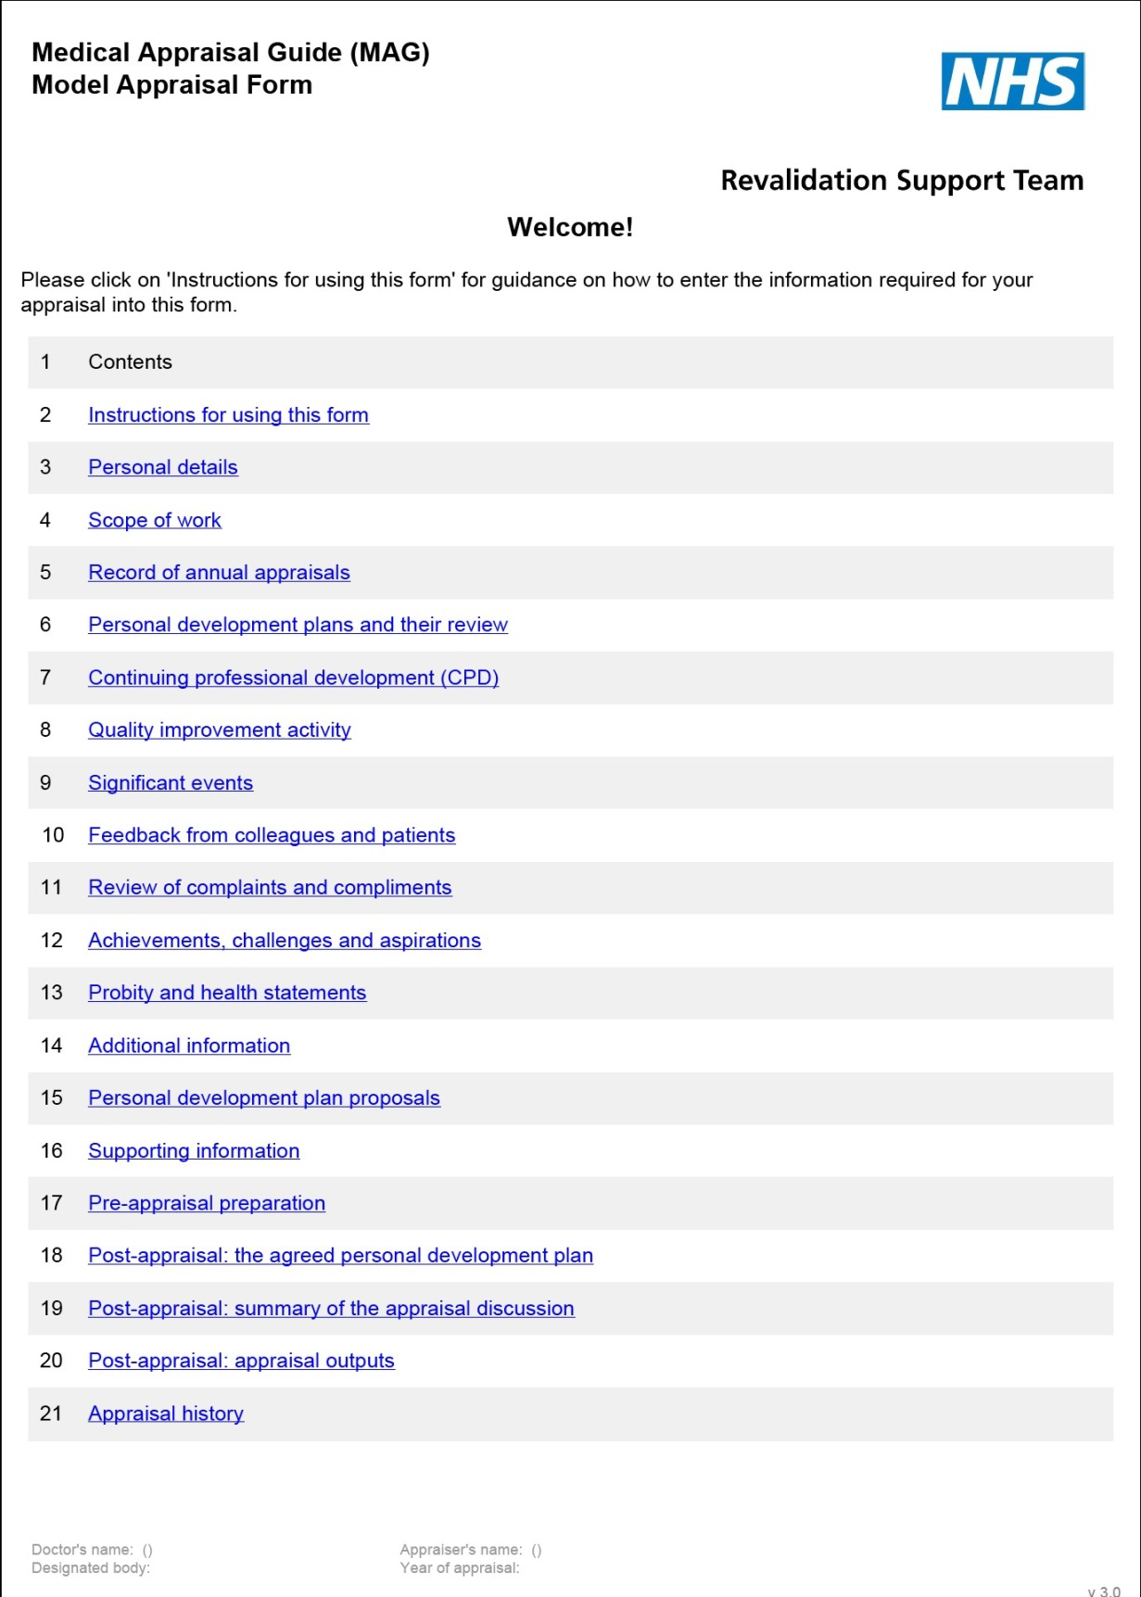

Adding value to supporting information

What does an appraiser think about when assessing a piece of supporting information? Overview/relevance
- Is it personal? Is it about the doctor?
- Is it personally meaningful? Has the doctor explained why?
- Is there any reflection?
- Why is this piece here? Why did the doctor choose to include it?
- What is the context? Can you "see the wood for the trees", especially if there is an excess of supporting information?

Quality
- Is there evidence of learning?
- Is there evidence of change?
- Has the doctor shown or explained the impact on their practice?

For revalidation
- Is there a serious cause for concern? If so, how will it be addressed?
- Which category of supporting information does it fit into?
- Is it appropriate and sufficient as supporting information for revalidation?
  - on its own?
  - with other items also provided?
- Are there any gaps in the supporting information? (Consider GMC Supporting Information for appraisal and revalidation guidance on the six types of supporting information)

Finally
- What can I add as the appraiser in the appraisal discussion?
- How will I do this?

Supporting Information Audit Tool
This part of the audit is for a more detailed look at documentation relating to SI and may be carried out as a separate exercise. Appraiser comments relating to the questions below should score marks even if the requirements are not fulfilled by the appraisee.
Continuing professional development
Is there documentation stating whether or not the relevant college requirements relating to CPD (or around 50 hours per year) have been reached? (1)
Is there documentation as to whether the CPD covers the doctor’s scope of work? (1)
Is there reference to safeguarding training (if relevant) and basic life support training? (2)
Is there documentation of whether there is personal reflection, learning and impact on practice? (3)
Is there documentation stating whether learning was shared? (1)
Total score 8
Quality improvement activity
(e.g. audit, case reviews, reviews of protocols, clinical outcomes etc.)
Is there documentation about the quality of the QI activity? (2)
Is there documentation of whether there is personal reflection, learning or change in practice? (3)
Is there documentation stating whether learning was shared? (1)
Total score 6
Significant event analysis
Is there documentation of whether there is personal reflection, learning and impact on practice? (3)
Is there documentation stating whether learning was shared? (1)
Total score 4
(state if no SEA have been submitted)
Feedback from colleagues
Is there documentation that the feedback was collected as per GMC guidance? (2)
Is there a summary of results? (2)
Is there documentation of whether there is personal reflection, learning and any impact on practice? (3)
Total score 6
(state if no feedback has been submitted)
Feedback from patients
Is there documentation that the feedback was collected as per GMC guidance? (2)
Is there a summary of results? (2)
Is there documentation of whether there is personal reflection, learning and any impact on practice? (3)
Total score 7
(state if no feedback has been submitted)
Review of complaints and compliments
Where relevant, is there documentation of whether there is personal reflection, learning and any impact on practice? (3)
Is there documentation stating whether learning was shared? (1)
Total score 4
(state if no complaints/compliments have been submitted)
Review of probity and health issues
Where relevant, is there documentation of whether there is personal reflection, learning and any impact on practice? (3)
Is there documentation stating whether learning was shared where relevant? (1)
Total score 4
Grand total out of 40

Exercise: Supporting information scenarios

A wider range of potential supporting information dilemmas are illustrated in the decision tree and supporting notes in the pack. If there is any doubt about the value and relevance of the supporting information, the appraiser should seek advice, for example from their appraisal lead.

For this exercise, consider your personal responses to the issues in the table.

Explanation of decision point | Your response?  Postpone or go ahead? Discuss? Put in the personal development plan (PDP)?  Impact on output statements?
No documentation received by mutually agreed date
GMC guidance on supporting information met but college or faculty recommendations not fully met
Supporting information does not appear balanced across the whole scope of work (for example light on the clinical role CPD)
Supporting information is present but does not include reflection on impact, outcomes or changes in behaviour

Supporting information scenarios: discussion points

Scenario | Discussion point
No documentation received by mutually agreed date | No matter how inexperienced doctors are in appraisal, they are professionals and should value the appraisal process sufficiently to provide the appraiser with documentation in adequate time to prepare. It is reasonable for the appraiser to ask to postpone the appraisal in these circumstances, although rarely the appraiser may judge that it is more appropriate to accept the documentation with only a very short time to prepare or to go ahead with no documentation at all, particularly if it is a first appraisal, in order to better understand the issues. The local appraisal policy may have strict guidelines or the appraiser may have some discretion depending on circumstances.
Handwritten documentation (illegible) | If the documentation provided is illegible, the appraiser is in the same position as if no documentation had been provided at all (see above).
Handwritten documentation (legible) | Most designated bodies are strict and demand that the professional documents for appraisal should be typed so that they are legible.  Appraisers need to know what the local appraisal policy is and what leeway they have to flex the policy. Patient feedback may take the form of a handwritten card or letter and this is usually acceptable as long as it is legible.  If the appraisal policy does not specify typed documents and the appraiser is able to prepare, then, in year one, it may be reasonable to go ahead with the appraisal with entirely handwritten documentation (as long as it is legible).
Typed documentation, no summary, PDP or mandatory information included, no previous appraisal | The appraisal documentation specifically asks for previous years’ summary and personal development plans (PDPs) because without these there is no handover from one appraisal to the next. In the first year, there will not be a previous summary or PDP to include if a doctor has not been part of an appraisal system previously. The appraisal should go ahead and the appraiser should highlight to the doctor the importance of these documents for future appraisals.

Typed documentation, no summary or PDP included, has had previous appraisal(s) | A doctor who has been involved in appraisal in previous years should be able to provide the summary and PDP from the previous year, even in the first year of revalidation. They should be aware of the importance of PDPs in providing the handover from one appraisal to the next.  If a doctor is unable to provide this documentation, the appraisal discussion should be postponed unless there is exceptionally good reason not to. However, the appraiser must have discretion to go ahead if the documents are not forthcoming after all reasonable attempts to retrieve them have been made. The doctor should know that failure to provide the previous PDP will mean that the statement about the progress with the previous PDP cannot be signed off and so the issue will be highlighted to the responsible officer. Although it may be possible to sign-off the PDP statement without the summary, the handover from one year to the next has been compromised and this omission (plus explanation) should be flagged to the responsible officer if a decision is made for the appraisal to go ahead.
Previous PDP and summary included but organisational mandatory information not included | Some organisations and specialities have mandatory training requirements that the doctor should demonstrate in the portfolio of supporting information, according to local policy. While this training may not be required by the GMC, if a local policy is clear that the appraisal should not go ahead without such documentation, postpone the appraisal. Alternatively, the appraiser may have discretion to go ahead and explore the context for failure to achieve the mandatory requirement and it may be an appropriate PDP objective for the coming year. Appraisers will need to know what their local policy says on this issue.
GMC guidance on supporting information met but college or faculty recommendations not fully met | If supporting information does not meet college or faculty guidance, the appraiser needs to judge whether the doctor is working in exceptional circumstances and whether it does meet GMC guidance. Normally, the appraisal can go ahead but it will be important to explore context and include appropriate items on PDP and/or flag up issues to the responsible officer for support if necessary.

Supporting information does not appear balanced across the whole scope of work (e.g. it is light on the clinical role or CPD) | The GMC guidance is clear that the doctor must provide supporting information in the six categories for all medically-related roles over the five-year revalidation cycle. In year one of revalidation, many doctors will not fully appreciate the new requirement to provide supporting information across the whole of their scope of work. The appraisal discussion provides the forum to explore this and to develop suitable strategies for collecting the information needed for subsequent years.  The context and detail of what is undertaken in each role will determine what constitutes sufficient continuing professional development (CPD) to remain up to date and fit to practise. The appraiser may feel that the CPD for the clinical role has been neglected in favour of other roles. This is a five-year process and the balance can be redressed in subsequent years if the issue is made explicit and understood by the doctor. The appropriate level of CPD for each role will depend on the level of complexity of the work undertaken and how supervised the work is. Speciality guidance will need to be taken into account. Suitable PDP objectives can drive improvements in balance across the scope of work.
Supporting information is present but does not include reflection on impact, outcomes or changes in behaviour | Reflection on impact and outcomes and changes in behaviour are what drive quality improvements in care. The appraiser has a vital role in facilitating this reflection and promoting development. The appraisal discussion provides the protected time to support the doctor in improving these areas in the portfolio of supporting information.  Suitable PDP objectives may need to be created to provide the focus on quality improvement.

- Appraisal algorithm

Output statements from appraiser to responsible officer

Taken from Medical Appraisal Guide (RST, 2012)

The appraiser makes a series of statements to the responsible officer that will, in turn, inform the responsible officer’s revalidation recommendation to the GMC. The appraiser should discuss these with the doctor.

There may be a clear and understandable reason why an appraiser is unable to make a positive statement. For example, a doctor may not have made significant progress with the previous year’s personal development plan because of a period of prolonged sickness.

If an appraiser is unable to confirm one or more than one statement, this does not mean that the doctor will not be recommended for revalidation; it simply draws an issue to the attention of the responsible officer.

The doctor and the appraiser should each have the opportunity to give comments on the statements to assist the responsible officer in understanding the reasons for the statements that have been made.

At this point, the appraiser may also wish to record other issues that the responsible officer should be aware of that may be relevant to the revalidation recommendation.

It would be inappropriate for the appraiser to report issues without the doctor’s knowledge. The appraiser’s statements should confirm that:
  - An appraisal has taken place that reflects the whole of a doctor’s scope of work and addresses the principles and values set out in Good Medical Practice.
  - Appropriate supporting information has been presented in accordance with the Good Medical Practice Framework for Appraisal and Revalidation and this reflects the nature and scope of the doctor’s work.
  - A review that demonstrates appropriate progress against last year’s personal development plan has taken place.
  - An agreement has been reached with the doctor about a new personal development plan and any associated actions for the coming year.

When conducting an appraisal, the appraiser must remain aware of the duty of a doctor, as laid out in Good Medical Practice. The appraisal summary should include a confirmation from the appraiser, and the doctor, that they are aware of those duties.

“I understand I must protect patients from risk of harm posed by another colleague’s conduct, performance or health. The safety of patients must come first at all times. If I have concerns that a colleague may not be fit to practise, I am aware that I must take appropriate steps without delay, so that the concerns are investigated and patients protected where necessary.”

This provides the context for a further statement that:
  - No information has been presented or discussed in the appraisal that raises a concern about the doctor’s fitness to practise.

The appraiser and the doctor should both confirm that they agree with the outputs of appraisal and that a record will be provided to the responsible officer.

If agreement cannot be reached, the responsible officer should be informed. In this instance, the appraiser should still submit the outputs of the appraisal but the responsible officer should take steps to understand the reasons for the disagreement.

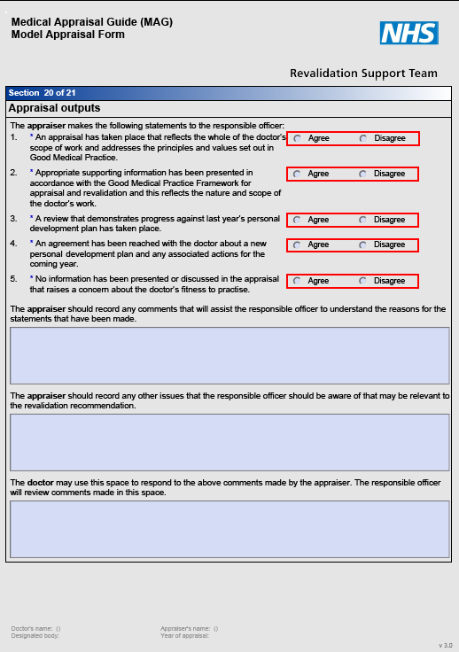

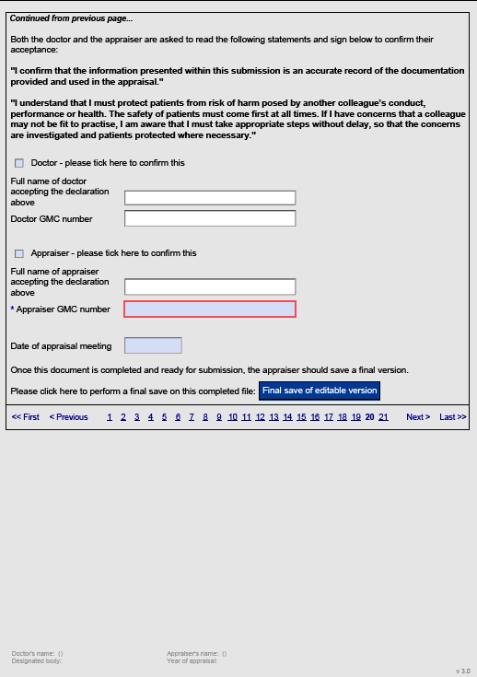
14. Providing a Professional Appraisal

These briefing notes are a starting point for creating a shared understanding of the purpose of revalidation and appraisal, and clarifying professional boundaries, behaviour and responsibilities in relation to the appraisal process.

- Purpose of revalidation
- To assure patients and public, employers and other health care professionals that licensed doctors are up to date and fit to practise.

Purposes of medical appraisal
Medical appraisal can be used for four purposes:
- To enable doctors to discuss their practice and performance with their appraiser in order to demonstrate that they continue to meet the principles and values set out in Good Medical Practice and thus to inform the responsible officer’s revalidation recommendation to the GMC.
- To enable doctors to enhance the quality of their professional work by planning their professional development.
- To enable doctors to consider their own needs in planning their professional development.
and may also be used:
- To enable doctors to ensure that they are working productively and in line with the priorities and requirements of the organisation they practise in.

Most doctors should have no difficulty in demonstrating that they are up to date and fit to practise and should spend most of their appraisal discussing their continuing professional development and how to improve the quality of their practice.

Professionalism
- Appraisals should not be vulnerable to appearances of collusion; all doctors have a right to a robust appraisal that promotes their personal and professional development.
- Both doctor and appraiser should be punctual and professionally presented. The appraisal will be conducted in a professional manner within an appropriate working environment (that is, professional, private/confidential, no interruptions, able to access necessary resources/internet).
- The appraiser and the doctor should report any concerns about the conduct of the appraisal to an appropriate person (for example appraisal lead).
- There should be a written complaints process and a process for dealing with significant incidents relating to the appraisal process.

Confidentiality and Good Medical Practice
- The content of the appraisal discussion will normally be kept confidential by the appraiser.
- The doctor and appraiser should understand that all doctors are subject to an over-riding duty to protect patients.
- If a doctor reveals something during the appraisal that gives rise to serious concerns about health, conduct or performance, the concern will outweigh the principle of confidentiality and the appraisal process will be suspended pending the outcome of responding to concerns procedures.
- Overall, the appraiser must apply their professional judgment to establish whether there is a patient/personal safety issue, in accordance with section 43 of the GMC’s Good Medical Practice:
“You must protect patients from risk of harm posed by another colleague's conduct, performance or health. The safety of patients must come first at all times. If you have concerns that a colleague may not be fit to practise, you must take appropriate steps without delay, so that the concerns are investigated and patients protected where necessary. This means you must give an honest explanation of your concerns to an appropriate person from your employing or contracting body, and follow their procedures.”
Section 43, Good Medical Practice (GMC, 2006)

Data protection
- The appraiser must not hold or retain their own independent records relating to the doctor or the appraisal other than for the immediate purpose of undertaking the appraisal.
- Electronic information must always be sent using secure email systems in accordance with local appraisal and information governance policies.
- Local information governance policies should cover whether personal computer systems and memory sticks can be used for appraisal and revalidation information; these policies must be followed.
- The appraiser has a professional and legal responsibility to handle all information in accordance within legal parameters and safeguards.

Information sharing
- The completed appraisal documentation, including the supporting information will be available for access by the responsible officer or someone acting with appropriate delegated authority.
- The appraisal documentation may be used for:
  - Appraisal
  - monitoring and managing patient safety and the doctor’s fitness to practise (including making fitness to practise recommendations)
  - facilitating early recognition of patterns of capability or conduct concerns
  - management and quality assurance of the systems and processes
  - the protection of the public
  - future legal action or defence by the designated body including indemnifying the responsible officer and/or appraiser.
- The appraisal summary and personal development plan (PDP) may be shared with named individuals according to local policy, and analysed to understand collective learning needs and constraints
- Appraisal documentation will not normally be used in a non-anonymised form for any other purpose, without the doctor’s consent.

Venue
- The doctor will normally nominate an appropriate, mutually-convenient venue for the appraisal meeting
  - The venue must allow the discussion to be private, confidential and free from interruptions; it must also provide access to the internet and other necessary resources.
  - Either the doctor or the appraiser may request reallocation if a venue cannot be agreed.
- If an unusual venue is agreed the agreement and reasons for the choice should be recorded in case an explanation is required later. The venue must always meet the criteria above.

Timing
- The appraisal will normally be in working hours, at a time and date that is mutually convenient and allows sufficient time for the appraisal discussion
- Either the doctor or the appraiser may request reallocation if personal timetables prove incompatible
- The appraisal meeting will normally take between 1 ½ to 3 ½ hours, depending on what is discussed and whether time is included to write-up and agree the appraisal outputs
- The doctor and appraiser will build in appropriate flexibility so that the appraisal is not cut short, they are fresh enough to give the appraisal discussion their full attention and there is appropriate time for reflection afterwards.
- If, in exceptional circumstances, doctor and appraiser mutually agree to meet at a time outside normal working hours, the agreement and reasons should be recorded in case an explanation is required later. They must both ensure they are able to give the appraisal discussion the time it requires.

Cancellation
- If something unexpected happens, the affected party will make every effort to communicate with the other party and, where applicable, the administrative team, to explain that there has been an unavoidable change of plan (such as sickness, transport failure).
- The administrative team (where there is one) should provide appropriate support in ensuring that the message is passed on and received as soon as possible.

Pre-appraisal documentation
- The doctor will normally provide everything that is required for the appraisal discussion to go ahead, two weeks before the appraisal date, unless another arrangement has been made by mutual agreement or is defined in the local appraisal policy.
- Documentation must be legible and professionally presented, and will normally be typewritten. (This may be defined in local policy.)
- If the doctor has not provided the required supporting information, the appraisal discussion may need to be postponed until the information is available and the appraiser has had adequate time to prepare.

Post-meeting documentation
- If not completed at the time of the appraisal discussion, the appraiser will ensure that the doctor receives the post-appraisal documentation as soon as possible afterwards. (A limit may be defined in local policy.)
- The doctor will sign-off the documentation and return it to the appraiser as soon as possible after receipt. (A limit may be defined in local policy.)
- Any appraisal documentation that is incomplete (that is, not fully submitted and signed-off by both parties) within 28 days of the appraisal discussion, will be reported to the responsible officer as an incomplete appraisal and an explanation sought in the annual exception audit.

Annual appraisal
- Engagement in annual appraisal requires the doctor to have an appraisal each year, and normally five in each revalidation cycle
- It is the responsibility of the doctor to complete their portfolio and engage with the annual appraisal process in a timely fashion
- It is the responsibility of the doctor to comply with local management requirements for arranging an appropriate appraisal
- If the allocated appraiser is unable to provide a timely appraisal then it is appropriate for the doctor to be reallocated to another appraiser
- Existing arrangements for joint appraisal of clinical academics in compliance with Follett principles are unaffected by the requirements of revalidation:
  - joint appraisal – one appraiser from the university and one from the designated body
  - these arrangements are for local agreement between the university and the designated body.

Setting boundaries to the appraisal discussion
- Setting explicit boundaries to the appraisal discussion should be included in the local appraisal policy and in appraiser training so that there is a shared explicit understanding of the expectations of a professional appraisal, the roles of both doctor and appraiser, and the limitations of confidentiality, prior to the appraisal discussion
- Designated bodies may find it helpful to produce written guidance to cover this explicitly and share it with the doctor prior to the appraisal.
- It is recommended that the appraiser directly address the issue of confidentiality and GMC requirements with the doctor at the start of the appraisal interview. This has been found to help create a professional atmosphere without interfering with rapport-building, especially if it builds on appropriate written information in the appraisal policy and pre-appraisal. An appropriate statement at the start of the appraisal meeting makes the responsibility and accountability of both parties explicit.

Example of appraiser statement: “This is your appraisal. I want to make sure that this time is useful to you and addresses the areas that are your main priorities but there are some formalities to cover first. You are aware that all appraisals are conducted under GMC guidance, and that all doctors have a duty of care towards each other and to promote patient safety. We are both responsible for taking appropriate action, should either you or I make any statement that raises an issue of patient safety. This might involve suspending the appraisal process, or exploring our options around how we proceed with this appraisal, until the issue has been addressed appropriately. We might have to take advice in such a situation. Do you agree?”

Communication skills for appraisers

Active listening
Active listening involves paying attention to the verbal cues (the words people use) non-verbal cues (such as body language) and para-verbal cues (such as intonation, volume and pace of speech) that lead to a fuller picture of what the doctor is trying to convey and perhaps what they are revealing unintentionally.

No rigid script for appraisal will work. Communication skills depend on being used flexibly in response to the individual and the level of rapport that has been established.

It helps to prepare some useful questions to ask. These may be used during the preparation phase and in the appraisal itself. Using them rigidly would sound stilted and prevent the free flow of the appraisal, but thinking them through beforehand can prevent difficulties with how to approach a topic with a doctor. You will rapidly develop your own style, but sometimes having a stem question or idea “up your sleeve” can help keep things moving.

Open questions: Six honest serving men
Kipling’s ‘Six honest serving men’ are the starting point for many open questions. They cannot be answered with a simple “Yes” or “No” that closes down the discussion, and are useful in getting the doctor to talk freely.
Extract from Rudyard Kipling (1902) The Elephant’s Child: “I keep six honest serving men,
(They taught me all I knew);
Their names are ‘What?’ and ‘Why?’ and ‘When?’ And ‘How?’ and ‘Where?’ and ‘Who?’”

“Please describe…” is another useful opener.

Closed questions
Closed questions are useful for refining understanding or eliciting detail and are generally those that can be answered “Yes” or “No” or with one word answers.

Clarification questions
More direct questions can be very useful in clarifying specifics in an area of discussion. They are sometimes called “funnel” questions because they lead the conversation in a particular direction. Beware of clarifying too soon. “Can you give me an example of that?” is a useful way to start to clarify an issue.

Paired questions

The use of paired opposites can be very helpful in introducing negatives in a non-threatening way. It can be an interesting and acceptable way of asking otherwise difficult questions.

For example: “Tell me about your greatest achievement over the past year.” “Now what was your greatest disappointment over the past year?” “What is the best/worst decision you have made this year?”

Echoing and the use of silence
When there is some ambiguity in what the doctor has said, or the appraiser is surprised and wants to buy thinking time (and find out more), or if the appraiser feels that the doctor has more to say and wants to encourage them to carry on talking, it can be very useful to echo the last thing that the doctor said, or the key phrase, or just to pause to give the doctor thinking time.

For example: Doctor: “When I look back on the significant event, I feel really frustrated.” Appraiser: “Frustrated…” (pause)

Alternatively, the appraiser could remain silent, while giving non-verbal cues that he/she is interested and wants to hear more, such as nodding, or giving non-specific para-verbal prompts, for example, “mm”.

Summarising
Towards the end of an area of discussion, it can be very helpful to check back with the doctor that there is a shared mutual understanding.

Appraiser: “So, just let me summarise what we have discussed…then you can add anything that I may have misunderstood or missed out…”

Conclusion
“Is there anything else/further we need to discuss?”
“Is there anything you would like to mention that has not been covered?”

General ideas
Listen and look, then reflect.
Share personal reflections and learning to build rapport, if appropriate.

Use of humour
While the use of humour can be a great icebreaker or defuse tension, it should be used judiciously, as the other person may not share your sense of humour.

Stem questions for appraisers

Stem questions are starting points, from which the discussion may go in many different directions. Below are some example stem questions you might wish to use to explore an area from the appraisal and revalidation portfolios. Use them to help prepare your interview.

A starter question
Many appraisers have found it fruitful to begin by asking the doctor about their most important area for discussion.
For example: “What is the most burning issue for you at the moment?”
“What do you most want to cover during this appraisal?”
“Is there anything that you particularly want to use this time to discuss and think through?”

In business meetings, it is increasingly common for ‘any other business’ to be taken at the beginning of the meeting so that an important item is allocated sufficient time. Similarly with appraisal, something important may have come to light since the forms were signed-off, or it may help the doctor to raise an issue they found difficult to put on paper.

Asking questions similar to those above is a good way of ensuring that the doctor’s needs do not get lost in the structure of the interview. Don’t be surprised if the doctor says that there isn’t a specific issue they’d like to discuss, but then spends a good proportion of the time on one issue after all!

It can also be useful to revisit this sort of question near the end of the appraisal discussion once relationships have been established.

Please note: Remember the six types of supporting information described by the GMC and the four domains of the GMC’s Good Medical Practise Framework for appraisal and revalidation.

Scope of work
Can you describe all the different areas that form part of your scope of work? Which of the areas of your scope of work do you find the most important and why? How do you keep up to date with each area?
How do you review what you actually do for each area?
How do you get feedback on your performance in each area? Do you work for any voluntary organisations?
Do you do any private work? What supporting information have you included for these roles?

Educational/managerial roles (if appropriate)
Describe any teaching/management that you do? Do you like teaching/management? Why or why not?
What do you enjoy most/least about the role?
What feedback have you received about your teaching/management?
What are your strengths and areas for development in your educational/managerial role?

Which areas of education/management do you find easy/hard? Where do you feel this area of your professional life is going? How would you most like to improve in this part of your work? Do you have any specific plans to do this? If so, how?
Is this role appraised elsewhere?

Research and academic roles (if appropriate)
Have you done any recent research? If so, what was it? What was your role in it? Who else was involved?
What went well? How could it have been improved?
Are there any issues in relation to the research you undertake? Where do you get appropriate support for your research?
What feedback have you received? Is this role appraised elsewhere?
If you are a clinical academic, you should have organised your appraisal according to Follett principles – if not, why not? What happened?

Knowledge, skills and performance
How would you describe yourself as a doctor? How do you think others would describe you? What makes you a good doctor?
What part of your job do you most/least enjoy and why? Any main challenges you wish to discuss?
Are there any complaints or significant events you wish to discuss? Have you ever had feedback about:
- your clinical experience
- personal organisation
- decision-making?
How do you handle conflicting demands upon your time? What puts you under pressure?
Describe any recent stressful situations… What did you do? Would you do the same again? What was your best decision/most difficult decision over the last 12 months?

Continuing professional development
How do you keep up to date? How do you learn best?
How do you tend to identify what you need to learn?
How do you record your learning? Tell me about what works for you… Do you keep a learning log with reflective notes?
Have you found this way of learning hard or easy? How do you organise your learning?

Tell me about what personal reading you choose to do? Which journals do you tend to read?
What do you think of e-learning opportunities?
What experience do you have of BMJ Learning/Doctors.net/online trackers? Are you part of a small group or action learning set?
What sort of clinical meetings do you attend?
Have you managed to attend any external meetings? What did you learn?
Why did you choose to attend those particular meetings?

Probity
What did you think about when you signed the probity statement in the documentation? Are there any probity issues or potential conflicts of interest that you wish to explore?
Do you believe that your probity would withstand scrutiny? How would you recognise a conflict of interest?
Who else helps you to ensure that your probity is beyond reproach?

Health
What did you think about when you signed the health statement in the documentation? Are there any health issues that might affect patient care?
What safeguards do you have in place to protect your health and wellbeing? How do you 'switch off' at the end of the day?
How do you manage the balance between work and home/family? Who is there to support you?
Who would recognise it if you were becoming unwell? What would you do?

Relationships with patients
How might your patients describe your care?
Describe a patient with whom you feel you have a good relationship. What makes it work well/effectively?
What about a patient with whom you have a more difficult relationship? Why do you think you find that relationship more difficult?
Have you had any difficult encounters with patients in the past year? What did you learn or what would you do differently?
Have you done a patient satisfaction survey to individual level? What did you learn from it? What are you particularly proud of or disappointed with in your relationships with patients?

Relationships with colleagues
Describe your team and where you see yourself within it. How would your colleagues describe you?
What might they say is your best/worst feature?
What are you particularly proud of or disappointed with in your relationship with colleagues? What could you do to improve your working relationships?
If you have done a colleague feedback exercise, what did you learn from it? If you have not yet done one, when will you need to have done one by?
How will you reflect on the feedback that you get?

Personal development plans and their review
Which objectives were easiest to achieve and why? Which objectives were most difficult to achieve and why? Which were the most valuable learning activities and why? Which were the least valuable learning activities and why?
In what ways have you been able to apply your learning in practice?
What benefits to your patients do you feel have occurred as a result of your learning?
Are there any learning needs that you wish to carry forward to your next personal development plan?

Achievements
What do you feel has been your biggest achievement since your last appraisal? (Or if already described in the documentation)
I notice that you are proud of your achievement …can you tell me more?

Challenges
What do you feel has been your biggest challenge since your last appraisal? How do you feel about that?
What do you think you have learned from thinking about that? How has it changed you?

Aspirations
What would you like to have achieved by your next appraisal? How would you like to see your career developing?
Have you any aspirations for the next five years? Where do you see yourself in five years’ time?

Revalidation
How do you see your appraisal linking to your revalidation? What are your concerns regarding revalidation?
How do you relate to your responsible officer?
When will you be put forward for a revalidation recommendation? How will you find out?
How can the annual appraisal process support you in gathering information that you will need? What else would make you feel well-prepared for revalidation?

Feedback skills

There are many ways to give feedback and most people find a structure useful. The most important goals to achieve whenever giving feedback are to be:
- honest
- balanced
- supportive - not destructive.

At the end the person receiving feedback should be clear where and how they can change to improve.

Pendleton's rules for giving feedback
Pendleton’s rules1 provide a structure for giving feedback in a particular way, as summarised below:
- Clarify any points of information or fact
- Ask the individual what he or she did well – ensure that they identify the strengths of the performance and do not stray into weaknesses
- Discuss what went well, adding your own observations
- Ask the individual to say what went less well and what they would do differently next time
- Discuss what went less well, adding your own observations and recommendations
- Close by reviewing the whole picture, focusing on what went well so that the feedback finishes in a ‘safe place’ for the recipient.

The ‘feedback sandwich’
Some people have described Pendleton’s suggested structure for giving feedback as the ‘feedback sandwich’ because the areas for development are sandwiched between two opportunities for positive feedback.

Some strengths of Pendleton's rules:
- Offer the appraiser the opportunity to evaluate their own practice and allows even critical points to be matters of agreement.
- Allow initial appraiser observations to be built upon by the observer.
- Ensure strengths are given parity with weaknesses.
- Deal with specifics.

1 The Consultation: An approach to learning and teaching (Pendleton, Schofield, Tate & Havelock, Oxford University Press, 2003)

Some difficulties with Pendleton's rules:
- People may find it hard to separate strengths and weaknesses in the formulaic manner prescribed. Insisting upon this formula can interrupt thought processes and perhaps cause the loss of important points. Though it sets out to protect the individual receiving feedback, it is artificial.
- Feedback on areas of need is held back until part way through the session, although appraisers' may be anxious and wanting to explore these as a priority. This may reduce the effectiveness of feedback on strengths.
Holding four separate conversations covering the same performance can be time-consuming and inefficient. It can prevent more in-depth consideration of priorities.

Pendleton states:
“Much has been made of the feedback dubbed the Pendleton rules. The key to effective feedback is to offer both challenge and support but the rules are often used as reasons to be supportive without being challenging.” (Pendleton, Schofield, Tate and Havelock, 1984)

Agenda-led outcome-based analysis (ALOBA)
This feedback structure is designed for use when giving feedback on a clinical consultation. However it is well-suited to giving feedback in many situations, including the appraisal discussion.

The advantage of this structure is that it is learner/doctor led. The appraiser starts by asking which area(s) the doctor would like to help with. The doctor is allowed to express their views, thoughts and possible solutions. By appropriate questioning, the appraiser can facilitate the doctor to propose ideas and solutions. At this stage the appraiser can bring suggestions and alternatives if appropriate. The doctor is more likely to run with an idea they have generated themselves rather than one which, on reflection, could be seen as having been imposed by the appraiser, although there is a useful role for the appraiser in signposting resources and opportunities the doctor may not have been aware of.

DOs and DON'Ts of giving feedback

Behaviour
Dos
Give it with care
Let the recipient invite it
Encourage self-criticism
Be specific
Outline the positive
Avoid evaluative judgments
Make the feedback actionable
Balance the positive and negative
Balance the timing of the positives and negatives
Choose the right time and place
Don’ts
Deny the other persons feelings
Be vague
Accuse
Take for granted the person has understood
Bring in third parties
Be negative
Be destructive
Be judgmental
Bring up behaviours that the person cannot help
Be overly-impressed
Be aggressive

  - Giving good constructive feedback

Why?
- Effective and honest communication is at the heart of the appraisal process
- Giving constructive (not destructive) feedback about an individual’s performance from your perspective helps them to develop their skills and qualities
- Always remember that feedback is for the benefit of the recipient not the feedback giver. It doesn’t help the doctor if you have proved how clever you are. First, do no harm!

Where?
- Use quiet conducive surroundings
- Allow enough time and avoid interruptions
- Plan and prepare well, agree the format and agenda
- Help the recipient:
  - clarify what they were trying to achieve
  - identify what went well, less well and why
  - decide how to take things forward

How?
- Be honest, respectful, systematic and supportive
- Use their experience and add to their perspective
- Guard against being destructive by:
  - building on their views
  - focusing on behavior not personality
  - using observations not judgments
- Summarise the discussion, agree action points and finish positively

What?
You could include:
- a strength that they need to maintain, keep doing, or do more of
- something that distracts them from their strengths
- a weakness that they should develop to a point of competence (or recognise and stop doing)

When?
- In some situations, depending on the rapport that has been developed, the doctor will feel able to invite the appraiser to provide feedback directly
- In most instances the circumstances, or the relationship, might inhibit the doctor from doing so, even when the doctor would like more challenge, so the appraiser has to judge the timing
- The appraiser can check whether the timing and degree of challenge are appropriate with the doctor by asking the doctor directly
- The appraiser should facilitate the feedback process using a structured approach that meets the needs of the doctor

Exercise: Giving feedback

This is an exercise to practice the essential communication skills required for appraisal both in questioning and giving feedback. It acts as a ‘dummy run’ for the partial appraisals to come.

Think of an issue that is real in your life and work at the moment and that you would like to explore with a colleague:
- Decide how you will let the appraiser know what you want to talk about
- Make sure that these are areas you are happy to discuss within this exercise
- Remember: the more these are ‘hot topics’ in your life and work at the moment, the more you will get out of the discussion

In your groups, work out who will be the appraiser, the doctor and the observer for the first cycle of the exercise. You will all have the chance to take every role.

The appraiser role
For ten minutes the appraiser will explore the doctor’s agenda, using open questions and active listening skills and gradually clarifying and summarising, until it is possible to help the doctor to move on.

The observer role
The observer should use the observation sheet provided to record comments and impressions; specific quotes are helpful. These will be collected by the course facilitators at the end. For five minutes the observer should feedback to the appraiser on their performance using Pendleton’s rules and the qualities of good feedback we discussed earlier.

The observer should act as the timekeeper for each round.

After the first round everyone changes roles, and the exercise is repeated. It is helpful to change position and sit in the right chair for your role, to help change focus.

After the second cycle, all change again so everyone experiences each role.

Time | Appraiser | Doctor | Observer
Start time | A | B | C
15 mins after start time | B | C | A
30 mins after start time | C | A | B

21. Preparing for appraisal

- Arrange a mutually-convenient date, protected time (1 ½ to 3 ½ hours) and an appropriate venue.
- Obtain the doctor's documentation and supporting information, ideally two weeks before the appraisal date. Doctors are required to produce typed, not handwritten, documentation and encouraged to use a suitable electronic platform, which is secure and allows supporting information to be uploaded, for example MAG Model Appraisal Form (RST, 2012). Documentation should include any specific requirements from the GMC as well as reflecting guidance from the royal colleges and faculties and any specific organisational requirements.
- Read the pre-appraisal documentation and supporting information.
- Review the supporting information in the light of the scope of work and the accompanying reflection in line with GMC guidance
- Note points for discussion or further exploration.

Some appraisers like to use a template to structure their notes (see the example on the next page).

Others find it easier to pre-populate parts of the summary of the appraisal with the details of the supporting information and context provided pre-appraisal and print out their draft and then write over it with the information arising from the discussion. This means that many ‘tick box’ elements can be dealt with before the appraisal discussion, leaving more time for the doctor to look at quality improvements and how to maintain and enhance their performance.

There is no golden formula and the best appraisers adapt their style according to the doctor they are appraising. However, there is no excuse for complacency and it would be wholly unprofessional not to prepare thoroughly for each appraisal.

Appraisal summary preparatory notes template

This template is designed for the appraiser’s use only, to make relevant preparatory notes. Sections may be copied and pasted into the doctor’s appraisal following the appraisal meeting as appropriate.

This template is taken from the NHS England Medical Appraisal Policy, annex J: Routine appraisers assurance tools.

Doctor’s name
Date of appraisal
Revalidation date

SETTING THE SCENE AND SCOPE OF WORK

SUPPORTING INFORMATION (list what is provided under the following headings. Include the action plan for any supporting information that is missing)
Quality Improvement Activity
1. Clinical audit
2. Review of clinical outcomes
3. Case review
4. Audit teaching programme
5. Evaluate health policy or management practice

Continuing professional development (may include college recommendations)
Significant Events
Significant events are reserved for the rare cases where there was a serious incident (for example unexpected death or permanent harm) and a significant untoward incident (SUI) process was initiated

The systems around SUIs are rarely activated in primary care but less serious significant event analyses may still be submitted for learning

Quality improvement activity (e.g. audit/case reviews)

Significant events (if applicable)

Feedback from colleagues (5 yearly)

Feedback from patients (where applicable and 5 yearly)

Review of complaints and compliments

Reference to any other clinical supervision/specialty appraisal also submitted/RO evidence

LAST YEAR’S PDP
Reflection prompt:
What went well? What could have been done better?
How has this learning affected the doctor personally?
How has it improved their patient care? Did they objectively demonstrate this?
Did they disseminate this learning to colleagues?
Refer to the doctor’s strengths and areas for development
Was it completed? If not, document why not

Domain 1: Knowledge, skills and performance
Domain 1
Knowledge, skills and performance
Attribute 1 - Maintain your professional performance
Attribute 2 - Apply knowledge and experience to practice
Attribute 3 - Ensure that all documentation
(including clinical records) formally recording your work is clear, accurate and legible

Domain 2: Safety and quality
Domain 2
Safety and Quality
Attribute 1 - Contribute to and comply with systems to protect patients
Attribute 2 - Respond to risks to safety
Attribute 3 - Protect patients and colleagues from any risk posed by your health

Domain 3: Communication, partnership and teamwork
Domain 3
Communication, Partnership and Teamwork
Attribute 1 - Communicate effectively
Attribute 2 - Work constructively with colleagues and delegate effectively
Attribute 3 - Establish and maintain partnerships with patients
New:
Teaching, training, supporting and assessing
Continuity and coordination of care

Domain 4: Maintaining trust
Domain 4
Maintaining Trust
Attribute 1 - Show respect for patients
Attribute 2 - Treat patients and colleagues fairly and without discrimination
Attribute 3 - Act with honesty and integrity

Summarising Comments

Appraiser:
Date:

Now copy and paste the text in each of the boxes to the relevant areas of your online toolkit.

  - Another appraisal preparation example template

Domain of Good Medical Practice
Supporting information?
Preparation points/areas to explore/examples of good practice to affirm/share
Reflection?
Lessons learned?
Actions agreed/PDP task(s) arising?

  - Homework for day one

Reflections

In the box below, jot down any reflections from today or any thoughts or questions to carry forward. These are purely for your own use and won’t be shared. (However, you may wish to start a CPD portfolio for your appraisal role and use these as a starting point.)

Preparing for the mini appraisal on day two

On day two you will have 30 minutes to conduct a mini appraisal, based on the real appraisal information of your ‘doctor’. That may sound a long time, but we suspect you will see that it isn’t. We have suggested that doctors provide reflection and supporting information on one domain of Good Medical Practice (Knowledge, Skills and Performance). Remember, though, that it is the doctor’s appraisal, so the agenda needs agreeing at the outset.

Consider how you will start the appraisal – thinking about how you will discuss the limitations of confidentiality, set the scene and agree what you will be discussing.

Looking again at the observation tool may help you as you structure what you plan to discuss and how you think you will go about it – it is intended to help you demonstrate effective appraisal techniques.

25. Exercise: Conducting an appraisal

This is the main exercise to allow you to demonstrate the essential communication skills required for appraisal. The format is the same as the ‘Giving feedback’ exercise from the first day of the training. Once again, you will be working in your trio and you will have an opportunity to take each of the three roles:
- doctor
- appraiser
- observer.

The cycle of three iterations will work in reverse order so that each delegate will appraise a different member of the trio in this exercise than in the giving feedback exercise. The main difference is the length of time allowed for the discussion (30 minutes). Like a full appraisal, it is important to do appropriate scene setting and elicit an agreed agenda at the beginning.

This exercise, like the previous one, works best if the discussion focuses on issues of real importance and relevance. This is exactly what happens in full appraisals and it is very reassuring to be able to rehearse the skills needed to deal with whatever the doctor brings up during a training exercise.

The doctor
The doctor should not role-play. It is important to be yourself as the doctor being appraised. One of the benefits of this training is the chance to use the skills of your appraiser to facilitate your reflection on an issue that is current for you.

The appraiser
For 30 minutes, the appraiser will conduct a partial appraisal, rehearsing all the skills they need, in particular by starting with appropriate scene setting. This may seem like a long time but it will not feel like it once the discussion has started.

Do not try to complete a whole appraisal in 30 minutes; you will not be able to demonstrate your skills adequately as you will rush from one area to another. Focus on covering one or two areas in appropriate depth for a real appraisal.

The observer
The observer will use the same style observation sheet as day one to record comments and impressions; specific quotes are helpful. These will be collected by the course facilitators at the end to help in producing the written feedback to individuals after the course.

For 10-15 minutes after the partial appraisal, the observer will have the opportunity to facilitate feedback with the appraiser about their performance. Remember to ask the appraiser how they thought it went first and to check back with the doctor being appraised.

The observer should act as the timekeeper for each round. It is important that the discussion is continued for the full 30 minutes to allow ample time to demonstrate all the core communication skills, but a 5 minute warning near the end of the time can be useful to allow time to wrap up and get back to safe ground if necessary. Use your discretion about the exact point to stop.

The three cycles are repeated and there is time for a coffee break, when the trio is ready, in between the second and third cycles. This break and going straight to lunch at the end allows for slightly different finish times between groups.

Time taken | Appraiser | Doctor | Observer
45mins | C | B | A
45 mins | B | A | C
45 mins | A | C | B

26. Sample medical appraisal feedback questionnaire

This questionnaire should be completed by the doctor and sent to the appraisal lead or appraisal manager when the post-appraisal sign-off has been completed, or completed online, in which case the results will be collated automatically.

It says:
Thank you for completing the following questionnaire. It will be used to provide information to the responsible officer and designated body about the quality of the appraisal and to provide feedback to help your appraiser. All feedback will be collated so that it is anonymous before being fed back to the appraiser. If you have a serious concern about the conduct of your appraisal, do not use this form and please contact the responsible officer or appraisal lead directly. (Add contact details as appropriate.) Any significant issues should be dealt with as they arise.

This questionnaire is available in the NHS England Medical Appraisal Policy, annex J: Routine appraisers assurance tools, and is taken from Quality Assurance of Medical Appraisers v5, appendix 5.

Dear Doctor

Now that your recent appraisal has been signed-off as complete, I would be very grateful if you will complete the following questionnaire. It will be used to provide information to the responsible officer about the quality of the appraisal and feedback to help your appraiser. All feedback will be collated so that it is anonymous before being fed back to the appraiser.

Please note that if you have a serious concern about the conduct of your appraisal, do not use this form but please contact Click here to enter text. directly, at: Click here to enter text..

If you answer ‘no’ to any of the ‘yes/no’ questions below, please use the relevant comments box to provide an explanation and constructive suggestions for improvement.

Medical appraisal feedback questionnaire
Name of designated body | NHS England
Name of doctor | Click here to enter text.
Name of medical appraiser | Click here to enter text.
Date of appraisal discussion | dd/mm/yyyy
Duration of appraisal discussion | Hours | <1  ☐ | 1-2  ☐ | 2-3  ☐ | 3-4  ☐ | >4  ☐
Was there sufficient protected time for the appraisal discussion? | Yes ☐ No ☐
Was the venue private and professional? | Yes ☐ No ☐
Comments Click here to enter text.

The administration and management of the appraisal system
Is the appraisal process satisfactory? |  |  |  | Yes ☐ No ☐
Did you have access to all necessary forms and materials for your appraisal? |  |  |  | Yes ☐ No ☐
Were you able to collect the necessary supporting information from the organisation(s) where you work? |  |  |  | Yes ☐ No ☐
Did the administrative support for the appraisal process meet your needs? |  |  |  | Yes ☐ No ☐
Any comments about the administration or management of your appraisal system
Click here to enter text.
The appraiser  (Please give your appraiser feedback for their personal development) | Poor | Borderline | Satisfactory |  | Good | Very good
Please rate your appraiser’s skills in… | 1 | 2 | 3 |  | 4 | 5
Establishing rapport | ☐ | ☐ | ☐ |  | ☐ | ☐
Demonstrating thorough preparation for your appraisal | ☐ | ☐ | ☐ |  | ☐ | ☐
Listening to you and giving you time to talk | ☐ | ☐ | ☐ |  | ☐ | ☐
Giving constructive and helpful feedback | ☐ | ☐ | ☐ |  | ☐ | ☐
Supporting you | ☐ | ☐ | ☐ |  | ☐ | ☐
Challenging you | ☐ | ☐ | ☐ |  | ☐ | ☐
Helping you to review and reflect on your practice | ☐ | ☐ | ☐ |  | ☐ | ☐
Helping you to identify gaps and improve your portfolio of supporting information for revalidation | ☐ | ☐ | ☐ |  | ☐ | ☐
Helping you to review your progress against your last personal development plan (PDP) | ☐ | ☐ | ☐ |  | ☐ | ☐
Helping you to produce a new PDP that reflects your development needs | ☐ | ☐ | ☐ |  | ☐ | ☐
Managing the appraisal process and paperwork | ☐ | ☐ | ☐ |  | ☐ | ☐
Would you be happy to have the same appraiser again? | Yes ☐ No ☐
Any other comments about your appraiser Click here to enter text.

The appraisal overall
Was the appraisal useful overall for…
Your personal development? | Yes ☐ No ☐
Your professional development? | Yes ☐ No ☐
Your preparation for revalidation? | Yes ☐ No ☐
Promoting quality improvements in your work? | Yes ☐ No ☐
Improving patient care? (where applicable) | Yes ☐ No ☐
Any other comments about your appraisal overall Click here to enter text.

Thank you for taking the time to complete this questionnaire.

27. Producing a personal development plan (PDP)
Aims
- explore the purpose of a personal development plan (PDP)
- explore the place of PDPs in appraisal and revalidation
- explore the limitations of PDPs
- explore what makes a good PDP based on explicit criteria
- provide practical experience of working up broad aims into PDP objectives.

Background considerations
What is the PDP for?
- to provide focus to personal and professional development
- to provide a series of stepping-stones that can be used to measure progress over time
- to help clarify ideas and plans before embarking on them
- to help prioritise personal learning needs and balance them with service needs.

Problems with PDPs
- only looking at them just before the next appraisal
- simplifying them to the level where there is no element of challenge because everything is already booked or easily achievable
- a snapshot view does not always fit with how the individual works/learns (global vs. sequential learning – individuals have differing preferences)
- the emphasis on achievement does not encourage aspirational objectives
- the annual cycle dictates an artificial timeframe
- avoiding the PDP becoming a continuing professional development (CPD) log
- deciding how many items are appropriate

What level of achievement is acceptable?
- How many items have been achieved in full?
- How many items have been discarded, superseded or are no longer appropriate?
- What if items are partially achieved?
- What about items that have more than a year timeframe?

Appraisers should use their professional judgement and expertise to form an opinion and, if in doubt, ask advice. Opinion will converge over time as the body of experience grows so the threshold for asking advice should initially be low.

28. What are SMART(IES) objectives?

S = Specific | (clearly defined so that the objective can be met and the doctor has been drawn into thinking carefully about it)
M = Measurable | (the outcome measure should be defined at the outset so that it is clear when the objective has been achieved.)
A = Achievable | (some potential objectives may be aspirational)
R = Relevant | (at this stage in career, work situation, looking at individual and local and national priorities)
T = Timed  I = Interesting  E = Economic  S = Share Successes | (have a timescale in which they will be achieved)  (something the doctor really wants or needs to do, so they are engaged)  (in terms of time and money and support needed to achieve the objective)  (defines how examples of good practice and learning will be shared with the wider team or successes celebrated)
29. Exercise: Practise writing an effective PDP objective

Practical exercise in trios:
- framing objectives that are achievable
- identifying the actual need
- exploring methods of reaching truly useful and structured objectives.

Consider the challenge on the slide – identifying a PDP objective from the partial appraisal discussion or for the doctor as a new appraiser - very vague and non-specific.

First try to write yourself an objective using the PDP headings.

Then spend time as a pair trying to help each other improve these PDP objectives to make them truly SMARTIES. They will be collected at the end to help inform the post event written feedback from the facilitators.

Suggestions for encouraging the doctor to frame objectives clearly:

- “Out of all that we have discussed, what is the one thing that you would like to take forward to work on next year?” – useful for getting the doctor to hone down into exactly what they want to do most.
- Sometimes try adding “What would really make a difference?” if the doctor is still struggling to identify a priority area to work on.
- Aim for real clarity and anchor it in the doctor’s experience of the change / learning. Try using the structure:

e.g. “By....I will have....and I will feel.....”

(Try to get the doctor to be this specific – work based on Egan’s ‘skilled helper’ model.)

- Look at the flowchart overleaf for building a PDP objective for ideas.

Building a PDP Objective

Identify learning/ development needs converting them to SMART objectives
Your appraisal
You will have collected supporting information for your appraisal across your scope of work under GMP domains including last year’s completed PDP. What does this ‘evidence’ say about your performance? What do you know about your performance that may not be captured by the supporting information? Were there any significant events or complaints that you need to act upon? What issues were raised during the appraisal discussion? What do you need to do better?

Your workplace
What doesn’t run well or runs well but could be strengthened? What significant events or complaints have affected your workplace? What development priorities might affect you over the next 12 months?

Prioritise
(Select the most important areas to focus on)
The wider world
What external developments will impact on the way you practise and will any learning needs arise from these?

What is the best way to learn this subject?
Reading – books & journals, internet resources
Meeting /conference – make sure it is relevant to your objective
Practical session – Hospital outpatient, other health professional
From and with colleagues at all levels – Consultants, GPs, nurses, allied health professionals, managers
Be creative and make it enjoyable

Select the activities to be used

Determine outcomes or evidence
What evidence of learning will you keep (notes/memos etc.)?
Will you be able to show changes in your practice (guidelines/protocols etc.)?
Will you be able to show any impact of your learning on patient care (audits, case reports etc.)?

Complete the PDP paperwork
Justify any changes to your initial learning plan, especially any deletions
Record what you have learned and particularly its impact on patient care
Start to think about your next PDP

30. What makes a good summary of appraisal?

Please use the ASPAT as guidance.

- It should be typed and stored electronically. It must be a professional document.
- It should be “owned” by the doctor.
- The appraiser should set the scene at the beginning of the document by referencing the scope of work and summarise at the end of the document commenting on the stage of the revalidation cycle and any outstanding information required.
- It should be an accurate and concise summary of the appraisal discussion.
- It should be a ‘stand-alone document’ in that it should contain enough information for the RO to make a decision for recommendation without having to delve into the supporting information.
- Strengths and achievements should be highlighted.
- Each domain section should have a succinct but informative summary of relevant information gathered from the supporting information and appraisal discussion.
- The commentary should include reference to supporting information seen and reviewed by the appraiser. Absence of required supporting information or failure to address previously identified PDP objectives should be noted and explained. Specific action points to correct the situation before the next appraisal (giving thought to the requirements of revalidation) or to an agreement that PDP items should be dropped should be noted.
- The appraiser should state whether the supporting information covers the scope of work.
- The quality of the supporting information, for example whether an audit was of good quality and a completed cycle, or whether the feedback was collected according to GMC guidance, should be commented on.
- Reference to whether specialty specific guidance (for example, college recommendations) has been followed and any ‘mandatory training’ required by the designated body has been completed should be documented.
- The appraiser should document the presence of reflection, shared learning and improvements in patient care where possible. Alternatively there should be documentation demonstrating that a discussion around these areas took place.
- The appraiser should avoid judgemental statements, which include either effusive or critical adjectives. These could ultimately be challenged by the doctor (or even the GMC) and might need to be justified in depth. It is better to say “The supporting information demonstrated an example of excellence by…” rather than “The supporting information was fantastic.”
- It is important to include examples of good practice and lessons learned and affirmation (where appropriate) but this should be evidence based and not unsubstantiated.
- Reference should be made to how development needs (rather than wants) have been identified and the summary should be linked to the PDP.
- Action points and PDP items are agreed between the appraiser and doctor and should be S.M.A.R.T (IES):
  - i.e. Specific, Measurable, Achievable, Relevant and in an appropriate Timeframe. (Interesting, Economic and Share Successes). There should be between 3-6 PDP items.
- These should include some element of agreed challenge for the following year.
- No sections should be left blank.
- It is a valuable document and should be kept safe for future years. Data protection and information governance legislation applies.
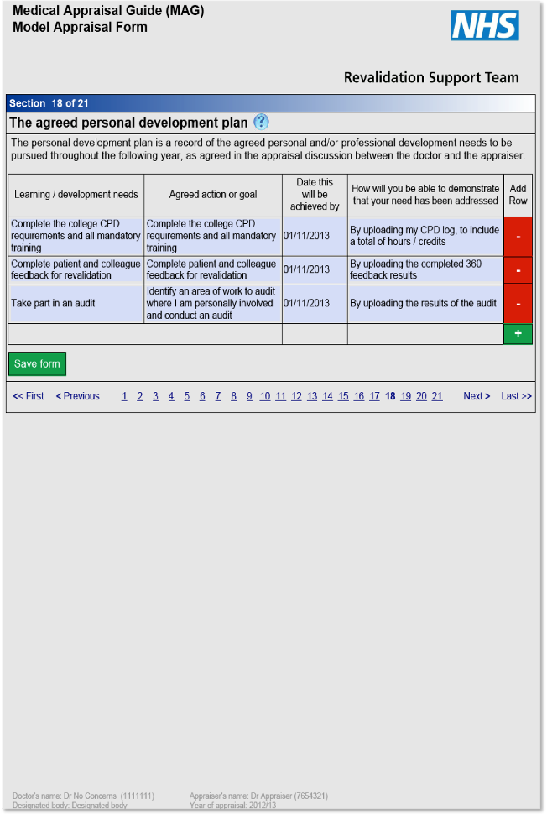
Example 1
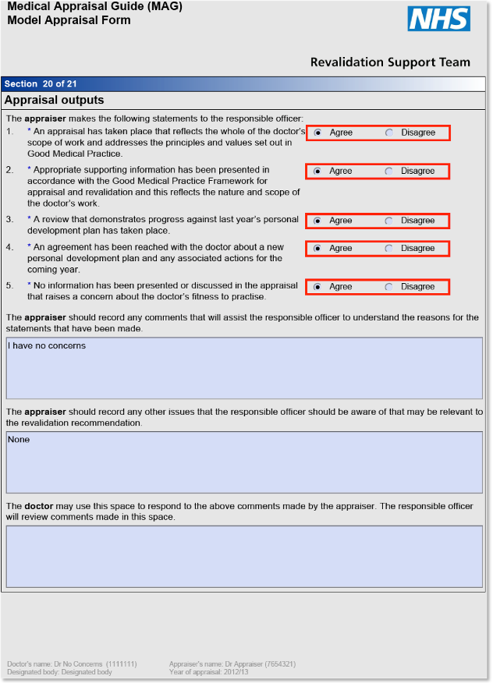
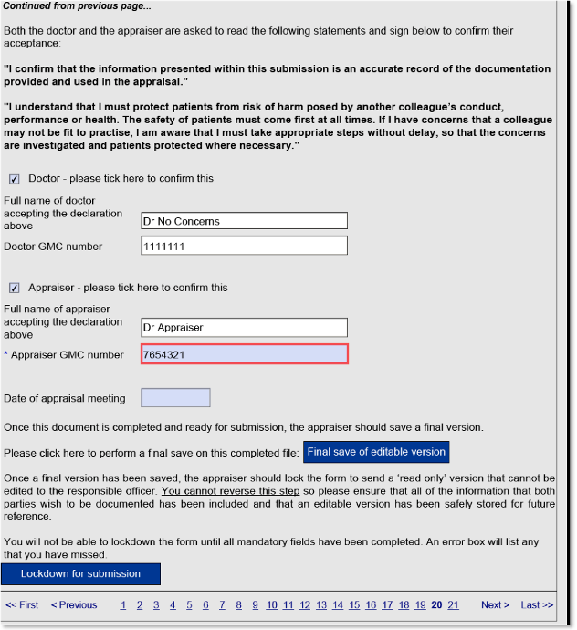
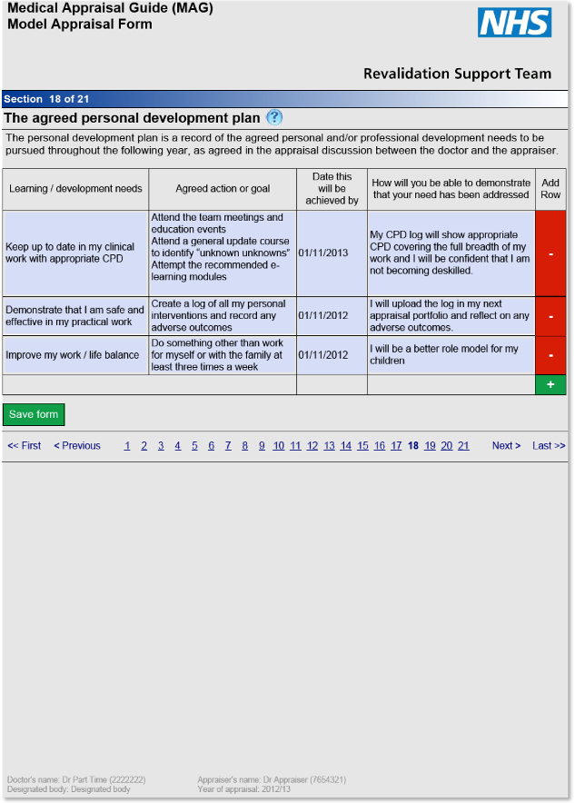
Example 2
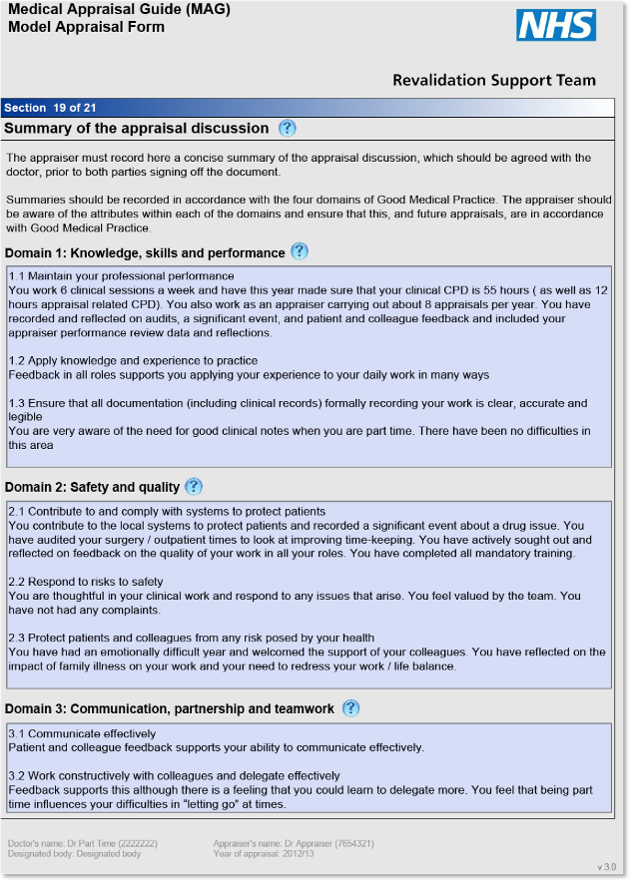
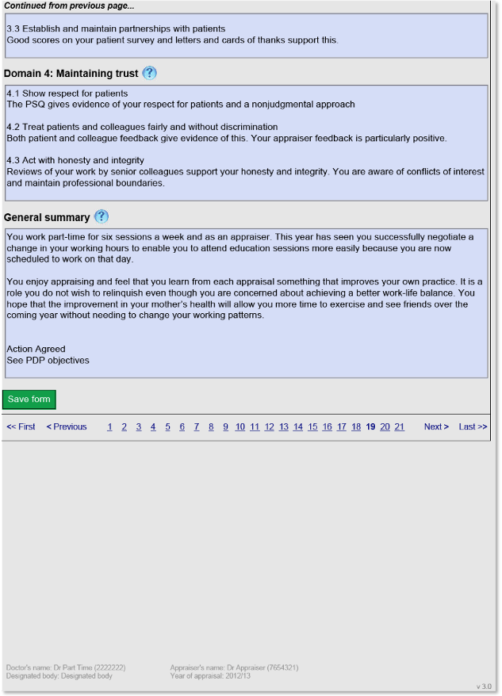
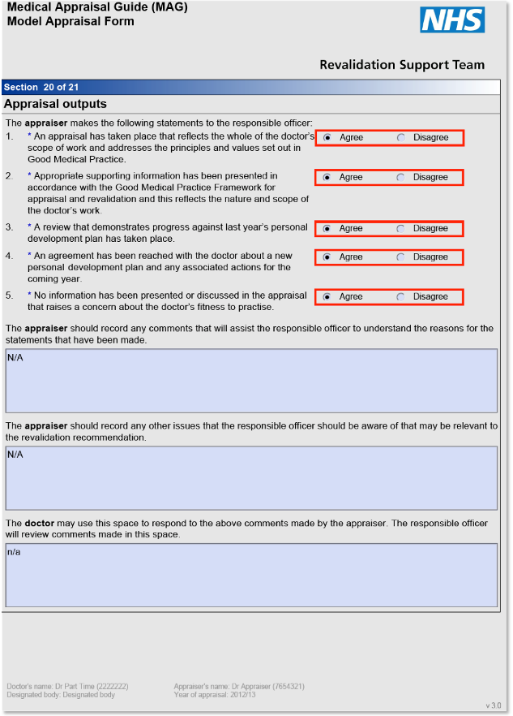
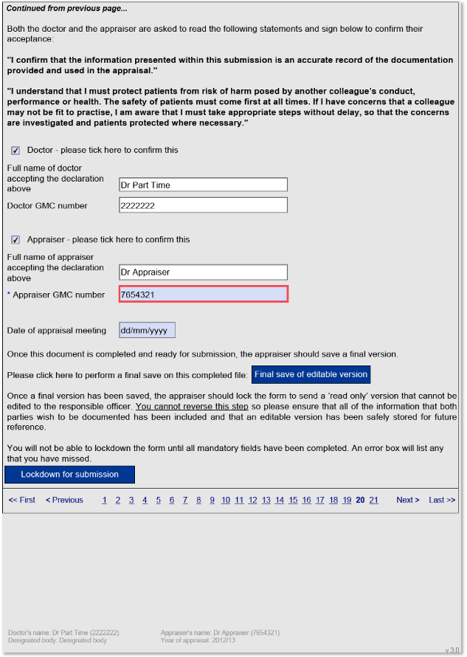
Example 3

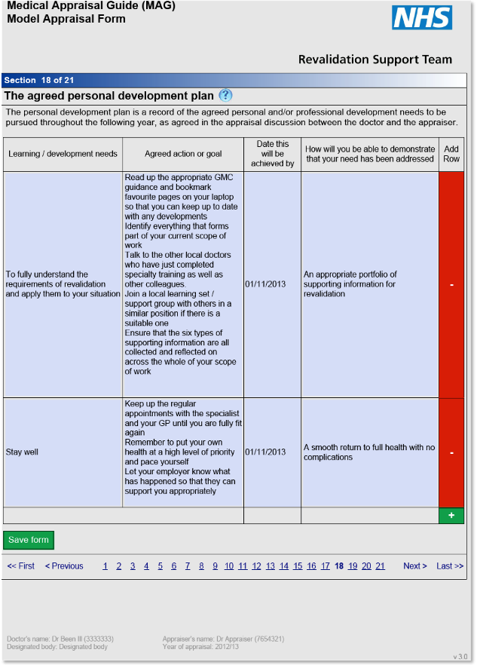
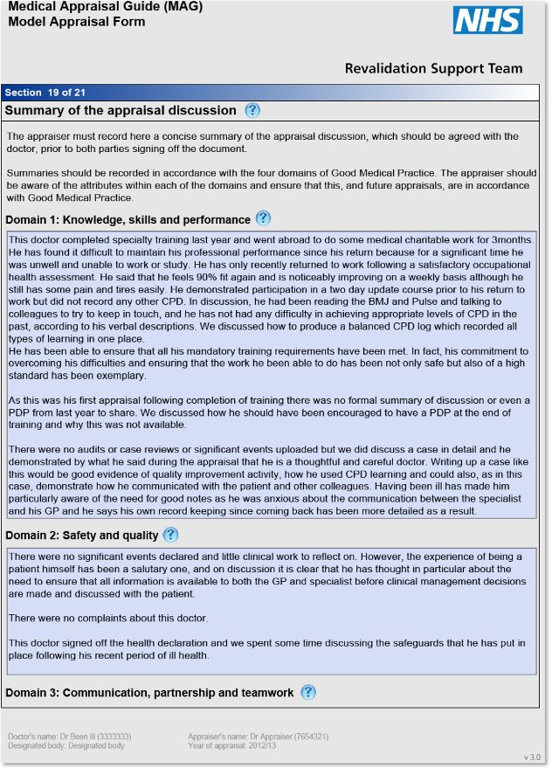
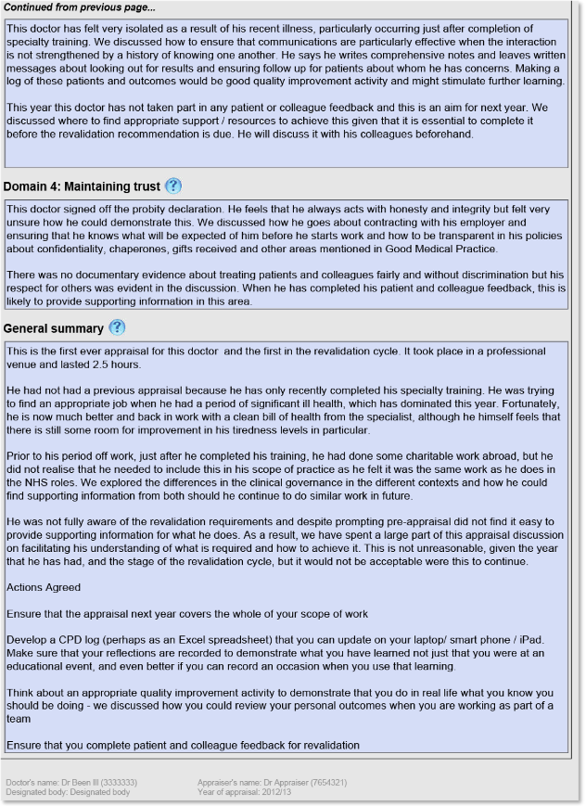
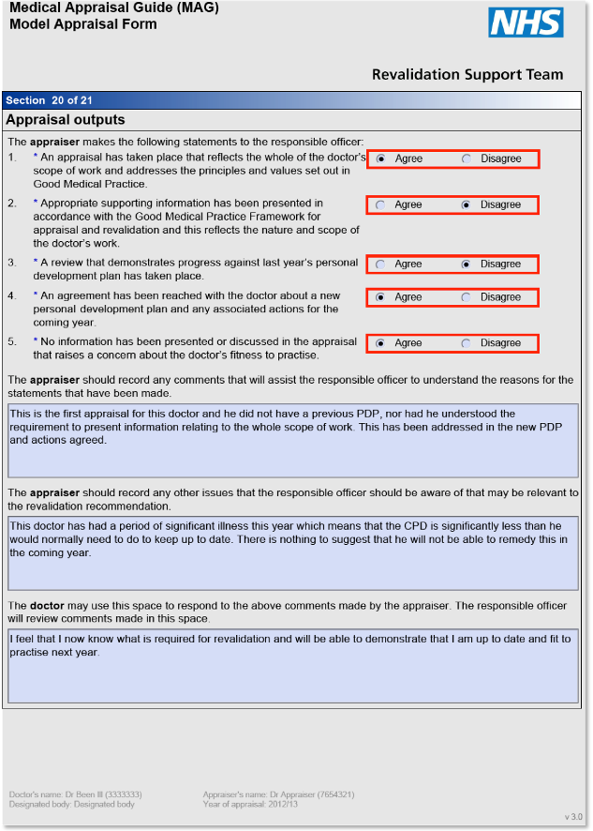
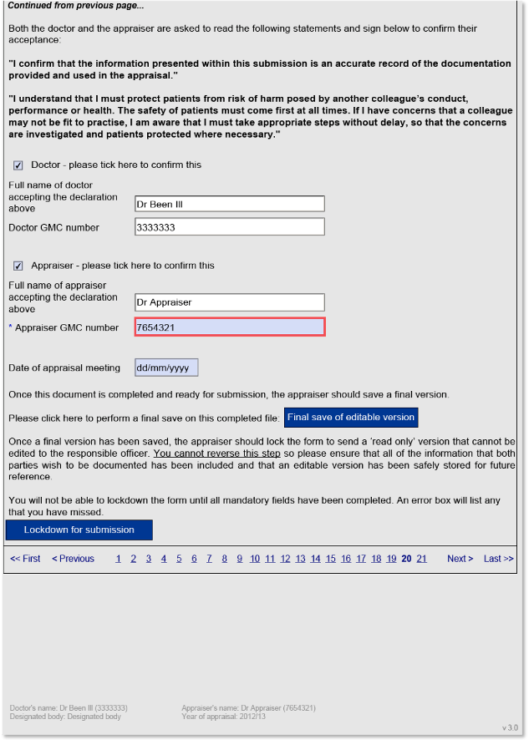

Appraisal summary and PDP audit tool (ASPAT)

Appraiser identifier | Click here to enter text.
Doctor identifier | Click here to enter text.
Date of appraisal | Click here to enter a date.
Organisation | Click here to enter text.
Auditor (usually the senior appraiser) | Click here to enter text.

Scale:
0 Unsatisfactory
1 Needs improvement
2 Good

Score each item out of two

Setting the scene and overview of supporting information
a) The appraiser sets the scene summarising the doctor’s scope of work | Choose an item.
b) The evidence discussed during the appraisal is listed  (not all senior appraisers feel that this is necessary, so if not required score 2) | Choose an item.
c) There is documentation of whether the supporting information covers the whole scope of work | Choose an item.
d) Specific evidence is summarised with a description of what it demonstrates | Choose an item.
e) Objective statements about the quality of the evidence are documented | Choose an item.
f) All statements made by the appraiser are supported by evidence | Choose an item.
g) Appraiser comments about evidence refer/fit in to the four GMC domains and associated attributes set out in the GMC guidance Good medical practice framework for appraisal and revalidation | Choose an item.
h) Reference is made to whether speciality specific guidance for appraisal has been followed e.g. college recommendations for CPD and quality improvement activity  (this is not a GMC requirement so if the senior appraiser does not feel that this is necessary, score 2) | Choose an item.
i) Reference to completion of locally agreed required training (e.g. safeguarding training, basic life support training) is made  (please insert agreed requirements, score 2 if none agreed) | Choose an item.
Comments: Click here to enter text.

Reflection and effective learning
a) There is documentation of evidence showing that reflection on learning has taken place or that the appraiser has discussed how the doctor should document their reflection | Choose an item.
b) There is documentation of evidence showing that learning has been shared with colleagues or that the appraiser has challenged the doctor to do so | Choose an item.
c) There is documentation of evidence showing that learning has improved patient care/practice or that the appraiser has explored how this might be taken further with the doctor | Choose an item.
Comments: Click here to enter text.

The PDP and developmental progress
a) There is positive recording of strengths, achievements and aspirations in the last year | Choose an item.
b) There is documentation of appropriate challenge in the discussion and PDP e.g. significant issues discussed and new suggestions made | Choose an item.
c) The completion (or not) of last year's PDP is recorded | Choose an item.
d) Reasons why any PDP learning needs that were not followed through are stated  (if the PDP was completed then score 2) | Choose an item.
e) There are clear links between the summary of discussion and the agreed PDP | Choose an item.
f) The PDP has SMART objectives  (specific, measurable, achievable, relevant, timely) | Choose an item.
g) The PDP covers the doctor's whole scope of work and personal learning needs and goals | Choose an item.
h) The PDP contains between 3-6 items | Choose an item.
Comments: Click here to enter text.

General standards and revalidation readiness
a) The documentation is typed and uploaded onto an electronic toolkit in clear and fluent English | Choose an item.
b) There is no evidence of appraiser bias or prejudice or information that could identify a patient/third party information | Choose an item.
c) The stage of the revalidation cycle is commented on | Choose an item.
d) There is documentation regarding revalidation readiness relating to supporting information (e.g. states that feedback and satisfactory QIA are already done). Any outstanding supporting information/other requirements for revalidation are commented on with a plan of action to address them | Choose an item.
e) Appraisal statements (including health and probity) have been signed off or if not, an explanation given  (if signed off score 2) | Choose an item.
Comments: Click here to enter text.

TOTAL SCORE (OUT OF 50) | Click here to enter text.

General comments from the senior appraiser:
Click here to enter text.

PROGRESS QA tool  Quality assurance and development of appraisal documentation | Score (out of 20)  0-2 (absent – well done)  0-4 (absent – well done) |  |  | Comments  How can the appraiser improve the appraisal documentation?
 | 1 | 2 | 3
Appraisal identifier (initials)
Professional (2) – is typewritten, objective, free from bias or prejudice, describes a professional appraisal: venue, time taken, good information governance, no identifiable third party info |  |  |  | 1
 |  |  |  | 2
 |  |  |  | 3
Reflects a good appraisal discussion (4) – demonstrates support, challenge and focus on the reflection and needs of the doctor |  |  |  | 1
 |  |  |  | 2
 |  |  |  | 3
Overview (2) – includes a description of the whole scope of work and context for the doctor, the appraisal and the revalidation cycle |  |  |  | 1
 |  |  |  | 2
 |  |  |  | 3
Gaps (2) – identifies any gaps in requirements for revalidation or scope of work and specifies how they will be addressed (or states if no gaps) |  |  |  | 1
 |  |  |  | 2
 |  |  |  | 3
Review supporting information (SI) and lessons learned (4) – reviews SI in relation to Good Medical Practice; comments on SI not supplied electronically and any information the doctor was asked to bring. Reflects on lessons learned, changes made and actions agreed. |  |  |  | 1
 |  |  |  | 2
 |  |  |  | 3
Encourages excellence (2) – affirms good practice, celebrates achievements and actions accomplished, gives examples of good practice and records aspirations (some of which may have a timescale over one year) |  |  |  | 1
 |  |  |  | 2
 |  |  |  | 3
SIGN OFFs & Statements (2) – ensures the input and output statements, including health and probity, have been completed, commented on and, where appropriate, explanation made to the RO |  |  |  | 1
 |  |  |  | 2
 |  |  |  | 3
Smart (2) – PDP objectives arising from the SI and appraisal discussion are SMART: Specific, Measurable, Achievable, Relevant and have a Timescale |  |  |  | 1
 |  |  |  | 2
 |  |  |  | 3
TOTAL
Overall impression:

EXCELLENCE QA Tool  Do the summary of appraisal, sign off statements and the Personal Development Plan (PDP): |  | Score  0=No (absent from summary)  1=Partially (room for improvement)  2=Yes (well done) | Comments
Overall | Encompass all? does the summary comment on context, including stage of revalidation cycle, and reflection on the whole of the scope of work?
 | Exclude bias and prejudice? are all statements objective, free from bias and prejudice and based on evidence? Is it a typed, professional document?
 | Challenge, support and encourage? Does the summary demonstrate that the appraisal was challenging, supportive and focussed on the needs of the doctor?
 | Explain why any statements (including health and probity) have not been agreed? does appropriate commentary explain any ‘no’ or ‘disagree’ answers? | (Score 2 if N/A)
Reviewing | Look at supporting information, lessons learned and changes made? does the summary drive quality improvements by reflecting what has been learned and what needs to be changed as a result?
 | Look at last year’s PDP and reflect on each objective? if any objectives have not been achieved, have the reasons been discussed and documented?
 | Encourage excellence, celebrate accomplishments and record aspirations? does the summary capture examples of good practice and record aspirations (some of which may have a timescale over one year)?
Planning ahead | Note any gaps/no gaps in the requirements for revalidation and how they will be addressed? what supporting information is outstanding for each role?
 | Contain SMART PDP Objectives? Are they Specific, Measurable, Achievable, Relevant and Timely? Do they challenge the doctor to make quality improvements?
 | Explain the new PDP items? does the summary show how the PDP objectives are relevant and derive from the supporting information and appraisal discussion?
Overall Comments Total

31. Appraiser assurance review template
This template may be used by you and your senior appraiser/appraisal lead as a structure for a face to face review of your appraisal work. Once completed it may be added to your own appraisal with your added reflection.

Section A
Appraiser’s name: Click here to enter text.
Reviewer’s name: Click here to enter text.
Reviewer’s role: Click here to enter text.
Date of review meeting: Click here to enter a date.

General
Specialty: Click here to enter text.
Other roles: Click here to enter text.
Start date as appraiser: Click here to enter text.
Have you signed a contract/consultancy agreement? Choose an item.
Date of signature of contract/consultancy agreement: Click here to enter text.

Number of appraisals in the last year: Click here to enter text.
Number of appraisals you would like to do next year: Click here to enter text.
Scope of appraisal work (e.g. primary care, secondary care, private, responsible officer appraisals): Click here to enter text.

Headlines
Looking at your last review’s development themes/objectives in relation to your role as appraiser, to what extent did you get to fulfil these?
Click here to enter text.
As an appraiser, what do you consider you did well in the last year?
Click here to enter text.
What is your approach to preparation and appraisal summaries completion?
Click here to enter text.
What difficulties/ barriers have you come across as an appraiser?
Click here to enter text.
How well does your appraisal work fit in with your other professional duties?
Click here to enter text.
Do you have any helpful tips/good practice to share?
Click here to enter text.
Do you have any suggestions for appraisal workshop topics?
Click here to enter text.
How would you like your appraisal work to develop?
Click here to enter text.

CPD for your appraisal work
Local appraiser groups/appraiser network meetings attended: Click here to enter text.
Comments on these, and any other CPD activities you have undertaken in relation to your appraisal work; possible development plans:
Click here to enter text.

Quality improvement activity for your appraisal work
(Appraisal office should provide the audit of appraisal summaries and PDPs if available)
Comments on the audit of your appraisal summaries and PDPs and any other quality improvement activity relating to your appraisal work; possible development plans:
Click here to enter text.

Significant events in your appraisal work
(Consider, for example, unexpected concerns, interrupted appraisal, failure to agree outputs with doctor)
Comments; possible development plans:
Click here to enter text.

Maintaining professional relationships with doctors you have appraised
(Appraisal office to provide doctor feedback if available,)
Comments on doctor feedback provided by the appraisal office and any other feedback from the doctors you have appraised; possible development plans:
Click here to enter text.

Maintaining professional relationships with colleagues in your appraisal work
Comments; possible development plans:
Click here to enter text.

Your health in relation to your appraisal work
Comments; possible development plans:
Click here to enter text.

Maintaining probity in relation to your appraisal work
(Consider, for example, identification of conflict of interest or appearance of bias with doctors you are asked to appraise, delivering a professional appraisal through diligent preparation and personal organisation.)
Comments, possible development plans:
Click here to enter text.

Complaints and compliments in relation to your appraisal work
(Appraisal office to provide information about complaints if available)
Comments; possible development plans:
Click here to enter text.

Any other comments before the discussion
Reviewer: Click here to enter text.
Appraiser: Click here to enter text.

Section B

Comments/summary following discussion
Reviewer: Click here to enter text.
Appraiser: Click here to enter text.

Personal development themes for your appraisal work
Click here to enter text.
Actions by reviewer/appraisal office
Click here to enter text.

Section C

Sign-off

We agree that the above is an accurate summary of the review discussion and agreed personal development themes/actions.

Signature: May be agreed by e-mail if both parties consent, in which case names sufficient:
Click here to enter text.
Date of sign-off: Click here to enter a date.

32. Dealing with difficult appraisals

- If issues of health, conduct or performance are suspected, concerns should be reported to the appropriate person and acted on according to the severity of the issue, as soon as possible after they have arisen. This is part of the normal duties of a doctor and not restricted to appraisal.

- There are times when an individual appraiser may not know how seriously to take a ‘soft’ concern and talking to others with more experience will usually resolve the dilemma. This will not necessarily prevent an appraiser from signing-off an appraisal depending on the nature of the concern but is likely to lead to the need to make a comment to the responsible officer in the appropriate box.

- If the appraiser intends to report concerns this should normally be discussed with the doctor so s/he is fully aware of the concerns.

- If unacceptable standards or poor engagement with the appraisal process are identified, these should, where possible, be resolved with the doctor so that the appraisal can be satisfactorily completed. For example, an interview could be re-scheduled if paperwork were delayed.
- If an appraiser remains unable to sign off an appraisal on the basis of the above guidance, their concerns should be made known to the appropriate person. A process for managing this should be locally agreed, and clearly described in the organisation’s medical appraisal policy.

Designated bodies other than NHS England may find the NHS England Medical Appraisal Policy and its annexes (available at https://www.england.nhs.uk/revalidation/appraisers/app-pol/) useful as a references when writing or reviewing their own appraisal policies and procedures. It describes the framework for appraisal of licensed medical practitioners who have a prescribed connection to NHS England, so designated bodies should note that as written it applies only within NHS England. Parts of the policy and its annexes may therefore need to be adapted for other designated bodies.
- If an appraisal cannot be signed-off, appraisers should ensure that they have records made and dated as soon as possible after the end of the appraisal meeting in order to justify their decision if challenged.

- The appraisal policy must contain a complaints and appeals policy so that a doctor who wants to complain or appeal knows how to do so and is treated fairly and transparently.

- If, after an appraisal, an appraiser becomes concerned about an appraisal or a doctor they should contact their appraisal lead or an experienced appraiser from their support group, or another appropriate person to discuss this. Remember: if in doubt, ask...

33. Exercise: Handling unexpected serious concerns arising during the appraisal discussion

Aims
This exercise aims to:
- explore under which circumstances an appraisal already being undertaken should be stopped/suspended
- explore what actions an appraiser should take under these circumstances
- ensure that appraisers are comfortable with how to carry forward a discussion without closing it down too soon explore the difference between illegal and legal but dangerous coping strategies
- ensure that the appraiser is aware of how to access performance and occupational health processes locally
- ensure that the appraiser is able to signpost services without taking on inappropriate roles.
(One outcome should be the awareness of an up to date list of occupational health or performance panel contact numbers and details and any other relevant information specific to the organisation / designated body)

Please read the statements which appraisers sign at the end of the appraisal before trying out the scenarios.

Scenario one

The appraisee is a high flyer with an incredibly full portfolio, fantastic supporting documentation and a great reputation. The appraiser innocently asks: "How do you manage to fit all this in?" at which point the appraisee blurts out:
- "Well, I couldn't do it if it weren't for the amphetamines."

(For the purposes of this exercise, please assume this does not refer to legal amphetamines prescribed appropriately for ADHD. This is clearly illegal behaviour)

The trio should take the theme from this unexpected statement, with the appraiser rehearsing forms of words and strategies to stop or suspend the appraisal, and support the appraisee in the actions they would need to take next.

Rehearse this as a role-play as it is much more powerful to have to work out what to say than to discuss the concept in the abstract.

(It is worth knowing that this is an anonymised version of a “cry for help” that has arisen in a real appraisal – but in the 10+ years of NHS appraisals it has been found that it is incredibly rare for such an issue to arise for the first time and without warning in an appraisal discussion.)

Scenario two

As above, no concerns at all, until the doctor says:
- "Well, I couldn't do it without having a drink every night..."

Repeat the role-play with this new issue, having rotated round the trio to give another doctor the chance to rehearse their appraiser skills.

You will find that there are two very different versions, depending on how the individual imagines the character in the role play – the doctor who is not drinking inappropriately and is absolutely safe to practice – and the doctor who is actually drinking at hazardous levels and is aware that their alcohol intake has become a problem that might affect their legality to drive and patient safety.

This is designed to show that there are shades of grey in exploring issues – it is important to be clear about what is said in jest and what is said because the appraisee is being serious for example. It may or may not be appropriate to suspend this appraisal and move into occupational health proceedings depending on the way it is played.

Scenario three

As above, no concerns at all, until the appraisal is over and you have agreed everything and the doctor says:

- “Actually, I wanted to tell you about my colleague. I am really worried because he has started to arrive late for work every day and I think he has started drinking really heavily since his divorce. On a couple of occasions, I have heard the nurses commenting that he smells of alcohol and his hands certainly don’t seem too steady.” (Pause)

Repeat the role-play with this new issue, having rotated round the trio to give the third doctor the chance to rehearse their appraiser skills.

Scenario four

You are at the end of the appraisal discussion and this is the second year of the revalidation cycle and the second time you have appraised this doctor. You are feeling uncomfortable because you do not think you can agree that this doctor has provided appropriate supporting information or made progress with last year’s PDP. The doctor so far has brushed off any comments you have made during the discussion in an attempt to prepare for the impending situation.

The doctor ends by saying: “Well, let’s get on and sign the paper work off and then we can both go off and get on with the important things in life...”

How would you respond?

34. Suggested challenges for common appraisal problems

Too much documentation
- How did you decide how much evidence to submit?
- What could you do to make preparing for your appraisal less time-consuming?
- How do you prioritise your work? How can we prioritise what we need to discuss?
- How would you assess this supporting documentation?
- What do you think is the most important piece of work/evidence/documentation in here…why?
- Help me to hone in on what really interests you…

The high flyer
- Looking at all these impressive achievements, which means the most to you, and why?
- Do you still feel driven to achieve more? Why?
- Are you aware of the ways in which you use your influence?
- Is there anything you would like to do but you feel you could never succeed at?
- How do you feel about revealing your weaknesses?
- Where do patients come in your order of priorities?
- I feel rather inadequate when I look at all you do. How do you think the other members of your department/practice feel?
- Within and beyond your professional activities, do you feel that anything important is being sacrificed on the altar of your success?
- How do you feel about your work/life balance?

The cynic/unbeliever/imminent leaver
- You seem to feel appraisal is merely a hoop to be jumped through… (pause)
- I’m sorry you feel like that. Do you know of anyone who has found it a positive experience?
- Let us try together to make this time as useful as possible for you. What are your top priorities this year?
- You seem very negative about the appraisal process. What upsets you about it?
- I feel that you would rather I were not your appraiser…?
- I am feeling unable to do a good job here. Is there anything I could change to make it more useful for you?
- What have you achieved that feels worthwhile? What could we achieve that would make this useful to you?

The dependent/disempowered
- How do you feel you could take control of this appraisal?
- I feel you are looking to me for answers. What are your priorities?
- How do you make decisions? Not just at work but in your life outside work too?
- I have the feeling you have felt unable to take control here…does that happen to you often?
- What do you feel about bullying? Have you ever had any experience of it?
- When you ask me what I think you should do, I feel that because this is your appraisal and your own solutions are likely to work best for you I shouldn’t be giving you the answers…(pause)
- I feel that I am being very useful to you, but what do you feel that you should be contributing here?
- I wonder whether I am doing too much of the talking here…?

The disclosure of poor performance
- What you have just said is really serious. Let’s take a bit of time outside the appraisal to explore that…
- You seem very upset. Do you need a break? Would this be a good time for me to go and get us both a coffee / tea?
- This seems to be outside the bounds of the appraisal discussion. Shall we stop the appraisal here for now?
- You know that what you have just said has implications for patient care… (pause)… I am glad you have felt safe to reveal that. I am here to support you in working through what to do next… (pause)… You know I will have to report this discussion because it affects patient care. We need to put things in place…What do you think we should do next?

The disclosure of illness/addiction
- Any of the challenges used for the revelation of poor performance, plus…
- You have obviously been worrying over this for some time… (pause)
- You seem to be telling me that you are seriously ill… (pause)
- Who else knows about this? Do you feel able to tell your colleagues/partners/spouse/a friend/your GP?
- What would you be telling another doctor in your position to do?

Whistleblowing
- This is a very serious accusation about your colleague. What are the implications?
- May I ask why you have raised this? What were your expectations?
- What do you feel your responsibility should be here?
- What you have told me is hearsay, but do you have evidence that needs acting on?
- Do you know about the whistleblowing policy locally?

35. Sample evaluation forms and reflective templates

Below over the next seven pages are blank forms and templates that you may find useful. They include sample evaluation forms for network meetings, a combined certificate of attendance and template for reflection, a training evaluation form, and a generic reflective template.

Insert Network Name - Evaluation Form
Insert Date and Venue

NHS England Insert Region/Area
  - In order to ensure the network meetings are beneficial, we would like to get your input about this and future events. The more detailed feedback you provide, the better we will be able to meet your needs.

Your Name (optional) Click here to enter text.…………..…………………………………….

Your e-mail (optional) Click here to enter text. ……………………………………………….

Which venue did you attend? Click here to enter text..........……………………………….

Today’s Event

What was your overall impression of today?
Excellent ☐ Good ☐ Fairly good ☐ Poor ☐ Very Poor ☐

What did you value most about the event?

Click here to enter text.
…………………………………………………………………………………………………

How useful to you personally was each session?

Insert topic
Very useful ☐ Moderately useful ☐ Limited use ☐ Not useful ☐

Insert topic
Very useful ☐ Moderately useful ☐ Limited use ☐ Not useful ☐

Insert topic
Very useful ☐ Moderately useful ☐ Limited use ☐ Not useful ☐

Insert topic
Very useful ☐ Moderately useful ☐ Limited use ☐ Not useful ☐

Insert topic
Very useful ☐ Moderately useful ☐ Limited use ☐ Not useful ☐

How would you rate the venue?
Excellent ☐ Good ☐ Fairly good ☐ Poor ☐ Very Poor ☐

How would you rate the facilitation?
Excellent ☐ Good ☐ Fairly good ☐ Poor ☐ Very Poor ☐

How would you rate the administration of the event?
Excellent ☐ Good ☐ Fairly good ☐ Poor ☐ Very Poor ☐

What could have improved the event, how could it have been different/better?

Click here to enter text.
……………………………………………………………………………………………
Appraisal and You

How would you rate your contribution to the event on a scale of 1-5?
1 = poor/little participation and 5 = excellent/full participation

1 ☐ 2 ☐ 3 ☐ 4 ☐ 5 ☐

Why did you give yourself this rating?

Click here to enter text.
………………………………………………………………………………………………...

What is the key area around appraisal that you and your team struggle with?

Click here to enter text.
…………………………………………………………………………………………………

How best could the All England Appraisal Network support you?

☐ Local events/conferences
☐ Regional events/conferences
☐ National events/conferences
☐ Providing training/CPD
☐ Providing train the trainer development days
☐ Providing networking opportunities
☐ Online resources such as templates, policy documents etc.
☐ Other

Please state: Click here to enter text.
………………………………………………………………………………………………….

Additional comments or suggestions for future networks:

Click here to enter text.
…………………………………………………………………………………………………

…………………………………………………………………………………………………

…………………………………………………………………………………………………

…………………………………………………………………… Thank You

Please return completed form to (insert e-mail address)

Certificate of Attendance and Template for Reflection

(Insert Name)
attended the

(Insert name of event)

(Insert date)

(Insert amount of CPD plus provider and code)

Paste signature here
(Insert Name)
(Insert Job Title)
NHS England (Insert Date)

What were you hoping to learn from this conference?
Click here to enter text.

What have you learnt?
Click here to enter text.

Have you identified any additional learning needs (personal or organisational) and if so, how will you address them?
Click here to enter text.

How will this session change your practice and have an impact on those you work with? (Consider how you might evaluate this).
Click here to enter text.

Training evaluation form

A. Information about the venue:

1. Date of the event:

2. Location of the event:

3. Were all the venue-related arrangements suitable for the training day?

Yes
No

Any comments about the venue (e.g. how to improve upon any particular aspects)?

B. Information about the facilitators

4. How do you rate the facilitators who ran the training event?
(Please insert the name of each facilitator and tick the box that most applies.)

Insert names of lead facilitators here:
Poor
Satisfactory
Unsure
Good
Very good

Any particular comments about the lead facilitators:

5. Communicating with you as an appraiser | Yes | No
Was a baseline needs assessment made to ascertain your level of prior knowledge?
Did the facilitators clearly explain the purpose of the training and its objectives?
Did the facilitators ask relevant questions throughout the session to ensure your understanding?
Was adequate time given for your questions?
Did the facilitators display knowledge and understanding of medical appraisal and revalidation?
Were examples used to aid understanding?
Was there an appropriate level of interaction and engagement with you as an appraiser?

6. Levels of confidence at the end of training | Yes | No
Did the training build on your level of prior knowledge and improve your confidence?
Do you feel the purpose of training and its objectives were met?
Are you confident about the key messages and ensuring that they are applied consistently?
Are you confident about how to provide a professional appraisal?
Are you confident about how to introduce the appraisal and highlight the GMC confidentiality limitations?
Are you confident about how and when to suspend an appraisal?
Are you confident about helping doctors to produce appropriate portfolios of supporting information for revalidation?
Are you confident about how to help doctors produce better personal development plan objectives?
Are you confident about how to make appropriate output statements to the responsible officer?
Are you already aware of the support structures and contact details you will need?
Are you confident that you know where to look for the latest information about medical appraisal and revalidation to keep up to date going forwards?

7a. Which part of the training did you find most useful, and why?

7b. Which part of the training did you find least useful, and why?

8. Please add any additional comments or observations here:

This page illustrates a generic reflective template that you could use for any learning event that you attend. It can then be loaded onto your own appraisal toolkit.

EDUCATIONAL MEETING

Topic:
Speaker:
Date:
Hours/Credits:
Reflective writing:

What were you hoping to learn from this educational session?

What did you learn in this session?

Have you identified any additional learning needs around this topic and if so, how will you address them?

How will this session change your practice and have an impact on those you work with? (Consider how you might evaluate this).

36. Useful websites and documents

Good Medical Practice (GMC, 2013)
http://www.gmc-uk.org/guidance/good_medical_practice.asp

Good Medical Practice framework for appraisal and revalidation (GMC, 2012)
http://www.gmc-uk.org/doctors/revalidation/revalidation_gmp_framework.asp

Supporting information for appraisal and revalidation (GMC, 2012)
http://www.gmc-uk.org/doctors/revalidation/revalidation_information.asp

GMC web pages on revalidation:
www.gmc-uk.org/doctors/revalidation.asp

BMA web page on appraiser selection, training and capacity:
http://bma.org.uk/practical-support-at-work/appraisals/selection-training-and-capacity

Academy of Medical Royal Colleges (AoMRC) revalidation:
http://www.aomrc.org.uk/revalidation/revalidation.html
and specialty advice:
http://www.aomrc.org.uk/revalidation/specialty-advice.html

Medical Appraisal Guide – a guide to medical appraisal for revalidation in England v4.0
(RST version 4, March 2013)
http://www.england.nhs.uk/revalidation/wp-content/uploads/sites/10/2014/02/rst-medical-app-guide-2013.pdf
This document leads you through the process for providing a medical appraisal for revalidation.

Quality Assurance of Medical Appraisers: Recruitment, training, support and review of medical appraisers in England (RST version 5, January 2014)
http://www.england.nhs.uk/revalidation/ro/app-syst/

NHS England Medical Appraisal Policy, Annex J: Routine Appraiser Assurance Tools (NHS England, 2015)
http://www.england.nhs.uk/revalidation/appraisers/app-pol/

Medical appraisal guide (MAG) form:
This is the PDF appraisal toolkit format that may be uploaded onto the NHS England RMS (revalidation management system) dashboard.
Link to the current version of the MAG form (under review):
http://www.england.nhs.uk/revalidation/appraisers/mag-mod/

BMJ e-learning resources (free to BMA members):
http://learning.bmj.com/learning/home.html

Appraisal e-learning modules:
Revalidation: a guide for appraisers
Challenge in appraisal
Calibrating the supporting information in medical appraisal
Quality improvement activity for appraisal and revalidation in the United Kingdom
Multisource feedback (MSF) for appraisal
Getting the most out of your appraisal
Tips for appraisers (a very basic overview)

HEE Appraiser Workshop Resources (HEE, 2015)
http://www.england.nhs.uk/revalidation/appraisers/meetings/hee-resources/

37. Support contacts

BMA Counselling Service
http://bma.org.uk/practical-support-at-work/doctors-well-being/about-doctors-for-doctors

Doctors’ Support Network and Support line
A self help organisation for doctors with or who have recovered from mental illness
http://www.dsn.org.uk/

National Counselling Service for Sick Doctors
http://www.ncssd.org.uk/

NHS Practitioner Health Programme
A free, confidential service for doctors and dentists living in London who have mental or physical health concerns and/or addiction problems
http://php.nhs.uk/

Royal Medical Benevolent Fund
Provides financial help for sick doctors
http://www.rmbf.org/

Sick Doctors’ Trust
A proactive service, self-help organisation for addicted physicians
http://sick-doctors-trust.co.uk/

The Skilled Helper: A Problem-Management Approach to Helping, 6th revised edition (Egan, G, Brooks/Cole, 1997)

