We are becoming a Learning Disability Friendly GP Practice / Primary Care Network (PCN)

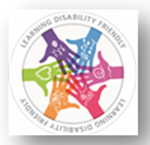

Dear
We want to make sure that our patients with a Learning Disability are well and healthy.
To make sure that we understand your needs, we want to ask you some questions.
Please answer the questions below:
Do you have any communication needs?  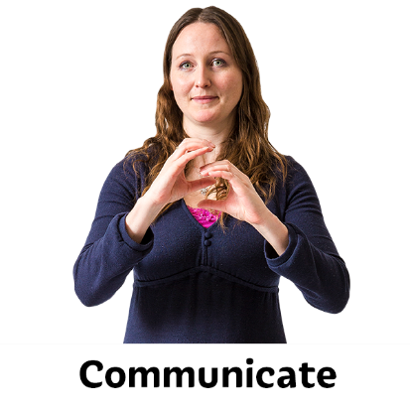 | YES or NO  Speak slowly  Give me time  Use pictures/ photos  I use Makaton  I use my mobile/ tablet  I need my carer with me  Other:
Do you need appointment reminders?  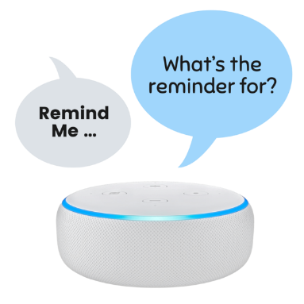 | YES or NO  I need appointment reminder by:  Phone  Text  Email  Other:
Do you need reasonable adjustments when accessing the surgery?  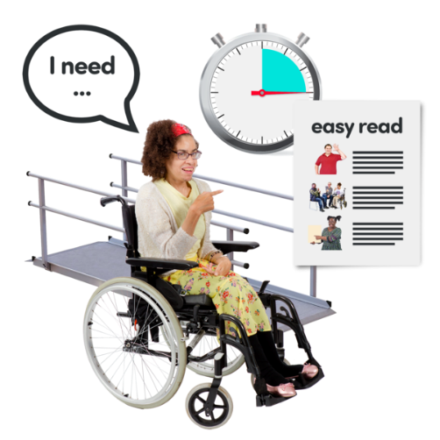 | I need longer appointment  I like to come in when it is quiet  I get anxious waiting  I like to know who will see me  I need easy read  I need my carer  Other:
Please give us your feedback.  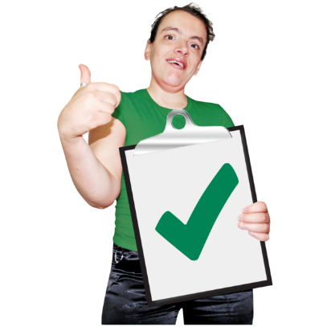 | What is good about your doctor’s surgery?
Please give us your feedback. | What is bad about your doctor’s surgery?

When you completed this form, you can choose how you return it to us.

You can either:
- Bring to the surgery. Give this form to the reception staff.

- Post this form to this address:

- Email this form to:

If you have any questions about how we can support you, you can speak to our reception staff and ask to talk to one of our Learning Disability Champions.

The Learning Disability Champions for your GP surgery are (amend):

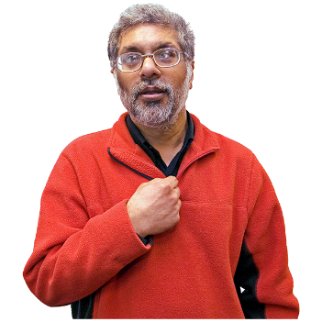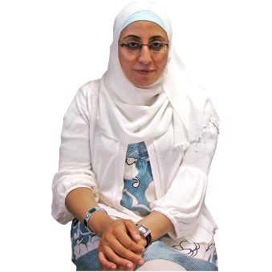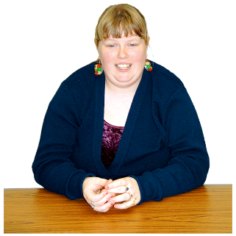
Dr Peter Smith Dr Sali Ahmad Lena Smith
(Doctor) (Doctor) (Care-coordinator)

Thank you.

