INVITATION LETTER for your Annual Health Check

Date: Please amend this letter.
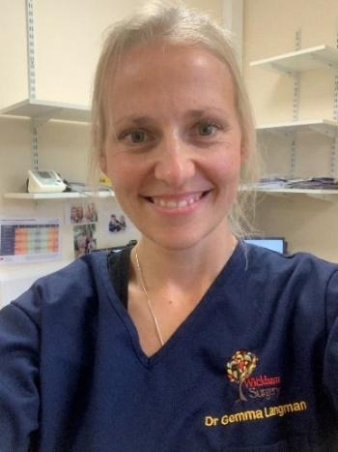 | Hello ………, my name is Dr Gemma Langman.  I am a doctor at your doctor’s surgery.  This is my photo.
People at your doctor’s surgery might wear a face mask. Sometimes they will wear an apron, goggles or gloves.

This is called Personal Protective Equipment or PPE.

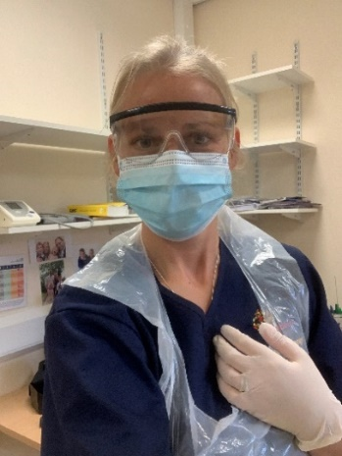 | When people wear PPE, they look different.  I want to show you what I look like with my PPE on.  But this is still me!
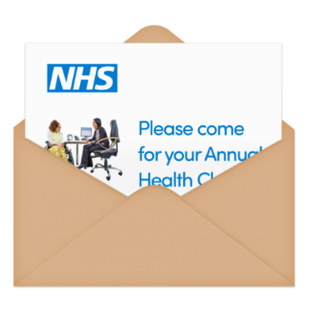 | I want to invite you for your Annual Health Check.
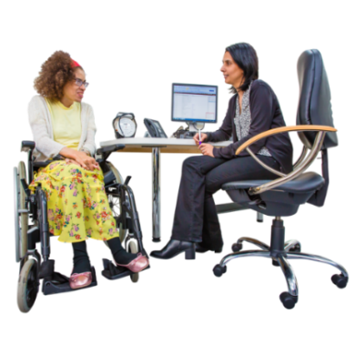 | Annual Health Check is important.  Annual Health Check is where we talk about your health and anything you need help with.
You can have a blood test and flu jab too.

Having a blood test and flu jab is your choice.

So please do not worry.

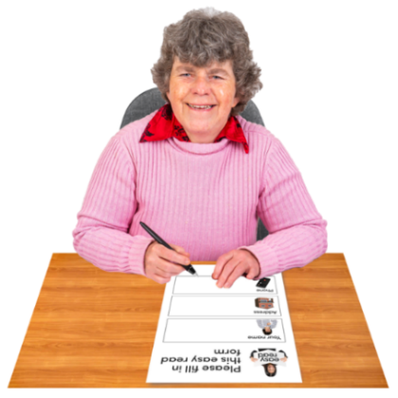 | You can prepare for a health check by completing the form I sent to you.  If you need help with the form, ask someone you trust.
You can send completed pre-health check form to me by post. Or you can bring it to your health check.

But you can still come to your appointment without the form!

I will call you on ……
to make an appointment for your health check.

If you don’t want to wait and you want to talk to me sooner, call me on ………

 | If you need to have your health check at home, please let me know.
 | Thank you.
Picture | Name  Title

